Supply, installation and commission of Air Conditioners units at Plant Health Pathology (Roodeplaat)

- Install two 12000 BTU Wall Split Rooftop Air Conditioners Units in Room L8,(PHP Main Campus) F-Wing Incubator Room (PHP Main Campus),

- Transfer Of existing L8 cooling unit and installation at A15
- After the completion of installation the mechanically cooling units must be able to maintain temperature of 18ºc , humidity of 45% over 24 hours and with acceptable gradient of deviation of +/- 20 degrees either side of 18º c under full load.
- All brickwork, removing and replacement of roof ceiling panels where necessary, fitting of a weatherproof isolator, wiring to cooling units from nearest power point where applicable
- Must be SABS standard and approved.
- Supplier/s must do all connecting controls
- Supplier/s must issue COC after completion
- Supplier/s must be CIDB registered
- All items should have at least twelve(12) months warranties and guarantees

- Installation of one Under ceiling air conditioner at L14 Incubation

- Supply & Install 24 000 BTU (Total area 48.00m²) under the ceiling air conditioner
- Remove the existing cooling unit and seal gaps or openings.
- The machine must be able to maintain 28°C all the time(24/7). After power failure unit should automatically come on to the programmed temperature. Certificate of compliance for electrical work to be issued upon completion.
- air-conditioner must have a remote control to adjust the temperature
- 6 monthly service plan must be included
- Twelve (12) month warranty on workmanship and equipment
- Potential bidders to attend a site inspection to familiarize themselves with the desired conditions and scope of work prior to quoting.
- Temperature mapping of the room will be done by an accredited metrology lab. (Arranged by PHP) to determine mean temperature across the room after installation and before sign off. Expectation to be 28°C (± 2)

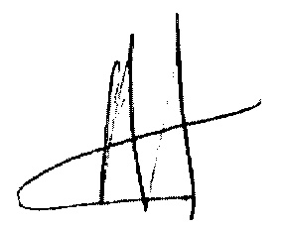
06/09/22

