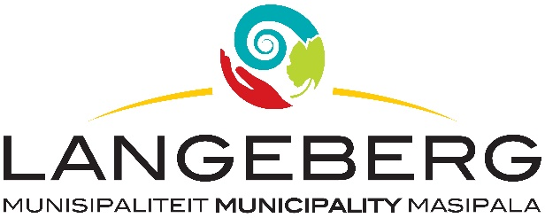

TENDER 51/2023

Tenders are hereby requested for the SUPPLY AND DELIVERY OF SAFETY CLOTHING, TEXTILE, FOOTWEAR AND LEATHER FOR A PERIOD OF THREE (3) YEARS, LANGEBERG MUNICIPALITY as specified in the bid document.

Completed Bids, in sealed envelopes, clearly marked “TENDER 51/2023: SUPPLY AND DELIVERY OF SAFETY CLOTHING, TEXTILE, FOOTWEAR AND LEATHER FOR A PERIOD OF THREE (3) YEARS, LANGEBERG MUNICIPALITY” should be placed in the tender box, at the Langeberg Municipal Office, 28 Main Road, Ashton, not later than 12:00 on 12 APRIL 2024 when the Bids will be opened in public. Late, faxed or e-mailed tenders will not be considered.

PLEASE NOTE:

The official Bid document must be fully completed in black ink, all pages must be submitted and the document should preferably be bound.

Supporting documents must be submitted separately and must be stapled or bound.
The lowest, or any tender, will not necessarily be accepted and council reserves the right to accept any tender. Tenders will be evaluated according to the Council’s Supply Chain Management Policy and the 80/20 Preference Point system. The Supply Chain Management Policy can be viewed at Municipal Offices or www.langeberg.gov.za

Tender documents are available from 08 MARCH 2024, on the Langeberg Municipal website: www.langeberg.gov.za

Please refer written enquiries to MS L JASS-HOLMES (ljassholmes@langeberg.gov.za).

DP LUBBE
MUNICIPAL MANAGER
Private Bag X2
Ashton,
6715

