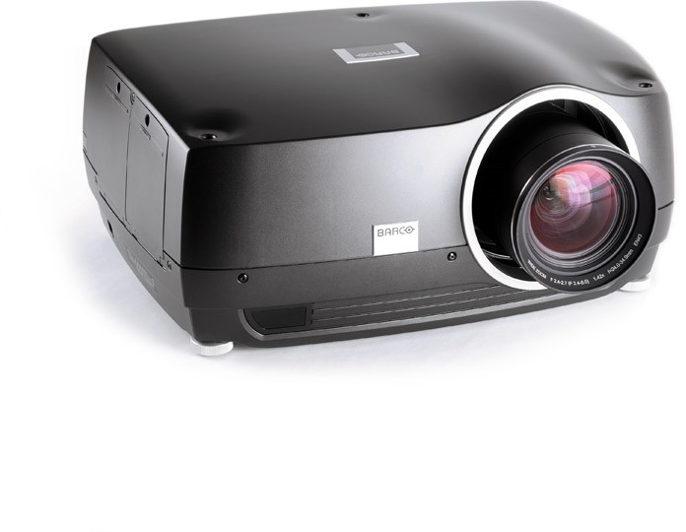

SPECIFICATIONS

Display colors 30-bit

Latency ~19 ms
Computer graphics formats 2,560 x 1,600 - 640 x 480

Horizontal scan frequencies 15 -150 kHz (resolution dependent)
Vertical scan frequencies 48 -190 Hz (resolution dependent)

Video formats HDTV (1080p, 1080i, 720p), EDTV (576p, 480p),
SDTV (576i, 480i)
Lens operation Motorized zoom, Focus, Shift, Iris and Mechanical shutter

Image width 0.5 -20 m
Light source LED

Lamp lifetime Up to 100.000 hours
Computer inputs 2 x DVI-D, 1 x VGA, 2 x HDMI 1.3a, 1 x XPort1, 1 x XPort2

Video Input 2 x HDMI 1.3a, 1 x YPbPr, 1 x Component
Control possibilities 1 x RJ-45 TCP/IP, 1 x 9-pin D-SUB RS232, 2 x USB
Resolution WQXGA (2,560 x 1,600) or WUXGA (1,920 x 1,200)

