Procurement Specification: Staff Uniform HSRC CCBR Sweetwaters
Background
Serving South Africa for more than 50 years, the HSRC is the largest research institute in Africa focusing on the social sciences and humanities. It produces and disseminates knowledge that contributes to policies and programmes to alleviate poverty, reduce inequality, and stimulate innovations for employment creation. More than knowledge production, the HSRC works towards the uptake of research for policy and impact. Collaborations and partnerships are critical and include local, regional and international public, private and community entities.
The Centre for Community Based Research Site based in Sweetwaters has grown in leaps and bounds over the years an continues to make an impact in the community. With the increasing number of projects on site, the staff complement has grown tremendously and it is only fitting to create a staff uniform collection that will not only help solidify the bond between the staff as a team, it also promotes unity and fosters togetherness. These characteristics helps when the staff are serving in the community.
Table of Quantities
Description | #
Female Short Sleeve Blouse – Annex D | 90
Female Long Sleeve Blouse – Annex D | 90
Female Golf T-shirt – Annex E | 90
Male Golf T-shirt – Annex F | 120
Male Long Sleeve Shirt – Annex G | 60
Jacket – Annex M | 150
Scrub Set – Annex N | 40
Scrub Top – Annex Q | 40
Polar Fleece Beanie – Annex H | 150
Water bottle – Annex P | 150
Lunch bag – Annex O | 150
Peak cap – Annex I | 50
Wide Brim Hat – Annex k | 50
Visor – Annex J | 50
Spare bibs/Outreach - L | 150
Spare caps/Outreach – Annex I | 150

Specifications:
Supplier Minimum requirements
Minimum 5 years’ experience within the textile, fashion or supplies industry
Provide evidence and examples of previous work in line with specifications for this order
Ability to produce work wear for bulk order,
Provide garments with design features consistent with specification below.
Local supplier (South African), utilising locally made garments
Provide samples as below prior to order confirmation:
- Samples in each size (Small, Medium, Large, X-Large)
- Sample for each item specified
- HSRC approval of sample design and quality in line with specifications below required prior to order being placed
Ability to deliver within 21 days of confirmed order unless otherwise agreed in writing with the HSRC.

Breakdown by size
Description | X  SMALL | SMALL | MEDIUM | LARGE | X  LARGE | XX  LARGE | XXX  LARGE | 5X  LARGE | Universal Size | Total
Female Short Sleeve Blouse | 2 | 14 | 22 | 17 | 20 | 14 | 0 | 1 | 0 | 90
Female Long Sleeve Blouse | 2 | 14 | 22 | 17 | 20 | 14 | 0 | 1 | 0 | 90
Female Golf T-shirt | 2 | 14 | 22 | 17 | 20 | 14 | 0 | 1 | 0 | 90
Male Golf T-shirt | 0 | 20 | 24 | 32 | 30 | 14 | 0 | 0 | 0 | 120
Male Long Sleeve Shirt | 0 | 10 | 12 | 16 | 15 | 7 | 0 | 0 | 0 | 60
Jacket | 2 | 24 | 34 | 33 | 35 | 21 | 0 | 1 | 0 | 150
Scrub Set | 0 | 4 | 8 | 8 | 12 | 7 | 0 | 1 | 0 | 40
Scrub Top | 0 | 4 | 8 | 8 | 12 | 7 | 0 | 1 | 0 | 40
Polar Fleece Beanie | 0 | 0 | 0 | 0 | 0 | 0 | 0 | 0 | 150 | 150
Water bottle | 0 | 0 | 0 | 0 | 0 | 0 | 0 | 0 | 150 | 150
Lunch bag | 0 | 0 | 0 | 0 | 0 | 0 | 0 | 0 | 150 | 150
Peak cap | 0 | 0 | 0 | 0 | 0 | 0 | 0 | 0 | 50 | 50
Wide Brim Hat | 0 | 0 | 0 | 0 | 0 | 0 | 0 | 0 | 50 | 50
Visor | 0 | 0 | 0 | 0 | 0 | 0 | 0 | 0 | 50 | 50
Spare bibs/Outreach | 0 | 0 | 0 | 0 | 0 | 0 | 0 | 0 | 150 | 150
Spare caps/Outreach | 0 | 0 | 0 | 0 | 0 | 0 | 0 | 0 | 150 | 150

NB. Please note – quantities per size subject to amendment based on cut/size of the sample garments provided.

Design/Construction:

- Garments colour – dark turquoise – Annexure A
- Alternative : navy blue
- Design element – Annexure B
- HSRC Logo Annexure C - Will be incorporated as full colour embroidery on items of clothing

- Female short & long sleeved blouse Annexure D
- 100% polyester
- Logo right chest
- Weight 100g/m2
- Mandarin Collar
- Inner collar design element
- Short sleeved blouse
- Long sleeved blouse as picture
- Keyhole and pleat detail at cuff with one button

- Female Golf T-shirt Annexure E
- Short sleeves
- Design element inner placket or collar
- 3 button placket
- Embroided Logo right chest
- Slim fit
- Ladies cut
- 100% pure cotton double mercerized

- Men’s Golf T-shirt Annexure F
- Short sleeves
- Design element inner placket or collar
- 3 button placket
- Embroided Logo right chest
- Slim fit
- 100% pure cotton double mercerized

- Men’s Shirt Annexure G
- 100% cotton double cloth
- Buttons
- Chest pocket
- One button at cuff
- Logo right chest

- Headwear
Polar Fleece Beenie Annexure H
- 280g 100% polyester micro fleece
- Classic beanie with turn-up
- Colour : Dark Turquoise
- Embroided logo centre & back
- One size fits all
Panel Brushed Cotton Cap Annexure I
- 72x44 100% acrylic
- Weight 265g
- Fabric Velcro closure & embroided self-colour eyelets
- 6 panel structured (nylon Buckram)
- Pre-curved Peak
- Logo front centre & back
- Colour Dark Turquoise
- To accommodate different hair types & textures
Twill Visor Annexure J
- 80/20 Poly cotton 108 x 58
- 4 needle stitch poly cotton sweatband
- Self-fabric Velcro closure
- Pre-curved peak
- Colour Dark Turquoise or white
Wide Brim Hat Annexure K
- Logo front centre & back
- Mainly for field workers
- 100% heavy brushed cotton
- 60-75cm
- With drawstring
- Flat embroidery front centre and back
- Self colour eyelets
- Colour – Dark Turquoise

- Bib Annexure L
- 80g
- 100% Non-woven Polyester
- 40cm x 60cm
- Logo - both bottom centre

- Jacket Annexure M
- Versatile jacket that offers four combinations:
- Lightweight outer and reversible polar fleece body warmer.
- Outer jacket features zip-off hood,
- Airtex lining, and storm flap, zippered inner and outer pockets.
- Garment is designed to allow for easy embroidery access
- Colour : Black & Grey
- Features:
- Outer jacket in water & wind resistant nylon fabric
- Reversible body warmer with coated polyester outer & fleece inner
- Branding:
- Embroided HSRC Logo on left hand side arm (13cm below the shoulder)
- To be catered for all sizes

- Scrubs Annexure N
- Jogger scrub set
- 72% Polyester
- 21% Rayon
- 7% Spandex
- One pocket right chest
- Logo on pocket
- Design element on collar and pocket

- Lunch Bag Annexure O
- 80gsm Non-woven polypropylene & Aluminium foil
- Front pocket original storage
- Carry strap
- 30cm x 15cm x 20xm
- Colour Dark Turquoise & white/Dark Turquoise design
- Logo as shown in picture

- Water Bottle with Hook Annexure P

- Scrubs Top – Annexure Q
- 72% Polyester
- 21% Rayon
- 7% Spandex
- One pocket right chest
- Logo on pocket
- Design element on collar and pocket

Order and Delivery specifications:
- Estimated quantities listed in Annexure C: Master Uniform list
- Sketch of garments and design to be provided for approval, allow for 1 x review and input from client
- Supplier must provide samples prior to bulk order:
  - 1x Sample in each size (Small, Medium, Large, X-Large. XXL, XXXL) of each garment
- Approval of sample design and quality required after reviewing samples and prior to bulk order being placed
- Following review of sample sizes exact quantities of each garment and each size will be confirmed
- Delivery to occur within 60 days of order

Annexure A

Colour : DARK TURQUOISE



Annexure B
Incorporated Design Element



Annexure C: HSRC logo attached

Annexure D:
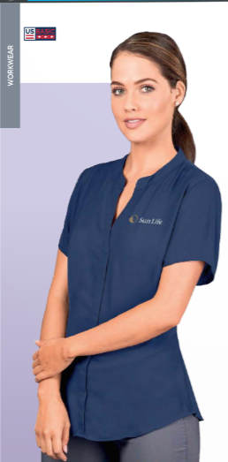
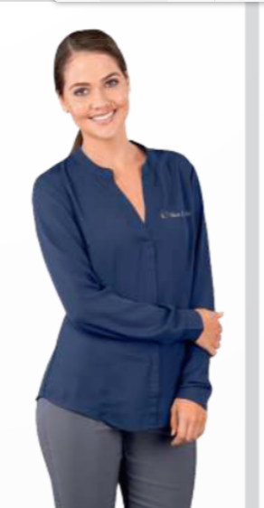
Design element
Design element
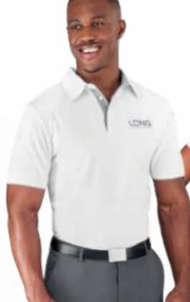
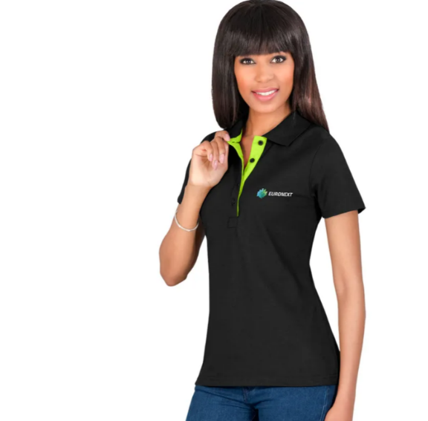
Annexure E Annexure F

Design element

Design element

Annexure G Annexure H

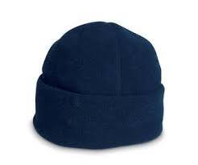
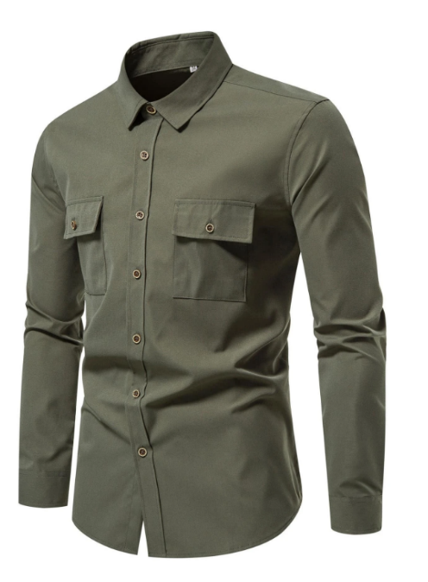

Logo
Design element

Annexure I

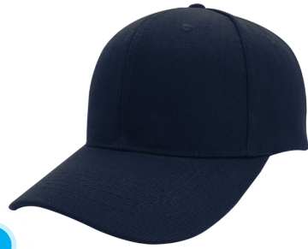

Logo

Annexure J

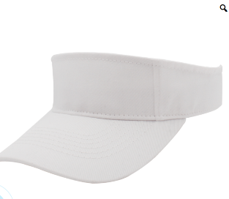

Logo

Annexure K Annexure L

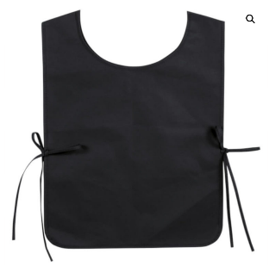
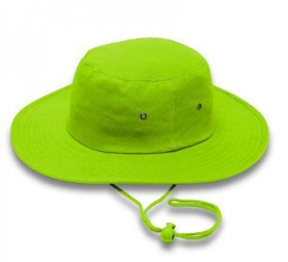

Logo
Logo

Annexure M Annexure N

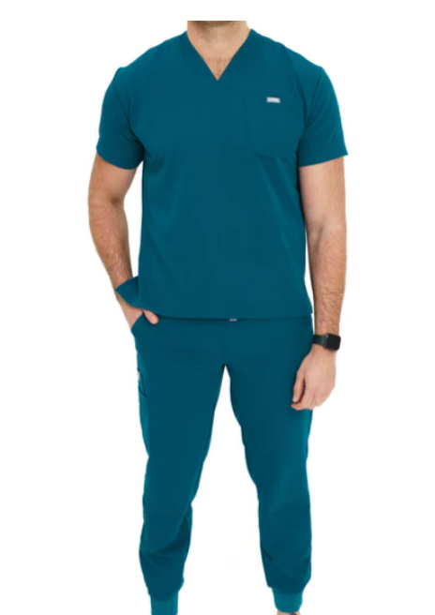
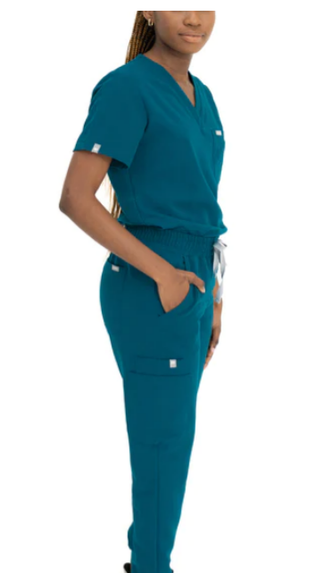
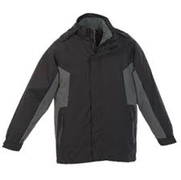
Annexure O Annexure P

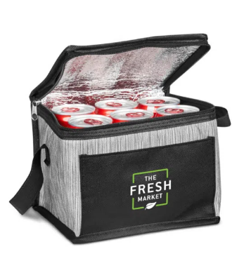
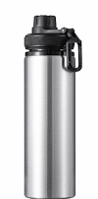
Logo
Logo

Annexure Q
