

MEMORANDUM

FROM : Iziko Museums of South Africa

REGARDING : RFQ Addendum IZIKO R&E RFQ PRINT & INSTALLATION 30/06/26

DATE : 03 July 2026

IMPORTANT:

In request to RFQ Number IZIKO R&E RFQ PRINT & INSTALLATION 30/06/26 Request for Quotation (RFQ) for Print and Installation of Exhibition Materials at Iziko South African Museum and Iziko South African National Gallery ad Iziko Groot Contantia.

We would like to provide some essential clarifications and instructions for the installation of prints after the online briefing that was held on Friday 3 July 2026 via https://meet.google.com/rks-zwex-uks.

Please take note of the following details below:

Matereality

- Item B- ‘Exhibition Titles’ includes Clear Perspex sheet with kiss-cut vinyl letters, fixed to drywall with applicable connections such as stand-off's.
- Item C&D- The cost of the Matt Laminated cover must be included in your cost
- The Material Wall box details are as follows:
  - Fabric wrapped to backing board applied to Box Mount
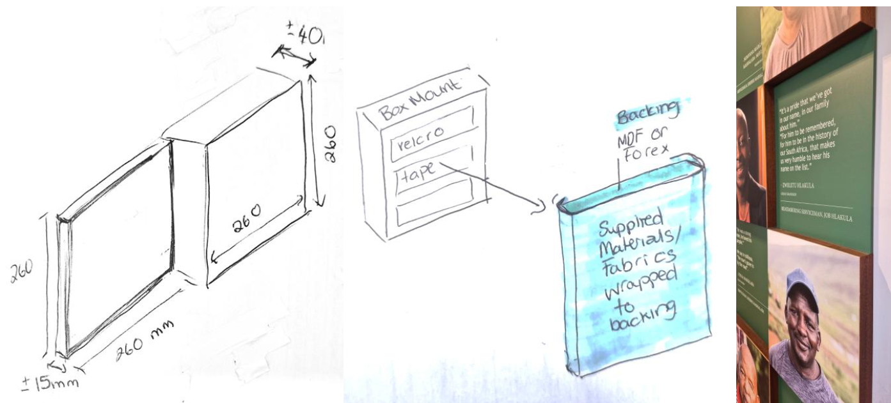
  - 16x Fabric pieces (supplied by Iziko) to be wrapped around MDF or Forex backing boards. Then applied to box mounts. 8x box mounts 15mm deep. 8x box mounts 40mm deep. Backing boards to be applied to box mounts using heavy duty stick on velcro tape. Box Mounts directly mounted to walls using French cleats or D rings. Sides of Box mounts to be painted wall colour. Colour to be supplied on appointment.

- Item I- ‘QR stickers’ may be costed on 3mm forex.

Amanzi eAfrika
- Item T – “Round acrylic 3mm 300mm diameter and 400mm diameter” cost for one of each size
- Item Z – the fabric specified is ‘polyflag fabric’

We hereby acknowledge receipt of the above referenced Addendum to the Request to RFQ and the RFQ Addendum shall be incorporated into our submission.

Name of Company…………………………………………….

Signature of Authorised……………………………………….

Representative…………………………………………………

Name/Title [print]……………………………………………….

Date……………………………………………………………...

