ARC Infruitec-Nietvoorbij
Private Bag X5026, Stellenbosch, 7599, South Africa
Technical information Facilities section: Mr John Saaiman 083 633 3277
and
Mr Virgil Agulhas 0734687110
DESCRIPTION OF SERVICE/PRODUCT:
Supply and installation of the shade netting cover in the SG parking area: ARC Infruitec, Main building Helshoogte Rd, Stellenbosch Central, Stellenbosch, 7599. Map address: -33.924941, 18.873518
Repair of shade net area |  | Quantity | If No, Please Indicate Deviation
1. Specific Description | Compliance to Specification (Yes/No)  *Describe If Specification Differs | Quantity | If No, Please Indicate Deviation
Supply and installation of the shade netting cover in the parking area for SG vehicles.  - Size of the parking: refer to the below sketch. The parking area is big enough to accommodate 4 vehicles (2 x 2). 7.5 x5mm & 5x5mm  - 6 x 40 mm steel poles  - 2 x cap galvanised  - It was ripped on various places due to strong winds and tear & wear, SP to give allowance for the repair of the existing frame (where necessary). Shade netting cover must be durable and sturdy enough to withstand harsh winds, provide protection from UV rays, and be made from materials strong enough to withstand the force of hail. |  | 2
- Bidders to attend compulsory site briefing.
- Contractor to state the guarantee on workmanship
- Work to resume on site within 07 days on receipt of the PSO (purchase order) and to be completed within 14 day

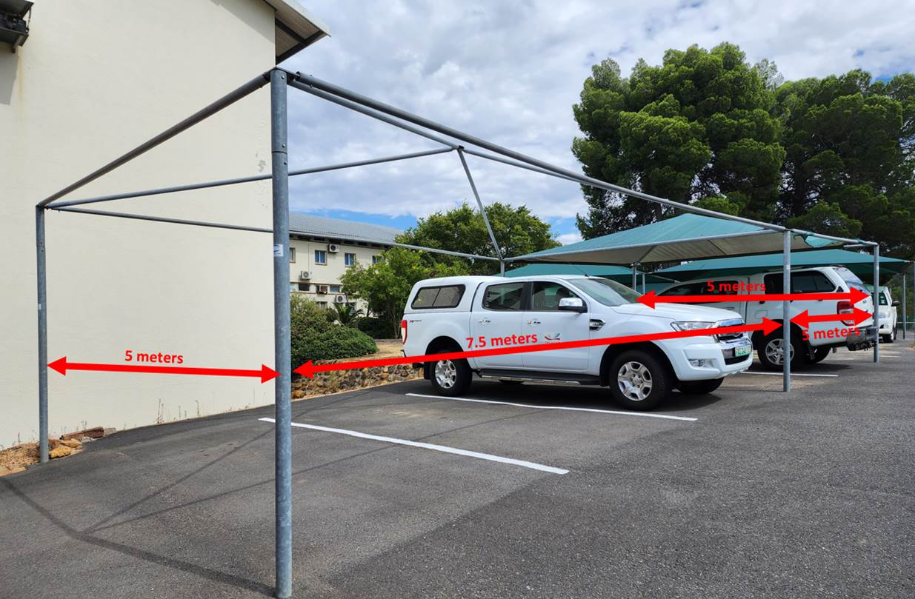
2. General
- Compulsory visit to site :  Date: 30 October 2023  Time: 11:00, cut of time is 11:10 and no late comers would be allowed |  | Contact person: John Saaiman 083 663 3277
- Parking area is located on the ARC Infruitec Helshoogte Rd, Stellenbosch Central
- Will supply the required safety equipment to complete the repair
- Will not damage existing frame
- Will only work on site during normal working hours (08:00 to 16:30)

PRICING SCHEDULE FOR DELIVERY AND INSTALLATION OF SHADE NETTING COVER IN THE PARKING AREA FOR

SG VEHICLES

Item description | Quantity | Unit price | Total Price
Supply and installation of the shade netting cover in the parking area for SG vehicles | 2
SUBTOTAL
VAT
GRANDTOTAL

Company name:……………………………………………………………………………………………….

Contact person:………………………………………………………………………………………………..

Contact number:……………………………………………………………………………………………….

Date and signature:…………………………………………………………………………………………

