DRAWING NO. 1: Proposed Service Road – Kerb Details
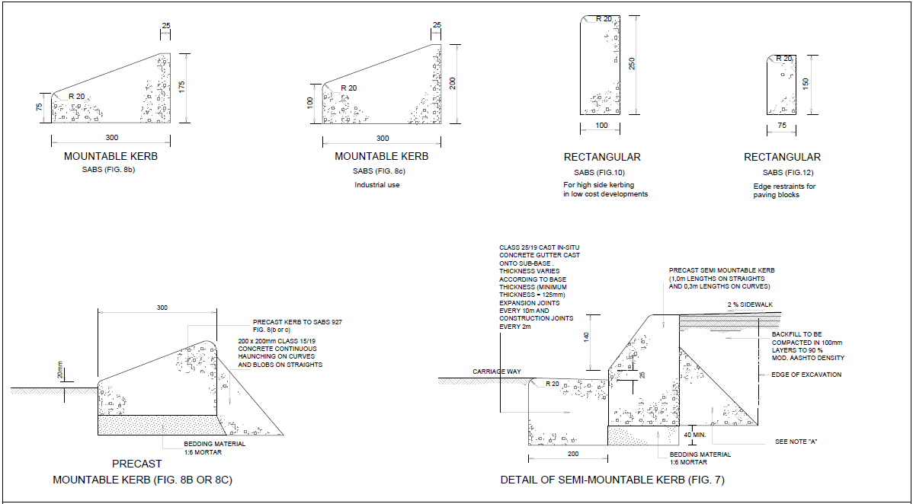
DRAWING NO. 2: Proposed Service Road – V Drain Details
