AGRICULTURAL RESEARCH COUNCIL

SPECIFICATIONS FOR TOOLS

Item no. |  | Description | Quantity
Supply building tools for Collection in Mtubatuba, KZN
ARC to collect from Hardware

1 | 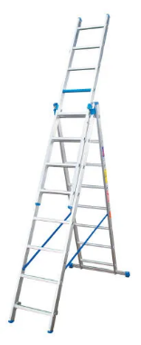 | 2.4 m 5-in-1 Step/Extension Aluminium Ladder | 1
2 | 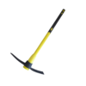 | Pick with Poly Pick Handle, hardened steel core | 2
3 | 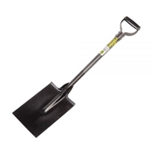 | Lasher Spade No2 | 2
4 | 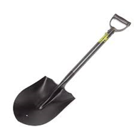 | Shovel Round Nose | 2
5 | 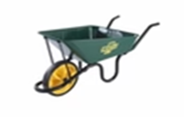 | Wheel Barrow Falcon Concrete | 1
6 | 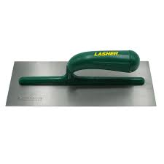 | Plaster Trowel (292 x 120mm) | 1
7 | 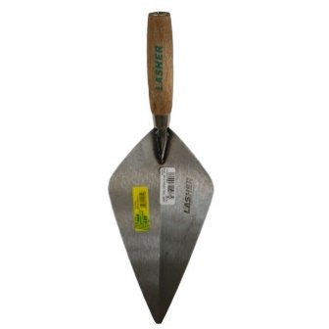 | Brick/builders Trowel (300mm) | 1
8 | 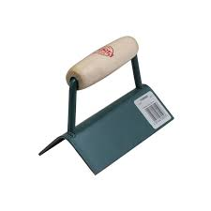 | Corner Trowel (150mm) outside | 1
9 | 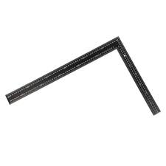 | Builders Square | 1
10 | 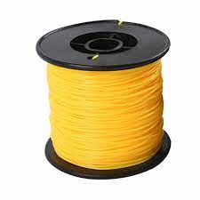 | Builder Line (0.90mm x 100m) | 1
11 | 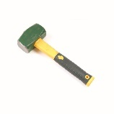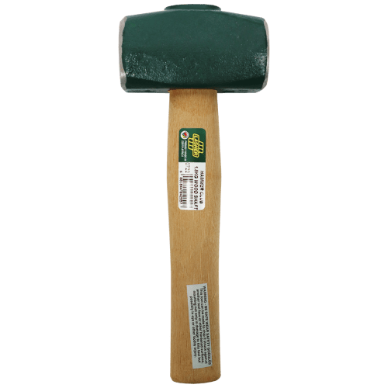 | Hammer 1.1kg and 1.8 kg | 2
12 | 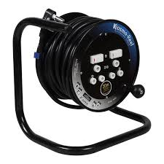 | Extension Cord 30m | 2
13 |  | Measuring Tape 10m and 30m | 2
14 | 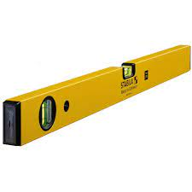 | Spirit Level (1200mm) | 1
15 | 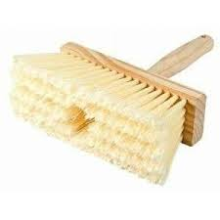 | Block Brush | 2
16 | 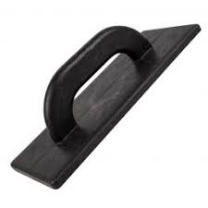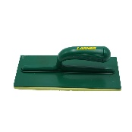 | Plastering Float | 2
17 | 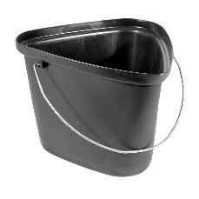 | Builders Bucket | 4
1.18 | 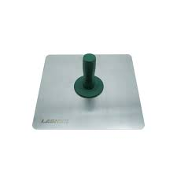 | Hawk | 2
19 |  | Thread Tape (19mmx50M) 100micron | 2
20 |  | Drill 720W with drill bit set (concrete) | 1
21 |  | Angle Grinder 2200W | 1
 |  | All items to be collection at any hardware in Mtubatuba, KwaZulu Natal

