REQUEST FOR QUOTATION
(Email submission)

- INVITATION TO QUOTE

The Playhouse Company invites suitably qualified service providers to submit quotations for the goods/services described below.

DESCRIPTION OF SERVICE: | Supply and deliver – Paraplegic flushing handles / mechanisms
RFQ NUMBER  (DD/MM/YY/LETTER) | 20/10/2026/PARH
Advert date: | 20/10/2026 | Closing date & Time: | 26/10/2026  @10H00 | Days  Open | 7
Compulsory site briefing date & time: | N/A | Delivery Address: | The Playhouse Company, Head Office  29 Acutt Street  Durban Central, Durban  4001
Submission: | KayK@playhousecompany.com  Buyer@playhousecompany.com |  | Tel: | (031)-369 9425  (031)-369 9485

SCOPE OF WORK / SPECIFICATIONS

Provide a clear, detailed description of the goods/services required, including:

Scope

(supply, delivery, installation, maintenance, etc.)
Supply and deliver:

- 4x Paraplegic toilet flushing handles / lever mechanisms, as shown in the attached reference picture.

Please include the following in your quotation:
- Product specifications
- Unit price, including applicable VAT
- Availability and delivery lead time

A physical sample will be provided to the successful bidder for reference.

Kindly only quote on supplying and delivering, the installation of will be done by our mantenance team (in-house).

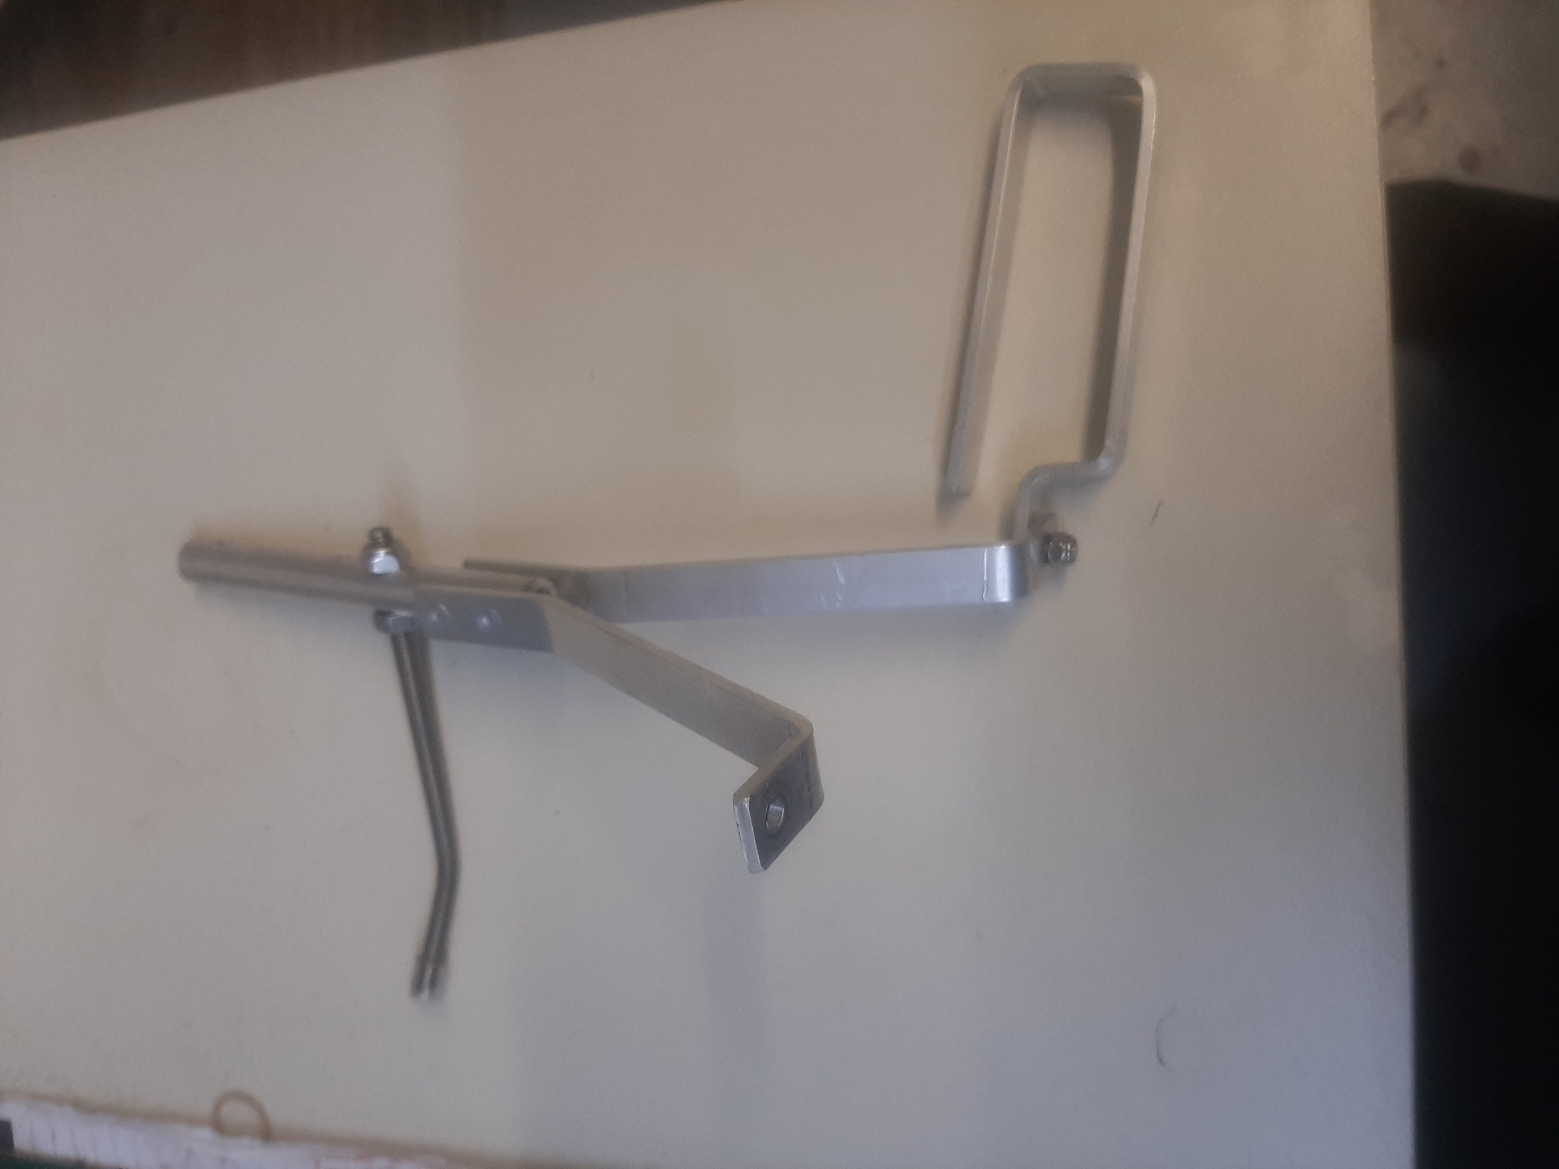

Technical Specifications

(e.g., dimensions, materials, model or equivalent

See spec above

Quantity/Days/Hours, etc.

4

Standards and compliance requirements

(e.g., SANS, OHS Act)

See spec above

MANDATORY REQUIREMENTS

Special conditions: | Mark with (X)
CSD registration report not older than 30 DAYS reflecting a compliant tax status.
Detailed pricing schedule/quotation inclusive of VAT.
Valid BEE affidavit / SANAS approved certificate.
Completed and signed SBD 4 document.
Attended the compulsory site briefing if applicable.
Any other applicable requirements.

- PRICING

All prices must be quoted in Rands and inclusive of VAT (if applicable). Provide a detailed breakdown of costs.

EVALUATION CRITERIA

Quotations will be evaluated based on:
- Compliance with specifications
- Price and Specific Goals

Preference point for price and specific goals (80/20) will be allocated as follows:

Bidder’s Name:
The specific goals allocated points in terms of this tender | Number of points allocated (80/20 system) | Percentage owned  %  (To be completed by the Tenderer) | Number of points claimed (80/20 system)  (To be completed by the tenderer)  *Number of points multiplied by Percentage owned
Owned by Black people | 6
Owned by Women | 4
Owned by Youth | 4
Owned by Disabled people | 2
Owned by SMME’S- QSE and EME | 4
Total Points | 20
**Means of Verification is a valid B-BBEE Certificate or affidavit. Failure to submit such will result in zero points being awarded.

- VALIDITY PERIOD

Quotations must remain valid for a minimum of 30 days from the closing date.

- CONDITIONS

- The Playhouse Company is not obliged to accept the lowest or any quotation.
- Late submissions will not be considered.
- All bids must be sent via the specified submission method.

SBD 4
BIDDER’S DISCLOSURE

- PURPOSE OF THE FORM

1.1 Any person (natural or juristic) may make an offer or offers in terms of this invitation to bid. In line with the principles of transparency, accountability, impartiality, and ethics as enshrined in the Constitution of the Republic of South Africa, 1996 (Constitution), and further expressed in the various applicable legislation, it is required for the bidder to make this declaration in respect of the details required hereunder.

1.2 If a person is listed in the Register for Tender Defaulters and/or the List of Restricted Suppliers, that person will automatically be disqualified from the bid process.

- DECLARATION ON EMPLOYMENT BY ORGAN OF STATE

  - Is the bidder, or any of the directors / trustees / shareholders / members / partners of the bidder employed by an organ of state, as defined in section 239 of the Constitution? YES/NO

  - If YES, furnish particulars of the names, individual identity numbers, in the table below:

Full Name | Identity Number | Name of organ of state

  - Do you, or any person connected with the bidder, have a relationship with any person who is employed by the procuring institution? YES/NO

2.3.1 If so, furnish particulars:

………………………………………………………………………………………………………………………………………………………………………………………………………………………………………………………

  - Does the bidder or any of its directors/trustees/shareholders members/partners or any person having a controlling interest in the enterprise have any interest in any other related enterprise, whether or not they are bidding for this contract? YES/NO

2.4.1 If so, indicate all companies registered in the CSD in the table below:

Supplier registration number (MAAA) | Status (active/inactive/deleted)

Failure to disclose all CSD-registered active companies linked to all Directors will lead to disqualification.

- GENERAL DECLARATION

I, ……………………………………………………................................., the undersigned, in submitting the accompanying bid, do hereby make the following statements that I certify to be true and complete in every respect:

  - I have read and I understand the contents of this disclosure.

  - I understand that the accompanying bid will be disqualified if this disclosure is found to be false.

  - The bidder has arrived at the accompanying bid independently from, and without consultation, communication, agreement or arrangement with any competitor.

  - In addition, there have been no consultations, communications, agreements or arrangements with any competitor regarding the quality, quantity, specifications, prices, including methods, factors or formulas used to calculate prices, market allocation, the intention or decision to submit or not to submit the bid, bidding with the intention not to win the bid and conditions or delivery particulars of the products or services to which this bid invitation relates.

  - The terms of the accompanying bid have not been, and will not be, disclosed by the bidder, directly or indirectly, to any competitor, prior to the date and time of the official bid opening or of the awarding of the contract.

  - There have been no consultations, communications, agreements or arrangements made by the bidder with any official of the procuring institution in relation to this procurement process prior to and during the bidding process except to provide clarification on the bid submitted where so required by the institution; and the bidder was not involved in the drafting of the specifications or terms of reference for this bid.

  - I am aware that, in addition and without prejudice to any other remedy provided to combat any restrictive practices related to bids and contracts, bids that are suspicious will be reported to the Competition Commission for investigation and possible imposition of administrative penalties in terms of section 59 of the Competition Act, 1998 (Act No. 89 of 1998) and or may be referred to law enforcement agencies for criminal investigation and or may be restricted from conducting business with the state for a period not exceeding 10 years in terms of the Prevention and Combating of Corrupt Activities Act, 2004 (Act No. 12 of 2004) or any other applicable legislation.

I CERTIFY THAT THE ABOVE IS CORRECT.

I ACCEPT THAT THE PROCURING INSTITUTION MAY REJECT THE BID OR TAKE APPROPRIATE ACTION AGAINST ME IF THIS DECLARATION IS FALSE.

……………………………… …………………………………………
Signature Date

……………………………… ………………………………………...
Designation Name of bidder

