Supply, deliver & install Smart energy meters

INTRODUCTION

The project is for the supply, Deliver and installation of smart energy meters throughout the Western Cape regional substations. Prasa (Metrorail) substations have limited energy meters that record the energy usage for energy management and energy efficiency as well as power quality. The utility Eskom and Municipality meters are not always in working conditions and the bills are sometimes estimated because of faulty meter readings. The bill is estimated based on usage history which does not include current situations where the substation has not been in use due to vandalism. The Eskom and Municipality bills cannot be verified and PRASA only pays whatever invoice that comes from these two entities. The Energy Meters would assist in Energy management studies to optimize the network power usage. This would therefore reduce the energy consumption and provide necessary information (current and voltage levels) during fault conditions. When power is fed from a far substation there are losses occurred on the line, this is why a typical feeding arrangement is required so that all these challenges of power losses are eliminated well in advance. Other regions also have no energy meters in their networks and would be done for them as well to minimise energy cost.

OBJECTIVE OF THE PROPOSED PROJECT

The objectives are to:
- Measure and analyse the power/energy usage
- Energy management to optimize the network power usage (reduce energy cost)
- Verify Eskom and Municipality bills
- Measure current and voltage levels during fault conditions to better understand the faults and their consequences if they are not prevented
- Get notifications or alarms during abnormal conditions
- Allow Electrical Control to make informed decisions before switching devices
- Assist in power quality management to Rolling stock
- Access substation information anywhere remotely
- Report on energy usage and improvements
- Have a software database for the recorded information

SCOPE OF WORK AND AREAS OF FOCUS
The scope of work for this project shall entail the following activities:
- The scope of works for this project is to install energy and power management tools (smart metering) to measure and monitor: power quality, energy, frequency, voltage, current and harmonics (voltage and current).
- The installation shall be done on 3 kV DC substations in the Western Cape Region.
- The contractor shall be responsible to provide all accessories and material required to complete the installation.
- The contractor will also provide the licence to access the data on the meters for a period of 15 years.
- The contractor must supply the energy meters that will be incorporated to the existing Osprey Pro system on our substations and they must also be utilizing the same licence as the meters that are already installed or provide an alternative that would link existing and new meters. Figure below shows the picture of the existing smart energy meters (VECTO111) that are already installed.
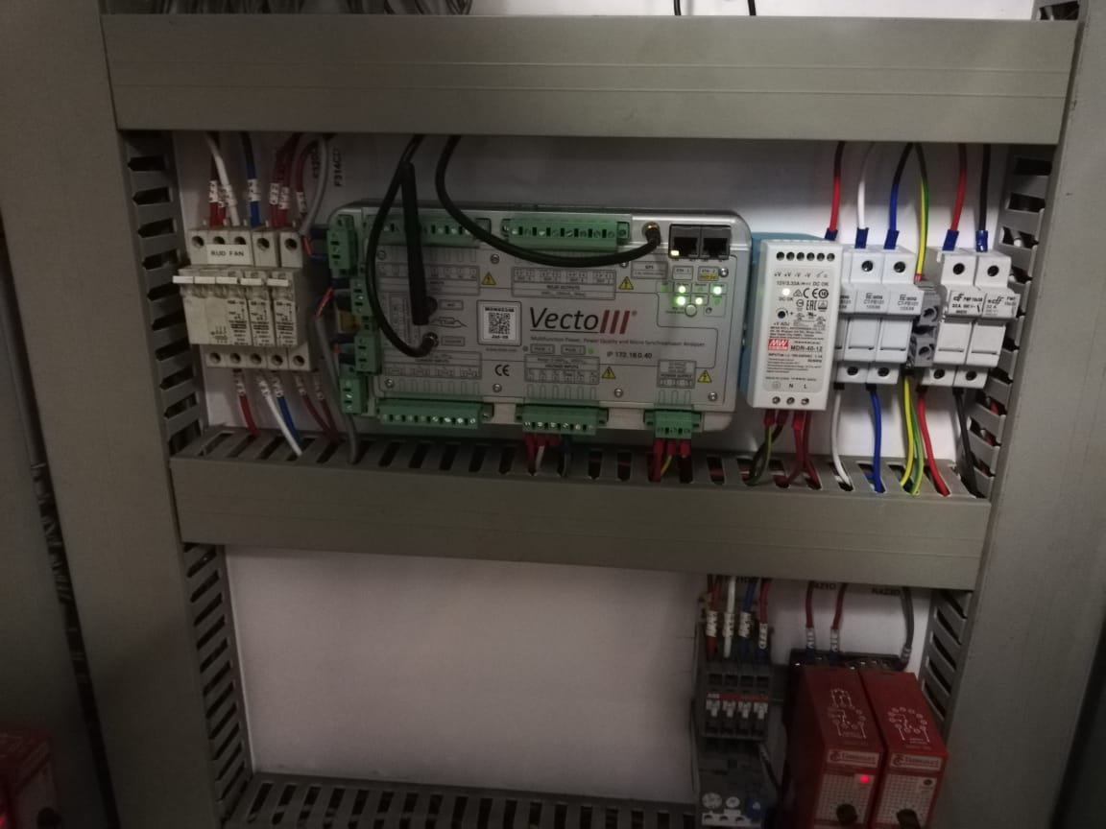

- The contractor shall provide training for utilisation of the software’s used on the meters for (Prasa) employees after installation.

TECHNICAL SPECIFICATIONS
The contractor must provide meters that can measure the following:
Measure and Log
- Voltage,
- Current,
- Power i.e. Real power (kW),
- Reactive power (kVAr),
- Apparent power (kVA),
- Frequency
- Power Quality
- Efficiency.

Have a Dashboard for information display (load profile, energy events, etc.).
AC Measurement:
- Power Quality (Voltage, current and Frequency)
- 3 phase voltages and current (to include all required probes)
- Energy, Power factor, Voltage and Current Harmonics
- Detect voltage dips/swells
- Three phase networks
- AC current up to 1000 A or more
- Logger to analyse and plot data

DC Measurements:
- 3 kV DC
- Up to 5 kA DC or more rated currents
- Power Quality, Voltage and Current
- Detect voltage dips/swells
The system must have SD Card to store more data, Wireless or Ethernet connection to PC for down loading data. The Data logger to have AC and DC probes. It should easily plot the results as per user requirement for reporting purposes. The logger must be able to send notifications when required. Provide casing for the equipment. The system should be able to measure from intervals of at least 1 second, and it must allow remote viewing through Ethernet communication.

Batter support:
Built-in battery support is required at each installation. The battery support must keep the measurement device, GPS and cellular modem fully operational in total absence of power for up to 60 minutes.
Communication support:
The following communication options shall be supported:
- IP based Ethernet
- IP based Cellular Modem

Real-Time-View

The system must support display of real-time-view data from any connected measurement device. The real-time data shall be visualised graphically and in tabled format.
The displayed data should be in the following format:
- Matrix containing voltage, current, power, power angle and power factor information.
- 3-Phase voltage and current phase
- Voltage and current waveform profile containing at least one cycle of data.
- Voltage and current harmonic spectrum (up to at least 50th harmonic)

Standards compliance:

- IEC61000-4-30 Ed3.0 Class-A PQ Measurement on both voltage and current inputs
- IEC61000-4-7 Class I – Harmonics and Inter-harmonics
- IEC61000-4-15 Class F1 - Flicker
- IEC62586: 2017 Part2 – Functional tests and uncertainty requirements (PQI-A-FI1-G)
- IEC61010 - Safety Requirements
- IEC61000-6-5; Defined for “substations” and interface type 3 – Immunity
- CISPR32 Class-A – Emissions

Voltage & Current Harmonics/Inter-harmonics & Harmonic Powers

- Compliant to IEC61000-4-7 Class I
- All harmonics to be recorded simultaneously
- THD as %
- Magnitude (up to 50th)
- Magnitude as % of declared voltage or as % of rated current (up to 50th)
- P, Q, S, Power Angle (up to 50th)
- P_{Total}, Q_{Total}, S_{Total}, Total Power Angle (up to 50th)
- Prevailing phasor amplitude (up to 50th)
- Prevailing phasor angle (up to 50th)

Higher Order Voltage & Current Harmonics & Harmonic Powers

- 2-25kHz with fixed 200Hz bands
- Magnitude
- Magnitude as % of declared voltage or as % of rated current
- All harmonics to be recorded simultaneously

Training:

- Contractor to provide Training for PRASA engineers and engineering Technicians for measurements, downloading and analyses of Data.
- Contractor to provide expertise for engineering analysis of data that would have been collected between 0-3 months after commissioning. The analysis will be summarised as report detailing trends, interruptions and exceptions.
- Contractor to install/setup the monitoring display in electrical department in infrastructure building.

Display tool: specifications

Display: 74.5 inch; Va, Direct LED (Full-array local dimming), 3840 x 2160 pixels
Viewing angles (H/V): 178 degrees/ 178 degrees
Refresh rate: 50Hz/ 60 Hz
Dimensions: 1676.4 x 960.12 x 83.82 mm
Weight: 28.8 kg
Connection part: 2 x HDMI, type A, full size

Maintenance unit (i7): specifications

Operating system | Windows 11 Home
Processor | Intel® Core™ i7-1165G7 (up to 4.7 GHz with Intel® Turbo Boost Technology, 12 MB L3 cache, 4 cores)
Chipset | Intel® Integrated SoC
Memory | 8 GB DDR4-2666 MHz RAM (2 x 4 GB)
Storage | 1 TB 5400 rpm SATA HDD
Graphics | Intel® Iris® Xᵉ Graphics
Audio | Dual speakers
Display | 39.6 cm (15.6") diagonal, FHD (1920 x 1080), micro-edge, anti-glare, 250 nits, 45% NTSC
Power | 45 W Smart AC power adapte
Battery type | 3-cell, 41 Wh Li-ion
Battery and Power | Up to 5 hours and 15 minutes ; Supports battery fast charge: approximately 50% in 45 minutes
Maximum battery life video playback | Up to 7 hours and 15 minutes
Wireless connectivity | Network interface  Integrated 10/100/1000 GbE LAN  Wireless  Realtek RTL8821CE-M 802.11a/b/g/n/ac (1x1) Wi-Fi® and Bluetooth® 4.2 combo
Ports | - 1 SuperSpeed USB Type-C® 5Gbps signaling rate  - 2 SuperSpeed USB Type-A 5Gbps signaling rate  - 1 HDMI 1.4b  - 1 RJ-45  - 1 AC smart pin  - 1 headphone/microphone combo  - 1 multi-format SD media card reader
Webcam | HP True Vision 720p HD camera with integrated dual array digital microphones
Colour | Natural silver Paint cover and base finish, vertical brushing pattern with IMR cover and keyboard frame
Weight | Weight Starting at 1.75 kg (Weight varies by configuration)
Dimensions | 35.85 x 24.2 x 1.99 cm (Dimensions vary by configuration)
Warranty | 1 year limited parts, labour, and carry-in service
Keyboard | Full-size, natural silver keyboard with numeric keypad

Location of these Energy meters and the monitoring unit:
Meters will be installed at these substations:
- GoodWood,
- Langa,
- False Bay and
- Salt River substations.
The Display unit will be at salt river in electrical department

 | PRASA WESTERN CAPE
 | Supply, Deliver and Install Energy meters
 | Benchmark-
 | Supply, Deliver and Install Energy meters
Item | Bill Description |  | Unit | QTY | Duration | Unit Rate | Total Amount
1 |  | Material
1.1 | Energy Meters (smart Meters) |  | Sum | 4 | 50% Local Content
1.2 | Software Licence for existing meters |  | sum
1.2 |  |  | sum | 4 | 5
1.3 | Software Licence |  | Years
1.3 |  |  | Years | 4 | 15
1.4 | Provide Training and Expertise |  | Week |  | 1
1.5 | Maintenance unit (i7) |  | item | 1
1.6 | Analysis report |  | item | 1 | 1
1.7 | Display tool |  | item | 1
 |  | WORKS SUB-TOTAL (EXCLUDING VAT)
 |  | VAT (15%)
 |  | CONTRACT TOTAL (INCLUDING VAT)

Table 1: Bill of Quantity

