Possible technologies to be installed in the simulation room and exhibition area

CUSS KIOSK
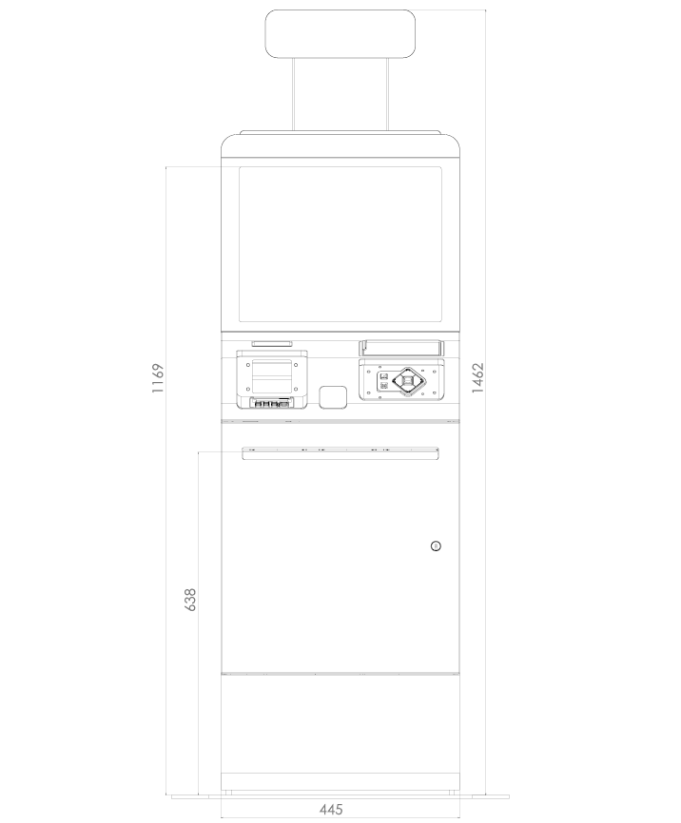
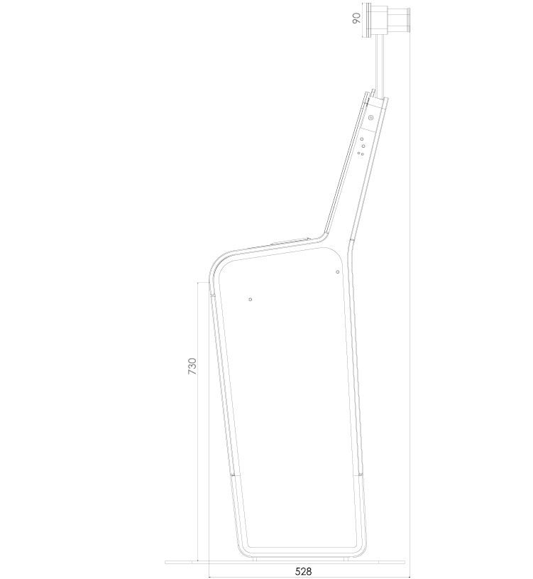
FIDS display 43 inch (Check-in and boarding)

60mm D

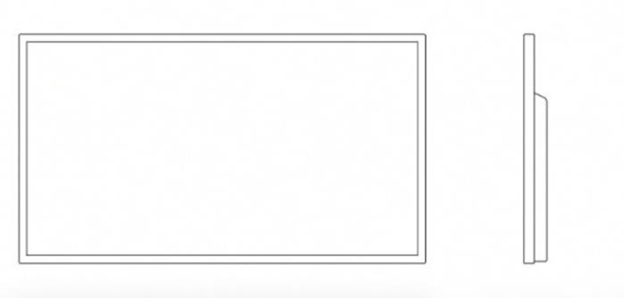550 mm H
960mm W

2D Barcode Kiosk

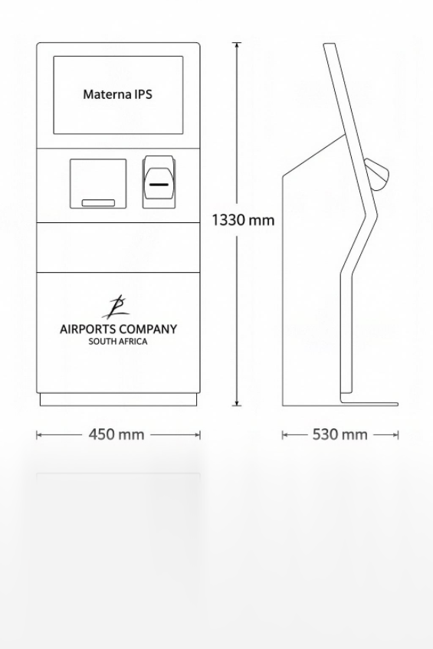

Parking System (Entry, APS, APC, Exit station):

- ENTRY:
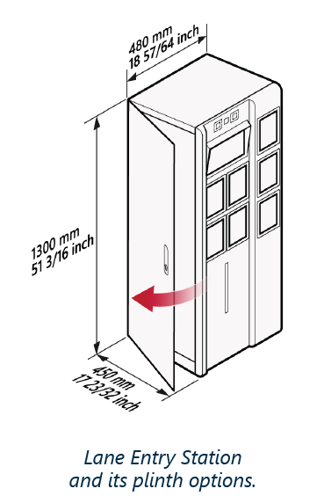

- APS:
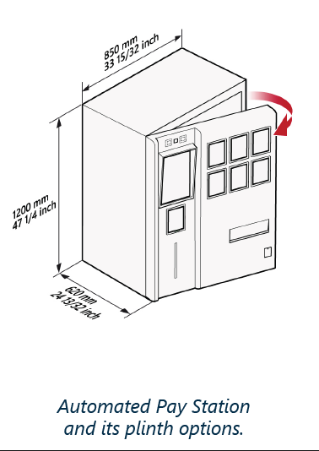

- APC:
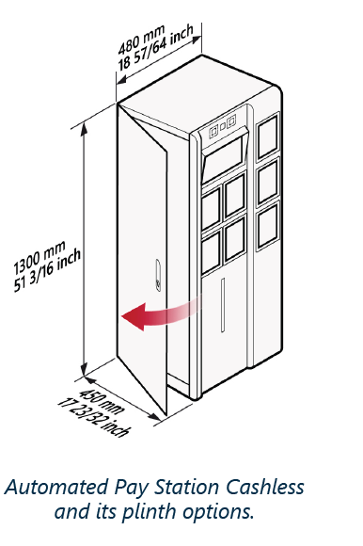

- Exit station:
