
Terms of Reference: Laptops, Laser printers, Label printers, Projectors & Mobile Wi-Fi routers
Background:
Client: Agricultural Research Council – Natural Resources & Engineering, Arcadia

Hardware Specifications:
2 X Laptops including USB wired mouse:

Screen size/Display: 15.6” / 2GB Dedicated RAM
Processor/CPU: 8 Core (Intel Core i7 / AMD Ryzen 7) (up to 4.7GHz)
Memory: 16GB Ram
Storage: 500GB SDD
Communication: Wi-Fi
Three-year, onsite, next business day warranty
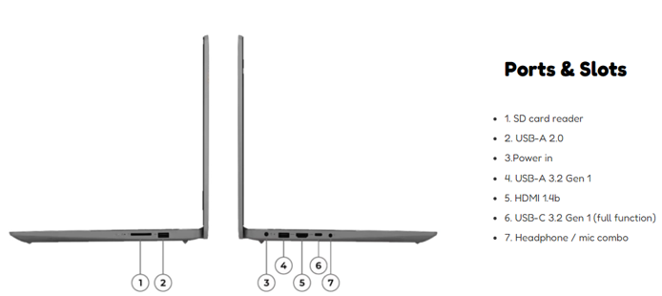

2 X Backpacks:

Durable backpack, which fits the size of the laptop.

2 x Laser printers (Black and White) including USB printer cables:

Prints up to 40 PPM (A4). Designed for work teams of up to 10 users.
350 sheet Standard paper capacity - variety of paper sizes and types to be accepted.
Auto duplex and booklet printing. Economy-mode for toner savings.
Standard print languages: PCL 6, PCL 5e, Postscript level 3 emulation, PDF, URF, PWG Raster. Connectivity Standard:
1 High speed USB 2.0; 1 host USB at rear side; Gigabit Ethernet 10/100/1000BASET network; 802.3az (EEE).
Printer cable (USB2.0, Type A to B, 2 meter)
Three (3) year extended warranty

2 x Label printers:

4 INCH D/T LABEL, 203 DPI, No Peeler
USB 2.0 Serial, Ethernet
12 Months Standard warranty

2 x Projectors:

3700 lumens, WUXGA full HD resolution digital signage projector
16:10 1920x1200
USB 2.0 A; USB 2.0 B (Service only)
RS-232C
Wi-Fi
VGA in x 2
VGA out
HDMI in x 2
Audio in/out, built in speaker
Projector management software
Projector content manager
12 Months Standard warranty

2 x Mobile Wi-Fi R219z (Router)

Weight - 95 g; Dimensions - 100 x 58 x 13.7 mm
Connectivity: 2G network - Download speed/upload speed 296/177 Kbps; 3G network - Download speed/upload speed 42.2/5.76 Mbps
4G network - Download speed/upload speed 150/50 Mbps; Wi-Fi standard - 802.11 b/g/n, 2.4GHz
Bands: 800 MHz, 900 MHz, 1800 MHz, 2100 MHz, 2600 MHz
12 Months Standard warranty

- NB Please provide a detailed specification in the quotation and provide pictures
- Provide warranty letters

