ARC INFRUITEC - NIETVOORBIJ

Private Bag/Private X5026, Stellenbosch, 7599, South Africa
Tel: (021) 809 3093. Fax: (021) 809 3400/3592

Office of the Supply Chain Management

1.1 Description of SERVICE: SUPPLY AND DELIVERY OF VARIOUS PEST CONTROL ITEMS

Background: Table grapes are harvested and packed for cold storage trials. Packing material are procured and stored in pack sheds before harvest commence. The pack sheds are infested with insects (tiny beetles) and rats & mice that damage the packing materials (rats & mice use pieces of boxes and sponges etc. for building nests. Tiny beetles crawl into boxes and box liners and it is unsanitary to pack grapes in these boxes). These pests need to be controlled in order to pack grapes for cold storage trials.

PURPOSE: To obtain rat & mice pellets and release foggers to control pests in pack sheds.

SCOPE OF WORK: Pest control items will be used to control rats & mice and tiny beetles in pack sheds in order not to damage and infest packing material to pack grapes for cold storage trials.

SPECIFICATION | Comply with specification. Please indicate (Yes or No)
 | Yes | No | If no, indicate deviation
1. TOTAL RELEASE FOGGER
- Dual action
- Residual activity
- Control crawling & flying incests
- 325ml Container
- Active ingredients:
  - Cyfluthrin (pyrethroid) 0,25g/kg
  - Propoxur (carbamate) 10,0g/kg
  - Dichlorvos (organophosphate 5,0g/kg
Coopers Ultrakill or Similar
2. RAT & MOUSE PELLETS
- Highly active anticoagulant
- Pellet bait
- 500g Tub
- Active ingredients:
  - Flocomafen 0,05g/kg

Coopers Ultrakill or Similar
GENERAL CONDITIONS FOR THE PURCHASE ORDER AGREEMENT

1.2 PRICING SCHEDULE

Item description | QTY | Unit price | Total Price
1. TOTAL RELEASE FOGGER  - Dual action  - Residual activity  - Control crawling & flying incests  - 325ml Container  - Active ingredients:  - Cyfluthrin (pyrethroid) 0,25g/kg  - Propoxur (carbamate) 10,0g/kg  - Dichlorvos (organophosphate 5,0g/kg  Coopers Ultrakill or Similar | x 7  (x 7 containers of 325ml EA)
2. RAT & MOUSE PELLETS  - Highly active anticoagulant  - Pellet bait  - 500g Tub  - Active ingredients:  - Flocomafen 0,05g/kg  Coopers Ultrakill or Similar | x 12  (x 12 Tubs of 500g EA)
Other: Delivery
SUBTOTAL
VAT
GRANDTOTAL

1. The specification prepared by:

Name: Adri Nieuwenhuys

Date: 25 / 07 / 2022

Signature: 

- The specification approved by:

Name: Phyllis Burger

Date: 25 / 07 / 2022
Signature: 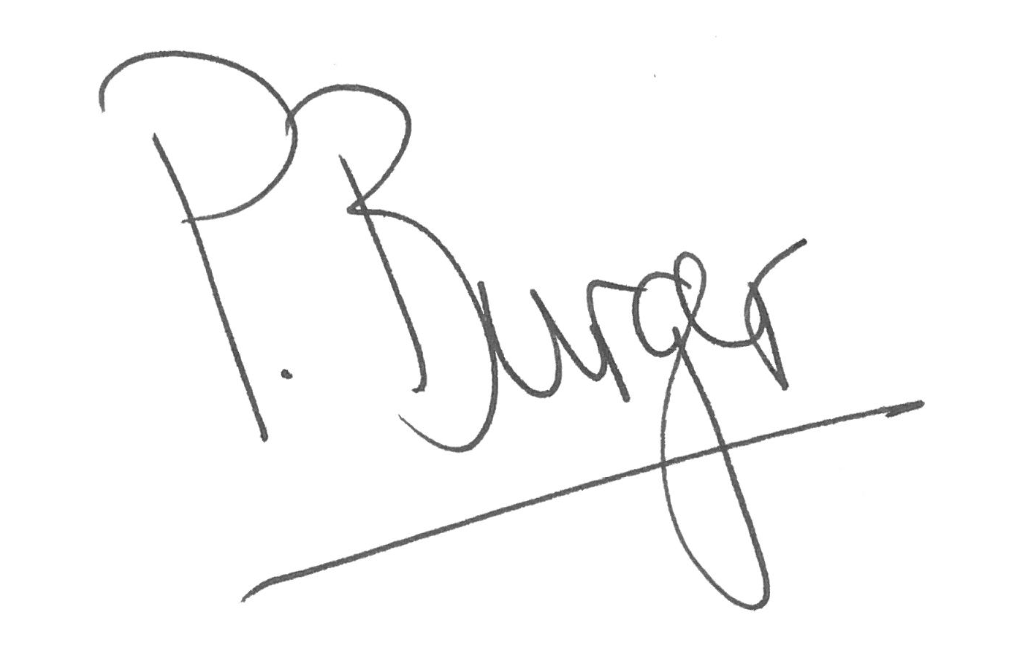

EVALUATION PROCESS & CRITERIA STAGE ONE FOR PEST CONTROL ITEMS
ADMINISTRATIVE COMPLIANCE EVALUATION OF ALL PROPOSALS
 | Comply with specification. Please indicate (Yes or No)
 | Yes | No | If no, indicate deviation
EVALUATION PROCESS: NB: It must be noted that ARC reserve the rights to request for clarification if all the below questions are not answered properly.
STAGE ONE: ADMINISTRATION COMPLIANCE
All suppliers are duly lodged will be examined to determine compliance with quoting requirements and conditions. Quotes with obvious deviations from the requirements/conditions, will be eliminated or disqualified from further adjudication.
          - Mandatory
Quotes will only be compliant if supplier has submitted the following documents:
Administrative documents
- According to National Treasury SCM Instruction number 4 of 2016/2017, only suppliers who are registered on Central Supplier Database (CSD) may be appointed. Suppliers is therefore encourage to register their entities on CSD, www.csd.gov.za and such information will be verified through Central Supply Database (CSD);
- All SBD documents must be submitted and completed;
- The supplier must comply with all the specification
- Contact Details, VAT number, Company registration number, Bank details must be appended on the supplier quote.
          - Non-Mandatory
- Valid B-BBEE certificate or sworn affidavit certify by commissioner of oaths.

Delivery Address: ARC Infruitec Nietvoorbij, Helshoogte Road, Stellenbosch
Supplier’s Details
Company Name: ……………………………………………………………………….
Contact person: …………………………………………………………………………
Contact number & Email : ..…………………………………………………………….
Date & Signature: ………………………………………………………………………
Arc Contact: name ……………., email……………………. Tel, ………………………….

