Specification for the Repair of diesel dispensing system, service and repair generator.

- Specification for the Repair of diesel dispensing system
  - Supply and replace the meter on the over flow line to the underground.
  - Hand pump with outlet on the generator tank to be removed.
  - Pipe and nozzle in the generator tank needs to be removed.
  - Supply and install pressure type on the diesel dispenser machine (preferably install a new diesel dispenser machine that will come with the new registry meter).
  - Hand pump on the pump set needs to be removed.
  - Supply and install new diesel pump.
  - Inspect the flow of diesel pipeline from the main diesel pipeline to the generator diesel tank and incinerator tank.

- Service and repair the generator.
  - Conduct “walk-around” inspection for oil, fuel and water leaks.
  - Check water jacket heater operation and condition of hoses and hose clamps.
  - Check charger voltage/current settings.
  - Drain lubrication oil and replenish with the correct grade of oil.
  - Check fan and alternator belt tensions
  - Replace water trap filter between diesel tank and engine.
  - Remove and replace all fuel and oil filters
  - Remove and replace all air filters (if required)
  - Check operation of fuel transfer pumps
  - Drain water in the radiator and put clean water with coolant
  - Grease and oil moving parts, as necessary
  - Start engine in test position, check and adjust the following:

- Start cut out function
- Generator output voltage stability
- Engine water temperature
- Engine oil temperature
- Charging alternator output

2.13 In test position, check the following safety shutdown devices:

- Low oil pressure
- High engine temperature
- Engine over speed
- Low water level

2.14 Record running hours of set

2.15 Check all indication lamps on electrical control panel

2.16 Clean corroded battery terminals

2.17 Operate the plant off load for 15 minutes.

2.18 Switch off engine and return plant selector switch to the “AUTO” position.

2.19 Clean the plant and its components as necessary.

2.20 Remove all discarded filters and oil from site and clean plant-room.

2.21 Quotations will be submitted for any faults identified during the oil and filter change.
- Supply and replace generator batteries.
- Test generator and run it for 15 minutes
NB: After the repairs are completed, the contractor must provide us with a written one-year guarantee.
All rubble must be removed onsite.

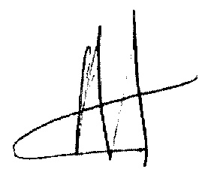
26/05/2022

