Service Desk
(INCIDENT MANAGEMENT)
SYSTEM

BID SPECIFICATION

PROJECT DESCRIPTION: APPOINTMENT OF A SERVICE PROVIDER TO SUPPLY A
CLOUD-BASED SERVICE DESK - INCIDENT MANAGEMENT SYSTEM

REQUEST FOR QUOTATION

The Human Sciences Research Council (HSRC) is seeking bids from sufficiently experienced and qualified service providers to provide a cloud-based service desk system.

Proposals must be sent via email to Mr. Meshack Monareng, email: mmonareng@hsrc.ac.za

There will be a compulsory briefing session | 07 December 2023  Time: 11:00-12:00  Online
The closing date for submissions | 13 December 2023 before end of business
Live demonstration | 22 January 2024 @ 10:00

BACKGROUND & INTRODUCTION

The Human Sciences Research Council (HSRC) is a research organisation that advances social sciences and humanities for public use. The HSRC subscribes to the values of good governance, accountable public administration and sound management of the resources as reflected in the Public Finance Management Act of 1999 (PFMA as amended by Act 1 of 1999) and other laws and regulations applicable to public administration.

Established in terms of section 2 of the Human Sciences Research Act 23 of 1968 (repealed by and continues to exit in terms of Human Sciences Research Council Act 17 of 2008), as South Africa’s statutory research council the HSRC has grown to become the largest dedicated research institute in the social sciences and humanities on the African continent, conducting cutting-edge public research in areas that are crucial to development.

The HSRC’s mandate is to initiate, undertake and foster strategic basic research and applied research in human sciences, and to gather, analyse and publish data relevant to developmental challenges in the South Africa, Africa and the rest of the world. It is further mandated to inform the effective formulation and monitoring of government policy; to evaluate policy implementation; to stimulate public debate through the effective dissemination of research-based data and fact-based research results; to foster research collaboration and to help build research capacity and infrastructure for the human sciences.

PROJECT GOALS

The HSRC currently makes use of a hosted Service Desk system (OMA). As part of the transformation and to enhance the service delivery, the organization is looking to replace the current system with a modern ITIL-aligned cloud-based system that will offer:

    - better self-service
    - support flexible/agile working practices
    - availability at any time of day
    - accessible both over the corporate network and the internet.

SCOPE OF SERVICES
This specification reflects the requirements of the HSRC Staff who will be users of the system.
The HSRC has a workforce of approximately 750 - 1000 staff members, 10 technicians and 2 super administrators per department, across all four HSRC offices countrywide.

Service providers are, therefore, invited to provide proposals for the supply and deployment of the Service Desk – Incident Management system, licensing, training and documentation. The service provider would be expected to provide the following deliverables:

  - Provide Service Desk Management application software that meets the system technical and modular functional requirements outlined in this document. The deliverable, in this case, is a Commercial Off-the-Shelf / out-of-the-box Service desk Management Software (customisable) and all the associated quantity of software licenses. The system will be used by twenty (20) different business units i.e. ICT, Finance and Supply Chain, Legal, HR Management and Facilities Management. The proposed solution should be scalable to expand beyond the initial intended 20 business units.

  - Provide Implementation and Technical Support Services to guarantee 100% success of the project and subsequent continual operation of the system. The deliverables, in this case, is a fully working Service Desk - Incident Management Software system that meets all the identified specific business requirements and use cases and all documentation including but not limited to use case specifications, technical design specifications, user manuals, installation manuals, operational manuals etc.

  - Training to assist the HSRC to become self-sufficient in supporting, maintaining, managing, and utilising the Service Desk Management Software. The training program and training materials provided by the successful bidder must ensure that the HSRC employees can manage and operate the system.

SERVICE REQUIREMENTS
The bidder must demonstrate in the proposal that the various requirements stipulated in this document can be met. The following capabilities and more processes must be supported by the system:

- Incident Management
- Service Level Management
- Asset Management
- Self-Service Management
- Knowledge Management
- Change Management
- Chabot capabilities
- Reports, etc.

The proposed solution must have the ability to create and configure multiple tenants (business units) – with the ability to configure and customize each tenant.

Software Specifications
The technical requirements for the Service-Desk Management System are detailed below and bidders are expected to respond to each line item stating clearly how their proposed system meets the requirements.

Minimum Technical Requirements: All items MUST be responded to.

NO. | REQUIREMENT | BIDDERS RESPONSE
INCIDENT MANAGEMENT
(The system should meet the below features on Incident Management for ICT, SCM, Legal, HR, Finance, Communication and Facilities)
1 | Incident Classification
2 | Record Service Requests
3 | Impact
4 | Priority Matrix
5 | Urgency
6 | Priority
7 | Status (e.g. Open, on hold, Closed, etc.)
8 | Link incidents to Assets and Ci’s
9 | Mailbox Management / Link an incident with an email
10 | Incident Templates
SERVICE LEVEL AGREEMENT MANAGEMENT
(The system should meet the below features on Service Level Agreement Management)

11 | Configuration of different levels of escalation
12 | Automation of escalation
13 | First response-based SLA
14 | Provision of notifications before SLA is breached
SELF-SERVICE
(The system should meet the below features on Self-Service)

15 | Self-Service portal included with the system
16a | Is it web-based?
16b | Is the solution cloud based or on premise?
17 | End users can create new requests
18 | Check status and update existing requests
19 | Update contact details
20 | Search knowledge base for users
21 | Access to Frequently Asked Questions (FAQs)
22 | View Announcements
23 | Take approval action
KNOWLEDGE MANAGEMENT
(The system should meet the below features on Knowledge Management)
24 | Access to knowledge management services for technicians
25 | Approval for newly added solutions
26 | Keyword search to find solutions based on request description
27 | Indexed document search for faster results
28 | Search history with previously resolved requests
ASSET MANAGEMENT
(The system should meet the below features on Asset Management)
29 | Automatic discovery of workstations in the network
30 | Discovery of all IP devices such as a printer, etc.
31 | Discovery and complete scan for Windows, Linux and Mac machines
32 | Asset history along with the request
33 | Relationship chart explaining the relationship between assets, workstations, software, people etc.
34 | Defining CI types and relationship types
35 | Integration of incident, problem and change with CMDB
REPORTING
(The system should meet the below features on Reporting)
36 | Pre-built standard reports
37 | Custom report
38 | Exporting reports to be exported in.CSV, XLs, and PDF formats
39 | Analysis of trends and performance levels
40 | Real-time update on reports

  - Licensing Specifications

- Provide recommendations on licensing requirements
- Deploy users under the recommended licensing structure and as per HSRC requirements and staffing

Testing Specification
- Test the performance of the system from the HSRC office and home network environment
- Assess the features, reliability, and performance thereof to determine adequacy

Training and Documentation Requirements
- Provide necessary training to general staff.
- Provide advanced administrative training to HSRC’s IT staff on maintaining and configuring the platform if need be.

PERIOD OF PERFORMANCE
The period of performance shall commence upon the signing of a Service Level Agreement (SLA), with the system expected to be implemented and completed within two (2) months of notice to proceed.

No guarantee is made regarding specific quantities of services that may be requested under this contract.

FINANCIAL STRUCTURE

The price schedule must cover the 60-month contract period.
NB: Bidders are required to provide a detailed cost breakdown in a table format.

  - Unless stated otherwise below, all prices offered by bidders shall be firm against any increase for the duration of the initial contract period.
  - Delivery charges, fees, insurance, expenses, and/or overhead shall be included in the total price.
  - The contractor shall set up its billing system to ensure that invoices do include Value Added Tax (VAT) and are in South African Rands.

The successful bidder is required to:

- Produce a design plan for the proposed system.
- Install, configure, test, and commission the system.
- Provide an electronic user manual to assist with operating the system.
- Provide HSRC IT technicians with training and a manual of the system to provide first-line support after going live.
- Provide ongoing 12 month system maintenance and ad-hoc support (120 hours).
- Provide training to the HSRC end-users to enhance user experience.

Internal LAN
The HSRC is using Juniper Ex-series 48 port switches across the organisation and all of these switches are Power over Ethernet (PoE's) compatible.

- Juniper Gig switches (PoE) – Rack-mountable.
- Cat5 cabling in Pretoria and Sweetwaters offices.
- Cat6 cabling in Durban and Cape Town offices.
- VLANs in all offices.
- 1 Gig inter-branch fibre backbone/ TENET connectivity.
- Each HSRC site can break out directly to the internet.
- All sites make use of SonicWall NSA firewalls (NGFWs).
- All sites have Sonic Point Wireless (Wi-Fi) connectivity.

- COMPULSORY REQUIREMENTS
The bidder which fails to meet the minimum requirements as mentioned below will be disqualified.

The bidder must:

- Submit a company profile which indicates a minimum of five (5) years’ experience in implementing, commissioning and supporting of the same system.
- Submit three (3) contactable reference letters from previous clients where similar services were rendered. All letters must be on the company letterhead of the referee and signed by the referee.
- Submit a document that indicates the system architecture and design, timelines and milestones for project completion, support and maintenance plan with turnaround times, training plan of HSRC staff etc.
- Submit proof of ownership of the proposed system or right to distribute/resell.

PROJECT MANAGEMENT AND REPORTING
The project should commence immediately following the signing of an SLA

- A Service Level Agreement (SLA) must be signed between the successful bidder and the HSRC.
- A Non-Disclosure Agreement (NDA) must be signed between the successful bidder and the HSRC prior to the execution of the SLA.
- The successful bidder must provide documented weekly progress reports and monthly reports about the implementation of the system.

COMPULSORY SUBMISSIONS

PLEASE COMPLETE THE TABLE BELOW AND ATTACH SUPPORTING DOCUMENTS

All bidders are expected to score 100% on the submission of the below listed (Compulsory) before they can be recommended for evaluation.

FUNCTIONALITY EVALUATION
REQUIRED DOCUMENTS TICK
1 Company Profile
2 Proof of business address
3 Registration Certificate with Industry Professional Bodies
4 Project Implementation Plan (Methodology & timeline)
5 Reference Letter/s from previous/current clients – with the same implementation
6 Proposed system (Functionalities)
7 Proof of ownership or right to distribute/resell the product
8 B-BBEE Status Level

- EVALUATION CRITERIA

Standard requirements:

Bidders need to demonstrate that they have been in existence and providing similar solutions for a minimum of 5 years

Phase 1 – Bid Evaluation

 | Functionality | Weight | Score
 | Experience and references | 10
1. | Provide a list of reference sites stating the project, value and duration of the project.  Reference sites should be listed in a table and should contain scope of work performed at each site.
2. | References | 15
The Service Provider must provide 3 written and contactable references where a similar system has been implemented

One Reference letter = (5 points)
Two Reference letters =(10 points)
Three Reference letters = (15 points)

3. | Implementation plan and Project team | 10
Provide a detailed implementation plan with clearly defined timelines, deliverables and milestones.

No implementation plan provided (0 points)
Partial / incomplete implementation plan submitted (2 points)
Complete and detailed implementation plan submitted (5 points)

Articulate project team members stipulating member roles and skills

No project team detail submitted (0 points)
Partial / incomplete project team detail submitted (2 points)
Complete project team detail submitted (5 points)
4. | System Functionality | 20
Provide evidence that the proposed solution meets the requirements listed in section 4.1 of this document

Not addressing all requirements (0 points)
All requirements addressed (20 points)
4. | Financials | 5
Provide Audited Financial statements for the last three years
Not submitted= (0 points)
Submitted =(5 points)
 | Total | 60

A minimum threshold of 70% (42 points) in Phase 1 is required to qualify for Phase 2

Phase 2 – Live Demonstration (Practical Evaluation)

 | Functionality | Weight | Score
1. | Multiple tenant creation and configuration | 8
 | Demonstrate the solution’s ability to create and configure multiple tenants
2. | Incident Management | 6
Demonstrate the solution’s ability to service the following requirements:

- Incident classification
- Record service events
- Impact
- Priority Matrix
- Urgency
- Priority
- Status (e.g. Open, On hold, Closed etc)
- Link incidents to assets and CI’s
- Mailbox Management / Link an incident to an mail
- Incident templates
3. | Service Level Management | 8
Demonstrate the solution’s ability to service the following requirements:

- Configuration of different levels of escalation
- Automation of escalation
- First response-based SLA
- Provision of notifications before SLA is breached
4. | Self Service | 4
Demonstrate the solution’s ability to service the following requirements:

- Self service portal included with the system
- Is it web-based?
- End users can create new requests
- Check status and update existing request
- Update contact details
- Search knowledge base for users
- Access to Frequently Asked Questions (FAQs)
- View announcements
- Take approval action
5. | Knowledge Management | 6
Demonstrate the solution’s ability to service the following requirements:

- Access to knowledge management services for technicians
- Approval of newly added solutions
- Keyword searches to find solutions based on request descriptions
- Indexed document searches for faster results
- Search history with previously resolved requests
6. | Asset Management | 4
Demonstrate the solution’s ability to service the following requirements:

- Automatic discovery of workstations in the network
- Discovery of all IP devices such as printers etc.
- Discovery and complete scan for Windows, Linux and Mac devices
- Asset history along with the request
- Relationship chart explaining the relationship between assets, workstations, software, people etc.
- Defining CI types and relationship types
- Integration of incident, problem and change with CMDB
7. | Reporting | 4
Demonstrate the solution’s ability to service the following requirements:

Pre-built standard reports
Custom reports
Exporting reports to be exported in .CSV, .XLS and .PDF formats
Analysis of trends and performance levels
Real-time updates on reports
 | Total |  | 40
A minimum threshold of 100% (40 points) is required for Phase 2 to qualify for the next stage.

Business unit requirements:

Supply chain
The HSRC has a Supply Chain Management (SCM) division whose sole purpose is to procure goods and services for the various business units within the organisation.
The employees send the requests to SCM via the e-Workflow system and emails. The service system will be used to:
- Administer the ticketing process for RFQ queries
- Track tickets /progress of workloads allocated to the SCM staff members
- Satisfaction survey for random end users/ customers regarding the service received and turnaround time.
- Reporting on number and type of received requests, SLA, etc.
- Dashboard on outstanding request outside of SLA.
- Linking of similar requests etc.

Facilities
The HSRC owns and is leasing part of the Pretoria building. The function of the Facilities/Building and Maintenance department is to provide services to ensure superior staff and tenant satisfaction and efficient property maintenance while protecting the investment from financial and legal liabilities. To do this, the Facilities unit has to

- Generate Job cards for service requests
- Log a ticket for maintenance re customer complaints ensuring complete tenant satisfaction
- Allocate to the maintenance team
- Follow-up on job cards
- Close, etc.

Finance
The HSRC has a Finance division responsible for all financial reports or movement of assets.
Currently requests are sent to the unit via email. The service system will be used to:

- Track tickets /progress of workloads allocated to the Finance staff members. (Budget verification / Reports / Moving of assets)
- Satisfaction survey for random end users/ customers regarding the service received and
Turn-around time.
- Reporting on number and type of received requests, SLA etc.
- Dashboard on outstanding requests outside of SLA.
- Draw weekly/monthly/quarterly reports.

Communication and Engagements

The HSRC Communication and Engagements unit is responsible for coordinating and ensuring seamless two-way communication with stakeholders internally and externally. The service system will be used to:

- Receive requests for the following services: events support, videography, photography, branding, design and layout, digital media and internal communication.
- Process requests
- Allocate requests to relevant team members
- Provide feedback on progress made
- Close requests/job cards

Human Resources

The Human Resources Unit serves different purposes:
- Payroll, Benefits, and Leave
- HR Information Systems
- HR Business Partnership
- Employee Wellbeing
- Capacity Development

The service system should be able to:

- Provide a tracking dashboard for all calls logged
- Provision for comments and reassignment – if applicable
- Have specific functionalities as per themes as tabled below – not only query related but also to ask questions for information purposes.

Payroll, Benefits, and Leave | Users to log a call to enquire about a salary related matter
HR Information Systems | Users to log a call to enquire about a HR Data related matter
HR Business Partnership | Users to log a call to enquire about HR Business partnership matter
Employee Wellbeing | Users to be able to have a counselling chat room in need
Capacity Development | Users to log a call to enquire about Capacity Development matters

- Appendixes

Appendix A:
HSRC WAN Diagram

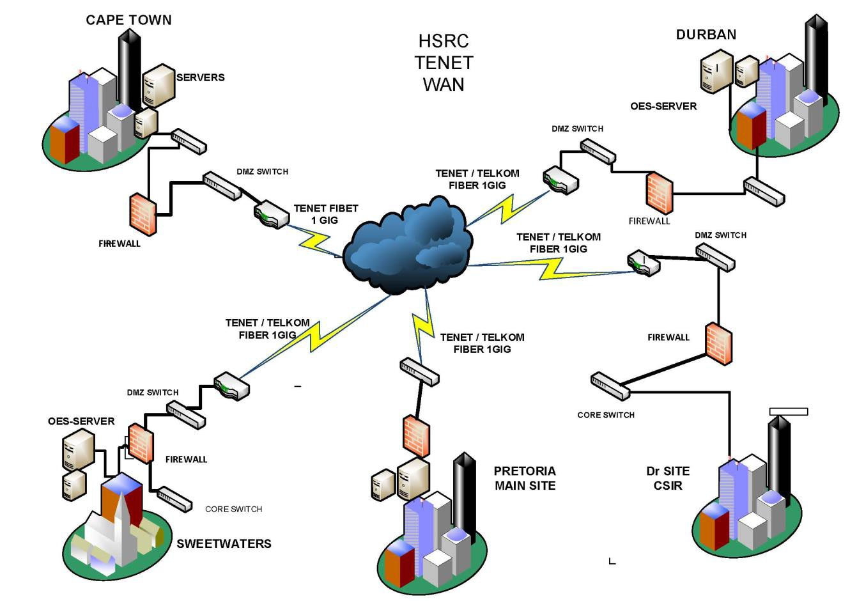

Appendix B:
HSRC LAN Diagram

