REQUEST FOR QUOTATION OF GOODS AND SERVICES
RFQ NO: 150AM(25/26) Water Testing
IMPORTANT INFORMATION FOR CONSIDERATION BY SUPPLIERS
NOTE:
- Tenderers are required to use this Request for Quotation (RFQ) Form when quoting and include VAT per item (where applicable), and the quotation must be on your company’s letterhead; correct banking details should also be included on the quotation.
- Quotations received after the closing date and time at Quotations@dffe.gov.za will NOT be accepted for consideration.
- For quotations with a Rand value up to R1 000 000, the preference point system of 80/20 will apply, where 80 points will be for (Price) and 20 points will be for Specific Goals (more than 50% ownership by (either Black, Women or Disability) in terms of section 2(1)(d) of the Preferential Procurement Policy Framework Act, 2000, (Act No 5 of 2000),
- A trust, consortium, or joint venture will qualify for Preference Points if their average combined ownership is more than 50% (fifty percent) of ownership on specific goals (e.g. two or more companies claiming preference points, Ownership/ Directorship will be combined and divided by the number of companies to ascertain the preference points),
- DFFE reserves the right to request additional information to validate any information submitted by bidders, including preference points claimed.
- Unless specifically stated by DFFE in the specification, all received prices must be firm until the required goods or services are delivered to the specified location. No price adjustment will be accepted except those that are subject to the rate of exchange.

- For bidders to claim preference points, the following must be adhered to;
- Submit a complete and signed SBD 6.1, which is used for claiming specific goals.
- Submit a Medical Certificate signed by a medical practitioner with a practice number when claiming for disability.
- Submit a SANAS/ Companies and Intellectual Property Commission (CIPC) Accredited B-BBEE certificate or sworn affidavit indicating the level of ownership in the enterprise by persons historically disadvantaged by unfair discrimination on the basis of race, gender, or
- Submit Ownership Certificate issued by the Companies and Intellectual Property Commission (CIPC)
- CSD Registration Report or MAAA..number.
- Failure on the part of a tenderer to submit proof or documents required in terms of this tender to claim points for specific goals with the tender will be interpreted to mean that preference points for specific goals are not claimed.
- DFFE reserves the right to:
- Perform due diligence during the evaluation of quotations on information submitted by tenderers.
- NOT to appoint any tenderer.
- Tenderers must indicate delivery timelines and quotation expiry date (Unless otherwise stated, quotations will be deemed valid for a period of 30 days from the date RFQ closes)
- Tenderers are required to duly complete and sign the SBD 4 and SBD 6.1 forms respectively,
- DFFE reserves the right to negotiate prices with the preferred tenderers in line with the legislative requirements.
In a case where there are pictures and or brand names on the specification, tenderers must note that those pictures are for illustration purposes, and similar or equivalent brand specifications will be accepted by the Department.
SUPPLIER DETAILS (TO BE COMPLETED BY THE USER)
SUPPLIER NAME:
TEL NO: |  |  |  | EMAIL ADDRESS:
CENTRAL SUPPLIER DATABASE (CSD) NUMBER
ATTENTION TO: |  | Zola Mdlangazi
DATE REQUESTED: |  | 01 October 2025
SERVICE/GOODS LOCATION |  | Pretoria
SUBMIT QUOTATION TO THE DEPARTMENT OF FORESTRY, FISHERIES AND THE ENVIRONMENT
ATTENTION TO: | Zola Mdlangazi
TEL NO: | 012 399 9059 |  | EMAIL ADDRESS: |  | Quotations@dffe.gov.za
CC EMAIL ADD: ZMdlangazi@dffe.gov.za
CLOSING DATE: 09-October 2025 |  |  | CLOSING |  | TIME |  | 1 | 1 | : | 0 | 0
MANDATORY REQUIREMENTS -YES |  |  |  | Proof Attached  (to be completed by DFFE)
Instrument quality certificate: ISO 9001 2015 Manufacturing Facilities, the bidder must submit proof of the ISO standard as stated below, before the DFFE issues an Official Order to the bidder, failure of submitting proof will lead to disqualification. |  |  | YES
 |  |  | NO
The above mandatory requirements will apply, and bidders must submit the requested requirements indicated above before finalisation of the RFQ process. Bidders who fail to comply with the mandatory requirements will be disqualified.

NO | BRIEF DESCRIPTION OF ITEM(S)/ SERVICE(S) REQUIRED | PICTURE | UNIT OF ISSUE  (BOX/ ITEM) | QUANTITY OF ITEM(S)
01 | Supply and Delivery of once (1) Waterproof Handheld Surface Water quality Monitoring Meter:  HI9829 or equivalent , dot matrix LCD, GPS, Logging with pH/ORP, EC, DO, Turbidity, 10 meter probe, carrying case,115V AA Batteries (4) / approximately 200 hours of continuous use without backlight (50 hours with backlight)  Dimensions: 185 x 93 x 35.2 mm (7.3 x 3.6 x 1.4”)  Weight: 400 g (14.2 oz.)  - Professional Waterproof Portable pH/ORP/ISE Meter compatible with HI9829  - Nitrate ISE 0.1M Standard (500 mL) compatible with HI9829  - Ionic Strength Adjuster (ISA) for Nitrate ISEs compatible with HI9829  - Electrolyte solution, 0.5M (NH₄)₂ SO₄, (4) 30 mL bottle compatable with HI9829  - Nitrate Combination Ion Selective Electrode, Polymer Membrane compatible with HI9829  - Ammonia ISE Filling Solution (4 x 30 mL Bottles) compatable with HI9829  - Ammonia Combination Ion Selective Electrode, Gas Sensing compatible with HI9829  - Ammonia ISE 0.1M Standard (500 mL) compatible with HI9829  - Quick Calibration Solution (500mL Bottle) compatable with HI9829  - Nitrate Ion Selective Electrode for HI76x9829 series of probes compatable with HI9829  - 100 ppm standard sachet for HI7609829- 12 nitrate ISE, 25 mL (25) compatable with HI9829  - Ammonium Ion Selective Electrode for HI76x9829 series of probes compatable with HI9829  - 100 ppm Ammonium Calibration Standard Sachets for HI7609829- 10 Ammonium ISE (25 x 20 mL) compatable with HI9829  - Two (2) years warranty against defects in workmanship and materials  NB: instrument quality certificate: ISO 9001 2015 Manufacturing Facilities, the bidder must submit proof of the ISO standard as stated above before the DFFE issues an Official Order to the bidder, failure of submitting proof will lead to disqualification. | 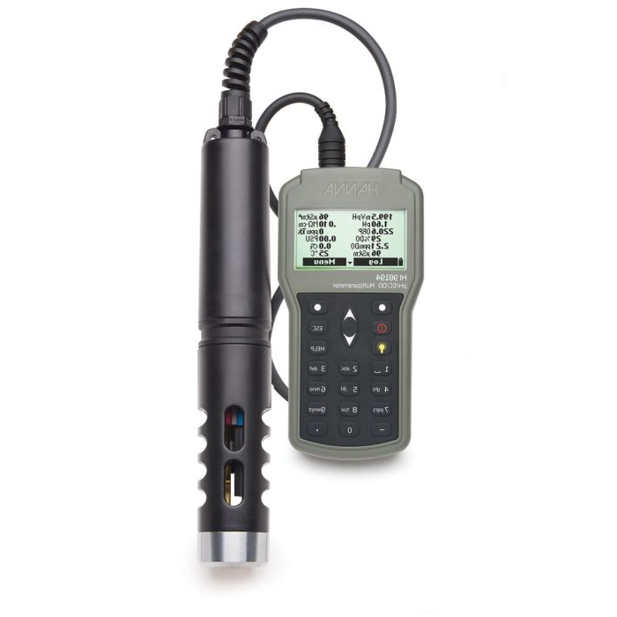  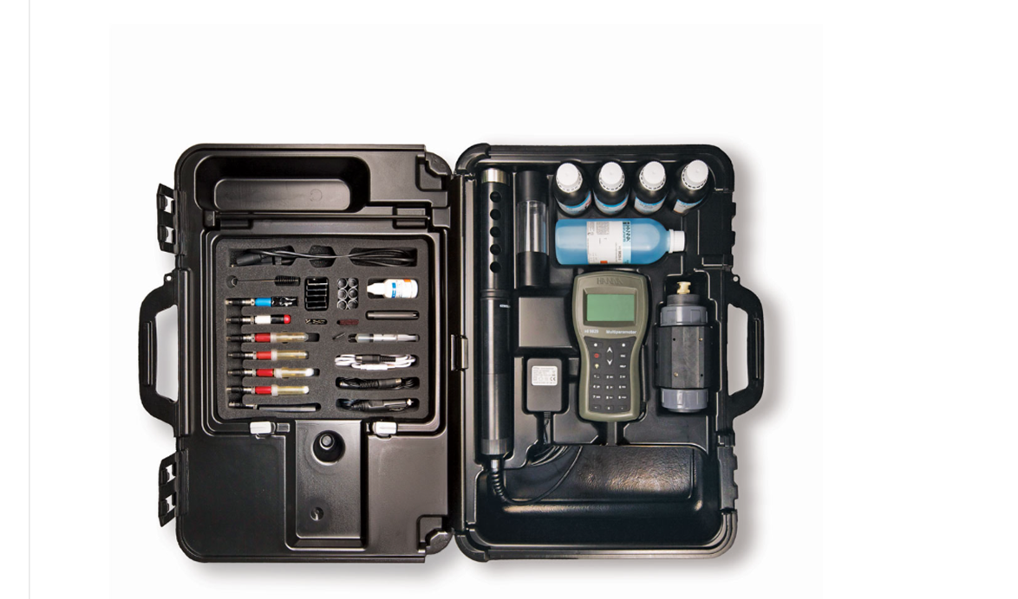 | Per Box | 01
Note: All delivery costs and all applicable taxes, includes value- added tax, pay-as-you-earn, income tax, unemployment insurance fund contributions, and skills development levies must be included in the bid price for delivery at the prescribed destination.
NB: The service provider must submit a valid quotation as per the above guideline on his/ her letterhead reflecting the item descriptions, validity, banking details, contact details and CSD MAAA number.
NB: No goods/ services should be delivered before an official order is received from the Department of Forestry, Fisheries and the Environment.
Failure to deliver goods within the agreed timelines might result in an order being cancelled and possible inclusion on the Database of Restricted suppliers by the National Treasury

