

NEC3 Term Service Contract (TSC3)

Between | ESKOM HOLDINGS SOC Ltd  (Reg No. 2002/015527/30)
and | (Reg No. ___________ )
for | Provide Mill Maintenance for Units 1-6 as and when required at Kriel Power Station for a period of 5 years.
Contents: |  | No of pages
Part C1 | Agreements & Contract Data | 19
Part C2 | Pricing Data | 4
Part C3 | Scope of Work | 24
Part C4 | Site Information | 3
CONTRACT No. | [Insert at award stage]
PART C1: AGREEMENTS & CONTRACT DATA

Contents: |  | No of pages
C1.1 | Form of Offer and Acceptance  [to be inserted from Returnable Documents at award stage] | 3
C1.2a | Contract Data provided by the Employer | 12
C1.2b | Contract Data provided by the Contractor  [to be inserted from Returnable Documents at award stage] | 2

C1.1 Form of Offer & Acceptance

Offer

The Employer, identified in the Acceptance signature block, has solicited offers to enter into a contract for the procurement of:

Provide Mill Maintenance for Units 1-6 as and when required at Kriel Power Station for a period of 5 years.

The tenderer, identified in the Offer signature block, has examined the documents listed in the Tender Data and addenda thereto and by submitting this Offer has accepted the Conditions of Tender.

By the representative of the tenderer, deemed to be duly authorised, signing this part of this Form of Offer and Acceptance the tenderer offers to perform all of the obligations and liabilities of the Contractor under the contract including compliance with all its terms and conditions according to their true intent and meaning for an amount to be determined in accordance with the conditions of contract identified in the Contract Data.

Options A | The offered total of the Prices exclusive of VAT is | R
 | Value Added Tax @ 15% is | R [●]
 | The offered total of the amount due inclusive of VAT is | R [●]
 | (in words) [●]

This Offer may be accepted by the Employer by signing the Acceptance part of this Form of Offer and Acceptance and returning one copy of this document including the Schedule of Deviations (if any) to the tenderer before the end of the period of validity stated in the Tender Data, or other period as agreed, whereupon the tenderer becomes the party named as the Contractor in the conditions of contract identified in the Contract Data.

Signature(s)

Name(s)

Capacity

For the tenderer:

Name & signature of witness | (Insert name and address of organisation) |  | Date
Tenderer’s CIDB registration number:

Acceptance

By signing this part of this Form of Offer and Acceptance, the Employer identified below accepts the tenderer’s Offer. In consideration thereof, the Employer shall pay the Contractor the amount due in accordance with the conditions of contract identified in the Contract Data. Acceptance of the tenderer’s Offer shall form an agreement between the Employer and the tenderer upon the terms and conditions contained in this agreement and in the contract that is the subject of this agreement.

The terms of the contract, are contained in:

Part C1 Agreements and Contract Data, (which includes this Form of Offer and Acceptance)

Part C2 Pricing Data

Part C3 Scope of Work: Service Information

and drawings and documents (or parts thereof), which may be incorporated by reference into the above listed Parts.

Deviations from and amendments to the documents listed in the Tender Data and any addenda thereto listed in the Returnable Schedules as well as any changes to the terms of the Offer agreed by the tenderer and the Employer during this process of offer and acceptance, are contained in the Schedule of Deviations attached to and forming part of this Form of Offer and Acceptance. No amendments to or deviations from said documents are valid unless contained in this Schedule.

The tenderer shall within two weeks of receiving a completed copy of this agreement, including the Schedule of Deviations (if any), contact the Employer’s agent (whose details are given in the Contract Data) to arrange the delivery of any securities, bonds, guarantees, proof of insurance and any other documentation to be provided in terms of the conditions of contract identified in the Contract Data at, or just after, the date this agreement comes into effect. Failure to fulfil any of these obligations in accordance with those terms shall constitute a repudiation of this agreement.

Notwithstanding anything contained herein, this agreement comes into effect on the date when the tenderer receives one fully completed and signed original copy of this document, including the Schedule of Deviations (if any).

Signature(s)

Name(s)
Capacity

for the Employer

Name & signature of witness | (Insert name and address of organisation) |  | Date

Note: If a tenderer wishes to submit alternative tenders, use another copy of this Form of Offer and Acceptance.

Schedule of Deviations to be completed by the Employer prior to contract award
Note:
- This part of the Offer & Acceptance would not be required if the contract has been developed by negotiation between the Parties and is not the result of a process of competitive tendering.
- The extent of deviations from the tender documents issued by the Employer prior to the tender closing date is limited to those permitted in terms of the Conditions of Tender.
- A tenderer’s covering letter must not be included in the final contract document. Should any matter in such letter, which constitutes a deviation as aforesaid be the subject of agreement reached during the process of Offer and Acceptance, the outcome of such agreement shall be recorded here and the final draft of the contract documents shall be revised to incorporate the effect of it.

No. | Subject | Details
1 | [●] | [●]
2 | [●] | [●]
3 | [●] | [●]
4 | [●] | [●]
5 | [●] | [●]
6 | [●] | [●]
7 | [●] | [●]

By the duly authorised representatives signing this Schedule of Deviations below, the Employer and the tenderer agree to and accept this Schedule of Deviations as the only deviations from and amendments to the documents listed in the Tender Data and any addenda thereto listed in the Tender Schedules, as well as any confirmation, clarification or changes to the terms of the Offer agreed by the tenderer and the Employer during this process of Offer and Acceptance.

It is expressly agreed that no other matter whether in writing, oral communication or implied during the period between the issue of the tender documents and the receipt by the tenderer of a completed signed copy of this Form shall have any meaning or effect in the contract between the parties arising from this Agreement.

 | For the tenderer: |  | For the Employer
Signature

Name
Capacity

On behalf of | (Insert name and address of organisation) |  | (Insert name and address of organisation)
Name & signature of witness
Date

C1.2 TSC3 Contract Data

Part one - Data provided by the Employer

Clause |  | Statement | Data
1 |  | General
 |  | The conditions of contract are the core clauses and the clauses for main Option:
 |  |  | A: Priced contract with price list
 |  | dispute resolution Option | W1: Dispute resolution procedure
 |  | and secondary Options
 |  |  | X1: Price adjustment for inflation
 |  |  | X2: Changes in the law
 |  |  | X17: Low service damages
 |  |  | X18: Limitation of liability
 |  |  | X19: Task Order
 |  |  | Z: Additional conditions of contract
 |  | of the NEC3 Term Service Contract April 2013 (TSC3)
10.1 |  | The Employer is (name): | Eskom Holdings SOC Ltd (reg no: 2002/015527/30), a state owned company incorporated in terms of the company laws of the Republic of South Africa  Morongwe Raphasha <RaphasMO@eskom.co.za>
 |  | Address | Registered office at Megawatt Park, Maxwell Drive, Sandton, Johannesburg
 |  | Tel No. | +27 13 296 3792
 |  | Fax No. | +27 13 296 3576
10.1 |  | The Service Manager is (name): | P Khumalo
 |  | Address | Kriel Power Station
 |  | Tel | 017 615 2683
 |  | Fax | N/A
 |  | e-mail | KhumalLP@eskom.co.za
11.2(2) |  | The Affected Property is | Kriel Power Station
11.2(13) |  | The service is | Provide Mill Maintenance for Units 1-6 as and when required at Kriel Power Station for a period of 5 years.
11.2(14) |  | The following matters will be included in the Risk Register | - Task order issued upon availability of funds  - Unprotected Strikes  - Environmental conditions: curing
11.2(15) |  | The Service Information is in | Part 3: Scope of Work and all documents and drawings to which it makes reference.
12.2 |  | The law of the contract is the law of | the Republic of South Africa
13.1 |  | The language of this contract is | English
13.3 |  | The period for reply is | - For Non outage periods : 24 hours  - For Outage periods, weekends, public holidays: 12 hours
2 |  | The Contractor’s main responsibilities | Data required by this section of the core clauses is also provided by the Contractor in Part 2 and terms in italics used in this section are identified elsewhere in this Contract Data
21.1 |  | The Contractor submits a first plan for acceptance within | Not applicable
3 |  | Time
30.1 |  | The starting date is (proposed) | ????
30.1 |  | The service period is | 60 months
4 |  | Testing and defects | As per section X18 and section 3.3.2
5 |  | Payment
50.1 |  | The assessment interval is | - between the 25th day of each successive month  - Service manager may when deemed necessary request Bi-Weekly payment assessments or on the completion of work
51.1 |  | The currency of this contract is the | South African Rand
51.2 |  | The period within which payments are made is | 14 days from receipt of a valid tax invoice
51.4 |  | The interest rate is | the publicly quoted prime rate of interest (calculated on a 365 day year) charged by from time to time by the Standard Bank of South Africa Limited (as certified, in the event of any dispute, by any manager of such bank, whose appointment it shall not be necessary to prove) for amounts due in Rands and  (ii) the LIBOR rate applicable at the time for amounts due in other currencies. LIBOR is the 6 month London Interbank Offered Rate quoted under the caption “Money Rates” in The Wall Street Journal for the applicable currency or if no rate is quoted for the currency in question then the rate for United States Dollars, and if no such rate appears in The Wall Street Journal then the rate as quoted by the Reuters Monitor Money Rates Service (or such service as may replace the Reuters Monitor Money Rates Service) on the due date for the payment in question, adjusted mutatis mutandis every 6 months thereafter (and as certified, in the event of any dispute, by any manager employed in the foreign exchange department of The Standard Bank of South Africa Limited, whose appointment it shall not be necessary to prove.
6 |  | Compensation events | There is no reference to Contract Data in this section of the core clauses and terms in italics used in this section are identified elsewhere in this Contract Data
7 |  | Use of Equipment Plant and Materials | There is no reference to Contract Data in this section of the core clauses and terms in italics used in this section are identified elsewhere in this Contract Data
8 |  | Risks and insurance
80.1 |  | These are additional Employer's risks | None
83.1 |  | The Employer provides these insurances from the Insurance Table | as stated for “Format TSC3” available on http://www.eskom.co.za/Tenders/InsurancePoliciesProcedures/Pages/EIMS_Policies_  From_1_April_2014_To_31_March_2015.aspx  (See Annexure A for basic guidance).
83.1 |  | The Employer provides these additional insurances | as stated for “Format TSC3” available on  http://www.eskom.co.za/Tenders/InsurancePoliciesProcedures/Pages/EIMS_Policies_  From_1_April_2014_To_31_March_2015.aspx  (See Annexure A for basic guidance)
83.1 |  | The Contractor provides these additional insurances: | None
83.1 |  | The minimum amount of cover for insurance against loss and damage caused by the Contractor to the Employer’s property is | the amount of the deductibles relevant to the event described in the “Format TSC3” insurance policy available on http://www.eskom.co.za/Tenders/InsurancePoliciesProcedures/Pages/EIMS_Policies_  From_1_April_2014_To_31_March_2015.aspx
83.1 |  | The insurance against loss of or damage to the works, Plant and Materials is to include cover for Plant and Materials provided by the Employer for an amount of | [●]
83.1 |  | The minimum amount of cover for insurance in respect of loss of or damage to property (except the Employer’s property, Plant and Materials and Equipment) and liability for bodily injury to or death of a person (not an employee of the Contractor) arising from or in connection with the Contractor’s Providing the Service for any one event is: | whatever the Contractor deems necessary in addition to that provided by the Employer.
83.1 |  | The minimum limit of indemnity for insurance in respect of death of or bodily injury to employees of the Contractor arising out of and in the course of their employment in connection with this contract for any one event is: | As prescribed by the Compensation for Occupational Injuries and Diseases Act No. 130 of 1993 and the Contractor’s common law liability for people falling outside the scope of the Act with a limit of Indemnity of not less than R500 000 (Five hundred thousand Rands)..
9 |  | Termination | There is no reference to Contract Data in this section of the core clauses and terms in italics used in this section are identified elsewhere in this Contract Data.
10 |  | Data for main Option clause
A |  | Priced contract with price list
20.5 |  | The Contractor prepares forecasts of the final total of the Prices for the whole of the service at intervals no longer than | Biweekly or Monthly
11 |  | Data for Option W1
W1.1 |  | The Adjudicator | the person selected from the ICE-SA Division (or its successor body) of the South African Institution of Civil Engineering Panel of Adjudicators by the Party intending to refer a dispute to him. (see www.ice-sa.org.za). If the Parties do not agree on an Adjudicator the Adjudicator will be appointed by the Arbitration Foundation of Southern Africa (AFSA).
 |  | Address | [●]
 |  | Tel No. | [●]
 |  | Fax No. | [●]
 |  | e-mail | [●]
W1.2(3) |  | The Adjudicator nominating body is: | the Chairman of ICE-SA a joint Division of the South African Institution of Civil Engineering and the Institution of Civil Engineers (London) (see www.ice-sa.org.za ) or its successor body.
W1.4(2) |  | The tribunal is: | arbitration
W1.4(5) |  | The arbitration procedure is | the latest edition of Rules for the Conduct of Arbitrations published by The Association of Arbitrators (Southern Africa) or its successor body.
 |  | The place where arbitration is to be held is | [●] South Africa
 |  | The person or organisation who will choose an arbitrator  - if the Parties cannot agree a choice or  - if the arbitration procedure does not state who selects an arbitrator, is | the Chairman for the time being or his nominee of the Association of Arbitrators (Southern Africa) or its successor body.
12 |  | Data for secondary Option clauses
X1 |  | Price adjustment for inflation
X1.1 |  | The base date for indices is | One month prior to Contract Start Date
 |  | The proportions used to calculate the Price Adjustment Factor are: | proportion | linked to index for | Index prepared by
 |  |  | 0.02 | Table D2- CPI | Seifsa
 |  |  | 0.80 | Table C3a -Labour | Seifsa
 |  |  | 0.03 | Table L2 -Transport | Seifsa
 |  |  | 0.15 | non-adjustable
 |  |  | 1.00
X2 |  | Changes in the law | There is no reference to Contract Data in this Option and terms in italics are identified elsewhere in this Contract Data.
X17 |  | Low service damages
X17.1 |  | The service level table is in | As per Annexure “B”
4.3.2 |  | Limitation of liability
X18.1 |  | The Contractor’s liability to the Employer for indirect or consequential loss is limited to | R0.0 (zero Rand)
X18.2 |  | For any one event, the Contractor’s liability to the Employer for loss of or damage to the Employer’s property is limited to | the amount of the deductibles relevant to the event described in the “Format TSC3” insurance policy available on http://www.eskom.co.za/Tenders/InsurancePoliciesProcedures/Pages/EIMS_Policies_  From_1_April_2014_To_31_March_2015.aspx
X18.3 |  | The Contractor’s liability for Defects due to his design of an item of Equipment is limited to | The greater of  - the total of the Prices at the Contract Date  and  - the amounts excluded and unrecoverable from the Employer’s insurance (other than the resulting physical damage to the Employer’s property which is not excluded) plus the applicable deductibles in the Employer’s assets and works / maintenance policies available on http://www.eskom.co.za/Tenders/InsurancePoliciesProcedures/Pages/EIMS_Policies_  From_1_April_2014_To_31_March_2015.aspx
X18.4 |  | The Contractor’s total liability to the Employer, for all matters arising under or in connection with this contract, other than the excluded matters, is limited to | the total of the Prices other than for the additional excluded matters.  The Contractor’s total liability for the additional excluded matters is not limited.  The additional excluded matters are amounts for which the Contractor is liable under this contract for  - Defects due to his design, plan and specification,  - Defects due to manufacture and fabrication outside the Affected Property,  - loss of or damage to property (other than the Employer’s property, Plant and Materials),  - death of or injury to a person and  - infringement of an intellectual property right.
X18.5 |  | The end of liability date is | 12 months after the end of the service period
X19 |  | Task Order
X19.5 |  | The Contractor submits a Task Order programme to the Service Manager within | Not applicable
Z |  | The additional conditions of contract are | Z1 to Z12 always apply.
Z1 | Cession delegation and assignment
Z1.1 | The Contractor does not cede, delegate or assign any of its rights or obligations to any person without the written consent of the Employer.
Z1.2 | Notwithstanding the above, the Employer may on written notice to the Contractor cede and delegate its rights and obligations under this contract to any of its subsidiaries or any of its present divisions or operations which may be converted into separate legal entities as a result of the restructuring of the Electricity Supply Industry.
Z2 | Joint ventures
Z2.1 | If the Contractor constitutes a joint venture, consortium or other unincorporated grouping of two or more persons or organisations then these persons or organisations are deemed to be jointly and severally liable to the Employer for the performance of this contract.
Z2.2 | Unless already notified to the Employer, the persons or organisations notify the Service Manager within two weeks of the Contract Date of the key person who has the authority to bind the Contractor on their behalf.
Z2.3 | The Contractor does not alter the composition of the joint venture, consortium or other unincorporated grouping of two or more persons without the consent of the Employer having been given to the Contractor in writing.
Z3 |  | Change of Broad Based Black Economic Empowerment (B-BBEE) status
Z3.1 |  | Where a change in the Contractor’s legal status, ownership or any other change to his business composition or business dealings results in a change to the Contractor’s B-BBEE status, the Contractor notifies the Employer within seven days of the change.
Z3.2 |  | The Contractor is required to submit an updated verification certificate and necessary supporting documentation confirming the change in his B-BBEE status to the Service Manager within thirty days of the notification or as otherwise instructed by the Service Manager.
Z3.3 |  | Where, as a result, the Contractor’s B-BBEE status has decreased since the Contract Date the Employer may either re-negotiate this contract or alternatively, terminate the Contractor’s obligation to Provide the Service.
Z3.4 |  | Failure by the Contractor to notify the Employer of a change in its B-BBEE status may constitute a reason for termination. If the Employer terminates in terms of this clause, the procedures on termination are P1, P2 and P4 as stated in clause 92, and the amount due is A1 and A3 as stated in clause 93.
Z4 | Ethics
Z4.1 | Any offer, payment, consideration, or benefit of any kind made by the Contractor, which constitutes or could be construed either directly or indirectly as an illegal or corrupt practice, as an inducement or reward for the award or in execution of this contract constitutes grounds for terminating the Contractor’s obligation to Provide the Service or taking any other action as appropriate against the Contractor (including civil or criminal action).
Z4.2 | The Employer may terminate the Contractor’s obligation to Provide the Service if the Contractor (or any member of the Contractor where the Contractor constitutes a joint venture, consortium or other unincorporated grouping of two or more persons or organisations) is found guilty by a competent court, administrative or regulatory body of participating in illegal or corrupt practices.  Such practices include making of offers, payments, considerations, or benefits of any kind or otherwise, whether in connection with any procurement process or contract with the Employer or other people or organisations and including in circumstances where the Contractor or any such member is removed from the an approved vendor data base of the Employer as a consequence of such practice.
Z4.3 | Notwithstanding the provisions of core clause 90.2, the procedures on termination in terms of this clause are P1, P2 and P4 as stated in the core clause 92 and the amount due is A1 and A3 as stated in core clause 93.
Z5 | Confidentiality
Z5.1 | The Contractor does not disclose or make any information arising from or in connection with this contract available to Others. This undertaking does not, however, apply to information which at the time of disclosure or thereafter, without default on the part of the Contractor, enters the public domain or to information which was already in the possession of the Contractor at the time of disclosure (evidenced by written records in existence at that time). Should the Contractor disclose information to Others in terms of clause 25.1, the Contractor ensures that the provisions of this clause are complied with by the recipient.
Z5.2 | If the Contractor is uncertain about whether any such information is confidential, it is to be regarded as such until notified otherwise by the Service Manager.
Z5.3 | In the event that the Contractor is, at any time, required by law to disclose any such information which is required to be kept confidential, the Contractor, to the extent permitted by law prior to disclosure, notifies the Employer so that an appropriate protection order and/or any other action can be taken if possible, prior to any disclosure. In the event that such protective order is not, or cannot, be obtained, then the Contractor may disclose that portion of the information which it is required to be disclosed by law and uses reasonable efforts to obtain assurances that confidential treatment will be afforded to the information so disclosed.
Z5.4 | The taking of images (whether photographs, video footage or otherwise) of the Affected Property or any portion thereof, in the course of Providing the Service and after the end of the service period, requires the prior written consent of the Service Manager. All rights in and to all such images vests exclusively in the Employer.
Z5.5 | The Contractor ensures that all his subcontractors abide by the undertakings in this clause.
Z6 | Waiver and estoppel: Add to core clause 12.3:
Z6.1 | Any extension, concession, waiver or relaxation of any action stated in this contract by the Parties, the Service Manager or the Adjudicator does not constitute a waiver of rights, and does not give rise to an estoppel unless the Parties agree otherwise and confirm such agreement in writing.
Z7 |  | Health, safety and the environment: Add to core clause 27.4
Z7.1 |  | The Contractor undertakes to take all reasonable precautions to maintain the health and safety of persons in and about the execution of the service. Without limitation the Contractor:  - accepts that the Employer may appoint him as the “Principal Contractor” (as defined and provided for under the Construction Regulations 2014 (promulgated under the Occupational Health & Safety Act 85 of 1993) (“the Construction Regulations”) for the Affected Property;  - warrants that the total of the Prices as at the Contract Date includes a sufficient amount for proper compliance with the Construction Regulations, all applicable health & safety laws and regulations and the health and safety rules, guidelines and procedures provided for in this contract and generally for the proper maintenance of health & safety in and about the execution of the service; and  - undertakes, in and about the execution of the service, to comply with the Construction Regulations and with all applicable health & safety laws and regulations and rules, guidelines and procedures otherwise provided for under this contract and ensures that his Subcontractors, employees and others under the Contractor’s direction and control, likewise observe and comply with the foregoing.
Z7.2 |  | The Contractor, in and about the execution of the service, complies with all applicable environmental laws and regulations and rules, guidelines and procedures otherwise provided for under this contract and ensures that his Subcontractors, employees and others under the Contractor’s direction and control, likewise observe and comply with the foregoing.
Z8 | Provision of a Tax Invoice and interest. Add to core clause 51
Z8.1 | Within one week of receiving a payment certificate from the Service Manager in terms of core clause 51.1, the Contractor provides the Employer with a tax invoice in accordance with the Employer's procedures stated in the Service Information, showing the amount due for payment equal to that stated in the payment certificate.
Z8.2 | If the Contractor does not provide a tax invoice in the form and by the time required by this contract, the time by when the Employer is to make a payment is extended by a period equal in time to the delayed submission of the correct tax invoice. Interest due by the Employer in terms of core clause 51.2 is then calculated from the delayed date by when payment is to be made.
Z8.3 | The Contractor (if registered in South Africa in terms of the companies Act) is required to comply with the requirements of the Value Added Tax Act, no 89 of 1991 (as amended) and to include the Employer’s VAT number 4740101508 on each invoice he submits for payment.
Z9 | Notifying compensation events
Z9.1 | Delete the last paragraph of core clause 61.3 and replace with:  If the Contractor does not notify a compensation event within eight weeks of becoming aware of the event, he is not entitled to a change in the Prices.
Z10 | Employer’s limitation of liability
Z10.1 | The Employer’s liability to the Contractor for the Contractor’s indirect or consequential loss is limited to R0.00 (zero Rand)
Z10.2 | The Contractor’s entitlement under the indemnity in 82.1 is provided for in 60.1(12) and the Employer’s liability under the indemnity is limited to compensation as provided for in core clause 63 and X19.11 if Option X19 Task Order applies to this contract.
Z11 | Termination: Add to core clause 91.1, at the second main bullet point, fourth sub-bullet point, after the words "against it":
Z11.1 | or had a business rescue order granted against it.

Z12 Contract Financial Commitments

Z12.1 | Task orders will be issued by the Service Manager on an “as and when” required basis. The liability of the Employer is limited to the total of the Prices stated in the specific Task Order and not the total Price stated in the Service Information. The Employer is not obliged to issue any Task Order to the Contractor despite the Contractor being awarded the contract.

Annexure A: Insurance provided by the Employer

These notes are provided as guidance to tendering contractors and the Contractor about the insurance provided by the Employer. The Contractor must obtain its own advice. Details of the insurance itself are available from the internet web link given below.

- Services provided in a TSC3 contract could include some element of construction or refurbishment as well as a continuous maintenance or operational service activity. If an event occurs which causes loss or damage, a claim could be made either against the Employer’s “works” type policy which may be in place for the Employer’s portion of the Affected Property concerned or against the Employer’s assets policy which may be in place for the Employer’s portion of the Affected Property concerned, or both.

- The cover provided and the deductibles under the works policy are different to those under the assets policy. Each policy has a range of applicable deductibles depending on the location of the Affected Property and the nature of the insurable event.

- The Contractor is required in terms of Contract Data for clause 83 to provide cover for the deductibles in the insurance provided by the Employer. This can be provided from his own resources on a ‘self insured’ basis or obtained by him from his own insurers. In order to assess the extent of this cover, tendering contractors and their brokers should consult the internet web link given below and scroll to ‘Format TSC3’ to establish both the cover and the deductibles in relation to the service provided in terms of this contract.

- Tendering contractors should note that cover provided by the Employer is only per the policies available on the internet web link listed below and may not be the cover required by the tendering contractor or as intended by each of the listed insurances in the left hand column of the Insurance Table in clause 83.2. In terms of clause 83.1 “the Contractor provides the insurances stated in the Insurance Table except any insurance which the Employer is to provide”. Hence the Contractor provides insurance which the Employer does not provide and in cases where the Employer does provide insurance the Contractor insures for the difference between what the Insurance Table requires and what the Employer provides.

- If Marine Insurance is required the Contractor needs to obtain a copy of the latest edition of Eskom’s Marine Policies Procedures found at internet website given below.

- Further information and full details of all Eskom provided policies and procedures may be obtained from:

http://www.eskom.co.za/Tenders/InsurancePoliciesProcedures/Pages/EIMS_Policies_
From_1_April_2014_To_31_March_2015.aspx

Annexure B: Table of low service damages (X17)

Low Service Damage Description | Value of Low Service Damages | Limit of Low Service Damage
Failing to do inspection on time | 0.5% of Task Order per day | Limited to 10% of the Task Order value
Monthly quality inspection reports not on-time | 1% of Task Order per month | Limited to 10% of the Task Order value
Approving works that does not meet the requirements | 1.5% of Task Order per activity | Limited to 10% of the Task Order value
Quality Check Approval of spares that does not meet the requirements | 1% of Task Order per item | Limited to 10% of the Task Order value
Not attending to the call-out in time (emergency)  (Maintenance: 1 hour) | 0.5% per call-out hour | Limited to 10% of Task Order Value
Submission of incorrect quality reports | 1% % of Task Order per report | Limited to 10% of Task Order Value

C1.2 Contract Data

Part two - Data provided by the Contractor

Clause | Statement | Data
10.1 | The Contractor is (Name):
 | Address
 | Tel No.
 | Fax No.
11.2(8) | The direct fee percentage is | 10%
 | The subcontracted fee percentage is | 10%
11.2(14) | The following matters will be included in the Risk Register
11.2(15) | The Service Information for the Contractor’s plan is in:
21.1 | The plan identified in the Contract Data is contained in:
24.1 | The key people are:
 | 1 Name:
 | Job:
 | Responsibilities:
 | Qualifications:
 | Experience:
 | 2 Name:
 | Job
 | Responsibilities:
 | Qualifications:
 | Experience:
 |  | CV's (and further key person's data including CVs) are in .
A | Priced contract with price list
11.2(12) | The price list is in
11.2(19) | The tendered total of the Prices is

Part C2: Pricing Data
TSC3 Option A

Document reference | Title | No of pages
C2.1 | Pricing assumptions: Option A | 2
C2.2 | The price list | 1
 | Total number of pages | 3

C2.1 Pricing assumptions: Option A

How work is priced and assessed for payment
Clause 11 in NEC3 Term Service Contract (TSC3) core clauses and Option A states:

Identified and defined terms | 11  11.2 | (12) The Price List is the price list unless later changed in accordance with this contract.
(17) The Price for Services Provided to Date is the total of

- the Price for each lump sum item in the Price List which the Contractor has completed and
- where a quantity is stated for an item in the Price List, an amount calculated by multiplying the quantity which the Contractor has completed by the rate.

 |  | (19) The Prices are the amounts stated in the Price column of the Price List. Where a quantity is stated for an item in the Price List, the Price is calculated by multiplying the quantity by the rate.

This confirms that Option A is a priced contract where the Prices are derived from a list of items of service which can be priced as lump sums or as expected quantities of service multiplied by a rate or a mix of both.

Function of the Price List
Clause 54.1 in Option A states: “Information in the Price List is not Service Information”. This confirms that instructions to do work or how it is to be done are not included in the Price List but in the Service Information. This is further confirmed by Clause 20.1 which states, “The Contractor Provides the Service in accordance with the Service Information”. Hence the Contractor does not Provide the Service in accordance with the Price List. The Price List is only a pricing document.

Link to the Contractor’s plan
Clause 21.4 states “The Contractor provides information which shows how each item description on the Price List relates to the operations on each plan which he submits for acceptance”. Hence when compiling the price list, the tendering contractor needs to develop his first clause 21.2 plan in such a way that operations shown on it can be priced in the price list and result in a satisfactory cash flow in terms of clause 11.2(17).

Preparing the price list
Before preparing the price list, both the Employer and tendering contractors should read the TSC3 Guidance Notes pages 14 and 15. In an Option A contract, either Party may have entered items into the price list either as a process of offer and acceptance (tendering) or by negotiation depending on the nature of the service to be provided. Alternatively the Employer, in his Instructions to Tenderers or in a Tender Schedule, may have listed some items that he requires the Contractor to include in the price list to be prepared and priced by him.

It is assumed that in preparing or finalising the price list the Contractor:

- Has taken account of the guidance given in the TSC3 Guidance Notes relevant to Option A;
- Understands the function of the Price List and how work is priced and paid for;
- Is aware of the need to link operations shown in his plan to items shown in the Price List;
- Has listed and priced items in the price list which are inclusive of everything necessary and incidental to Providing the Service in accordance with the Service Information, as it was at the time of tender, as well as correct any Defects not caused by an Employer’s risk;
- Has priced work he decides not to show as a separate item within the Prices or rates of other listed items in order to fulfil the obligation to complete the service for the tendered total of the Prices.
- Understands there is no adjustment to items priced as lump sums if the amount, or quantity, of work within that item later turns out to be different to that which the Contractor estimated at time of tender. The only basis for a change to the (lump sum) Prices is as a result of a compensation event.

Format of the price list
(From the example given in an Appendix within the TSC3 Guidance Notes)

Entries in the first four columns in the price list in section C2.2 are made either by the Employer or the tendering contractor.

If the Contractor is to be paid an amount for the item which is not adjusted if the quantity of work in the item changes, the tendering contractor enters the amount in the Price column only, the Unit, Expected Quantity and Rate columns being left blank.

If the Contractor is to be paid an amount for an item of work which is the rate for the work multiplied by the quantity completed, the tendering contractor enters the rate which is then multiplied by the Expected Quantity to produce the Price, which is also entered.

If the Contractor is to be paid a Price for an item proportional to the length of time for which a service is provided, a unit of time is stated in the Unit column and the expected length of time (as a quantity of the stated units of time) is stated in the Expected Quantity column.

C2.2 the price list

Item No. | Description | Unit | Qty | Rate | Amount
100 | PRELIMINARY & GENERAL
101 | Site-Establishment | Sum | 1
102 | Transport | Month | 60
103 | PPE & Covid 19 Consumables | Yearly | 5
104 | Health & Safety File | Yearly | 5
105 | Medicals & Induction | Yearly | 5
106 | Tools & Consumables | Sum | 1
106 | Site De-establishment | Sum | 1
200 | NORMAL HOURS
201 | Site Manager (x1) | Hr | 9600
202 | Quality Controller (x1) | Hr | 9600
203 | Supervisor(x1) | Hr | 9600
204 | Planner(x1) | Hr | 9600
205 | Safety Officer(x1) | Hr | 9600
206 | Fitter (x6) | Hr | 57600
207 | Rigger (x1) | Hr | 9600
208 | Boilermaker (x1) | Hr | 11200
209 | Welder (x1) | Hr | 9600
210 | Storeman (x1) | Hr | 9600
211 | Semi-skilled Worker (x6) | Hr | 57600
300 | OVERTIME SATURDAY
301 | Site Manager (x1) | Hr | 2400
301 | Quality Controller (x1) | Hr | 2400
302 | Supervisor(x1) | Hr | 2400
302 | Planner(x1) | Hr | 2400
303 | Safety Officer(x1) | Hr | 2400
303 | Fitter (x6) | Hr | 14400
304 | Rigger (x1) | Hr | 2400
304 | Boilermaker (x1) | Hr | 2400
305 | Welder (x1) | Hr | 2400
305 | Storeman (x1) | Hr | 2400
306 | Semi-skilled Worker (x6) | Hr | 14400
400 | OVERTIME -SUNDAY /PUBLIC HOLIDAY
401 | Site Manager (x1) | Hr | 1200
402 | Quality Controller (x1) | Hr | 1200
403 | Supervisor(x1) | Hr | 1200
404 | Planner(x1) | Hr | 1200
405 | Safety Officer(x1) | Hr | 1200
406 | Fitter (x6) | Hr | 7200
407 | Rigger (x1) | Hr | 1200
408 | Boilermaker (x1) | Hr | 1200
409 | Welder (x1) | Hr | 1200
410 | Storeman (x1) | Hr | 1200
411 | Semi-skilled Worker (x6) | Hr | 7200
 | SUMMARY
100 | PRELIMINARY & GENERALS
200 | NORMAL HOURS
300 | OVERTIME -SATURDAYS
400 | OVERTIME-SUNDAYS & PUBLIC HOLIDAYS
 | TOTAL

Contractor Signature: ______________________________________ Date: ______________________

Part C3: Scope of Work

Document reference | Title | No of pages
 | This cover page | 1
C3.1 | Employer’s Service Information | 23
 | Total number of pages | 24

C3.1: Employer’s service Information

Contents

Part 3: Scope of Work

1. Introduction……………………………………………………………………………………………………..4
2. Supporting Clauses…………………………………………………………………………………………….4
2.1 Scope 4
2.1.1 Purpose 4
2.1.2 Applicability 4
2.1.3 Effective date 4
2.2 Normative/Informative References 4
2.2.1 Normative 4
2.2.2 Informative 4
2.3 Definitions 4
2.4 Abbreviations 4
2.5 Roles and Responsibilities 5
2.6 Process for Monitoring 5
2.7 Related/Supporting Documents 5
3. Mill maintenance contract scope of work 6
3.1 Scope overview 6
3.2 System description 6
3.2.1 Coal feeder 6
3.2.2 Mill assembly 8
3.2.3 Mill Reject system 9
3.2.4 PF pipes and distribution 10
3.2.5 Mill gearbox lubrication system 11
3.2.6 Mill Gearbox 12
3.2.7 PA fans 13
3.2.8 Mill and PA fan motors 14
3.2.9 Seal air fan 14
3.2.10 Weight of mill components 15
3.3 Maintenance Philosophy and Limitations 16
3.3.1 Mill Ball Cycle Unit 1 – 3 10.8E Mills – High Chrome Material 16
3.3.2 Milling plant performance monitoring 17

Appendix A – Eskom Document Hierarchy………………………………………………………………………….19

Figures
Figure 1: Coal feeder assembly 6
Figure 2: Feeder profile are dimensions 7
Figure 3: Mill assembly 8
Figure 4: Mill outlet PF pipe and distribution box 10
Figure 5: Unit 1-3 mill gearbox lube oil system 11
Figure 6: 10.8E Gearbox 12
Figure 7: L2 PA fan side view GA drawing 13
Figure 8: Seal air fan side view GA drawing 14
Figure 9: Ball cycles 16

Tables
Table 1: Feeder profile settings 7
Table 2: Electrical motor data 14
Table 3: 10.8E internal component info 15

Introduction
Mill maintenance demands a well-planned effort to have all mills available and reliable when on load. This document defines the scope of work required to achieve the goal of reliable and available mills

Supporting Clauses

Scope

Purpose
The purpose of the document is to define the work a contractor has to execute on the milling plant on unit 1 – 3.

Applicability
This document shall apply to Kriel Power Station.

Effective date
This document is effective from the date of authorisation.

Normative/Informative References
Parties using this document shall apply the most recent edition of the documents listed in the following paragraphs.

Normative
- ISO 9001 Quality Management Systems
- EBP1059 Maintenance Execution Strategy for Milling Plant
- EPB1147 Kriel milling plant operation and protection philosophy

Informative
- EBP1212 Kriel combustion control philosophy protections and operational ranges

Definitions

Abbreviations
Abbreviation | Explanation

Roles and Responsibilities
Insert text here.

Process for Monitoring
Insert text here.

Related/Supporting Documents
Insert text here.
List related documents and documents superseded by this document.
Also list the forms and records that you have referred to and which shall be maintained, if there are any. If there are no related/supporting documents, insert ‘Not applicable’ to retain paragraph numbering.

Mill maintenance contract scope of work

Scope overview
The contract scope covers the works required to maintain the mills on unit 1, 2 & 3. The scope includes all labour and equipment required and excludes the spares needed for the works.
The scope includes maintenance activities on 18 mill groups. A mill group consists of a coal gate, feeder, mill, PA fan, seal air fan and distribution box.

System description
Mills are used to grind coal into small particles to enable larger amount of coal to be burnt in the boiler (per second). This is necessary to achieve the required heat input to the furnace to achieve the correct boiler steam flow and pressures.

Coal feeder

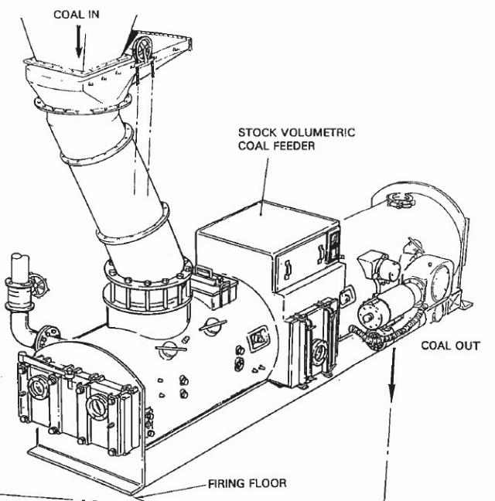
Figure 1: Coal feeder assembly

Each coal feeder is located on 15m level above the mill. The coal feeder comprises a main belt conveyor and a cleanout chain conveyor housed is a cylindrical steel tube, each having its own independent drive unit. The purpose of the coal feeder is to supply the mill with a measured amount of coal, controlling the coal flow on the set point provided by the DCS. The coal firing rate is adjusted to control the boiler main steam pressure.
Coal is gravity fed from the bunker and passes through the bunker outlet gate (coal gate) down through the coal pipe to flow onto the enclosed main belt conveyor. Side and end skirts are fitted at the inlet section of the feeder to guide the coal onto the belt and a levelling bar sets the coal height. The main conveyor belt drive unit comprises of an electric motor, VSD and a gearbox mounted on the conveyor drive pulley.
At the inlet end of the feeder there is a seal air pipe which pressurises the feeder with cold air from the FD fan discharge, it stops hot PA from blowing up from the mill into the feeder casing. Quick release access doors and covers are provided for inspection and maintenance purposes.
The feeder profile bar must be kept in a good condition and set with an accuracy of ±2%. See Table 1: Feeder profile settingsTable 1 and Figure 2: Feeder profile are dimensionsFigure 2 for details of the feeder profile area.
 | Unit 1 - 3 | Unit 4 - 6
A | 0,61 | 0,61 | [m]
B | 0,325 | 0,325 | [m]
C | 0,135 | 0,14 | [m]
D | 0,053 | 0,058 | [m]
Table 1: Feeder profile settings
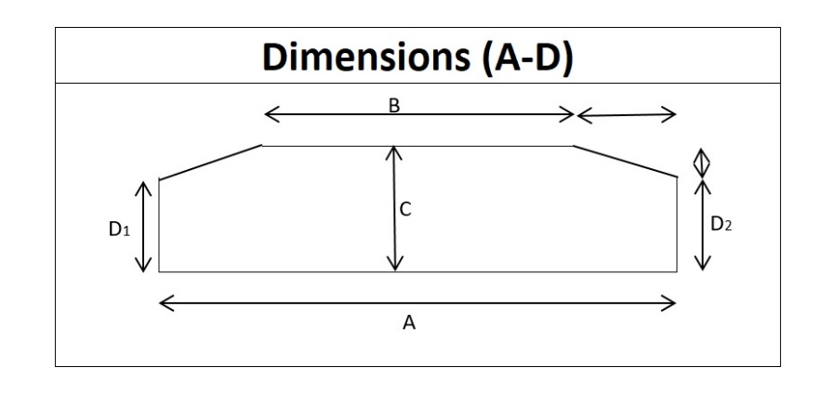
Figure 2: Feeder profile are dimensions

Mill assembly
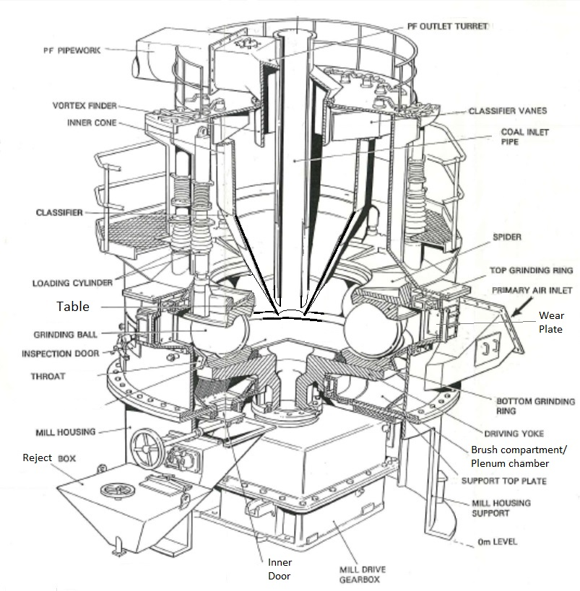
Figure 3: Mill assembly
The mills used at Kriel Power station are medium speed ball mills, type E. The mills were manufactured by Babcock. The mills differ in sizes for Unit 1 -3 and Unit 4 -6, the sizes are denoted by the centre to centre distance of ball races 180⁰ apart. The 10.8E mills (108 inches) are used in Unit 1 -3 while 12E mills (120 inches) are used in Unit 4 -6.
Each coal mill can be divided into four levels for descriptive purposes, see Figure 3 above for details. The first level is the mill housing which is cylindrical in shape. Within the housing is the mill drive gearbox and access to the gearbox is obtained through the cut outs in the housing. The mill housing is mounted on its own steel foundation frame and the gearbox is mounted independently on its own foundation frame. Welded to the top of the mill housing support is the support top plate which has six wear plates bolted to it. One wear plate and top plate have a cut out in them so that the pyrite rejects fall into the reject bin.
The support top plate provides the base for the second level which is the mill housing barrel; the mill housing barrel is cylindrical in shape and is bolted to the support top plate. Mounted in the mill housing is the driving yoke, the bottom grinding ring, grinding balls, the top grinding ring and the spider. Access to this area is through inspection doors and “ball filling” door fitted to the mill barrel. Two ducts welded to the mill housing supply the primary air to this section of the mill.
Level three is the Pulverised Fuel (PF) classifier which comprises a lower cylindrical shell with a wide bottom flange which is bolted to the top of the mill housing. Bolted to the top flange of the lower classifier is the upper classifier which is a cylindrical top piece and houses the sixteen (16) adjustable vanes. The lower flange of the upper classifier is the mounting point for the loading cylinders of the air bag loading cylinders.
PF is graded in the classifier and when the PF has reached the required fineness it passes through the vortex finder into the PF outlet turret which comprises the fourth level. In appearance, the turret resembles a top hat with a cylindrical section, and the rectangular PF pipe section is attached to the outlet turret. The raw coal pipe is attached to the top and passes through the cylindrical section to the bottom of the classifier.
Access to the top of the mill is via fixed steel ladders. There is a platform at the access door and ball loading cylinders (same level) and a platform on top of the classifier.
Each coal mill has a flexible foundation. The coal mill, gearbox and plinth for the gearbox drive motor are mounted on a substantial rectangular concrete block called an inertia block. This inertia block is in turn seated on spring units and visco dampers; the idea is to dampen the vibrations that are generated by the coal mill. Access to the base are of the inertia block is via a manhole and steel rungs cast into the vertical concrete face of the access shaft which is approximately six (6) meters in depth.

Mill Reject system
The rejects are removed manually by OPS, minimum twice a shift with the boiler ashing. OPS must unblock the inner and outer doors when necessary and notify Maintenance if there are defects.
The system consists of a reject bin, inner and outer reject doors and brushes inside the plenum chamber. The rejects/pyrites falls in to a sluice way fitted with nozzles to blow the material to the ash sump with high pressure jets. The sluice ways, grating, and nozzle maintenance is not part of the milling plant maintenance scope.

PF pipes and distribution
The PF is transported to the PF burners through the PF pipes, with a distribution box installed to split the flow into six. The PF leaves the mill through a single outlet turret to the distribution box, where the flow is split in two stages, see Figure 4 below. The six PF pipes from the distribution box is routed to each burner.
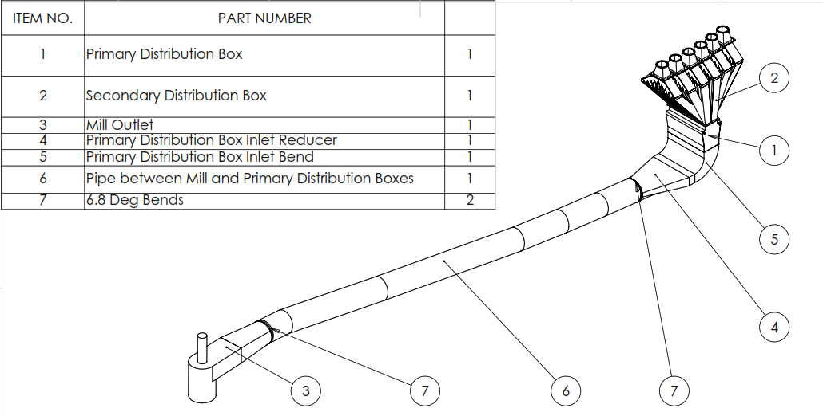
Figure 4: Mill outlet PF pipe and distribution box
The mill outlet, main pipe to the distribution box and the distribution box damper is maintained by the Mill maintenance team.
The main PF pipe from the mill to the distribution box is tiled, it requires minimal maintenance.

Mill gearbox lubrication system
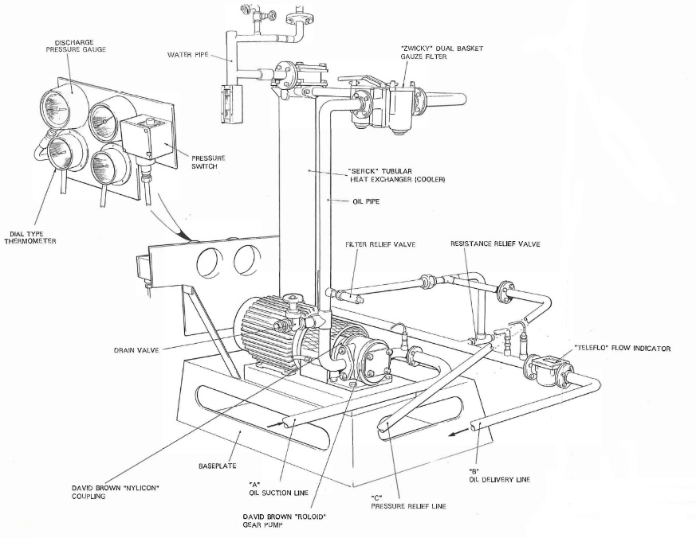
Figure 5: Unit 1-3 mill gearbox lube oil system
The oil is circulated by a gear type oil pump directly connected to a three-phase induction motor by a flexible coupling, which draws oil from the sump of the gearbox. The oil is discharged under pressure to the duel basket strainer, flows from the strainer through an oil cooler, through the delivery pipe to the gearbox distribution system.
The oil cooler is a cast iron cylinder containing aluminium/brass tubes through which the cooling water flows. The oil enters at the top of the Unit and is directed over the tubes by a series of baffles, leaving the unit at the bottom. The cooling water is supplied from a secondary cooling system, entering at the top of the cooler, and then makes a double pass through the cooler before leaving at the outlet branch, also at the top of the cooler. The cooling water flow is regulated by means of valves on the inlet and outlet pipes and should flow at a rate of 31,8 litres per minute, as shown on the flow indicator on the inlet pipe.
A pressure gauge is mounted on the pipeline between the oil pump and the strainer indicating the oil pressure before the strainer. Under normal conditions the oil pressure should not differ by more than 50kPa and shown on the pressure gauge on the strainer outlet. If the strainer is blocked the differential pressure across the filter will increase. If the filter is totally blocked the oil is relieved by the pressure relief valve back to the gearbox sump.
The other pressure relief valve is situated after the oil cooler, which returns oil back to the gearbox if the supply line of the gearbox becomes blocked.
The temperature of the oil leaving the oil cooler should be about 50 C; it should not exceed 71 C as this will cause overheating in the gearbox. The flow rate of oil to the gearbox is normally 55 litres per minute at 110kPa.

Mill Gearbox
The power is transmitted by the gear unit at reduced speed from the prime mover, an electric motor, to the coal mill. The motor drives the gear unit input shaft at 920 r/min and the gear unit output shaft rotates the mill table at 26.7 r/min.
The 10.8E mills are driven by double reduction gearboxes powered by three phase induction motors. The mills operate at a speed of 37.443 rpm, this being the output speed of the gearbox. The input speed to the gearbox is 970 RPM and the speed reduction translates to a speed reduction ratio of 25.906 to 1. The rotation of the input shaft is "Clockwise" when viewed from the motor and the output coupling also rotates "Clockwise" when viewed from above.
The gearbox installation is done with a special trolley built for this purpose. The trolley runs on rails installed in the concrete to an area where a crane has access to lift it to a trailer.
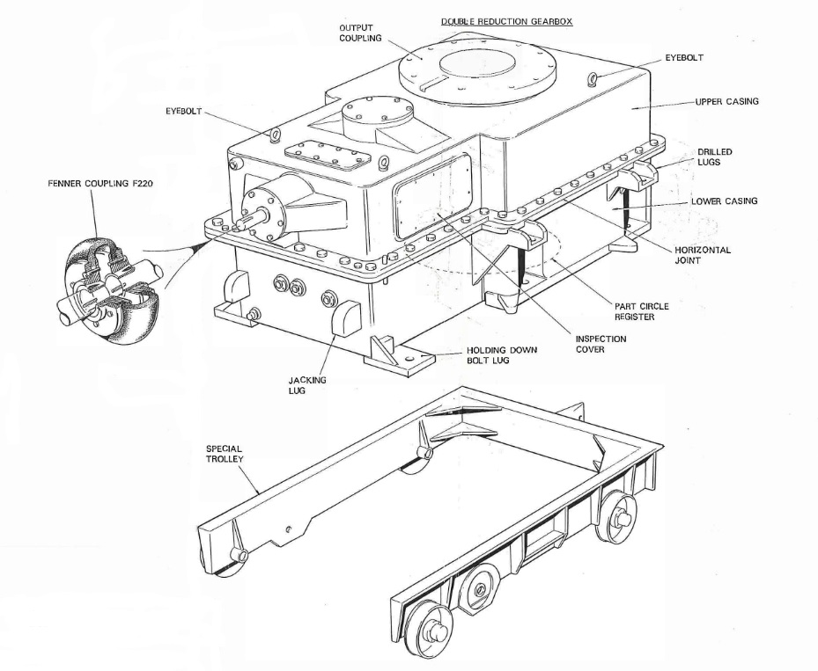
Figure 6: 10.8E Gearbox

PA fans
All mills have dedicated PA fans that forms part of the mill group, following the same operating and maintenance philosophy. The PA fans blow hot air through the mill to the furnace, taking suction from the windbox. The ash load on the PA fans are relatively low and the impellers have very little cracks when tested biannually, impeller replacement or repair frequency is normal.
Units 1-3 (L2 fan)
Manufacturer Howden power
Type L2
Size 12000, arrangement 516, handing LO
Rotation C CW B
Impeller: Type L2 with 12 off blades
Effective Diameter 2114
Approximate weight 1600 kg
Boss Diameter 270 mm
Bore 180 mm
Key 28mm X 16mm
Speed 1485 rpm
Output 42 m³/sec
S.W.G. 31,77 inches
Bearings 4" thrust & journal, sleeve, SAFL
4" journal only, sleeve, SAFL
Coupling Wellman Bibby HLC 290
The PA flow rate is controlled with “Axial Vane Control” (AVC). The vanes are installed with their axis of rotation parallel to the PA impeller’s axis of rotation. The vanes are opened and closed with links installed on an operating ring to synchronise the movement.
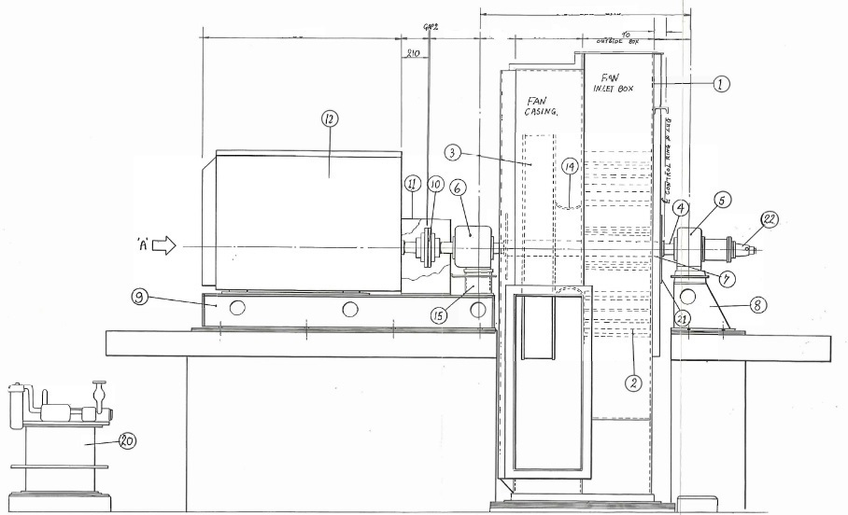
Figure 7: L2 PA fan side view GA drawing

Mill and PA fan motors
There are two types of motors used on the mills and PA fans, supplied from different manufacturers: GEC and Actom.
The motors are 3,3kV induction motors. The motor is cooled by a heat exchanger mounted on top of the motor. There is a cooling air fan outside the motor casing which is attached to the motor non-drive end. This allows cooling air to be circulated through the heat exchanger as soon as the motor starts. Air is also used in a closed circuit in the motor which is circulated by two fixed fans on either end of the motor.
The rotor is supported at either end by a disc lubricated plain bearing. The bearing makes use of an oil pick up disc. The oil is picked up from the reservoirs by the disc and transported to the top of the bearing, running down, back to the reservoir through ports. The oil level is monitored through sight glasses on the side of the bearing housing.
The bearings are naturally cooled, oil lubricated journal bearings. The oil level is viewed through a sight glass on one side of the bearing. The oil level must be maintained at half the level of the glass.
 | Power | Speed
Mill motor | 328 kW | 985 rpm
PA fan motor | 465 kW | 1490 rpm
Table 2: Electrical motor data

Seal air fan
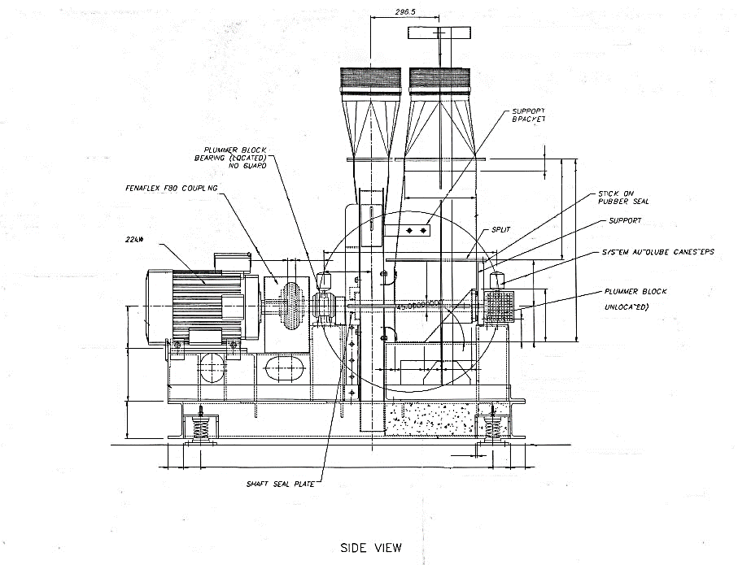
Figure 8: Seal air fan side view GA drawing
The seal air fan is a CFW 900 m diameter TRB-B Blower driven direct inline via a fenner flex rubber coupling by a 22 kW/ 2 pole/ 3ph/ 380V/ 50Hz/ IP65/ class F/ cast iron/ foot mounted motor.
Fan duty: 0.817 m³/s @ 14717 Pa @STP
Impeller CFW Industries Ø900 mm TRB-B
Motor 22 kW 2 pole 3ph 380V
50Hz IP65 class F
Cast iron foot mounted – B3
Frame size 180M
Coupling F80 Fenner flex rubber coupling
C/w taper locks Ø50 mm bore on one side
Ø48 mm on opposite side
Fan bearings Ø50 mm Plummer Block
Spherical roller bearings: SNL 511-609 Housing
22211 EK Bearings
H311 Sleeves
FRB 9.5/100 Locating rings
TSN 511 G seals
Bearing lubrication Auto lube plastic canisters
Grease LGMT2
Paint finish SAS Cargoline Battleship Grey
Anti-Vibration Mounting SLF-B 450 Red
Spring type anti vibration mountings
Fan paint SAS Cargoline Battleship Grey

Weight of mill components
Mill Type: 10,8E Babcock and Wilcox Vertical Spindle Mill
Item | Component Description | Dimensions | Mass
1 | Top and Bottom Grinding Ring Set | Outer Diameter 3404 mm | 7 tons each
 |  | Ring Thickness 244mm
2 | Hollow Ball (11 off) | Outer Diameter 768mm | 1.11 ton each
 |  | Wall Thickness 103mm
3 | Hollow Ball (Filler Ball 1 off ) | Outer Diameter 690mm | 0.86 ton each
 |  | Wall Thickness 60mm
4 | Spider |  | 8 tons
5 | Yoke |  | 14 tons
6 | Mill top (classifier) |  | 14 tons
7 | Gearbox (empty) |  | 17 tons
8 | Mill motor |  | 4 tons
Table 3: 10.8E internal component info

Maintenance Philosophy and Limitations
The mills should be serviced every 5000 hours (breaker running hours). The mill motor running hours are recorded on the DCS for good record keeping. The contractor must ensure all resources and equipment are available to service the mills in time and attend to breakdowns. The work must be planned to have all mills below 5000 hours (±500 hours), do ball changes in time and replace rings when required.
When the grinding rings are at their end of life; the mill should be re-built with new rings, balls, throat, classifier, vanes, ball loading cylinders, raw coal pipe and refurbished outlet bend.
The PA fan impellers must be tested for cracks and their thickness measured every two years, if it does not fall in the outage philosophy (GO/MGO) it must be done by shutting down the mills one by one to get access.

Mill Ball Cycle Unit 1 – 3, 10.8E Mills – High Chrome Material
Cycle 0: 11 balls 765 mm to 690 mm diameter
Cycle 1: 11 balls 765 mm to 690 mm diameter
Cycle 2: 12 balls 690 mm to 640 mm diameter
Cycle 2: 12 balls 690 mm to 640 mm diameter
Cycle 0: 765 mm balls are used in a set of 11 balls until they reach 690 mm. When the set reaches 690 mm, they are removed and cycle 1 starts.
Cycle 1: 765 mm balls are used in sets of 11 balls until they reach 690 mm. When the set reaches 690 mm a filler ball is added and cycle 2 starts.
Cycle 2: The same balls from cycle 1 are used with the filler ball added, now 12 in total. The balls are used until they wear down to the scrap size of 640 mm when they are removed.
Cycle 3: The original balls from cycle 0 are used with the filler ball added, now 12 in total. The balls are used until they wear down to the scrap size of 640 mm when they are removed.
The above cycles are based on the high chrome material with a wear rate of 220 h/mm for the balls and 645 h/mm for the top ring and 750 h/mm on the bottom ring.
The rings are discarded at the thickness of 50 mm to avoid ring cracking. Mills that have overrun the minimum thickness of 50 mm start forming cracks in the top of the ball profile and then fails completely when the thickness is about 30 mm.
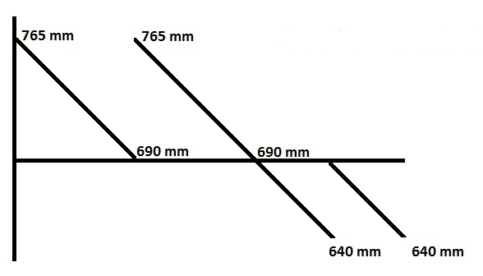
Figure 9: Ball cycles

Contract boundaries
For the purpose of this contract, the following are the physical boundaries of the plant worked on:
- Coal gate inlet flange below the bunker
- PA fan inlet bellow and inlet flange
- Mill inertia dampers and springs
- Distribution box damper
The following equipment are included:
- Coal gate, knife gate, feeder assembly, inlet and outlet raw coal pipes, discharge square to round
- PA fan casing, actuator, impeller, bearings, lube oil system, motor, motor base
- Mill inertia block, dampers, springs, seal around inertia block, motor and gearbox bases
- Mill assembly, motor, gearbox, lube oil system, PF pipes and hangers up to the distribution box, distribution box damper assembly
- Seal air fan assembly

Site management and reporting
The site manager is responsible to ensure there is good communication between Eskom and the contactor at all times. Eskom official communication is done via emails, MS Teams calls and messages.
It is the contractor’s responsibility to maintain the yard (site establishment), including the fence around it.
The supervisor is responsible to manage the work teams to execute the planned work (Preventative Maintenance (PM)) and breakdowns (corrective maintenance (CM)).
The contractor must supply transport for all the workers on site (home-work-home) and vehicles for the two standby teams.
The contractor must have two teams on standby for emergency work (after hours) at all times. The first team must consist of fitters and assistants/semi-skills of which at least one is an RP. The second team must consist of at least one Boilermaker and one Welder – this team will be called out by the fitters if the defect requires cutting and welding.
QC
The contractor must inspect the plant (normal services or breakdowns) and issue Eskom with an inspection report. The contractor must propose the repair that must be done to restore the design base of the equipment. Eskom will evaluate the inspection report and repair proposal and amend if necessary, the signed report from Eskom will be the approved scope of work.
Where technical specifications cannot be met for any reason, a Technical Notification (TN) must be raised to Eskom Engineering to inform Eskom of the condition (i.e. temporary repairs, alignment or vibration that is out of spec).

Eskom meetings
All Eskom meetings must attended by the relevant personnel. The following are the minimum requirements:
- Departmental meeting: Daily meeting at 07:30 with the Boiler Maintenance Manager
- Plant focus meeting: Daily meeting at 08:00 attended by the supervisor to discuss defects loaded in the 24 hours prior to the meeting.
- Production meeting: Daily meeting at 09:00 attended by the site manager to discuss urgent production matters and risks.
- Lockdown meeting: Weekly meeting with Works Management to discuss the planned work for the coming week, attended by the supervisor.
- Outage meeting: Daily meeting when a unit is on outage, attended by the site manager.
- Short-term opportunity outages: Ad hoc meetings scheduled when a unit is off load, attended by the supervisor.
- Contract management and KPI meeting: Monthly meeting with the contract manager.

Eskom Training requirements
The contractor has to send employees for the following Eskom training:
- PSR – Responsible Person (RP): The contractor must have 6 personnel trained and authorised as RPs (including the supervisor) within 3 months of contract award.
- SAP – The contractor must send two personnel for SAP training to track spare availability, orders and draw material from stores. One of the persons to gain SAP access must be the Storeman.
- FFFR – Competent person: All artisans have to attend FFFR training on site and be authorised as a competent person.

PPE specification
The contractor must supply all employees with the necessary PPE. All employees must be easily identifiable by their PPE; the overalls and hardhats must have the name of the company clearly embroided or printed on. The employees are not allowed to wear PPE from a different company.
Flame repellent?

Minimum qualification and experience of labour on site
Site manager

Maintenance activities and specifications

Technical specifications
- The mill performance is measured in its ability to grind the coal to the required fineness and deliver the required throughput. Mill maintenance must be executed strictly on schedule to ensure this requirement is met. Where performance issues are identified the contractor must attend to the defect with urgency to get the performance in specification.
- The mill must pass the “Clean air curve” test after each mill service, this proves the restrictions to flow in the mill are acceptable. Too much restriction will cause PA fan saturation when it is on load (vanes opening 100%) or too little restriction will allow too much material to be rejected or there are air leaks.
- The mill must pass the “PF fineness” test, failing to do will result in clinkering on the unit. Changes to the classifier vanes is required to correct the PF fineness.
- The feeder profile area must be set accurately to prevent the mill from choking due to excessive coal. Performance and Testing (P&T) must be called to verify the area after any work on the profile area.
- The “Load line” test is done by P&T to confirm the calibration of the coal flow and air flow transmitters, defects on these will be loaded for repairs (normally C&I defects).
- The vibration of the mill motor, gearbox, seal air fan, seal air fan motor, PA fan, PA fan motor must be below 5 mm/s RMS. Eskom performs vibration monitoring on these components and load defects when necessary.
- The gearbox and PA fan lube oil condition is monitored by Eskom and load defects when necessary.
- All welding must be done according to an approved WPS with an approved ITP/QCP.

Commissioning
The contractor is responsible for the commissioning of all plant when the permit is cleared. The equipment must be tested (limit switches etc.) and run (where applicable) to confirm the instrumentation is working and the mechanical components are in order (pressure and flow are in spec). When the plant is commissioned it is handed back to OPS for use.

Ad hoc tasks
There are tasks on the milling plant that are not done frequently, but should be done when required. The following are tasks that will be scoped when failures occur:
- Repair ceramic tiles (high alumina content) in the PF outlet turret, PF pipe to DB, feeder outlet square to round
- Replace motor base plate and install new grout (Mill and PA fan)
- Replace mill inertia block dampers and springs
- Clean mill gearbox lube oil coolers

Mill master task list - Mechanical maintenance

Sub-System | PMT | PMT task | Task description | Frequency | Department | Group name
Seal air fan | 1054 | 105406 | Inspect/replace fan bearings. | AR | MMD Mills | Mill service
Seal air fan | 1054 | 105407 | Fan Impeller and Bearings Inspection | 2Y | MMD Mills | Seal air fan inspection
Seal air fan | 1054 | 105408 | Thickness Testing Impeller and Ducting | 4Y | MMD Mills
Seal air fan | 1054 | 105409 | Non-Destructive Testing and Magnetic Partical Inspection | 2Y | MMD Mills | Seal air fan inspection
Seal air fan | 1054 | 105410 | Coupling Inspection | 2Y | MMD Mills | Seal air fan inspection
Seal air fan | 1054 | 105411 | Refurbishment | AR | MMD Mills
Seal air fan | 1054 | 105413 | Maintenance Walkdown | NWPR | MMD Mills | MMD Mills walkdown
Seal air fan | 1054 | AT105414 | Grease fan bearings | 3M | MMD Mills
Mill | 1085 | 108505 | Major Repairs | AR | MMD Mills
Mill | 1085 | 108506 | Ball Change | AR | MMD Mills
Mill | 1085 | 108508 | Maintenance Walkdown | NWPR | MMD Mills | MMD Mills walkdown
Mill | 1085 | AT108560 | Replace gearbox | AR | MMD Mills
Mill | 1085 | AT108561 | Replace labyrinth seal | AR | MMD Mills
Mill | 1085 | AT108563 | Mill Service | AR | MMD Mills
Gearbox | 1056 | 105604 | Inspection | AR | MMD Mills
Gearbox | 1056 | 105605 | Major Inspection | AR | MMD Mills
U1-3 Mill motor coupling | 1038 | 103803 | Coupling Inspection | AR | MMD Mills
U1-3 Mill motor coupling | 1038 | 103806 | Maintenance Walkdown | NWPR | MMD Mills | MMD Mills walkdown
U4-6 Mill motor coupling | 1046 | 104603 | Coupling Inspection and Lubrication | AR | MMD Mills
U4-6 Mill motor coupling | 1046 | 104606 | Maintenance Walkdown | NWPR | MMD Mills | MMD Mills walkdown
U1-3 Gearbox lube oil coupling | 1038 | 103803 | Coupling Inspection | AR | MMD Mills
U1-3 Gearbox lube oil coupling | 1038 | 103806 | Maintenance Walkdown | NWPR | MMD Mills | MMD Mills walkdown
U4-6 Gearbox lube oil coupling | 1037 | 103703 | Coupling Inspection | AR | MMD Mills
U4-6 Gearbox lube oil coupling | 1037 | 103706 | Maintenance Walkdown | NWPR | MMD Mills | MMD Mills walkdown
PA fan aux lube oil pump coupling | 1037 | 103703 | Coupling Inspection | 2Y | MMD Mills
PA fan aux lube oil pump coupling | 1037 | 103706 | Maintenance Walkdown | NWPR | MMD Mills | MMD Mills walkdown
Feeder | 1151 | AT116110 | Refurbish feeder | AR | MMD Mills
Feeder gearbox | 1057 | 105703 | Inspection | AR | MMD Mills
Feeder gearbox | 1057 | 105707 | Maintenance Walkdown | NWPR | MMD Mills | MMD Mills walkdown
Clean out conveyor gearbox | 1057 | 105703 | Inspection | AR | MMD Mills
Clean out conveyor gearbox | 1057 | 105707 | Maintenance Walkdown | NWPR | MMD Mills | MMD Mills walkdown
PA fan | 1055 | 105502 | Major Inspection and Rebuild | 6Y | MMD Mills
PA fan | 1055 | 105503 | Minor Inspection and Cleaning | 2Y | MMD Mills
PA fan | 1055 | 105507 | NDT | 2Y | MMD Mills
PA fan coupling | 1046 | 104603 | Coupling Inspection and Lubrication | 2Y | MMD Mills
PA fan coupling | 1046 | 104606 | Maintenance Walkdown | NWPR | MMD Mills | MMD Mills walkdown
Hot air damper | 1210 | 121008 | Maintenance Walkdown | NWPR | MMD Mills | MMD Mills walkdown
Tempering air damper | 1210 | 121008 | Maintenance Walkdown | NWPR | MMD Mills | MMD Mills walkdown
Quick close damper | 1210 | 121008 | Maintenance Walkdown | NWPR | MMD Mills | MMD Mills walkdown
Distribution box damper | 1210 | 121003 | Damper actuator inspection | 6M | MMD Mills
Distribution box damper | 1210 | 121006 | System Testing - Functional Tests | AR | MMD Mills
Distribution box damper | 1210 | 121008 | Maintenance Walkdown | NWPR | MMD Mills | MMD Mills walkdown
Mill sump pump | 1023 | 102305 | Inspection | 2Y | MMD Mills
Mill sump pump | 1023 | 102306 | Major Inspection and/or Refurbishment | AR | MMD Mills
Mill sump pump | 1023 | 102307 | Functional Testing | AR | MMD Mills
Mill sump pump | 1023 | 102309 | Maintenance Walkdown | NWPR | MMD Mills | MMD Mills walk down
Ball loading system pressure regulating valve | 1119 | 111901 | Set Point Verification / Clean / Lubricate | AR | MMD Mills
Ball loading system pressure regulating valve | 1119 | 111904 | Functional Testing | AR | MMD Mills
Ball loading system pressure regulating valve | 1119 | 111906 | Maintenance Walkdown | NWPR | MMD Mills | MMD Mills walk down
Ball loading system PRV | 1017 | 101701 | Set Point Verification / Clean / Lubricate | AR | MMD Mills
Ball loading system PRV | 1017 | 101704 | Functional Testing | AR | MMD Mills

- The Contractor will provide the following resources:
 | Maintenance
Site Manager | 1
Supervisor | 1
Quality Controller | 1
Fitter | 2
Boiler Maker | 1
Welder | 2

- Contractor will also provide:
    - Documentation that verifies that the work performed meets the minimum standards established by the specifications.
    - Monthly activity reports to indicate their involvements in the daily running of the power station and interface with the relevant department.
    - Monthly presentation to management on continual improvement and area of concern/risks.
    - Strive to minimise rework and save cost.
    - Conduct and Provide report on Supplier/Contractor quality internal Audits.
    - Develop a training program in conjunction with the Business Process. Design and deliver a successful training program that enhances employee’s skills. Offer on the job and awareness training

1.6.2 Deliverables

- Documentation that verifies that the work performed meets the minimum standards established by the specifications.
- Monthly activity reports to indicate their involvements in the daily running of the power station and interface with the relevant department.
- Monthly presentation to management on continual improvement and area of concern/risks.
- Strive to minimise rework and save cost.
- Conduct and Provide report on Supplier/Contractor quality internal Audits.
- Develop a training program in conjunction with the Business Process. Design and deliver a successful training program that enhances employee’s skills. Offer on the job and awareness training

1.6.3 Contractor to adhere to the following:

- Interfacing with others is necessary and will occur on an on-going base.
- The Contractor will attend meetings to discuss any items arising in connection with Quality Control contract with the Contract manager and to complete the assessment.

1.6.4 Interpretation and terminology

The following abbreviations are used in this Service Information:

Abbreviation | Meaning given to the abbreviation
PSR | Plant Safety Regulations
AP | Accounts Payable
OSHACT | Occupational Health and Safety Act
PPE | Personal Protection Equipment
SAP | System Application Products
PSR | Plant Safety Regulations
ORHVS | High Voltage Regulations
CPA | Cost Price Adjustment
QCP | Quality Control Plan
C&I | Control and Instrumentation
QMS | Quality Management Systems
LAR | Local Access Register
- Management strategy and start up.
  - The Contractor’s plan for the service
The Contractor will submit a plan to the Service Manager for acceptance within the period stated in the service agreement.

Requirements which are to be incorporated into the Contractor’s plan:

- Document 240-85065548 requirements (project controls for contractors)
- Level 4 programme when Task Order is provided to the Contractor

  - Management meetings

Regular meetings of a general nature may be convened and chaired by the Supply Manager as follows:

Title and purpose | Approximate time & interval | Location | Attendance by:
Risk register and compensation events | Discussions to take place as soon as a risk is notified | Service Manager’s office | Contractor, Service Manager, Co-ordinator and Contracts Supervisor
Overall contract progress and feedback | Weekly basis during Outages Thursdays 14:00-15:00 | Service Manager’s office | Service Manager, Contractor, Co-ordinator and Contracts supervisor
Daily Outage Progress | Daily 10:00am during outages | Outage Boardroom | Outage Execution Manager, Planner, Service Manager, Co-ordinator and Contract Supervisors
Daily Safety Toolbox Talks | Daily before work starts on site with signed attendance registers by Contractor’s employees and signed off minutes by the Contractor’s Site Manager | Contractors Yard | Contractor and his employees
Contractor Weekly Safety Meeting | Wednesdays during Outages 11:00-12:00 | Outage Boardroom | Safety Officers, Supervisors, Outage planners and Co-ordinators
Plant Safety Walk down | Tuesdays 08:00am and Thursdays 08:00am during Outages | Outside the unit on Outage shutter door | Safety Officers, Supervisors, Outage planners and Co-ordinators
Contractors Meeting | Daily 15:00pm during outages | Service Manager’s office | Outage Co-ordinator, Contractor, Contractor Planner and Supervisor

If the Contractor can’t attend any meeting his feedback should be formally communicated through to the Service Manager.

The Contractor will provide a detailed feedback report on a daily basis during Outages providing accurate feedback on the status of service carried out by the Contractor. This report should indicate accurate progress of service and if any constraints are experienced, the Contractor to communicate with the Service Manager and mitigate the risks with action plans.

Meetings of a specialist nature may be convened as specified elsewhere in this Service Information or if not so specified by persons and at times and locations to suit the Parties, the nature and the progress of the service. Records of these meetings shall be submitted to the Service Manager by the person convening the meeting within five days of the meeting.

All meetings shall be recorded using minutes or a register prepared and circulated by the person who convened the meeting. Such minutes or register shall not be used for the purpose of confirming actions or instructions under the contract as these shall be done separately by the person identified in the conditions of contract to carry out such actions or instructions.

  - Contractor’s management, supervision and key people
The Contractor to provide a key list of personnel who will carry out the work on site with their qualifications attached. A company organogram will be needed by the Service Manager to communicate accordingly to comply with the NEC3 Term Services Contract communication structures. Contractor to refer to Kriel Power Station Contractor SHE Requirements RSR0001

  - Provision of bonds and guarantees
Not Applicable

  - Documentation control
Documentation requirements covers the life cycle of the project from the initial engineering stages through to installation and commissioning including operating, maintenance and the training stages of the project. Not only must these documents be comprehensive and complete but comply with strict document control and revision procedures.

The Contractor is responsible to plan the supply of the documentation during the various project stages and to provide the documentation in accordance with the Contractor Document Submission Schedule (CDSS). A document is thus any written or pictorial information describing, defining, specifying or certifying activities, requirements, procedures or results.

All the drawings issued by the Employer for this contract is copyright protected and are not to be copied by the Contractor.

It is the responsibility of the Contractor to update any drawings that may have changed due to modifications on the plant. These drawings should be submitted and registered correctly by the Contractor to the drawing office at Kriel Power Station.

The Contractor submits all documentation on a formal transmittal form to the Service Manager.

All manuals, documents, drawings and engineering documentation shall be presented in British English in both software and hardware.

All Communications will be filed and kept on site at all times as it is crucial to have the correct communication structures. These communication documents should at all times adhere to the NEC 3 Term Service Contract communication requirements.

Contractor Document Submission Schedule (CDSS)

Document Name/Description | Date/Time documents to be submitted
A programme in Primavera format as referred to document number (240-85065548) | One week after receipt of task order
Baseline risk assessment | A month before start of the work
QCP’s | A month before start of the work
Contractor’s Safety file | Two week before start of work
Inspection report | 24 hours after stripping activity
Daily progress report | After Every Shift
Technical report and data pack | Within 14 days of completion of the services

  - Invoicing and payment
Within one week of receiving a payment certificate from the Service Manager in terms of core clause 51.1, the Contractor provides the Employer with a tax invoice showing the amount due for payment equal to that stated in the Service Manager’s payment certificate.

The Contractor shall address the tax invoice to:

Eskom Holdings SOC Ltd
Reg. No. 2002/015527/30
Accounts Payable
Email to: Invoiceseskomlocal@eskom.co.za

The Contractor keeps records of all invoices submitted and paid up to the end of the project, as well as details of Actual Costs.
All invoices are hand delivered to the Kriel Finance Department (Account payables) and include on each invoice the following information:

Name and address of the Contractor and the Service Manager;
The contract number and title;
Contractor’s VAT registration number;
The Employer’s VAT registration number 4740101508;
Description of service provided for each item invoiced based on the Price List;
Total amount invoiced excluding VAT, the VAT and the invoiced amount including VAT

Contractor is required to follow the correct process to ensure the payment is effected in accordance with contractual payment terms.

Contractor is required to follow the correct process to ensure payment is effected in accordance with contractual payment terms:

2.6.1 Service related invoices

- Once the service have been delivered/completed both parties have to agree that the service has been delivered/completed successfully prior to invoicing
- An assessment payment certificate must be completed between the Contractor and Service Manager according to the service performed. Both parties have to sign the assessment/certificate
- A copy of assessment/payment certificate must be obtained by the Contractor to enable the creation of an invoice and to prevent any discrepancies. A copy of the assessment/payment certificate must be attached to the original invoice
- Service Manager performs a service entry and Goods Receipt on the SAP system. (Assessment/Payment Certificate issued as a source document for Service Entry Goods Receipt)
- Service Manager will the forward the Service entry and Goods Receipt Note number to the Contractor within 3 working days after the service has been rendered and the Assessment/Payment certificate signed
- Contractor must forward the original invoices together with a copy of the Assessment/Payment certificate to the Eskom Documentation Centre.

2.6.2 Goods Delivered Invoices

- Once the Goods are delivered, the Service Manager preforms a Goods Receipt on the SAP system. (The delivery note is used as source document for Goods Receipt. The invoice should not be used as a delivery note)
- Service Manager will then forward the Goods Receipt note to the Vendor immediately or within 3 working days after the Goods are delivered.
- Vendors must then forward the Invoices together with a copy of the Assessment/Payment certificate to the Eskom Documentation Centre

2.6.3 Invoices linked to commodity prices

- The requirements are the same as for Goods Delivered Invoices.
- Invoices which are linked to commodity prices will result in CPA (Contract Price Adjustment).
- Attach a copy of the material invoice that has been previously paid to the CPA invoice, as well as the calculation sheet and all indices attached other than SEIFSA.
- The relevant Eskom Department will then complete the CPA calculation sheet and forwards it to the Eskom Documentation Centre.

2.6.4 Retention Invoices

- The requirements are the same as for Goods Delivered and service related Invoices.
- Where Retention is applicable on the contract, the Eskom SAP system will automatically create the Retention, and the amount deducted from the invoiced amount.
- Invoices related to retentions release require a defect or completion certificate and a retention release certificate from the Service Manager and must be attached to the original invoice. The original invoice for the retention to be released must be accompanied by the approved and signed completion/defect certificate and retention release certificate and forwarded by the Service Manager to the Documentation Centre to effect payment.

2.6.5 Foreign exchange Invoices

- The requirements are the same as for Goods Delivered and service related Invoices.
- The following has to be attached to the Invoice before it will be processed: Commercial invoice. Bill of entry (SAD500), SARS release notification, Customs worksheet, Bill of Lading or Airway Bill and approved Exchange Control Approval (EXCON).

2.6.6 General Information related to Eskom Invoices

- Contractor must ensure that the Service Entry and Goods Receipt Note number appears on the invoice. (It can be printed or hand written on the invoice).
- Eskom Purchase Order number must appear on invoice.
- Invoices must be VAT compliant in line with the VAT Act requirements.
- Invoices submitted must reflect the bank account details. A once off copy of the banking details may be forwarded to the Documentation Centre and it will be attached to each scanned invoice.
- Invoices must be original or certified as an original in line with the VAT Act. No electronic invoices will be accepted.
- Eskom’s correct name “Eskom Holdings SOC Limited” must appear on the invoice.
- The Eskom VAT registration number: 4740 101 508 must appear on the invoice.
- No pro-forma invoices will be accepted.
- Contractor cannot be utilized by Eskom for more than 3 times without a contract being established.

Note:
- Invoices must be delivered to the Eskom Documentation Centre, as this will speed up the payment process and ensure that invoices are not lost and payments delayed. There is no need for Service Manager to sign invoices as they perform Goods Receipt in the system. The assessment certificate and Goods Receipt serves as the approval of payment.
- Eskom Documentation Centre will review invoices according to a checklist and on completion scan the documentation into Accounts Payable processing system (Documentation can only be scanned where the Purchase order no. and Goods Receipt Note no. is reflected on the invoice, and the invoice complies with the VAT Act).

Invoices are processed and released for payment by Accounts Payable Section only where the source documentation is 100% correct)

  - Contract change management
Any change of the Contractor’s company ownership should be communicated through to the Service Manager. Failing to do this may lead to contract termination with legal consequences.

The correct processes and procedures will be communicated through to the Contractor by the Service Manager.

If the Employer’s Service Manager change the Contractor will be notified by the Employer as soon as possible to ensure that the Contractor follow the correct communication channels.

  - Records of Defined Cost to be kept by the Contractor
In order to substantiate the Defined Cost of Compensation Events, the Employer may require the Contractor to keep records of amounts paid by him for people employed by the Contractor, Plant and Materials, work subcontracted by the Contractor and Equipment.

The Contractor’s Site Manager will complete the site daily log and this will be submitted to the Service Manager for his signature before 12 am of the following morning barring weekends. The Friday and weekend logs will be submitted before 12 am Mondays. The log will include but not be limited to the following:

• Date and day.
• Weather.
• Site Conditions.
• Work Done.
• People who are employed by the Contractor
• Work sub-contracted by the Contractor
• Any incidents during that period.

Any communication and documentation during this service agreement to be filed in the contract file. This file is in the possession of the Service Manager at all times.

  - Insurance provided by the Employer
As stated in Contract Data and as per Annexure A within this Service Agreement.

  - Training workshops and technology transfer
The Service Manager may request a detailed workshop or bar charts which fit into the logic and time span of the Accepted Programme, and reflects the required manufacturing completion dates.

The Contractor should create a programme for training on the plant for the Employer’s nominated employees if required from the Service Manager.

This training should be relevant for the Employer’s employees to perform front line fault finding or maintenance.

  - Design and supply of Equipment
Details of the design of Equipment is shared with the Service Manager, not necessarily for his acceptance but, as an assurance that the Equipment will be able to allow the Contractor to Provide the Service efficiently and without delay.

Also the Employer may wish to exercise constraints or include witness and hold points during manufacture, assembly or delivery of such Equipment.

The Contractor submits particulars of the design of an item of equipment to the Service Manager for acceptance when the Service Manager instructs him to. A reason for not accepting is that the design of the item will not allow the Contractor to provide the service in accordance with the Service Information, accepted plan or the applicable law.

  - Things provided at the end of the service period for the Employer’s use
    - Equipment
The Contractor is to hand over a serviceable plant to the Employer by the end of this contract.

    - Information and other things
The Contractor has the right to use Equipment, Plant, and Materials as stated in this Service Information provided by the Employer to provide the service.

At the end of the service period the Contractor returns all Equipment and surplus materials to the Employer. Provides items of equipment for the Employer’s use as stated in the Service Information and provides information and other things as stated in the Service Information.

  - Management of work done by Task Order

A Task is work within the service which the Service Manger may instruct the Contractor to carry out within a stated period of time.

A signed Task Order is the Service Manager’s instruction to carry out a Task.

Task Completion is when the Contractor has done all the work in the Task and corrected Defects which would have prevented the Employer or Others from using the Affected Property and Others from doing their work.

Task Completion Date is the date for completion stated in the Task Order unless later changed in accordance with this contract.

A Task Order includes:

- A detailed description of the work in the Task
- A priced list of items of work in the Task in which items taken from the Price List are identified.
- The starting and completion dates for the Task
- Conditions of the service agreement is in accordance with the Task Order issued

The Service Manager consults the Contractor about the contents of a Task Order before he issues it.

The Prices for items in the Task price list which are not taken from the Price List are assessed in the same way as compensation events.

No Task Order is issued after the end of the service period.

Work will not commence on site without the Contractor receiving a signed detailed task order that has been agreed upon by the Service Manager and the Contractor.

It is the Contractors responsibility to provide the Service Manager a detailed Task Order programme for acceptance within the period stated in the Contract Data.

Only when the Task Order programme is accepted and agreed upon by the Service Manager and the Contractor will any work commence on site.

When any emergencies do arise, it is required from the Contractor to adhere to the following terms:

- The Contractor will be informed of emergencies when the Service Manager first becomes aware of it.
- Response time within 2 hours for any communication when the Contractor acknowledges the emergency.
- Provide a programme within 8 hours after Task Order provided to the Contractor
- Mobilise within 5 hours after Task Order have been accepted by both parties.

- Health and safety, the environment and quality assurance
  - Health and safety risk management

The Contractor undertakes to take all reasonable precautions to maintain the health and safety of persons in and about the execution of the service. Without limitation the Contractor:
accepts that the Employer may appoint him as the “Principal Contractor” (as defined and provided for under the Construction Regulations 2003 (promulgated under the Occupational Health & Safety Act 85 of 1993) (“the Construction Regulations”) for the Affected Property;
warrants that the total of the Prices as at the Contract Date includes a sufficient amount for proper compliance with the Construction Regulations, all applicable health & safety laws and regulations and the health and safety rules, guidelines and procedures provided for in this contract and generally for the proper maintenance of health & safety in and about the execution of the service; and
undertakes, in and about the execution of the service, to comply with the Construction Regulations and with all applicable health & safety laws and regulations and rules, guidelines and procedures otherwise provided for under this contract and ensures that his Subcontractors, employees and others under the Contractor’s direction and control, likewise observe and comply with the foregoing.

The Contractor, in and about the execution of the service, complies with all applicable environmental laws and regulations and rules, guidelines and procedures otherwise provided for under this contract and ensures that his Subcontractors, employees and others under the Contractor’s direction and control, likewise observe and comply with the foregoing.

  - Environmental constraints and management
All service providers appointed to render any services within Eskom Kriel Power Station are required to comply with the station’s Environmental Management System requirements.

NB: Before commencing with any work, the service providers are required to visit the station’s environmental section for evaluation. The station’s environmental practitioner will evaluate the services to be rendered by the service provider and therefore allocate relevant legal and other requirements documents which the Contractor shall comply with during the works. The service provider together with Eskom’s Environmental practitioner shall sign in the Environmental Agreement Register to indicate that the agreement is reached.

The service provider shall then commence with the works but paying inordinate attention towards implementing the relevant legal and other requirements measures as agreed in the register. Failure to comply with this agreement may ultimately lead to the termination of this contract. This requirement shall also be clearly stipulated in the NEC contracts between Eskom Kriel Power Station and any service providers.

It should always be noted that Kriel Power Station is ISO14001 certified and therefore promotes Integrated Environmental Management (IEM) philosophy which aims to achieve a desirable balance between conservation and development. All activities taking place within Kriel Power Station must consider section 28 of the National Environmental Management Act (107 of 1998) which makes provision for the duty of care approach. The contractor’s team must commit to review and to continually improve environmental management, with the objective of improving overall environmental performance. The Contractor must consult with Kriel Environmental section on a regular basis for on-going assistance and advices.

The EMS shall clearly cover the following areas as per ISO 14001;
- Environmental policy
- Environmental legal and other requirements
- Risk Assessments/Aspects & Impacts Register
- Improved management of monitoring and measurement documentation( e.g. devices calibration certificates)
- Provision of necessary resources (e.g. computers, adequate human resource) and allocation of roles and responsibility (through clear appointments) to achieve effective implementation of the EMS.
- Continuous commitment towards complying with operational controls such as work instructions, operational procedures, etc. (either provided by the Contractor or by Service Manager) as well as emergency preparedness and response procedures/plans.
- The contractor shall continually evaluate the compliance to legal requirements (e.g. sewage treatment plant permits and other applicable legislation); this should also be documented within the monthly environmental site inspections reports.
- Kriel Power Station’s procedure for non-conformity, corrective action and preventive actions shall be followed in case of the environmental incidents.
- Contingency plans.

Environmental Management Programmes

- Environmental Management Programmes shall be established and maintained to ensure that objectives and targets are achieved.

Audits

Audits covering various Environmental aspects, Safety, Operational, IBI and Maintenance Management at the plant shall be carried out within an acceptable interval to ensure compliance with statutory requirements and Eskom’s policies, Directives, procedures etc.

  - Quality assurance requirements
The Contractor shall be required to demonstrate by means of a Contract Quality Plan (CQP) that this organisation is so structured that all the requirements of the specification will be properly monitored and controlled. The Contract Quality Plan (CQP), which must include the Quality Control Plan (QCP), is to be drafted in accordance with QM-58 and the Supplier Contract Quality Requirement Specification (QM58). The Quality documents are to be submitted for approval to the Project Manager within thirty (30) days after a contract has been awarded to the Contractor.

No work may commence unless the Contract Quality Plan and Quality Control Plan documents have been approved in writing and a copy submitted to the Project Manager. The Contractor, in conjunction with the Project Manager must sign off all Quality Control documents after completing all work as per the agreed scope. The Contractor to submit a copy of the final signed off documents/data packages to the Project Manager within one (1) week after completion of work.

The Contractor shall be required to read and fully understand the contents of the Supplier Contract Quality Requirement Specification (QM58) and a copy is to be kept in possession or on premises.

The Contractor shall comply with all Employer’s requirements as set out in QM-58 (Supplier Contract Quality Specification). .

The Contractor further ensures that the subcontractor’s programmes comply with the requirements of the Service Information.

The Contractor notifies the Service Manager of any changes to the Quality System and obtains agreement prior to implementation on existing orders and contracts, or sub orders and sub contracts.

The Supplier Contract Quality Requirement Specification (QM58) shall remain applicable in the event of the contract being extended or modified for reasons permitted.

By signature and acceptance of this contract the Contractor acknowledges and agrees to comply with and adhere to Eskom’s policies and procedures (current and/or latest revisions) including the Supplier Contract Quality Requirement Specification (QM58).

3.3.1 Contract Quality Management Plan Requirement

The Contractor prepares a contract quality management plan that, where appropriate, indicates the following:

- Indicates the interface with the Contractors quality system and applicable documents such as procedures and work instructions
- Establishes communication channels between the Contractor and the Service Manager in respect of quality and the integration of such with the prescribed contract communication channels
- Indicates how specific subcontractors will be monitored
- Identifies items or activities for which quality control plans will be prepared
- Identifies the specifications, drawings and acceptance criteria for material for which quality control plans are not required
- Identifies the areas or processes requiring special controls
- Identifies the Contractor’s Management Representative and personnel responsible for the control of quality activities and their relationship to the Contractor’s management structure
- Identifies the documents which are to be submitted to the Service Manager
- Indicates the Contractor’s quality monitoring programme

The Contractor periodically updates the contract quality management plan to reflect changes in any of the above details. The frequency of such updates is determined by the Service Manager but will not be greater than one year.

3.3.2 Quality Control Plan

The Contractor’s or Subcontractor’s quality control plans cover inspection and test proposals for items or activities to be supplied as part of the service.

The quality control plan indicates the following as appropriate:

- The identification of the item.
- A list of the sequence of operations including inspections and tests.
- The identification of the specification, drawings or procedures for each operation.
- The acceptance criteria with reference to the appropriate technical specification, in-house, national or international standard and relevant clause number.
- The inspections and tests the Contractor has nominated for hold and witness points.
- Provision for inspections and tests nominated by the Service Manager.
- Provision for inspection status indication.
- Inspection and test records which are generated by the Contractor.
- Competence of the people-Level II welding inspector, Coded welders, N3 Fitters /Boiler makers
- Personnel qualifications from approved training and accredited institute
- ITPs and welding procedures
- Material certificates
- Organogram indicating the quality person and his/her duties
- Adhere to the QM58
- Follow the Eskom welding rule book

The quality control plans are reviewed by the Service Manager to allow for insertion of his specific requirements, including hold and witness points, prior to commencement of work. The Contractor does not commence work until the Service Manager accepts.

The Contractor shall comply with:

a) The Occupational Health and Safety Act, 1993, and all Regulations made there under.
b) All Employer Safety and Operating Procedures, which are attached hereto.

The Contractor acknowledges that he is fully aware of the requirements of all the above and undertakes to employ only people who have been duly authorised in terms thereof and who have received sufficient safety training to ensure that they can comply therewith.

The Contractor undertakes not to do, or not to allow anything to be done which will contravene any of the provisions of the Act, Regulations or Safety and Operating Procedures.

The Contractor shall appoint a person who will liaise with the Employer Safety Officer responsible for the premises relevant to this contract. The person so appointed shall on request:

a) Supply the Employer Safety Officer with copies of minutes of all Health and Safety Committee meetings, whenever he is required to do so.
b) Supply the Employer Safety Officer with copies of all appointments in respect of employees employed on this contract, in terms of the Act and Regulations and shall advise the Employer Safety Officer of any changes thereto.

Employer may, at any stage during the currency of this agreement be entitled to:

a) Do safety audits at the Contractor's premises, its work places and on its employees.
b) Refuse any employees, sub-Contractor or agent of the Contractor access to its premises if such person has been found to commit any unlawful act or any unsafe working practice or is found to be not authorised or qualified in terms of the Act.
c) Issue the Contractor with a work stoppage order or a compliance order should Employer become aware of any unsafe working procedures or conditions or any non-compliance with the Act, Regulations and Procedures by the Contractor or any of its Employees, sub-Contractors or agents. Stoppages of this nature will not constitute a compensation event.

List of minimum statutory appointments required (where applicable), as required by the OHS Act:

OHS Act, Section 16(2) – Employer
OHS Act, GMR 2(1) – Supervision of Machinery
OHS Act, GMR 2(7) – Assist the designated person
OHS Act, CR 6(1) – Construction Supervisor (Authorised Supervisors and Responsible Persons must be appointed as Construction Supervisor)
OHS Act, CR 6(2) – Assistant Construction Supervisor
OHS Act, Section 17 – Health and Safety Rep
OHS Act, GAR 9 – Incident investigation
OHS Act, CR 12 – Demolition work
OHS Act, CR 19 – Explosive Powered Tools
OHS Act, CR 22 – Electrical installations and machinery
OHS Act, GSR 3 – First Aiders

- Procurement SD&L add when available
  - People
    - Minimum requirements of people employed
It is the Contractor’s sole responsibility to ensure all its employees have permits to perform work in the Republic of South Africa.
    - BBBEE and preferencing scheme
Where a change in the Contractor’s legal status, ownership or any other change to his business composition or business dealings results in a change to the Contractor’s B-BBEE status, the Contractor notifies the Employer within seven days of the change.

The Contractor is required to submit an updated verification certificate and necessary supporting documentation confirming the change in his B-BBEE status to the Employer within thirty days of the notification or as otherwise instructed by the Employer.

Where, as a result, the Contractor’s B-BBEE status has decreased since the starting date the Employer may either re-negotiate this contract or alternatively, terminate the Contractor’s obligation to provide the service.

Failure by the Contractor to notify the Employer of a change in its B-BBEE status may constitute a reason for termination will be dealt with according to the NEC3 TSC penalty/termination clauses

    - Accelerated Shared Growth Initiative – South Africa (ASGI-SA)
N/A

  - Subcontracting
    - Preferred subcontractors
The Employer may list which subcontractors or suppliers the Contractor is required to enter into subcontracts with.

If the Contractor subcontracts work, he is responsible for providing the Service as if he had not subcontracted. This contract applies as if a Subcontractor’s employees and equipment were the Contractor’s.

    - Subcontract documentation, and assessment of subcontract tenders
When the Contractor uses a Subcontractor he needs to engage with him on a NEC basis. The Subcontractor needs adhere to all processes, policies and procedures of Eskom as service should be provided as if not subcontracted to Eskom.

All reporting will happen based on the NEC standard forms or as agreed upon in the Kick off meeting.

    - Limitations on subcontracting
The Contractor submits the name of each proposed Subcontractor to the Service Manager for acceptance. A reason for not accepting the Subcontractor is that the appointment will not allow the Contractor to Provide the Service.

The Contractor does not appoint a Subcontractor until the Service Manager accepted them.

    - Attendance on subcontractors
The Subcontractor should attend all morning feedback Outage meetings to provide accurate feedback on the progress of service. Assessment meetings between Service Manager and the Contractor should be avoided by the Subcontractor.

  - Plant and Materials
    - Specifications
Plant and Materials are defined as items intended to be included in the Affected Property. This will refer to replacement of worn or defective parts, routine replacement as part of regular preventative maintenance and supply of spare parts.

    - Correction of defects
The Service Manager arranges for the Employer to allow the Contractor access if it is needed for correcting a Defect.

The Contractor needs to correct a Defect within one day or when the first available opportunity arises.

    - Contractor’s procurement of Plant and Materials
The Contractor will do all procurement of materials according to own procurement processes. All materials purchased by the Contractor to be installed to Affected Property will be kept and preserved according to the storage relevant specification. The Contractor may at any point be requested by the Service Manager to submit the storage and preserving specification for any material or plant. All plant and material to be stored at an area demarcated by the Service Manager and it is the responsibility of the Contractor to prepare the area and make it comply with the storage and preserving specification.

    - Tests and inspections before delivery
The Contractor does not deliver those Plant and Materials which the Service Information states are to be tested or inspected before delivery until the Service Manager has notified the Contractor that they have passes the test or inspection.

All holding points on QCP should have been adhered to and signed off by both parties before accepting any material or goods on site.

    - Plant & Materials provided “free issue” by the Employer
The Employer has service air operating at 600 kPa that the Contractor is allowed to use. Other facilities provided by the Employer can be seen in Section 5.8 of this contract.
- Working on the Affected Property
  - Employer’s site entry and security control, permits, and site regulations

- The Contractor applies for temporary access permits (Contractor’s Permit) at the Security gate, prior to the Possession Date.
- The Contractor personnel are required to be in possession of a Contractor’s Permit at all times.
- All Contractor personnel are issued with a temporary access permit (Contractor’s Permit) which contains the following information:
- Name
- ID Number
- Company
- Validity date
- All Contractors’ permits are submitted to Protective Services when the workers leave the site after completion of the works.
- In order to assist Protective Services with the issuing of permits and the identification of personnel on site, the Contractor supplies a list of all personnel that he intends using on site, at least 24 hours prior to entry of the Security Area.
- This list is delivered to Protective Services, or is faxed to (017) 615 2602
- The list, identified with the Contractor’s name, contains the following information:
- Employee Name
- Employee ID Number
- Eskom Safety Co-ordinator signature
- Service Manager signature
- Copy of the first page of the ID book of every employee of the Contractor, photocopied to reduce the size to 65%.
- To speed up the process of gaining access to the site, the Contractor compiles detailed lists of all tools and equipment to be taken on site before arriving at the Power Station Security gate.
- A special Tool List form is available at Protective Services.
- An authorised copy of this list is retained to be used again when the tools and equipment is removed from site after the completion of the works.
- The Contractor's visitors and all personnel conform at all times to the security arrangements in force at the site.
- Application forms for visitors are filled in by the Contractor's Site Manager and approved by the Employers Representative, one day before the visit and submitted to the Employer’s Protective Services office.
- Visitors are not allowed on site if the necessary forms are not in the possession of security staff.
- The Chief of Protective Services may, with valid cause, remove any of the Contractor's personnel from the site, either temporarily or permanently, without any prejudice. He may deny access to the site to any person whom, in the opinion of the said Chief of Protective Services, constitutes a security risk.
- No unauthorised vehicles are allowed on site.
- Only Contractor’s vehicles with displayed Contract Vehicle Permits disks are allowed on site.
- Contract Vehicle Applications are directed to the Employers Representative.
- The Contractor is restricted to the working areas associated with his place of work.
- The Contractor is forbidden to enter any other areas, and must ensure that his employees abide by these regulations.
- Parking inside the power station is strictly forbidden, except for loading purposes.
- No recruiting of casual labour is done on Eskom premises, including the area outside the Power Station Security Gate.

5.1.2 Eskom Life Saving Rules:

Five Life Saving Rules have been developed that will apply to all Eskom employees, agents, consultants and contractors.

Rule 1: Open, Isolate, Test, Earth, Bond, And / Or Insulate before touch - that is any plant operating above 1 000 V.

Rule 2: Hook up at heights - no person may work at height where there is a risk of falling.

Rule 3: Buckle up – no person may drive any vehicle on Eskom business and/or on Eskom premises: unless the driver and all passengers are wearing seat belts.

Rule 4: Be sober (no person is allowed to work under the influence of drugs and alcohol.)

Rule 5: Use a permit to work – where an authorization limitation exists, no person shall work without the required permit to work.

- Kriel Power Station Health and Safety Standards
- Specifications for Contractors attached to the Invitation to Tender. This procedure will be handed over during tender enquiry and will enable the successful Tenderer to compile a Health & Safety plan that has to be approved by the Employer prior to commencement of work.
- Compliance with Eskom & Kriel No Smoking Policy
- Adhere to the OHS Act 85 of 1993
- All staff will undergo Safety Induction, presented by Kriel Risk Management Department
- Employer’s site regulations, covering the following:
- Clean lines
- Storage of material
- Safety precautions and fire prevention
- Permits to work
- Other Contractor's work
- Representation of sub-contractors
- Constant Supervision for hot work
- Handing over of works
- Contractor's Site
- Disposal of waste, oil residue and sludge
- Hot Work permit for welding
- Working at heights
- Working in and around an area that contains flammable substances
- Testing for combustible gases
- Availability of fire extinguishers when working in an area that contains flammable
- Substances
  - People restrictions, hours of work, conduct and records
The Contractor provides the necessary resources to carry out the service as stated in the Service Information.

The Contractor provides everything to carry out the Service Information of this contract unless where otherwise stated in this Service Agreement. Everything that should be provided by the Employer is stated in this Service Agreement, anything not stated in the Service Agreement should be provided by the Contractor to execute the work as stated in the Service Information

It is very important that the Contractor keeps records of his people working on the Affected Property, including those of his Subcontractors. The Service Manager shall have access to all records of the Contractor and Subcontractor at any time when deemed necessary.

  - Health and safety facilities on the Affected Property
Any emergency equipment or fire suppression systems to be utilized by the Contractor when an emergency arise

Please refer to SHE Requirements for Contractors – Refer to RSR0001 Heading 8.1

  - Environmental controls, fauna & flora
General environmental requirements referred to in section 3 above, Kriel Power Station ISO14001

  - Cooperating with and obtaining acceptance of Others
This sub-paragraph could be used to deal with two issues.
1) The cross reference from core clause 25.1 about cooperation generally as well as details about Others with whom the Contractor may be required to share the Affected Property. See clause 11.2(9) for the definition of Others.
2) Requirements for liaison with and acceptance from statutory authorities or inspection agencies.

  - Records of Contractor’s Equipment
The Contractor will at all times keep record of his equipment on site with relevant inspections carried out. Inspection reports should be accessible by the Service Manager at any given time when he deems necessary.

All equipment or tools signed in by the Contractor should strictly adhere to the gate access rules and procedures.

All Equipment including hired should be inspected and approved before accepted on site.

The Contractor will keep records of all hired Equipment to execute the Service Information

  - Equipment provided by the Employer
It is the responsibility of the Contractor to provide his Equipment list to the Service Manager with all calibration certificates etc.

The Employer provides Equipment as stated in the Service Information, anything not stated in the Service Information the Contractor have to provide and already accounted for in the Price List.

  - Site services and facilities
    - Provided by the Employer
The Employer will provide in the way of water, waste disposal, ablutions, fire protection and lighting (etc) on the Affected Property. Power will be provided by the Employer the Contractor needs to ensure his own cabling, connections, DB Boards and CoC certificates of installations and connections.

Refuse Disposal

The Employer provides special colour coded bins for refuse disposal. These bins are emptied by the Employer free of charge.

The Contractor ensures that all workers under his control strictly adhere to the correct use of refuse bins as stated in the Plant.

Supply of Electricity

- Employer will make available to the Contractor 220/230-volt electrical supply free of charge from the closest existing point of supply.
- The Contractor is to make provision for the necessary extensions and plug points.
- All Electrical boards must be inspected and tested before connecting to a power supply and then a CoC must be issued by the Contractor
- The Contractor will adhere to the Electrical Installation Regulations of 1992

Medical Facilities

- The Contractor provides a First Aid service to his employees and subcontractor. In the case where these prove to be inadequate, like in the event of a serious injury, the Employer’s Medical Centre and facilities are available.
- Outside the Employer’s office hours, the Employer’s First Aid Services are only available for serious injuries and life threatening situations.
- The Employer is entitled, however, to recover the costs incurred, in the use of the above Employer’s facilities, from the Contractor.

Toilet Facilities

The Employer provides the Contractor access to toilet facilities.
Temporary chemical toilets are provided by the Contractor where deemed necessary.

    - Provided by the Contractor
- The Contractor shall provide, for his own use adequate size offices.
- A cleaning service must also be provided.
- Domestic rubbish will be removed free of charge.
- The Contractor shall dismantle and clear off site all such infrastructure at the discretion of the Service Manager on completion of the contract.
- No such dismantling and clearance work shall be carried out without prior approval by the Service Manager.
- Any electrical equipment or appliances used by the Contractor shall conform to the applicable South African Safety standards and Kriel standard PSR 010, and shall be maintained in safe and proper working condition.
- The Employer shall have the right to stop the Contractor’s use of any electrical equipment or appliance, which in the Employer’s opinion does not conform to the foregoing.

- Site Location

- The boundary of the site is within the Power Station boundary fences.
- The Contractor is to mark the boundaries of his site clearly.
- The Contractor is to ensure that all his material and equipment is always within the boundaries of his site.
- A site for the Contractor will be provided if needed. (The exact position will be determined on site).
- The Contractor will ensure further treatment of the yard area to keep all neat and tidy at all times.
- The Contractor shall also include for such items as security, watch and access arrangements to his yard area.
- The Contractor shall not occupy any site area other than that located to him
- On completion of the service on Site, all areas allocated to the Contractor shall be re-instated to their former condition to the satisfaction of Employer

Contractor’s site requirements

- The Contractor supplies, installs, properly maintains and removes all temporary construction facilities and utilities necessary for the complete performance of the service

Including the following:

- The Contractor’s yard should adhere to sound housekeeping, failing with this the Employer may use another Contractor to clean up the Contractor’s yard. These costs will be carried by the Contractor.
- Any damage to installed lighting is repaired at the Contractor’s expense.
- The reticulation of electricity, water and any other services required by the Contractor from a supplied central distribution point.
- Hazardous Substances to be contained as per Eskom requirements.
- Transportation on and off site
- Telephone connections may be available and the Contractor applies via the Services Manager for a connection. Connection fees and calls are for the Contractor’s account.
- Compressed air and gases
- Maintenance of lay-down and storage areas
- Electric panels and distribution wiring for erection and within Contractor's yard
- Security of Contractor's yard
- Temporary lighting to ensure safe working conditions.

Accommodation

The provision of accommodation for Contractor's personnel is the responsibility of the Contractor.
The Contractor or any of his employees or subcontractors is not allowed to use the Employer’s dining facilities. The shop next to the main office building may be utilized by the Contractors.

  - Control of noise, dust, water and waste.
All waste introduced to and/or produced on Employer’s Premises by the Contractor for this order, must be handled in accordance with the minimum requirements for the Handling and Disposal of hazardous waste in terms of Government Legislation as proclaimed by the Department of Water Affairs and Forestry 1994 Ref.: BN0621-16296-5. (A copy of this document is available at the Power Station for reference purposes).

Provide sufficient storage containers, labelled depicting general or hazardous waste and store in a designated storage area
No hazardous waste may be stored for a period of more than 90 days on the Kriel Power Station’s premises
Ensure that all hazardous waste is disposed of at a licensed Class H disposal site. A copy of the hazardous waste disposal certificate must be submitted to the Service Manager.

Ensure that the Contractor’s site does comply with the general good housekeeping practices. Redundant material will be removed to allocated sites. No scrap shall be stored in the Contractor’s yard. Scrap is to be cleared from Site daily.

  - Hook ups to existing works
Any work performed at heights, must adhere to the correct safety standards, procedures and specifications stated in the Health and safety risk management of Kriel Power Station. Refer to RSR0001 heading 5.7

  - Tests and inspections
    - Description of tests and inspections
The Contractor gives at least 48 hours in advance notification to the Supervisor or the Authority for inspection/test and hold or witness points, which require their attendance. The Contractor confirms readiness for inspection at least 24 hours prior to the test.

The Contractor ensures that all work has been fully inspected, accepted and documented prior to requesting any inspection by the Supervisor.

The Contractor and the Employer provide materials, facilities and samples for tests and inspections as stated in the Service Information.

    - Materials facilities and samples for tests and inspections
The Contractor shall ensure that surfaces to be protected are inspected in order to evaluate extent of surface preparation for which he will be responsible. All inspection arrangements with Kriel Power Station Engineering Department will be made 24 hours in advance.

List of drawings

Drawings issued by the Employer
This is the list of drawings issued by the Employer at or before the Contract Date and which apply to this contract.

Drawing number | Revision | Title

C4: Site Information

Part 4: Site Information

Document reference | Title | No of pages
 | This cover page | 1
C4 | Site Information | 2
 | Total number of pages | 3

Part 4: Site Information

General description
The Kriel Power Station is situated approximately half way between Bethal and Ogies on the R545, being just over 30 km from each town and 10 km north-west of Kriel town.

Kriel Power Station is situated in a summer rainfall area with an average annual precipitation of about 750 mm falling almost entirely during the months of October to April. The average rainfall per month generally exceeds 40 mm during this period, although drought periods do occur which can last for 20 days or longer. Drought periods occur most frequently during the months of October/November and March/April. January is statistically the highest rainfall month with an average monthly rainfall of about 130 mm. June has the lowest rainfall with an average monthly rainfall of about 7 mm.

Approximately 85% of the annual rainfall occurs in the summer months and heavy falls of 125 to 150 mm occasionally occur in a single day. The annual average number of thunderstorms is about 75. These storms are often violent with severe lightning and strong (but short-lived) gusty winds and are sometimes accompanied by hail. This region has among the highest hail frequencies in South Africa; about 4 to 7 occurrences (depending mainly on altitude) may be expected annually.

January is normally the hottest month with an average daily maximum temperature of 27°C with a mean daily temperature in winter being about 16°C. Winter average daily temperatures vary from 18, 5°C maximum to -1°C minimum. The extreme temperatures recorded range from 34, 7°C to minus 12, 4°C for the period 1920 - 1984. (Source: Weather Bureau, Pretoria)

Winds are generally light to moderate except during thunderstorms. Generally the prevailing wind directions are from the North West during the day and from the east at night. During daytime, the prevailing winds are from the north-western direction. During night-time, the prevailing winds are from the north-eastern direction. The highest recorded average wind speed is 17, 6 km/hour. The average wind velocity over the year is 14, 5 km/hour.

(Source: Brewer & Conlin, 1996, Reference 4, page 2.5.)

Existing buildings, structures, and plant & machinery on the Site
Not applicable. The Contractor to specify any information required if necessary.

Subsoil information
Not applicable. The Contractor to specify any information required if necessary.

Hidden services
All known services will be brought to the attention of the Contractor by Employers Representative. Should the Contractor encounter any other services in the work area, he will immediately bring them to the attention of the Employers Representative who will issue instructions as to what actions are to be taken.

The protection of all pipes, gauges and plant is of extreme importance. Should any damage take place, which is due to the Contractors negligence, another Contractor will be brought onto site to affect repairs. All costs will be to the account of the Contractor who caused damage.

Other reports and publicly available information

The assumed 1 in 10 year rainfall figures are:
Month | Cumulative rain (mm) | No of days with rainfall > 10mm
January | 200 | 6
February | 150 | 6
March | 120 | 5
April | 110 | 4
May | 40 | 3
June | 20 | 2
July | 30 | 2
August | 30 | 2
September | 60 | 3
October | 140 | 6
November | 160 | 7
December | 170 | 6

This total is required by the Employer for budgeting purposes only. Actual amounts due will be assessed in terms of the conditions of contract.
Available from Engineering Contract Strategies Tel 011 803 3008 Fax 086 539 1902 www.ecs.co.za

