Pressed Metal Lapel pins
Size | Shape | Colour | Logo | Quantity
25mm | Circle | deep Gold | Full Colour G20 LOGO | 90
25mm | Circle | Deep Gold | GOLD LOGO | 70
Lapel pin container |  |  |  | 160

Details:

- All the lapel pins must have the wording in circular around the circle: LEADERS’ SUMMIT
- Each lapel pin must be engraved with a unique number under it.
- Each lapel pin must have strong magnetism to be able to clip it on heavy coats
- The lapel pins must have smooth polished finishing
- Each lapel pin must be contained in its leather container which bears the design on the opening lid ( see figure 2) –
- Three samples must be provided before going into production.

EXAMPLES

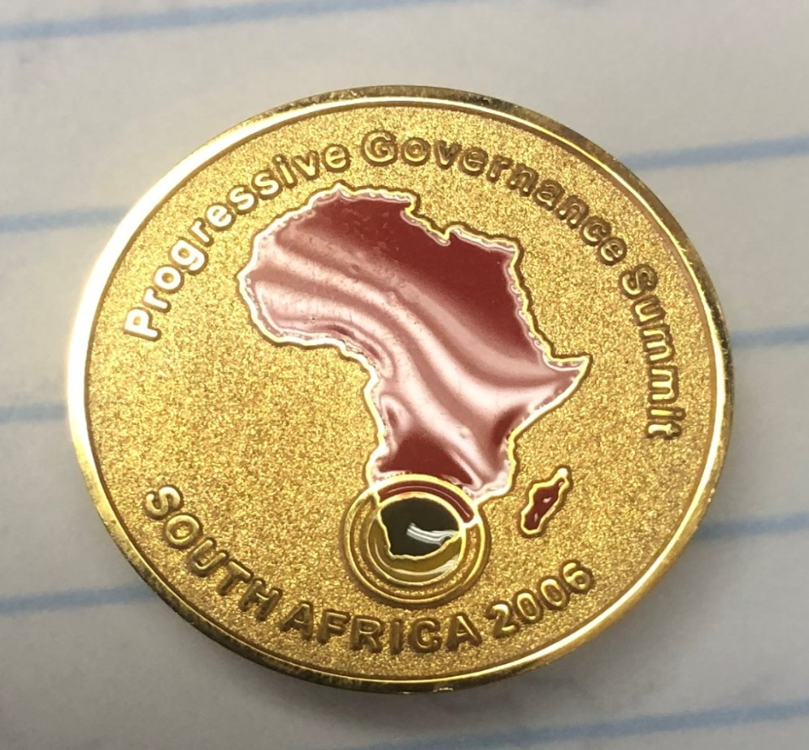
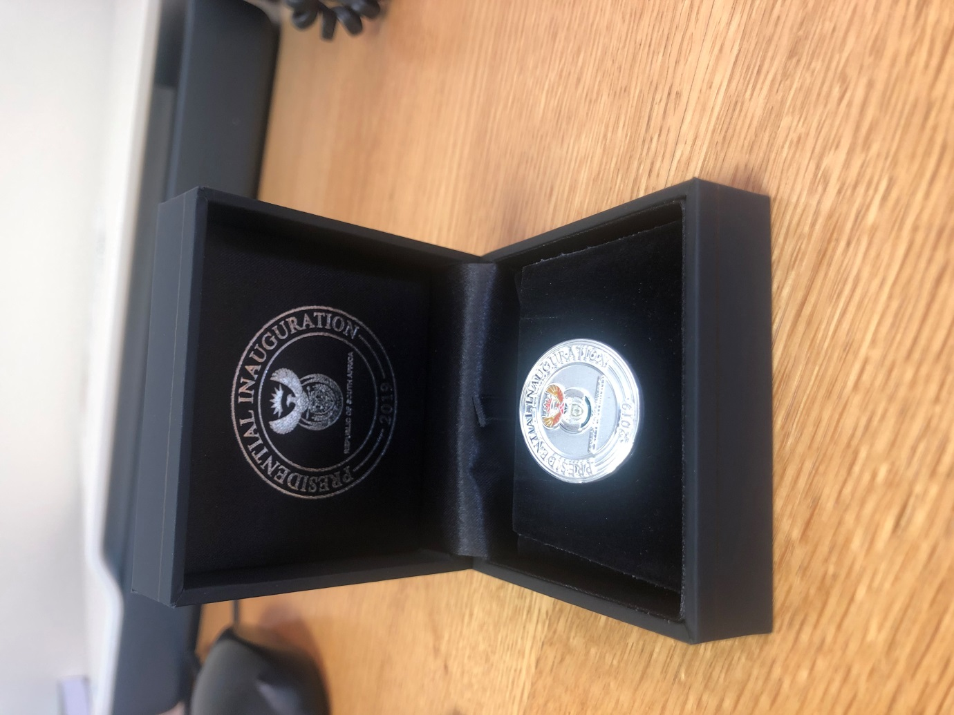
Figure 2: Lapel pin Container
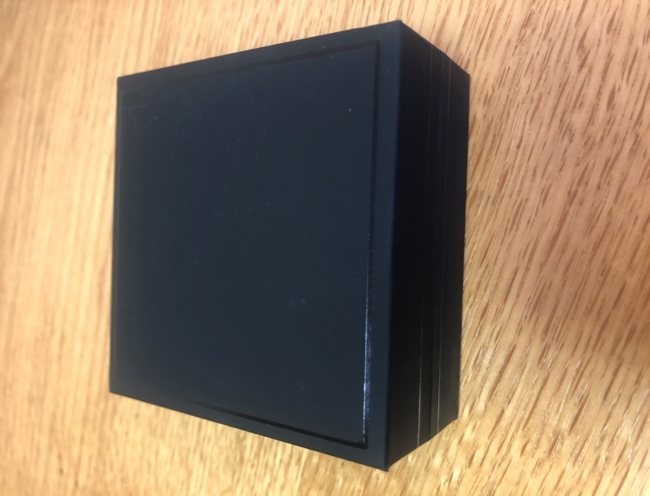
Lapel pin pouch when closed

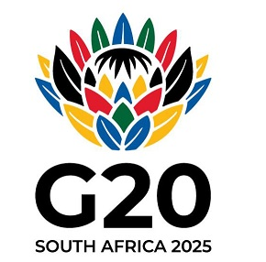
G20 Logo

