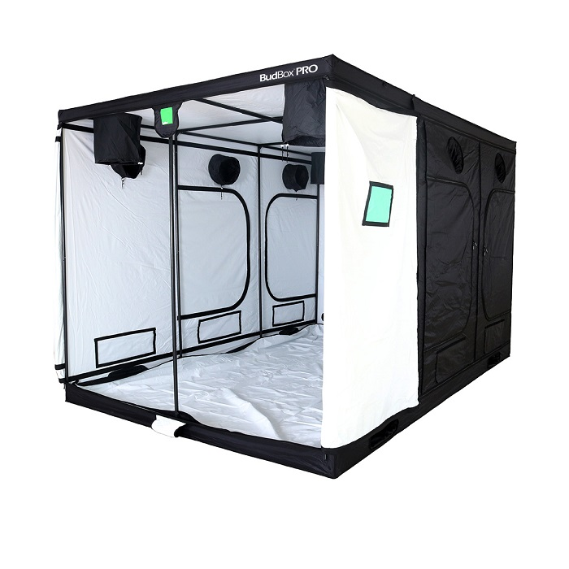

Description
BudBox PRO White TITAN 2-HL 3.6m x 2.4m x 2.2m: The Budbox HL range features tents that are 20cm higher than the standard Budbox ranges, with all of the features that make Budbox tents the most trusted name in the indoor grow tent market.
- BudBox Pro – superbly designed and constructed, premier grow tents
- Pro White material offers class leading PAR results
- Strong, powder-coated 16mm steel framework
- Metal, click-lock connectors for enhanced structural strength and long-term stability
- Creates a sealed area that locks in light, smells and sounds
- Tough, thick, durable yet lightweight outer shell that’s easy to fit in minutes
- Features a green tinted viewing window, to keep a close eye on your growing environment without unzipping the door
- Intake and extraction ports with tightening drawstrings attached, large enough for acoustic ducting
- Military-grade, high-quality zips
- Large ventilation panel/s for increased passive air flow

