Security perimeter fence around the breeding house
100 mm
Site visit briefing and quote template

The fence consists of three parts namely the Main body with a Back part and the smaller Front part. Specs for each will be discussed with a picture.
The total fence project
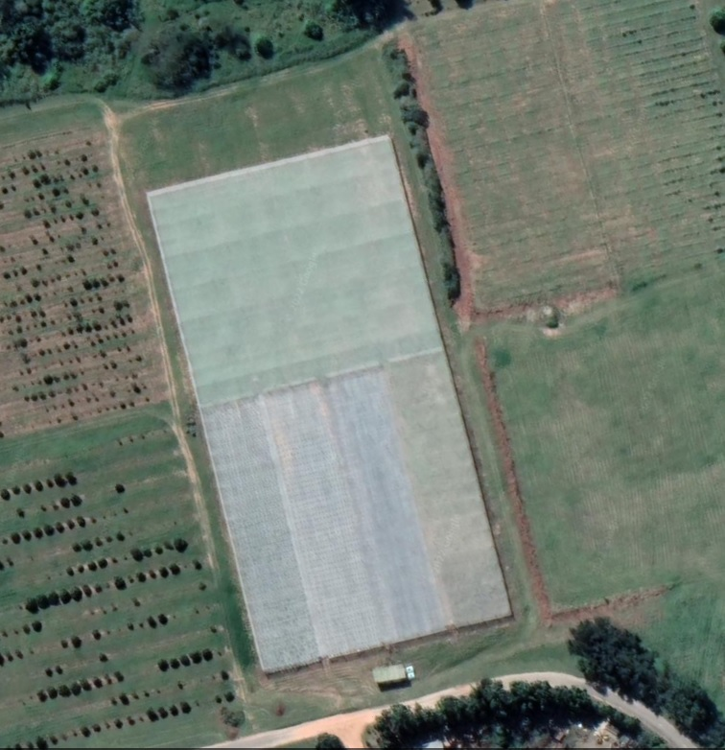
Back part
Main Body
Front part

The main body
3
2
1
Main Body
The main body (excluding the back part and the green line on the front) already consists of perimeter poles on which the shade net is attached, and this must be used to fix the fence onto. As the back part does not have any poles, these should be supplied and anchored for three sides to complete the main body. There must be three 3m-wide gates included (the front two must be sliding gates) the side gate at the back must be a swing gate).
The fence material to be fixed against the poles should be galvanized welded mesh or a similar non-rust option with a total length including the gate openings of ±580 meters (this should be confirmed by measuring it during the site meeting).
The Back part of the main body main body
The back part is an extension of the shade net covered area to allow for the vehicles, entering at the main body gates, to exit or turn and does not have poles. The distance (to be confirmed at site meting) are two short sides of 25m each and the back is 90m, thus a total of 140m with a 3meter-gate opening on the left side. The distance between the poles should be either 3 or 4 meters. The same galvanized welded mesh (See photo) used on the main body must be used here to form one fenced area. (2.5 mm wire thickness, ±1800mm high, aperture 50 x 100mm. Razor wire only on back section.

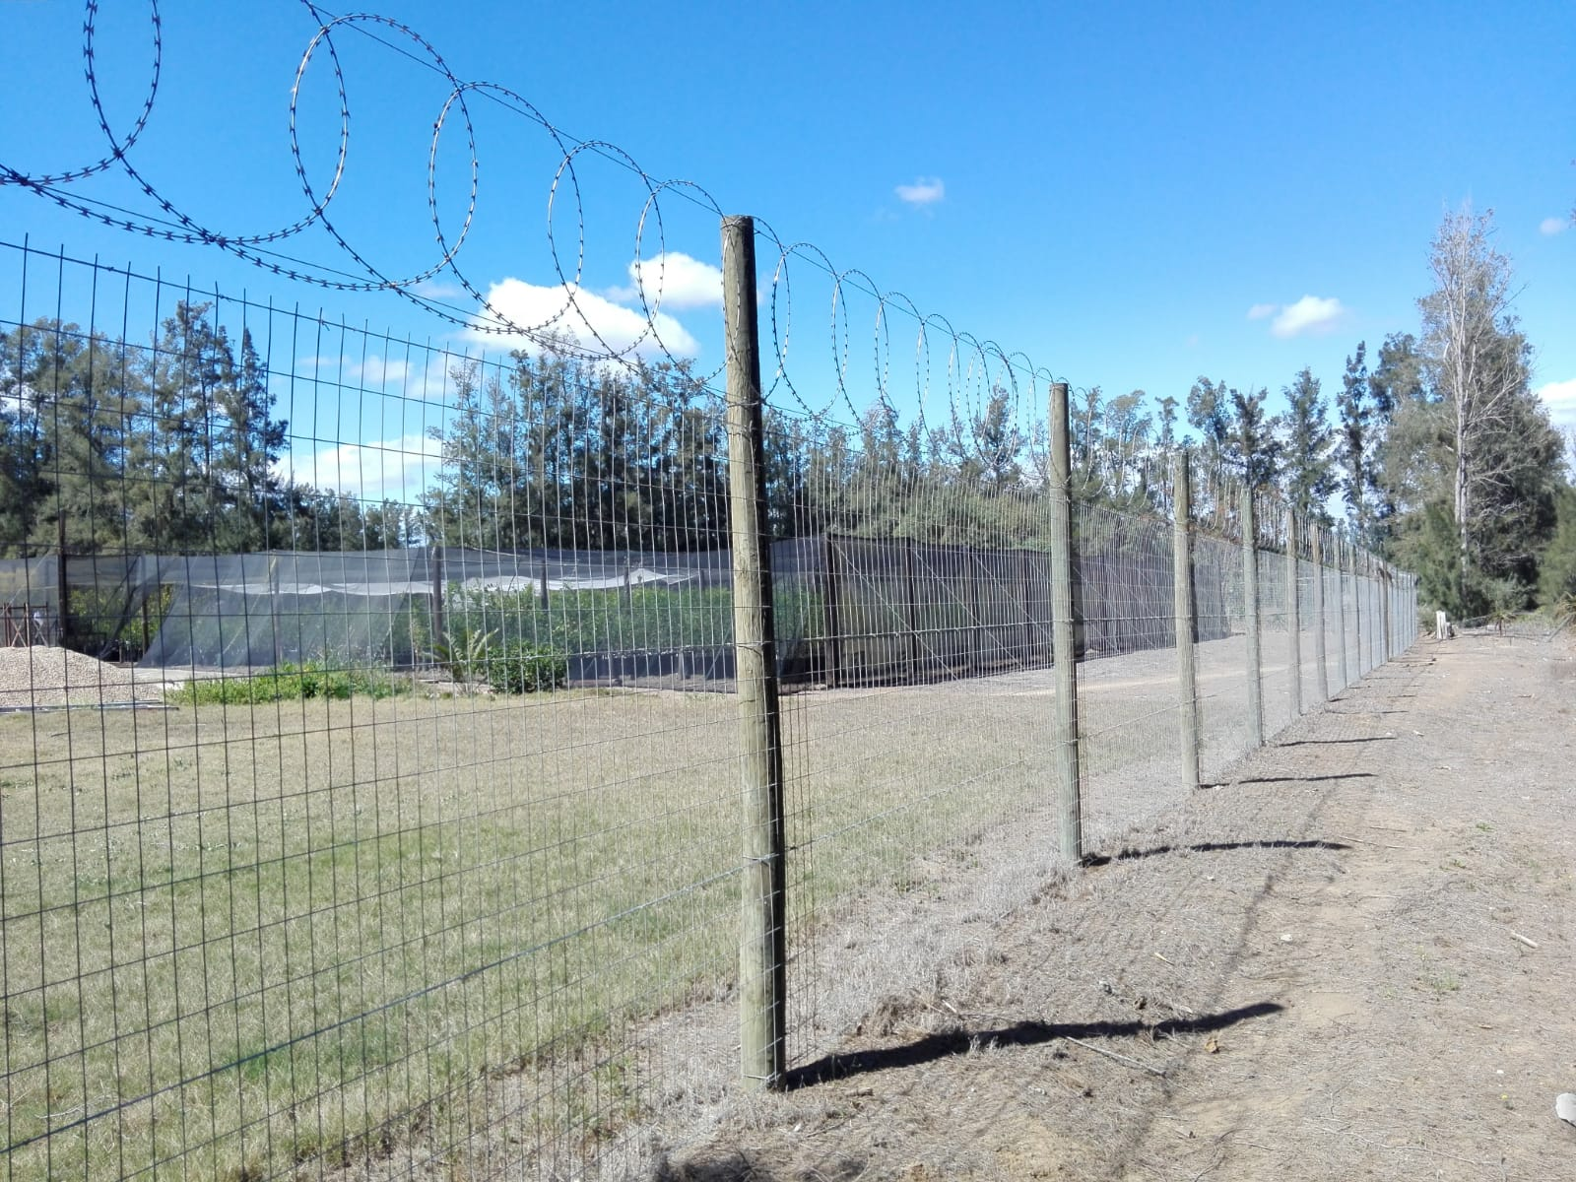
The Front part
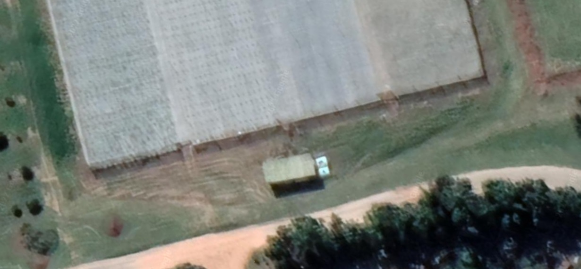
Perimeter of ± 105 m (to be confirmed during site meeting)
Need high tensile welded mesh panels with narrow apertures allowing clear line of sight above secured by customised bracket system that is tamper proof and easy to assemble *see example in the picture”. A modular system will allow for a range of extensions to be installed to suit our future requirements including spikes and electric fencing and a seamless joining of panels along the entire length of the post for maximum strength and rigidity.
Fence type (similar to De-fence medium security system) with the following specifications:
- Installation included
- Preferably no drilling and welding required onsite
- Long anti-rust design
- Easy to move the panels without damaging the fence
- No welding results in cleaner looking fence
- One pedestrian gate
- One big gate (See picture – can be single big swig gate)
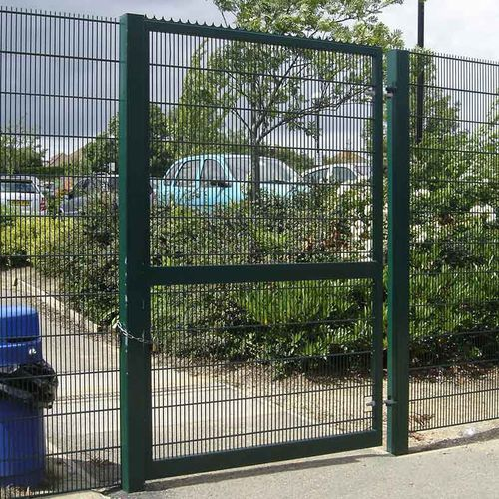
Panel Specifications
Width | 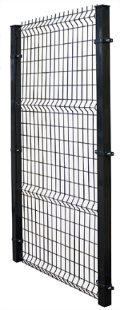 | 2900mm
Height |  | 2050mm
Mesh Aperture |  | 50mm x 100mm
Wire Diameter |  | 4.5mm Horizontal and Vertical
Wave Bends |  | 4 Strengthening Bends
Coating Finishes |  | Electro Galvanised and Powder coated

Post Specifications
Profile | Tube, 60mm x 60mm
Wall Thickness | 2mm
Surface Treatment | hot dipped galvanised OR pre-galv and powder coated
Height | Panel Height + 600mm
Post Cap | PVC

Please use the tables below as a guide for the minimum information needed on the quote.
Two quotes are needed:
- Total main body including the back part with three gates
- Total front part with two gates
MAIN BODY
Item | Description | Unit (e.g. each, roll, meter | Cost per unit | Quantity | Total
Welded mesh |  | Roll (30m)
Gates (Front) |  | Each |  | 2
Gate (Back) |  | Each |  | 1
Poles (Back part |  | Each
Razor wire (Back part) |  | Roll (____)
Other
Total for main body:

Front part
Item | Description | Unit (e.g., each, meter, | Cost per unit | Quantity | Total
Fence |  | ±105m
Gates (Pedestrian)) |  | Each |  | 1
Gate (Big gate) |  | Each |  | 1
Other:
Total for front fence:

