EXPRESSION OF INTEREST
PROCUREMENT DOCUMENT: TEMPLATE
DISCLAIMER
Whilst every effort has been taken to ensure that the content of this template is as up to date as possible (as at the version release date), the author(s) accept no responsibility for the legislative compliance of any procurement document produced when using this template.
The final procurement document that is produced should be carefully checked to ensure compliance with Council Policy, Legislation, the Conditions of Tender, the Conditions of Contract, and the specific Contract Specifications.
INSTRUCTIONS
**** DO NOT USE A FILE THAT HAS BEEN USED ON ANOTHER CONTRACT ****
Parts of the template are deleted when compiling a document. A fresh template must be downloaded when compiling a new document.
Guidance on the use of this template is provided in the COMMENTS pane. Turn the comments OFF before final printing.
BLACK text: default text (can be edited / deleted if required)
GREEN text: optional text (select as is necessary)
RED text: needs to be carefully edited by the compiler
BLUE text: hyper-links
PURPLE text: data input controls
Highlighted text: pay careful attention
Data is entered semi-automatically into the document from the data tables.
'Ctrl+A' then 'F9' OR 'Print Preview' is also used to insert/update data.

Users can 'jump' between relevant sections in the document using the hyper-links.
An editable (WORD), version of this document must be made available at the BSC meeting.

Data Item | Edit data within (grey) brackets (see 2) above}

Contract Details
Contract Number | WS 7742
Contract Title | Creation of a High-Pressure Jetting Contractor Panel for the Sanitation Operations Department for a period of six months, as and when required
Date of Issue | September 2023

Unit & Department Details
Unit Name | Water and Sanitation
Unit Head’s Name | Ednick Msweli
Unit Address | Water and Sanitation Building  3 Prior Road  Durban  4001
Department Name | Sanitation Operations

Tender Details
Employer (1.1.1.15) | eThekwini Municipality
Agent’s Name | Nkosinathi Dlamini
Agent’s Tel | 031 311 5753 (t)
Agent’s Email | Nkosinathi.Dlamini@durban.gov.za
Site Inspection Type | no clarification meeting
Tender Delivery Place | Municipal Building, 166 K.E. Masinga Road  (formerly Old Fort Road)
Tender Delivery Date | on or before Friday, 29 September 2023
Tender Delivery Time | at or before 11:00
Box | and placed in the tender box located in the ground floor foyer
Tender Validity Period | 84 Days
Tender Opening | in the SCM Boardroom, 6th Floor, Municipal Building, 166 KE Masinga Road (formerly Old Fort Road )

Cluster
Trading Services
Unit
Water and Sanitation
Department
Sanitations Operation

PROCUREMENT DOCUMENT
CALL FOR EXPRESSION OF INTEREST
Contract №: |  | WS 7742
Title: |  | Creation of a High-Pressure Jetting Contractor Panel for the Sanitation Operations Department for a period of six months, as and when required
Issued by: Water and Sanitation

Date of Issue: September 2023 |  |  | Document Version : 01/04/2021

INDEX

PART PAGE

E1 SUBMISSION PROCEDURES

E 1.1 Notice and invitation to submit an expression of interest 2
E 1.2 Submission Data 3

E2 RETURNABLE DOCUMENTS

E 2.1 List of Returnable Documents 6
E 2.2 Submission Schedules 7

E3 INDICATIVE SCOPE OF WORK

E 3.1 Standard Specifications 26
E 3.2 Project Specifications 28
E 3.3 Particular Specifications 33
E 3.4 Locality Plan 34

PART E1 : SUBMISSION PROCEDURES

E1.1 : NOTICE AND INVITATION TO SUBMIT AN EXPRESSION OF INTEREST

eThekwini Municipality (Water and Sanitation Unit: Sanitation Operations Department) invites expressions of interest for the undertaking of high-pressure jetting for the ReActive and ProActive maintenance throughout the City for sanitation infrastructure with the Sanitation Operations Department for a period of 3 months, which will be as and when required; at the rates stipulated within this Expression of Interest.
Only respondents who comply with the following are eligible to have their submissions evaluated. | - Completed 5 relevant high-pressure jetting sewer jobs within the last 5 years  - Has the relevant high pressure jetting vehicle and water tank capacity
Submissions must be made on official tender documentation issued (either in hard copy or in electronic format) by the eThekwini Municipality. Electronically downloaded documentation (see Cl. H.1.2) should be printed in its entirety, and suitably bound by the tenderer. Hard copy versions are available as indicated below, for the indicated non-refundable tender charge.
(H.1.4) Queries relating to these documents, up to 3 days prior to the close of tenders, may be addressed to the Employer’s agent whose contact details are: | Nkosinathi Dlamini  031 311 5753 (t)  Nkosinathi.Dlamini@durban.gov.za
(H.2.7) Tender offers shall be delivered to: | Municipal Building, 166 K.E. Masinga Road  (formerly Old Fort Road)  and placed in the tender box located in the ground floor foyer
(H.2.9) Tender offers shall be delivered: | on or before Friday, 29 September 2023  at or before 11:00
Requirements for sealing, addressing, delivery, opening and assessment of tenders are stated in the Tender Data

PART E1 : SUBMISSION PROCEDURES

E1.2: SUBMISSION DATA

E1.2.1 STANDARD CONDITIONS FOR THE CALLING FOR EXPRESSIONS OF INTEREST

The conditions applicable to this call for expressions of interest of tender are the Standard Conditions for the calling for Expressions of Interest as contained in Annex H of the CIDB Standard for Uniformity in Construction Procurement (July 2015) (See www.cidb.org.za).

The Standard Conditions for the calling for Expressions of Interest make several references to the Submission Data for details that apply specifically to this submission. The Submission Data shall have precedence in the interpretation of any ambiguity or inconsistency between it and the Standard Conditions for the calling for Expressions of Interest.

E1.2.2 SUBMISSION DATA

Each item of data given below is cross-referenced to the clause in the Standard Conditions for the calling for Expressions of Interest.

H.1.1 The employer : The Employer is the eThekwini Municipality as represented by the Deputy Head : Sanitation Operations Department.

H.1.2 Tender documents
1) The documents associated with the calling for expressions of interest issued by the employer comprise:
E1 SUBMISSION PROCEDURES
E1.1 Notice and invitation to submit an expression of interest
E1.2 Submission Data
E2 RETURNABLE DOCUMENTS
E2.1 List of Returnable Documents
E2.2 Submission Schedules
E3 INDICATIVE SCOPE OF WORK
E3.1 Indicative scope of work

2) In addition Respondents are advised, in their own interest, to obtain their own copies of the following acts, regulations, and standards referred to in the this document as they are essential for the Tenderer to get acquainted with the basics of construction management, the implementation of preferential construction procurement policies and participation of targeted enterprise and labour.
- The Occupational Health and Safety Act No 85 and Amendment Act No 181 of 1993, and the Construction Regulations 2014.
- The Preferential Procurement Policy Framework Act No 5 of 2000, and the Preferential Procurement Policy Framework Act Regulations (2017).
- The Construction Industry Development Board Act No 38 of 2000 and the Regulations of July 2015.
- SANS 1921:2004 – Construction and Management Requirements for Works Contract, Parts 1 to 3.
- SANS 1914:2003 - Targeted Construction Procurement, Parts 1 to 6.
- South African Road Traffic Signs Manual - Vol 2: Chapter 13: Roadworks Signing.

Submissions must be submitted on official submission documentation issued by the eThekwini Municipality:
- Electronically downloaded documentation is obtainable from the National Treasury’s eTenders website OR the eThekwini Municipality’s Vendor Portal. The entire document should be printed and suitably bound by the tenderer.

H.1.4 The employer’s agent : The Employer’s agent is: Nkosinathi Dlamini, Tel: 031 311 5753 (t), Email: Nkosinathi.Dlamini@durban.gov.za

H.2.1 Eligibility : A Respondent will not be eligible to make a submittion if:
(a) The Respondent does not comply with the legal requirements stated in the Employer’s current SCM Policy;
(b) The Respondent cannot provide proof that he is in good standing with respect to duties, taxes, levies and contributions required in terms of legislation applicable to the work in the contract.
(c) Respondents are required to be registered on the National Treasury Central Supplier Database (CSD) as a service provider. In the case of a Joint Venture, this requirement will apply individually to each party in the Joint Venture. Respondents not so registered, at time of closing of submissions, will not be eligible to submit tenders.
H.2.1.1 Only those respondents who satisfy the following eligibility criteria are eligible to submit expressions of interest. The Tenderer can be compliant for a single, multipile or all criteria listed below. Whatever option the Tenderer is compliant with, will render the tenderer compliant to be on the particular database (provided compliance with the Expression of Interest document).
a) Completed a minimum of 5 jobs for the high-pressure jetting of sewer network infrastructure with a water tank capacity of ≤ 3 000ℓ over the last five years.
b) Completed a minimum of 5 jobs for the high-pressure jetting of sewer network infrastructure with a water tank capacity between > 3 000ℓ to < 10 000ℓ over the last five years.
c) Completed a minimum of 5 jobs for the high-pressure jetting of sewer network infrastructure with a water tank capacity of ≥ 10 000ℓ over the last five years.
H.2.1.2 Only those respondents who satisfy the following eligibility criteria are eligible to submit expressions of interest. The compliance of this eligibility criteria must match the Tenderers compliance of H 2.1.1, in-order for the tenderer be on that particular database (provided compliance with the Expression of Interest document).
a) Has one high-pressure jetting vehicle with a water tank capacity of ≤ 3 000ℓ.
b) Has one high-pressure jetting vehicle with a water tank capacity between > 3 000ℓ to < 10 000ℓ.
c) Has one high-pressure jetting vehicle with a water tank capacity of ≥ 10 000ℓ.

H.2.5 Clarification meeting : There are no compulsory clarification meetings.

H.2.7 Making a submission : The Employer’s address for delivery of submissions is contained in the Notice and invitation to submit an expression of interest.

Identification details to be shown on each submission package are:
Contract No. : WS 7742
Contract Title : Creation of a High-Pressure Jetting Contractor Panel for the Sanitation Operations Department for a period of six months, as and when required

Alternatively, if registered on the eThekwini Municipality’s Vendor Portal, submissions can be submitted electronically via URL:

https://ethekwinivendor.durban.gov.za/tenders/availabletenders/
H.2.9 Closing time : The closing date and time for submissions is: on or before Friday, 29 September 2023 at or before 11:00.

Telephonic, telegraphic, telex, facsimile or e-mailed submissions will not be accepted.

H.3.9 Evaluation of responsive submissions : All respondents who submit responsive submissions and:
a) are registered at time of closing of submissions on the National Treasury Central Supplier Database (CSD) as a service provider (in the case of a Joint Venture, this requirement will apply individually to each party in the Joint Venture).
b) submit a valid Tax Clearance Certificate OR Tax Compliance Status PIN, issued by the TCS System of the South African Revenue Services, or has made arrangements to meet outstanding tax obligations;
c) do not have any of their directors/shareholders is not listed on the Register of Tender Defaulters in terms of the Prevention and Combating of Corrupt Activities Act of 2004 as a person prohibited from doing business with the public sector;
d) have not abused the Employer’s Supply Chain Management System or have failed to perform on any previous contract and have been given a written notice to this effect;
e) have completed the Compulsory Enterprise Questionnaire and who are considered by the Employer not to have any conflicts of interest which may impact on their ability to perform the proposed contract in the best interests of the Employer or potentially compromise the tender process and are free of persons in the state who are not permitted to submit tenders or to participate in the contract; and
f) are registered and in good standing with the compensation fund or with a licensed compensation insurer;
g) meet the minimum Tenderer Experience eligibility (H 2.1.1);
h) meet the minimum High-Pressure Jetting Vehicle Availability eligibility (H 2.1.2);
will be place into a Alphabetic - Numeric Roster System and utilised as per E 3.2.2 description.

The additional conditions of submission are:
H.2.4 Acknowledge addenda
Add the following paragraphs to the clause:
“Acknowledgement of receipt will be by the return of the relevant completed and signed portion of the addenda, to the address / fax number / email address as specified on the addenda. Failure of the tenderer to comply with the requirements of the addenda may result in the tender submission being made non-responsive.”

H.3.11 Prohibition on awards to persons in the service of the state : Clause 44 of the Supply Chain Management Regulations states that the Municipality or Municipal Entity may not make any award to a person:
(a) Who is in the service of the State;
(b) If that person is not a natural person, of which a director, manager, principal shareholder or stakeholder is a person in the service of the state; or
(c) Who is an advisor or consultant contracted with the municipality or a municipal entity.
Should a contract be awarded, and it is subsequently established that Clause 44 has been breached, the Employer shall have the right to terminate the contract with immediate effect.

H.3.12 Appeals
In terms of Regulation 49 of the Municipal Supply Chain Management Regulations persons aggrieved by decisions or actions taken by the Municipality, may lodge an appeal within 14 days of the decision or action, in writing to the Municipality. All appeals (clearly setting out the reasons for the appeal) and queries with regard to the decision of award are to be directed to:
The City Manager
Attention Ms S. Pillay eMail: Simone.Pillay@durban.gov.za
P O Box 1394
Durban
4000

PART E2 : RETURNABLE DOCUMENTS

E2.1 : LIST OF RETURNABLE DOCUMENTS

E2.1.1 General

The submission document must be submitted as a whole. All forms must be properly completed as required, and the document shall not be taken apart or altered in any way whatsoever.

The respondant is required to complete each and every Schedule and Form listed below to the best of his / her ability as the evaluation of submissions will be based on the information provided by the respondant. Failure to complete the Schedules and Forms to the satisfaction of the Employer will inevitably prejudice the tender and may lead to rejection on the grounds that the submission is not responsive

E2.1.2 Returnable Schedules, Forms and Certificates
Entity Specific
Compulsory Enterprise Questionnaire
Tax Compliance Status PIN / Tax Clearance Certificate
Contractor's Health and Safety Declaration
MBD 4: Declaration of Interest
MBD 8: Declaration of Bidder’s Past SCM Practices
Joint Venture Agreements (if applicable)
Record of Addenda to Tender Documents (if applicable)
Eligibility
Eligibility: Declaration of Municipal Fees
Eligibility: Registration with Compensation Commissioner
Eligibility: CSD Registration Report
Eligibility: Experience of Tenderer
Eligibility: Tenderer High-Pressure Jetting Vehicle Availability

E2.1.3 Preferential Procurement Schedules and Affidavits

In the event of the Tenderer not being registered with the eThekwini Municipality the following documents, available from Room 614, 6th Floor, 166 KE Masinga Road, Durban or on the internet, must be completed and submitted prior to the submission of tenders:

- Application for Registration on the eThekwini Municipality Procurement Directory.
- Application for Targeted Enterprise Status.
- Women Equity Declaration Affidavit.
- Declaration for Black Business Enterprise / Woman Business Enterprise / SMME Status.

PART E2 : RETURNABLE DOCUMENTS

E2.2 : SUBMISSION SCHEDULES

The submission schedules as listed in E2.1.2 can be found on pages 8 to 24.

COMPULSORY ENTERPRISE QUESTIONNAIRE

Ref | Description | Complete or  Circle Applicable
1.1 | Name of enterprise
1.2 | Name of enterprise’s representative
1.3 | ID Number of enterprise’s representative
1.4 | Position enterprise’s representative occupies in the enterprise
1.5 | National Treasury Central Supplier Database Registration number | MAAA
1.6 | eThekwini Supplier Database:  Reference number (PR), if any: | PR
1.7 | VAT registration number, if any:
1.8 | CIDB registration number, if any:
1.9 | Department of Labour:  Registration number
1.10 | Department of Labour:  Letter of Good Standing Certificate number
2.0 | Particulars of sole proprietors and partners in partnerships (attach separate pages if more than 4 partners)
 | Full Name | Identity No. | Personal income tax No. *
2.1
2.2
2.3
2.4
3.0 | Particulars of companies and close corporations
3.1 | Company registration number, if applicable:
3.2 | Close corporation number, if applicable:
3.3 | Tax Reference number, if any:
3.4 | South African Revenue Service:  Tax Compliance Status PIN:

4.0 | Record in the service of the state (Insert on a separate page if necessary)
 | Indicate by marking the relevant boxes with a cross, if any sole proprietor, partner in a partnership or director, manager, principal shareholder or stakeholder in a company or close corporation is currently or has been within the last 12 months in the service of any of the following:
 | ¨ | a member of any municipal council |  | ¨ | a member of any provincial legislature
 | ¨ | an official of any municipality or municipal entity |  | ¨ | a member of an accounting authority of any national or provincial public entity
 | ¨ | a member of the board of directors of any municipal entity |  | ¨ | a member of the National Assembly or the National Council of Province
 | ¨ | an employee of any provincial department, national or provincial public entity or constitutional institution within the meaning of the Public Finance Management Act, 1999 (Act 1 of 1999) |  | ¨ | an employee of Parliament or a provincial legislature
 | Name of sole proprietor, partner, director, manager, principal shareholder or stakeholder |  | Name of institution, public office, board or organ of state and position held |  |  | Status of service  (tick appropriate column)
 |  |  |  |  |  | Current | Within last 12 mths
5.0 | Record of spouses, children and parents in the service of the state (Insert on a separate page if necessary)
 | Indicate by marking the relevant boxes with a cross, if any spouse, child or parent of a sole proprietor, partner in a partnership or director, manager, principal shareholder or stakeholder in a company or close corporation is currently or has been within the last 12 months in the service of any of the following:
 | ¨ | a member of any municipal council |  | ¨ | a member of any provincial legislature
 | ¨ | an official of any municipality or municipal entity |  | ¨ | a member of an accounting authority of any national or provincial public entity
 | ¨ | a member of the board of directors of any municipal entity |  | ¨ | a member of the National Assembly or the National Council of Province
 | ¨ | an employee of any provincial department, national or provincial public entity or constitutional institution within the meaning of the Public Finance Management Act, 1999 (Act 1 of 1999) |  | ¨ | an employee of Parliament or a provincial legislature
 | Name of spouse, child or parent |  | Name of institution, public office, board or organ of state and position held |  |  | Status of service  (tick appropriate column)
 |  |  |  |  |  | Current | Within last 12 mths
The undersigned, who warrants that he / she is duly authorised to do so on behalf of the enterprise:
    - authorizes the Employer to verify the tenderers tax clearance status from the South African Revenue Services that it is in order.
    - confirms that the neither the name of the enterprise or the name of any partner, manager, director or other person, who wholly or partly exercises or may exercise, control over the enterprise appears on the Register of Tender Defaulters established in terms of the Prevention and Combating of Corrupt Activities Act of 2004.
    - confirms that no partner, member, director or other person, who wholly or partly exercises, or may exercise, control over the enterprise appears, has within the last five years been convicted of fraud or corruption.
    - confirms that I / we are not associated, linked or involved with any other tendering entities submitting tender offers and have no other relationship with any of the tenderers or those responsible for compiling the scope of work that could cause or be interpreted as a conflict of interest.
    - confirms that the contents of this questionnaire are within my personal knowledge and are to the best of my belief both true and correct.
NAME (Block Capitals): |  | Date
SIGNATURE: |  | Date

TAX COMPLIANCE STATUS PIN / TAX CLEARANCE CERTIFICATE

SARS has introduced a new Tax Compliance Status System. Tenderers can submit a Tax Compliance Status PIN (TCS PIN) instead of an original Tax Clearance Certificate. This TCS PIN can be used by third parties to certify the taxpayer’s real-time compliance status.

Separate Tax Clearance Certificates / TCS PINs are required for each entity in a Joint Venture.

The TCS PIN(s) are to be entered under item 3.4 on form Compulsory Enterprise Questionnaire.

Tenderers are to include, at the back of their tender submission document, a printout of their Tax Compliance Status PIN (TCS PIN) OR an original Tax Clearance Certificate.

Failure to include the required document will make the tender submission non-responsive.

I, the undersigned, who warrants that they are authorised to sign on behalf of the Tenderer,
confirms that the information contained in this form is within my personal knowledge and is to the best of my belief both true and correct, and that the requested documentation has been included in the tender submission.
NAME (Block Capitals): |  | Date
SIGNATURE: |  | Date

CONTRACTOR'S HEALTH AND SAFETY DECLARATION

In terms of Clause 5(1)(h) of the OHSA 1993 Construction Regulations 2014 (referred to as "the Regulations" hereafter), a Principal Contractor may only be appointed to perform construction work if the Client is satisfied that the Principal Contractor has the necessary competencies and resources to carry out the work safely in accordance with the Occupational Health and Safety Act No 85 of 1993 and the OHSA 1993 Construction Regulations 2014.

To that effect, a person duly authorised by the tenderer, must complete and sign the declaration hereafter in detail.

Declaration by Tenderer
1 | I, the undersigned, hereby declare and confirm that I am fully conversant with the Occupational Health and Safety Act No 85 of 1993 (as amended by the Occupational Health and Safety Amendment Act No 181 of 1993), and the OHSA 1993 Construction Regulations 2014.
2 | I hereby declare that my company has the competence and the necessary resources to safely carry out the construction work under this contract in compliance with the Construction Regulations and the Employer's Health and Safety Specifications.
3 | I propose to achieve compliance with the Regulations by one of the following (Tenderers are to Circle Applicable - Yes or No):
 |  |  |  | Circle Applicable
(a) | From my own competent resources as detailed in 4(a) hereafter. |  |  | Yes | NO
(b) | From my own resources still to be appointed or trained until competency is achieved, as detailed in 4(b) hereafter: |  |  | Yes | NO
(c) | From outside sources by appointment of competent specialist Subcontractors as detailed in 4(c) hereafter: |  |  | YES | NO
4 | Details of resources I propose:  (Note: Competent resources shall include safety personnel such as a construction supervisor and construction safety officer as defined in Regulation 8, and competent persons as defined in Regulations 9, 10, 11, 12, 13, 14, 16, 17, 20, 21, 22, 23(1), 24, 25, 26, 27, 28 and 29, as applicable).
(a) | Details of the competent and qualified key persons from my company's own resources, who will form part of the contract team:
 | NAMES OF COMPETENT PERSONS | POSITIONS TO BE FILLED BY COMPETENT PERSONS
(b) | Details of training of persons from my company's own resources (or to be hired) who still have to be trained to achieve the necessary competency:
 | (i) By whom will training be provided?
 | (ii) When will training be undertaken?
 | (iii) Positions to be filled by persons to be trained or hired:
(c) | Details of competent resources to be appointed as subcontractors if competent persons cannot be supplied from own company:
 | Name of proposed subcontractor:
 | Qualifications or details of competency of the subcontractor:
5 | I, the undersigned, hereby undertake, if this tender is accepted, to provide, before commencement of the works under the contract, a suitable and sufficiently documented Health and Safety Plan in accordance with Regulation 7(1) of the Construction Regulations, which plan shall be subject to approval by the Client.
6 | I, the undersigned, confirm that copies of this company's approved Health and Safety Plan, the Client's Safety Specifications as well as the OHSA 1993 Construction Regulations 2014 will be provided on site and will at all times be available for inspection by the Principal Contractor's personnel, the Client's personnel, the Employer’s Agent, visitors, and officials and inspectors of the Department of Labour.
7 | I, the undersigned, hereby confirm that adequate provision has been made in the tendered rates and prices in the Bill of Quantities to cover the cost of all resources, actions, training and all health and safety measures envisaged in the OHSA 1993 Construction Regulations 2014, and that I will be liable for any penalties that may be applied by the Client in terms of the said Regulations (Regulation 33) for failure on the Principal Contractor's part to comply with the provisions of the Act and the Regulations.
8 | I, the undersigned, agree that failure to complete and execute this declaration to the satisfaction of the Client will mean that this company is unable to comply with the requirements of the OHSA 1993 Construction Regulations (2014) and accept that this tender will be prejudiced and may be rejected at the discretion of the Client.

I, the undersigned, who warrants that they are authorised to sign on behalf of the Tenderer, confirms that the information contained in this form is within my personal knowledge and is to the best of my belief both true and correct.
NAME (Block Capitals): |  | Date
SIGNATURE: |  | Date

MBD 4: DECLARATION OF INTEREST

MSCM Regulations: “in the service of the state” means to be:
(a) a member of:
(i) any municipal council.
(ii) any provincial legislature.
(iii) the national Assembly or the national Council of provinces.
(b) a member of the board of directors of any municipal enterprise.
(c) an official of any municipality or municipal enterprise.
(d) an employee of any national or provincial department, national or provincial public enterprise or constitutional institution within the meaning of the Public Finance Management Act, 1999 (Act No.1 of 1999).
(e) a member of the accounting authority of any national or provincial public enterprise.
(f) an employee of Parliament or a provincial legislature.

“Shareholder” means a person who owns shares in the company and is actively involved in the management of the company or business and exercises control over the company.
1 | No bid will be accepted from persons in the service of the state¹.
2 | Any person, having a kinship with persons in the service of the state, including a blood relationship, may make an offer or offers in terms of this invitation to bid. In view of possible allegations of favouritism, should the resulting bid, or part thereof, be awarded to persons connected with or related to persons in service of the state, it is required that the bidder or their authorised representative declare their position in relation to the evaluating/adjudicating authority and/or take an oath declaring his/her interest.
3 | In order to give effect to the above, the following questionnaire must be completed and submitted with the bid.
 | 3.1 Name of enterprise |  |  | Complete Item 1.1
 | Name of enterprise’s representative |  |  | Complete Item 1.2
 | 3.2 ID Number of enterprise’s representative |  |  | Complete Item 1.3
 | 3.3 Position enterprise’s representative occupies in the enterprise |  |  | Complete Item 1.4
 | 3.4 Company Registration number |  |  | Complete Item 3.1 or 3.2
 | 3.5 Tax Reference number |  |  | Complete Item 3.3
 | 3.6 VAT registration number |  |  | Complete Item 1.7
 | 3.7 The names of all directors / trustees / shareholders / members / sole proprietors / partners in partnerships, their individual identity numbers and state employee numbers must be indicated in paragraph 4 below. In the case of a joint venture, information in respect of each partnering enterprise must be completed and submitted.
 |  |  |  |  |  | Circle Applicable
 | 3.8 Are you presently in the service of the state? |  |  |  |  | YES | NO
If yes, furnish particulars: ……….…………………………………………..…………………………….………
……………………………………………………………………………………………………………………..
 | 3.9 Have you been in the service of the state for the past twelve months? |  |  |  |  | YES | NO
If yes, furnish particulars: ……….…………………………………………..…………………………….………
……………………………………………………………………………………………………………………..
 | 3.10 Do you have any relationship (family, friend, other) with persons in the service of the state and who may be involved with the evaluation and or adjudication of this bid? |  |  |  |  | YES | NO
If yes, furnish particulars: ……….…………………………………………..…………………………….………
……………………………………………………………………………………………………………………..
 | 3.11 Are you, aware of any relationship (family, friend, other) between any other bidder and any persons in the service of the state who may be involved with the evaluation and or adjudication of this bid? |  |  |  |  | YES | NO
If yes, furnish particulars: ……….…………………………………………..…………………………….………
……………………………………………………………………………………………………………………..
 | 3.12 Are any of the company’s directors, trustees, managers, principle shareholders or stakeholders in service of the state? |  |  |  |  | YES | NO
If yes, furnish particulars: ……….…………………………………………..…………………………….………
……………………………………………………………………………………………………………………..
 | 3.13 Are any spouse, child or parent of the company’s directors, trustees, managers, principle shareholders or stakeholders in service of the state? |  |  |  |  | YES | NO
If yes, furnish particulars: ……….…………………………………………..…………………………….………
……………………………………………………………………………………………………………………..
 | 3.14 Do you or any of the directors, trustees, managers, principle shareholders, or stakeholders of this company have any interest in any other related companies or business whether or not they are bidding for this contract ? |  |  |  |  | YES | NO
If yes, furnish particulars: ……….…………………………………………..…………………………….………
……………………………………………………………………………………………………………………..
4 | The names of all directors / trustees / shareholders / members / sole proprietors / partners in partnerships, their individual identity numbers and state employee numbers must be indicated below. In the case of a joint venture, information in respect of each partnering enterprise must be completed and submitted
 | Full Name | Identity No. | State Employee No. |  | Personal income tax No.
 | Use additional pages if necessary

I, the undersigned, who warrants that they are authorised to sign on behalf of the Tenderer, confirms that the information contained in this form is within my personal knowledge and is to the best of my belief both true and correct.
NAME (Block Capitals): |  | Date
SIGNATURE: |  | Date

MBD 8: DECLARATION OF BIDDER’S PAST SUPPLY CHAIN MANAGEMENT PRACTICES

1.0 | This Municipal Bidding Document must form part of all bids invited.
2.0 | It serves as a declaration to be used by municipalities and municipal entities in ensuring that when goods and services are being procured, all reasonable steps are taken to combat the abuse of the supply chain management system.
3.0 | The bid of any bidder may be rejected if that bidder, or any of its directors have:  a) abused the municipal entity’s supply chain management system or committed any improper conduct in relation to such system.  b) been convicted for fraud or corruption during the past five years.  c) wilfully neglected, reneged on or failed to comply with any government, municipal or other public sector contract during the past five years.  d) been listed in the Register for Tender Defaulters in terms of section 29 of the Prevention and Combating of Corrupt Activities Act (No 12 of 2004).
4.0 | In order to give effect to the above, the following questions must be completed and submitted with the bid.
 |  | Circle Applicable
4.1 | Is the bidder or any of its directors listed on the National Treasury’s Database of Restricted Suppliers as companies or persons prohibited from doing business with the public sector?  (Companies or persons who are listed on this Database were informed in writing of this restriction by the Accounting Officer / Authority of the institution that imposed the restriction after the audi alteram partem rule was applied.)  The Database of Restricted Suppliers now resides on the National Treasury’s website (www.treasury.gov.za) and can be accessed by clicking on its link at the bottom of the home page. | YES | NO
4.1.1 If YES, provide particulars.
………………………………………………….……………………………….……………..………………..………………………………………..
…………………………………………………………………………………….………………………………..……………………………………..
4.2 | Is the bidder or any of its directors listed on the Register for Tender Defaulters in terms of section 29 of the Prevention and Combating of Corrupt Activities Act (No 12 of 2004)?  The Register for Tender Defaulters can be accessed on the National Treasury’s website (www.treasury.gov.za) by clicking on its link at the bottom of the home page. | YES | NO
4.2.1 If YES, provide particulars.
………………………………………………….……………………………….……………..………………..………………………………………..
…………………………………………………………………………………….………………………………..……………………………………..
4.3 | Was the bidder or any of its directors convicted by a court of law (including a court of law outside the Republic of South Africa) for fraud or corruption during the past five years? | YES | NO
4.3.1 If YES, provide particulars.
………………………………………………….……………………………….……………..………………..………………………………………..
…………………………………………………………………………………….………………………………..……………………………………..
4.4 | Does the bidder or any of its directors owe any municipal rates and taxes or municipal charges to the municipality / municipal entity, or to any other municipality / municipal entity, that is in arrears for more than three months? | YES | NO
4.4.1 If YES, provide particulars.
………………………………………………….……………………………….……………..………………..………………………………………..
…………………………………………………………………………………….………………………………..……………………………………..
4.5 | Was any contract between the bidder and the municipality / municipal entity or any other organ of state terminated during the past five years on account of failure to perform on or comply with the contract? | YES | NO
4.5.1 If YES, provide particulars.
………………………………………………….……………………………….……………..………………..………………………………………..
…………………………………………………………………………………….………………………………..……………………………………..

I, the undersigned, who warrants that they are authorised to sign on behalf of the Tenderer, confirms that the information contained in this form is within my personal knowledge and is to the best of my belief both true and correct.

I accept that, in addition to cancellation of a contract, action may be taken against me should this declaration prove to be false.
NAME (Block Capitals): |  | Date
SIGNATURE: |  | Date

JOINT VENTURES AGREEMENTS

Joint Venture agreement and Power of Attorney Agreements to be attached here (if applicable).

RECORD OF ADDENDA TO TENDER DOCUMENTS

I / We confirm that the following communications received from the Employer or his representative before the date of submission of this tender offer, amending the tender documents, have been taken into account in this tender offer.

ADD. № | DATE | TITLE OR DETAILS
1
2
3
4
5
6
7
8
9
10

I, the undersigned, who warrants that they are authorised to sign on behalf of the Tenderer, confirms that the information contained in this form is within my personal knowledge and is to the best of my belief both true and correct.

It is also confirmed that the requirements, as stated on the Addenda, have been complied with.
NAME (Block Capitals): |  | Date
SIGNATURE: |  | Date

ELIGIBILITY: DECLARATION OF MUNICIPAL FEES

I, the undersigned, do hereby declare that the Municipal fees of:

.........................................................................................................................................................................
(full name of Company / Close Corporation / partnership / sole proprietary/Joint Venture)

(hereinafter referred to as the TENDERER) are, as at the date hereunder, fully paid or an Acknowledgement of Debt has been concluded with the Municipality to pay the said charges in instalments.

The following account details relate to property of the said TENDERER:

Account | Account Number: to be completed by tenderer
Consolidated Account
Electricity
Water
Rates
JSB Levies
Other
I acknowledge that should the aforesaid Municipal charges fall into arrears, the Municipality may take such remedial action as is required, including termination of any contract, and any payments due to the Contractor by the Municipality shall be first set off against such arrears.
- Where the tenderer’s place of business or business interests are outside the jurisdiction of eThekwini municipality, a copy of the accounts/ agreements from the relevant municipality are to be provided.

- Where the tenderer’s Municipal Accounts are part of their lease agreement, then a copy of the agreement, or an official letter to that effect, is to be provided.

Tenderers are to include, at the back of their tender submission document, a printout of the above account’s and or agreements signed with the municipality.

Failure to include the required document will make the tender submission non-responsive.

I, the undersigned, who warrants that they are authorised to sign on behalf of the Tenderer,
confirms that the information contained in this form is within my personal knowledge and is to the best of my belief both true and correct, and that the requested documentation has been included in the tender submission.
NAME (Block Capitals): |  | Date
SIGNATURE: |  | Date

ELIGIBILITY: REGISTRATION WITH COMPENSATION COMMISSIONER

The Occupational Injuries and Diseases Act (130 of 1993 as amended) (the Act) refers. A summary of the pertinent Clauses is listed below. The act is to be referenced for the full text of the clauses.

Clause 80: Employer to register with commissioner and furnish him with particulars
The Act requires that an Employer carrying out business in the Republic to register with the Compensation Commissioner. Any person who fails to comply with the provisions of this clause is guilty of an offence.

Clause 82: Employer to furnish returns of earnings
The Act requires an Employer to furnish the commissioner with a return showing:
- The amount of earnings paid by him to his employees.
- Any further information as may be prescribed or as the commissioner may require.
Any Employer who fails to comply with the provisions of this clause is guilty of an offence.

Clause 86: Assessment to be paid by an employer to commissioner
The Act states that an Employer will receive notices of assessment from the commissioner. The Employer must pay the commissioner the assessment amount on the notices.

Clause 89: Mandators and contractors
The Act requires a contractor (a person with a contract with a mandator) to register as an Employer in accordance with the provisions of the Act and pay the necessary assessments. Failing registration or payment of assessments, the mandator is required to pay the assessments in respect of the employees of the contractor. The mandator is allowed to recover the assessment amounts paid from the contractor.

The Department of labour issues contractors with a Letter of Good Standing if the contractor has complied with the requirement(s) of the Act and is in “good standing” with the Compensation Fund. Employers can check the validity of such Letters of Good Standing on the internet (https://cfonline.labour.gov.za/VerifyLOGS ).

Tenderers are to include, at the back of their tender submission document, a printout of their most recent Letter of Good Standing from the Department of Labour.

Failure to include the required document will make the tender submission non-responsive.

I, the undersigned, who warrants that they are authorised to sign on behalf of the Tenderer,
confirms that the information contained in this form is within my personal knowledge and is to the best of my belief both true and correct, and that the requested documentation has been included in the tender submission.
NAME (Block Capitals): |  | Date
SIGNATURE: |  | Date

ELIGIBILITY: CSD REGISTRATION REPORT

The Conditions of Tender, requires a tenderer to be registered, at the time of tender closing, on the National Treasury Central Supplier Database (CSD) as a service provider.

CSD Registration Reports can be obtained from the National Treasury’s CSD website at https://secure.csd.gov.za/Account/Login.

The date of obtaining the printout is to be indicated on the printout.

The following is an example of the beginning of the printout obtained from the above website.

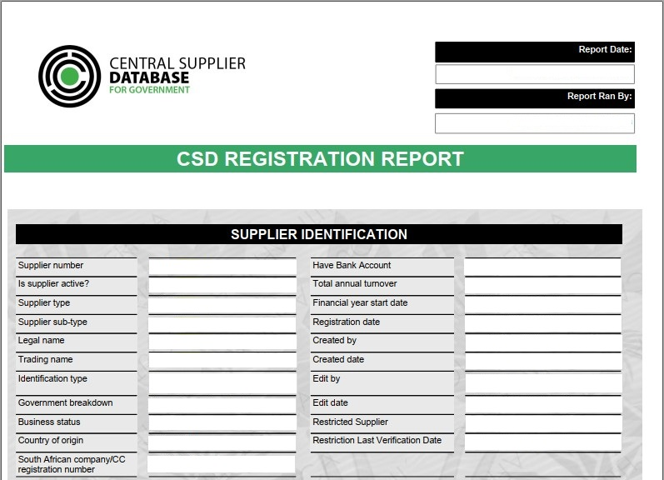

Tenderers are to include, at the back of their tender submission document, a printout of their (full) CSD Registration Report.

I, the undersigned, who warrants that they are authorised to sign on behalf of the Tenderer,
confirms that the information contained in this form is within my personal knowledge and is to the best of my belief both true and correct, and that the requested documentation has been included in the tender submission.
NAME (Block Capitals): |  | Date
SIGNATURE: |  | Date

ELIGIBILITY: EXPERIENCE OF TENDERER

This form is to be copied and used for each submission of experience, as may be required.

Where options are provided ( * ), only one (1) selected option should be clearly marked with an “ X “.

Tenderer’s CIDB Grade: | 1* | 2* | 3* | 4* | 5* | 6* | 7* | 8* | 9* | Experience as a: |  |  |  |  |  |  |  |  |  |  | Sub-Contractor* |  |  |  |  |  |  |  |  |  |  |  | Main Contractor*
Client / Employer: | Entity Name:
Client / Employer: | Contact Name:
Client / Employer: | Contact Tel: |  |  |  |  |  |  |  |  |  |  |  |  |  |  |  |  | - |  |  |  |  |  |  |  |  |  |  | -
Client / Employer: | Contact Cell: |  |  |  |  |  |  |  |  |  |  |  |  |  |  |  |  | - |  |  |  |  |  |  |  |  |  |  | -
Client / Employer: | Contact email / other:
Contract Details | Contract Number:
Contract Details | Contract Title:
Contract Details | Has this Contract been completed? |  |  |  |  |  |  |  |  | Y* |  | N* |  |  |  | Commencement Date: |  |  |  |  |  |  |  |  |  | d | d |  |  | m |  |  |  | m |  |  | 2 | 0 |  | y |  | y
 |  |  |  |  |  |  |  |  |  |  |  |  |  |  |  | Completion Date  (if applicable): |  |  |  |  |  |  |  |  |  | d | d |  |  | m |  |  |  | m |  |  | 2 | 0 |  | y |  | y
Tendered Value (Contract Sum) OR Sub-Contract Value: | R |  |  |  |  |  |  |  |  | Final Contract Price  OR Final Value of Sub-Contract: |  |  |  |  |  |  |  |  |  |  |  |  |  |  |  | R
Contract Scope-of-Work  (Description of Works components) | If available in hard copy, the Scope-of-Work can be attached.  Only include the Scope-of-Work (contract description). The Specification is not required.

Tenderers are to submit the verification for each experience claimed, via the Tenderer’s Experience: Proforma Client Reference of High-Pressure Jetting, located on page 23.

I, the undersigned, who warrants that they are authorised to sign on behalf of the Tenderer,
confirms that the information contained in this form is within my personal knowledge and is to the best of my belief both true and correct, and that the requested documentation has been included in the tender submission.
NAME (Block Capitals): |  | Date
SIGNATURE: |  | Date

Failure to include the required document will make the tender submission non-responsive.

Tenderer’s Experience: Proforma Client Reference of High-Pressure Jetting

The Tenderer shall provide details on each of the previously completed projects listed as “High-Pressure Jetting” in a brown field’s environment. The Client Reference Proforma must be completed by the respective Client/s for each of the completed projects as claimed by the Tenderer. Proforma Report on the Tenderer’s Competence and Performance on a Similar Completed Project for Expression Of Interest Recommendation Purposes. The following is to be completed by the previous Client

Project Details:

Project Name :
Project Order Number :
Employer :
Value of work - total invoice : (value in R)
Yes
No
Was project in eThekwini (selected one) : or
Project Location :
Contract Duration: Completion Date:
Brief Description of the Project:

Any remarks considered necessary to assist in evaluation of the Service Provider?

NOTE TO PREVIOUS CLIENT

The project had to be successfully completed within required specifications and quality to qualify for the evaluation.

Client’s contact person: _______________________ Order №: _______________

Client Signature: _______________________ Date: ______________________

Stamp of the Project Employer

JELIGIBILITY: TENDERER HIGH-PRESSURE JETTING VEHICLE AVAILABILITY

TENDERER HIGH-PRESSURE JETTING VEHICLE AVAILABILITY SCHEDULE | Jetting Related Vehicle Registration | High-Prressure Jetting – Water Tank Capacity ≤ 3 000ℓ |  | High-Prressure Jetting – Water Tank Capacity between > 3 000ℓ to < 10 000ℓ |  | High-Prressure Jetting – Water Tank Capacity ≥ 10 000ℓ |  | All claimed vehicle availability must be accompanied with the Log Book. Failure to include the required log book will make the eligibility for tenderer high-pressure jetting vehicle availability submission non-responsive
TENDERER HIGH-PRESSURE JETTING VEHICLE AVAILABILITY SCHEDULE | Jetting Engine Size  (≥ 4 cylinder: Diesel) | High-Prressure Jetting – Water Tank Capacity ≤ 3 000ℓ |  |  |  | High-Prressure Jetting – Water Tank Capacity ≥ 10 000ℓ
TENDERER HIGH-PRESSURE JETTING VEHICLE AVAILABILITY SCHEDULE | Jetting Machine – Model | High-Prressure Jetting – Water Tank Capacity ≤ 3 000ℓ |  |  |  | High-Prressure Jetting – Water Tank Capacity ≥ 10 000ℓ
TENDERER HIGH-PRESSURE JETTING VEHICLE AVAILABILITY SCHEDULE | Jetting Machine – Make | High-Prressure Jetting – Water Tank Capacity ≤ 3 000ℓ |  |  |  | High-Prressure Jetting – Water Tank Capacity ≥ 10 000ℓ

I, the undersigned, who warrants that they are authorised to sign on behalf of the Tenderer,
confirms that the information contained in this form is within my personal knowledge and is to the best of my belief both true and correct, and that the requested documentation has been included in the tender submission.
NAME (Block Capitals): |  | Date
SIGNATURE: |  | Date

PART E3 : INDICATIVE SCOPE OF WORK

PAGE

E 3.1 STANDARD SPECIFICATIONS 26

E 3.2 PROJECT SPECIFICATIONS 28

E 3.3 PARTICULAR SPECIFICATIONS 33

E 3.4 LOCALITY PLAN 34

E3.1 STANDARD SPECIFICATIONS

E3.1.1 The Specifications on which this Expression Of Interest is based are the eThekiwini Municipality’s (City of Durban) Standard Engineering Specifications (hereafter referred to as the Standard Engineering Specifications). This document is obtainable separately, and Tenderers shall obtain their own copies of the applicable Sections.

Part | Description | Date of Issue
AB | General Specifications | July | 1992
B | Site Clearance | March | 1990
C | Concrete Work | February | 1987
DA | Earthworks: Bulk | January | 1985
DB | Earthworks for Pipe Trenches | July | 1992
DC | Earthworks for Concrete Lined Canals
DD | Earthworks for Structures
EA | Lime Stabilisation
EB | Graded Crushed Stone | December | 1988
EC | Cement Treated Graded Crushed Stone | December | 1988
ED | Road Asphalt | July | 1992
EE | Pre-coated Stone Chippings
EF | Kerbs and Haunches | July | 1992
EG | Sidewalks, Footpaths and Median Areas | July | 1992
EH | Steel Guardrails & Conc. Median Barriers
EJ | Concrete Interlocking Block Surfaces
EK | Waterbound Macadam Base
EL | Dumprock Subgrade Improvement
EM | Concrete Surface to Roads
EN | Slurry Sealing
EP | Single Seal Surface Treatment
F | Protection Works | July | 1992
G | Pre-stressing
H | Reinforced Earth
J | Piling
K | Bearings
L | Structural Work
PB | Pavement Layers of Gravel Material
PC | Stabilisation of Gravel Base
PD | Surface Treatment: Modified Binder
PE | Pressure Pipelines: Steel
PF | Pressure Pipelines: Other Than Steel
PG | Non Pressure Pipelines and Pc Culverts | July | 1992
PH | Manholes and Appurtenant Drainage Works | July | 1992
PJ | Pipe Jacking
PG | Lateral Support Systems
PS | Pump Stations: Sewage
S | Reinstatement | March | 1993
TA | Road Signs | October | 1989
TB | Road Markings | October | 1989

C3.1.2 AMENDMENTS TO THE STANDARD SPECIFICATIONS

Introduction

In certain clauses the standard, standardized and particular specifications allow a choice to be specified in the project specifications between alternative materials or methods of construction and for additional requirements to be specified to suit a particular contract. Details of such alternative or additional requirements applicable to this contract are contained in this part of the project specifications. It also contains additional specifications required for this particular contract. The number of each clause and each payment item in this part of the project specifications consists of the prefix PS followed by a number corresponding to the number of the relevant clause or payment item in the standard specifications. The number of a new clause or payment item, which does not form part of a clause or a payment item in the standard specifications and which is included here, is also prefixed by PS, but followed by a new number which follows on the last clause or item number used in the relevant section of the standard specifications.

PSOAB Over Pumping and Bagging
The flow of sewage must be maintained at all times and the Contractor must make his own arrangements for any bypassing, over-pumping and vetter bagging of the sewer line. This will include all resources and equipment that is deemed necessary for the maintaining of sewer flows at all times. Further precautions should be taken to ensure that sewer flow control operations do not cause flooding or damage to public or private property. If over pumping is considered advantageous, the pumping system employed shall have a high degree of reliability and a backup pump must be readily available. Precautions must be taken to prevent sewer line from damage that may be caused by surcharging. At no time shall any sewer pipe be subjected to a pressure greater than 0.05 bar. The contractor will only be allowed to over pump outside the normal working hours if the equipment to be used is in keeping with the standard noise requirements (not exceed 50 decibels) or as set out in the SABS code of practise for noise pollution. Any accidental spillage or discharge must immediately be treated with an approved disinfectant and the affected area cleaned up in a manner approved by the Employers Representative. All major spills must be reported to the Engineer.

In addition, this contract will also contain various references to clauses from the SABS 1200 Standardised Specifications, the following standardised specifications shall apply:
SABS 1200 A : General
SABS 1200 C : Site Clearance
SABS 1200 DB : Earthworks (Pipe Trenches)
SABS 1200 DM : Earthworks (Roads and sub grade)
SABS 1200 GA : Concrete (Small works)
SABS 1200 L : Medium Pressure Pipelines
SABS 1200 LB : Bedding (Pipes)
SABS 1200 LD : Sewers
SABS 1200 LE : Stormwater Drainage
SABS 1200 LF : Erf Connections
SABS 1200 MM : Ancillary Roadworks

E 3.2 PROJECT SPECIFICATIONS

E 3.2.1 Scope of work
eThekwini Municipality (Water and Sanitation Unit : Sanitation Operations Department) invites expressions of interest for the City’s high-pressure jetting program for ReActive and ProActive, for a period of six months, which will be as and when required, and will utilize the Alphabetic - Numeric Roster System, and bound by the rates stipulated within this Expression of Interest.

Raw sewerage is classified as a hazardous material and requires immediate attention and intervention to restore the sanitation network, back to full operational status.

The type and volume of work required and expected, necessitates the Managing Contractor to ensure that the staff are competent in dealing with working in conditions:

- with live sewer flows,
- various pipe and manhole composition, size, depth range, and location (water courses, road reserves, road carriage ways, riverbeds, river crossings, pipe bridges) and infrastructure conditional assessment;
- take into account the various avoidable and unavoidable constraints (confined spaces, private property, protest action, traffic volumes, site conditions, existing services, theft, mining, vandalism and Acts of God),
- undertake of bush/brush cutting, traffic control and/or working within private property for the sewer pipe maintenance.

The type of work required and expected, the Tenderer has the option to select to be on a single, multipile or all three database (provided the Tenderer meets the Expression of Interest document requirements. The three high-pressure jetting database are:

- High Pressure Jetting of sewers with a jetting vehicle which has a water tank capacity of ≤ 3 000ℓ (at a rate of R 3 800 per day)
(inclusive of bush/brush cutting, traffic control and/or working within private property).

and/or

- High Pressure Jetting of sewers with a jetting vehicle which has a water tank capacity between > 3 000ℓ to < 10 000ℓ (at a rate of R 4 500 per day)
(inclusive of bush/brush cutting, traffic control and/or working within private property).

and/or

- High Pressure Jetting of sewers with a jetting vehicle which has a water tank capacity ≥ 10 000ℓ (at a rate of R 5 500 per day)
(inclusive of bush/brush cutting, traffic control and/or working within private property).
The work required to be undertaken as follows:
- All jobs will be created by eThekwini Municipality’s, Water and Sanitation Unit, Sanitation Operations staff
- All jobs can only be authorized by the eThekwini Municipality’s, Water and Sanitation Unit, Sanitation Operation’s: Area Manager (Northern, Central, Western or Southern)
- The High-Pressure Jetting Contractor (obtained from the Alphabetic - Numeric Roster System, E3.2.2: described below) will undertake the high-pressure jetting of sewer at the rates indicated within this Expression of Interest
- The High-Pressure Jetting Contractor will upon receipt of the job:
- Go to job site and complete the job
- Report back to the eThekwini Municipality’s, Water and Sanitation Unit, Sanitation Operation’s: Area Manager (Northern, Central, Western or Southern) or their representative.
- After the job is completed the High-Pressure Jetting Contractor will send the invoice to the relevant eThekwini Municipality’s, Water and Sanitation Unit, Sanitation Operation’s: Area Manager (Northern, Central, Western or Southern). The invoice will include the following minimum info:
- Unique Fault number
- Job initial photo (to be taken when arrival on site)
- Fault completion photo, which must include the GPS co-ordinates and date
- Value to be paid to the High-Pressure Jetting Contractor
- Details of the high-pressure jetting. Specifics of the high-pressure jetting; staff, plant, vehicle and equipment utilized
- Municipality Representative for the Work
- Upon receipt of the invoice the relevant eThekwini Municipality’s, Water and Sanitation Unit, Sanitation Operation’s: Area Manager (Northern, Central, Western or Southern) will verify the completion of the job and the details within the invoice.

The eThekwini Municipality’s, Water and Sanitation Unit, Sanitation Operation’s: Area Manager (Northern, Central, Western or Southern) will have his/her staff undertake site visits and assessments (before, during and post work completion), to ensure the work in completed as per the specification, standards and safety factors.

E 3.2.2 Alphabetic - Numeric Roster System
The Alphabetic - Numeric listed roster system will be created by the eThekwini Municipality’s, Water and Sanitation Unit, Sanitation Operation’s: Area Manager (Northern, Central, Western or Southern) based on the panel information created from this Expression of Interest, the contractors listed Alphabetic and then Numeric will be selected to undertake high-pressure jetting of sewer at the rates indicated within this Expression of Interest.

This roster system will enable a fair, equitable and transparent allocation of projects. The contractors will be on a rotational basis.
E 3.2.3 The High Pressure Jetting Specifications
High-Pressure Jetting Machine Required Specifications | Details - Technical | Requirements and Conditions
Water capacity range | ≤ 3 000 ℓ | Blockage Clearance
Water capacity range | > 3 000 ℓ < 10 000 ℓ | Blockage Clearance - primarily
Water capacity range | ≥ 10 000 ℓ | Blockage Clearance and/or Cleaning/Flushing
Rates per day for the High-Pressure Jettting per Water Tank Capacity | ≤ 3 000 ℓ | R 3 800 per day
 | > 3 000 ℓ < 10 000 ℓ | R 4 500 per day
 | ≥ 10 000 ℓ | R 5 500 per day
Flow rate range | 80 - 270 ℓ/min | Dependent on HP operation required
Pressure range | 80 - 340 bars | Measured at the nozzle - factors that will determine the appropriate pressure to be used will be a combination of what HP jetting operation is to be undertaken i.e., blockage clearance and/or cleaning, as well as knowing the size of pipe and condition of the pipe.  NB. in the event of not knowing the condition of the pipe a pressure of 130 bar is not to be exceeded for all pipe materials and 100 bar is not to be exceeded for pitch fibre pipe
Hose Diameter | 19mm - 25mm | Internal diameter
Minimum hose length | 120m | On hydraulically activated hose reel
Extension hose | 100m | If required - to be included in all inclusive rate
Pressure gauge | 1no. | Required at the pump
Minimum type of jetting heads required | Retro-jet, grenade bomb, sand/sludge removal nozzle, penetrating nozzle (forward blaster) | Or similar approved.  All jetting heads are to be compatible with the pressure and flow characteristics of the jetting unit. Other required small tools and equipment to be included in all inclusive rate
Size of sewer lines to be cleaned | Varies  (150mm - 1 350mm) | Size range of sewer infrastructure within eThekwini
Pipe material & condition | Unknown | Maximum pressures not to be exceeded as detailed under Pressure range conditions.  NB. If jetting operations necessitate the increase in pressure required to remove a blockage when the pipe condition and material has not been established, then the supt is to be notified prior to increasing the pressure
Water Cap and Tap Meter Number | Required | Meter number to be filled on daily maintenance form
Registration Number of vehicle | Required | Registration Number to be filled on daily sewage maintenance job card – see annexure?
Communication | Required | Provision of cell phone to supervisor to effect communication with EWS Control and Supt - to be included in all inclusive rate
Preferred Method/Sequence of Work | The appropriate working pressure is to be chosen dependent on the type of jetting head/heads required for the blockage clearance and cleaning/flushing of the line, structural condition of the pipe (if known) and pipe material (if known) - refer to "pressure range" info above. | Where possible, jetting operations are to undertake ideally from the downstream manhole jetting up towards the upstream manhole. The jetting head is to be kept moving at all times in order to not cause damage to the pipe wall.  Once the jetting head has passed through the blockage, a steady rewind rate of 100-200mm/s should be maintained to ensure effective cleaning.  It is important to note what debris is being washed back in order to determine if a different jetting head is required for example where fats/grease appear in the debris, a specific jetting head for this can then be used.  Once a blockage has been removed, a material specific jetting head, can be used to clean the pipe if necessary. If blockage removal cannot be achieved from the downstream manhole, then operations may need to be carried out from the upstream manhole.  Care must be taken when releasing the hose/jetting head into the manhole as the equipment itself may damage the manhole/pipe which could be filled with backed up flow.  The operator should be using a jetting head with a single forward-facing jet in addition to the rear facing jets during this type of operation.  Care must be taken during jetting operations not to allow the jetting head to embed itself too far and too tightly in the blockage.  The jetting head should be gradually worked into the blockage breaking it up into smaller pieces reducing the likelihood of the jetting head/hose being trapped in material that could reform another blockage.  Care must be taken to avoid this type of scenario. For flushing/cleaning operations in general, the sequence of work should start with the manholes at the highest section of the line (multiple manholes and segments of pipe) working down towards the lowest section of the line.
Removal of sand/silt/debris during HP jetting operations | Required | Provision of approved traps/debris baskets must be used in downstream manholes to prevent the transportation of sand/silt and debris past the downstream manhole. Sand/silt/debris to be placed in approved watertight container/waterproof bags which will be allowed to be stored on site for the duration of a workday but must be transported and disposed of at a hazardous skip located at a designated Wastewater pump station within the operational area that you are working in (may need to increase current no. of skips) at the end of each workday. No sand/silt/debris will be allowed to remain on site. Costs for this is to be included in the all-inclusive rate.
Road signage and traffic control | Required | Where necessary and inaccordance with "Safety at Roadworks in Urban Areas - Site Manual" - to be included in all inclusive rate
Recording and reporting | Require | To be completed and submitted on a daily basis by the appointed contractor to the employers agent
Supporting specification | WRC Sewer Jetting Code of Practice, 2nd Edition | In addition to the requirements detailed in this particular specification, it is expected that the successful tenderer will carry out HP jetting operations in accordance with the overall relevant requirements and recommendations of this code of practice, with particular attention and adherence to the method of working for drain and sewer cleaning, recommended pressures and minimum flow rates, hold time and health & safety general information/guidance
Minimum crew size | One supervisor and two assistants | Suitably qualified with relevant experience required by all staff
Location | Northern, Central, Western, Southern | Within the eThekwini Municipality boundary

E 3.2.4 Sewer Working Conditions
Contractors must ensure that their staff are competent in dealing with working in conditions with live sewer flows, over pumping, diversions and/or bypass and siphons, etc.

E 3.2.5 Disposal of Damaged Infrastructure and Project Debris
No indiscriminate spoiling of material will be allowed. All surplus or unsuitable material shall be spoiled in designated areas as directed by the Employers representative.

E 3.2.6 Project Photographs
The High-Pressure Jetting Contractor will be require to provide good quality colour photographs for the project before, during and after as directed by the Employers reperesentative; who will also stipulate the quantity of photographs for each phase.

E 3.2.7 Collusion
Any form of collusion, corruption or bribery between the Contractor and eThekwini staff will immediately result in the Contractor being disqualified.

E 3.3 PARTICULAR SPECIFICATIONS

In addition to the Standardized and Project Specifications the following Particular Specifications / Policies shall apply to this contract and are available on web address: ftp://ftp.durban.gov.za/cesu/StdContractDocs/:

Part AH - OHSA 1993 Safety Specification
(26 Pages)

Standard Environmental Management Plan for Civil Engineering Construction Works
(24 Pages)

E 3.4 LOCALITY PLAN

E 3.4.1 eThekwini Municipality highlighting 4 Sanitation Zones (North, Central, West, and South)
E 3.4.2 eThekwini Municipality Northern Sanitation Zone
E 3.4.3 eThekwini Municipality Central Sanitation Zone
E 3.4.4 eThekwini Municipality Western Sanitation Zone
E 3.4.5 eThekwini Municipality Southern Sanitation Zone

E 3.4.1 eThekwini Municipality highlighting 4 Sanitation Zones (North, Central, West, and South)

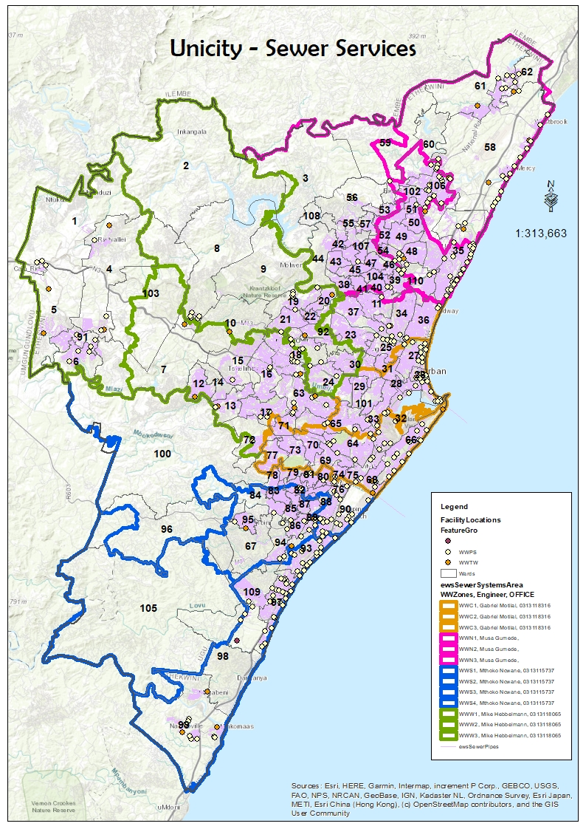 E 3.4.2 eThekwini Municipality Northern Sanitation Zone

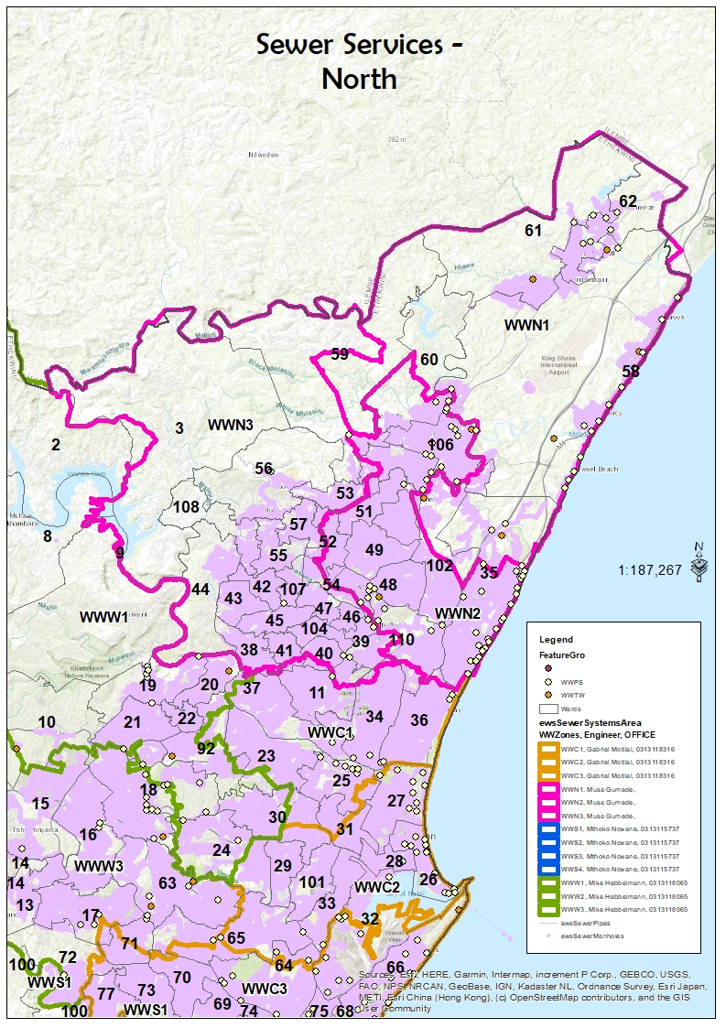 E 3.4.3 eThekwini Municipality Central Sanitation Zone

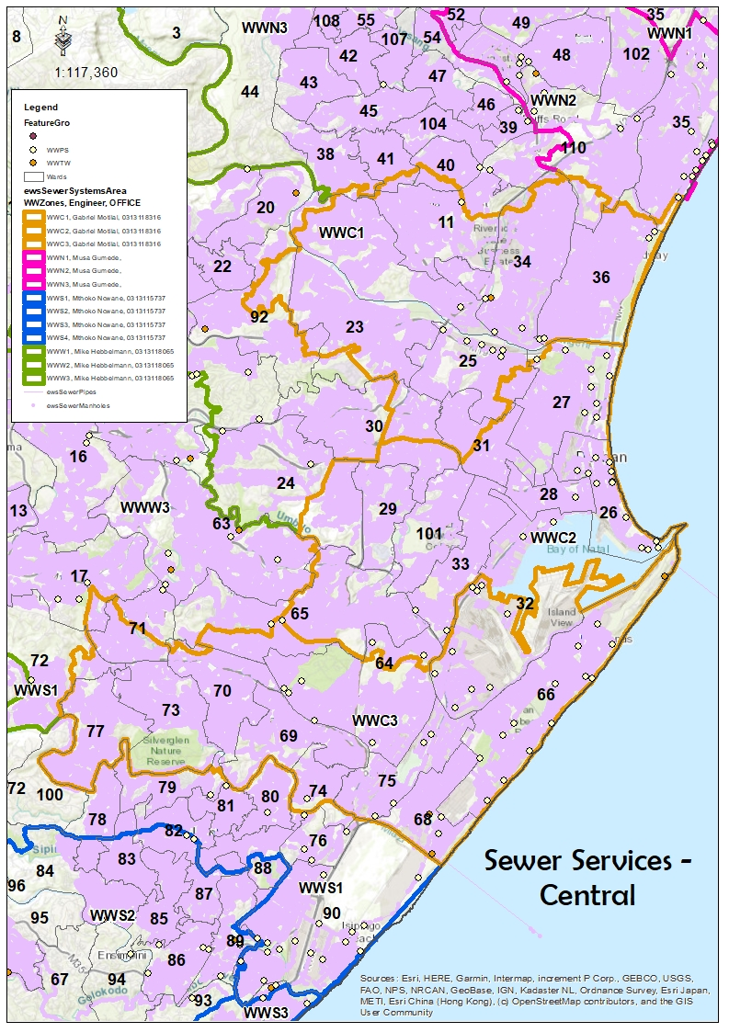
E 3.4.4 eThekwini Municipality Western Sanitation Zone

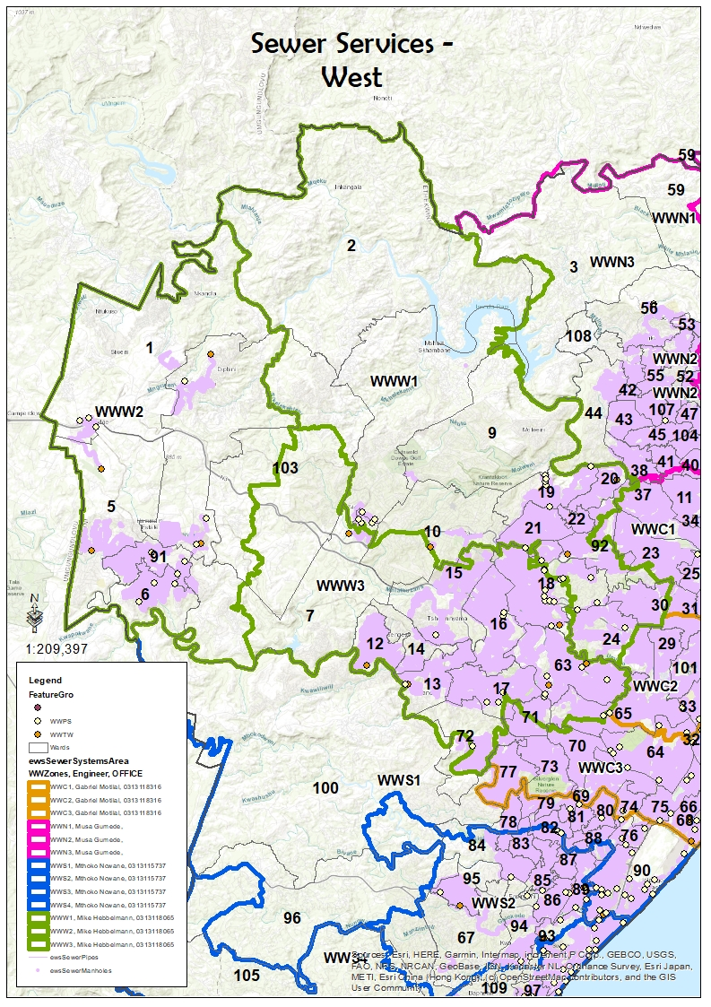
E 3.4.5 eThekwini Municipality Southern Sanitation Zone

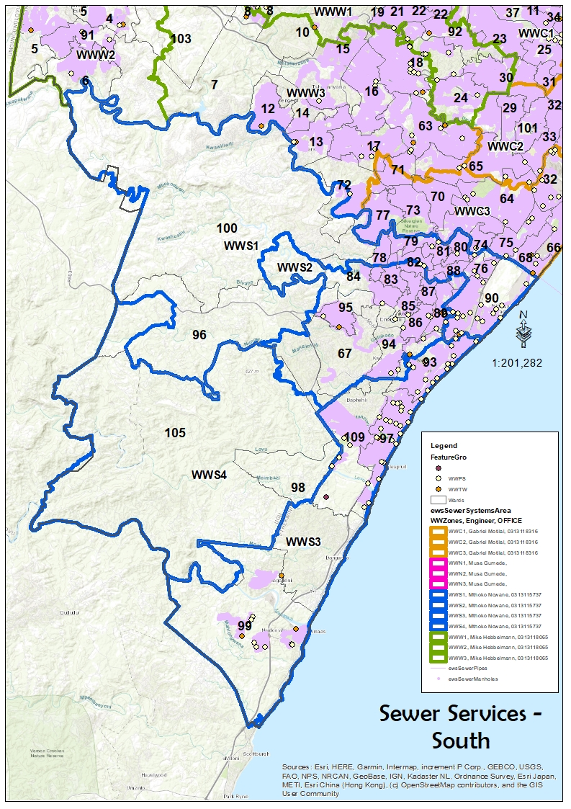

The End

Creation of a High-Pressure Jetting Contractor Panel for the Sanitation Operations Department for a period of 3 months, as and when required

