ENOCH MGIJIMA LOCAL MUNICIPALITY
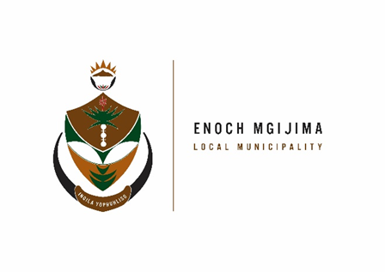
TENDER NOTICE

PROJECT NAME | TENDER NUMBER | CLOSING DATE | DOCUMENT PRICE | PPPFA | ENQUIRIES
CALL FOR PROPOSALS FROM THE PRIVATE DEVELOPERS TO PARTNER WITH THE MUNICIPALITY FOR THE DEVELOPMENT OF HUMAN SETTLEMENT PROGRAMMES OVER A PERIOD OF TEN (10) YEARS | SCM25/05/2024 | 18 June 2024 | R300.00 | 80/20 | SCM Related: Ms. AMagqaza  Tel No: 045 807 2090  Email Address: AMagqaza@enochmgijima.gov.za  Technically Related: Ms.A Mayeza  Tel No: 045  Email Adress: AMayeza@enochmgijima.gov.za

The PPPFA act No.5 of 2000 and the New amended regulations of 2022 effective as from the 16 January 2023 as per gazette No. 47452 is scheduled as follows:
PPPFA – |  | 80/20
PRICE – |  | 80 Points
BBBEE – |  | 10 Points
SPECIFIC GOALS - |  | 10 Points
 | 55
Banking details
: Acc Name: Enoch Mgijima Local Municipality
Bank :FNB
Acc No :62438159809
Acc Type :Cheque
Branch Code : 250655 (internet Banking)
Ref : 3010142551022
Bid documents containing detailed terms of reference will be available as from 17 May 2024 ; 08h00 - 16h00 week days, from the Supply Chain Management offices: Budget and treasury offices at No. 25-27 Owen Street; Queenstown upon payment of a non–refundable fee (either in cash or by means of an EFT made payable to the Enoch Mgijima Local Municipality) . Completed bid documents are to be place in a sealed envelope clearly marked the Bid number and Project Name and must be deposited in a bid Box situated at Budget and treasury offices at No. 25-27 Owen Street; Queenstown no later than 12h00pm on the closing date at which all bids will be opened in public
More details about the advert contact Ms. A Magqaza (045 807 2090)
Issued By

A NTENGENYANE KOMANI HOSPITAL
MUNICIPAL MANAGER N6 ROUTE
KOMANI

