Classification | Clarification to Tender Documents |  | Date | 14 April 2025

For Attention | All Tenderers |  | Clarification No. | 1

From | Procurement & Supply Chain Management |  | Contact number  and details | 017 749 5408

Subject | Sulphur Trioxide Plant at Tutuka Power Station within a period of 18 months after tender award

No. | Question | Answer
1. | We see E-tendering option is removed from the Eskom bulleting website; can you please advise us on where we can register our company to e-Tendering.  Please refer to below screenshot:  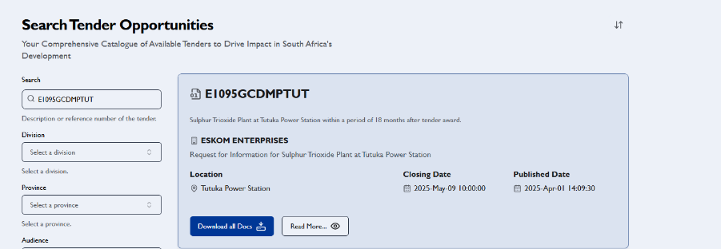  Your prompt response will be appreciated. | The issue is resolved, the respond to Request for Information (RFI) to be responded on e-tendering.

