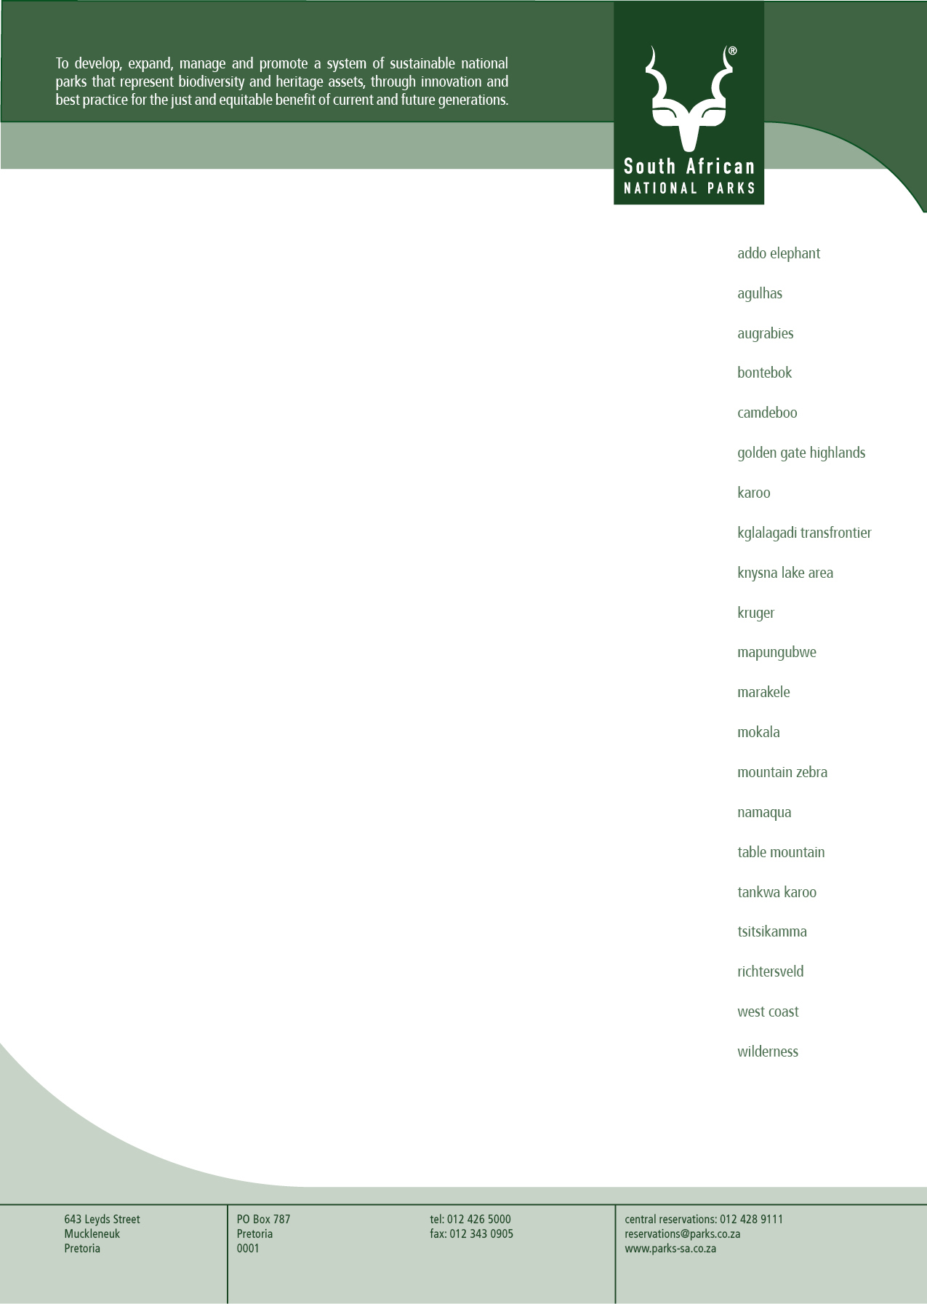

NOTICE OF EXTENSION OF BID VALIDITY PERIOD

TO : POTENTIAL BIDDERS

FROM : FHATUWANI MATSHILI
MANAGER: SCM TENDERS - KNP

SUBJECT : REQUEST FOR APPROVAL TO EXTEND VALIDITY PERIOD FOR THE FOLLOWING TENDERS:

Please refer to the table below for the new proposed expiry dates of the relevant tenders:
Nr | Description | Bid number | Closing date | Expiry date | Extended validity expiry date | New/Extended validity expiry date | New extended validity expiry date
1 | Road Construction, Rehabilitation and Maintenance in The Kruger National Park on an “as and when” Required Basis for a Period of Five (5) Years. | KNP-014-23 | 30 April 2024 | 05 March 2025 | 03 June 2025 | 01 September 2025 | 30 November 2025
2 | Appointment of panel of service provider(s) for the supply and delivery of electrical ware/material on an as and when required for the period of five (5) years. | KNP-016-23 | 09 May 2024 | 05 March 2025 | 03 June 2025 | 01 September 2025 | 30 November 2025
3 | Appointment of service provider/s for the supply and delivery of plumbing ware/material/parts on an as and when required for the period of five (5) years. | KNP-002-24A | 31 July 2024 | 26 February 2025 | 27 May 2025 | 25 August 2025 | 23 November 2025
4 | Appointment of panel of service provider/s for the supply and delivery of building material and paint on an as and when required for the period of five (5) years. | KNP-009-24A | 29 October 2024 | 26 February 2025 | 27 May 2025 | 25 August 2025 | 23 November 2025
5 | Appointment of panel of service providers to supply and deliver laundry chemicals, cleaning chemicals, cleaning equipment and hygiene products “on an as and when required” at Kruger National Park for the period of five (5) years. | KNP-010-24A | 26 November 2024 | 26 March 2025 | 24 June 2025 | 22 September 2025 | 21 December 2025
6 | Appointment of panel of service providers to supply and deliver refrigeration spare parts in the Kruger National Park on an as and when required basis at Kruger National Park for the period of five (5) years. | KNP-015-23 | 31 July 2024 | 26 February 2025 | 27 May 2025 | 25 August 2025 | 23 November 2025
7 | Appointment of a service provider to supply, deliver and service 4x tractors; 4x grader blades and 4x trailers at Kruger National Park for a period of three (3) years. | KNP-016-24A | 19 Mar 2025 | 17 July 2025 | 15 October 2025
8 | Appointment of a service provider for the supply and delivery of energy efficient water heating systems ware/material parts on an as and when required for the period of five (5) years. | KNP-017-24 | 16 May 2025 | 13 September 2025 | 12 December 2025
9 | Appointment of a service provider for the maintenance refurbishment retrofitting and new installation of energy efficient water heating systems, as and when required for the period of three (03) years with an option to extend max two (02) years. | KNP-018-24 | 16 May 2025 | 13 September 2025 | 12 December 2025
10 | Appointment of a service provider for upgrade and maintenance for a two-way radio & microwave system network in the Kruger National Park for a period of 3 years with an option to extend for an additional two (2) years, subject to supplier performance. | KNP-019-24A | 09 May 2025 | 06 September 2025 | 05 December 2025
11 | Appointment of a panel of electrical contractors for maintenance and servicing of electrical infrastructure as and when required in the Kruger national park for the period of five (5) years. | KNP-020-24A | 05 May 2025 | 02 September 2025 | 01 December 2025
12 | Appointment of a service provider for the development and implementation of ISO 45001 and 14001 for Kruger National Park for the period of three (3) years. | KNP-021-24A | 22 April 2025 | 20 August 2025 | 18 November 2025
13 | Appointment of a service provider for the development and implementation of ISO 31001 for Kruger National Park for the period of three (3) years. | KNP-022-24A | 22 April 2025 | 20 August 2025 | 18 November 2025
14 | Appointment of service provider for the supply, delivery and installation of diesel generators in the Kruger National Park for the period of five (5) years as and when required. | KNP-023-24A | 06 May 2025 | 03 September 2025 | 02 December 2025
15 | Appointment of a panel of service providers for general renovation, upgrading and smaller building works in the Kruger National Park “as-and-when-required basis for a period of five (5) years. | KNP-024-24 | 28 May 2025 | 25 September 2025 | 24 December 2025
16 | Appointment of a service provider for the installation, integration, monitoring and maintenance of automatic number plate recognition (ANPR) in the Kruger National Park for a period of five (5) years. | KNP-026-24 | 12 Jun 2025 | 10 October 2025 | 08 January 2026

Bidders are required to download EXTENSION OF TENDER VALIDITY document/file attached under each tender description and return the signed copy to Mr. Fhatuwani Matshili @ fhatuwani.matshili@sanparks.org

For any questions regarding this submission, please contact Fhatuwani Matshili on (013) 735 4311 or fhatuwani.matshili@sanparks.org

Compiled by

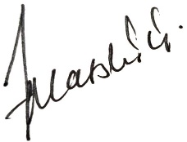
__________________________________
Name: Fhatuwani Matshili
Designation: Manager Tenders: KNP

