TRANSNET FREIGHT RAIL


Facility Profile:
Orchards

ANNEXURE A: FACILITY profile

Corridor | Location | Siding Name | Siding Size (SQM) | Wagons per Shunt | Siding Capacity (TEU per annum)
Cape Corridor | Orchard | Orchard S/100579 | 21 893 sqm | 36 Wagons | 40 000

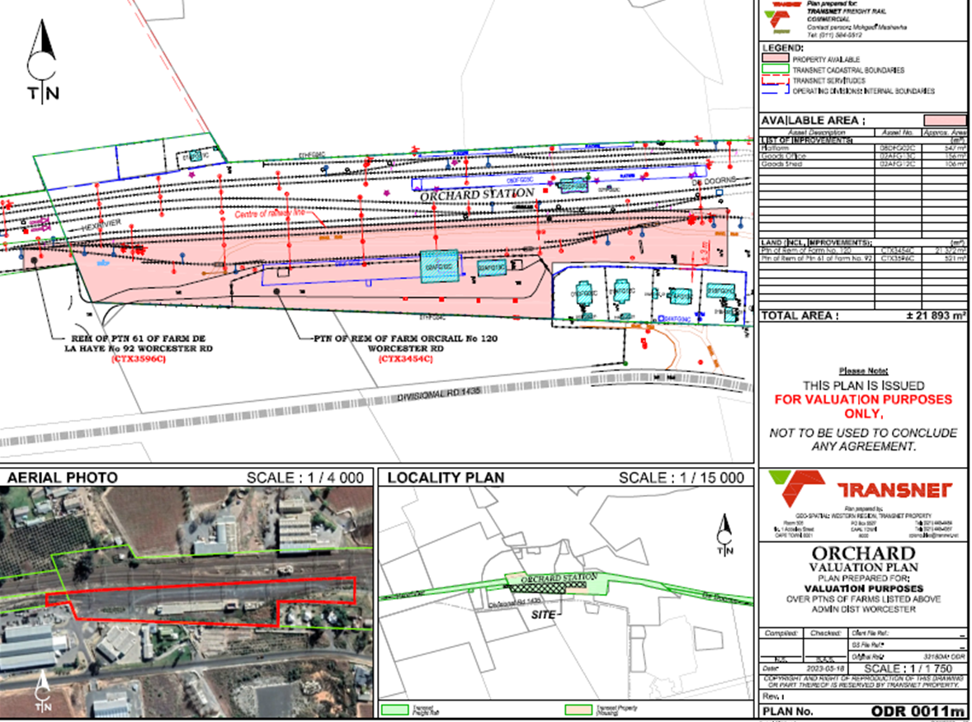

- Rail lines
- Land for development

