FRANCES BAARD DISTRICT MUNICIPALITY

INVITATION TO BID

Frances Baard District Municipality (FBDM) hereby invites qualified service providers to submit proposals for the above-mentioned project.

This bid will be evaluated in terms of the 80/20 preference point system as prescribed in the Preferential Procurement Regulations, 2022 pertaining to the PPPF Act (No 5 of 2000) and the Supply Chain Management Policy of Frances Baard District Municipality. FBDM is not bound to accept the lowest bid. FBDM reserves the right to partial acceptance of one or more bids.

The closing date for submissions is 03 May 2023 at 12h00. Bids will be opened in public immediately after the stated closing time.

Proposals should be clearly marked: BID 23/22: TRAINING ON BUSINESS ADMINISTRATION SERVICES: SAQA ID: 14338 –SAQA ID 14348 - SAQA ID 14349 - SAQA ID14351 (RE-ADVERT) and submitted to The Municipal Manager, Frances Baard District Municipality, Private Bag X 6088 Kimberly, 8300, or hand delivered to the Frances Baard District Offices: 51 Drakensberg Avenue, Carters Glen, Kimberley (for attention Mr. P. Souden).

Bid documents are obtainable at FBDM’s offices during working hours or on the FBDM Website (www.francesbaard.gov.za). Enquiries on technicalities may be directed to Ms. M. Mosala at tel. (053) 838 0911 and for supply chain matters to Mr. P. Souden at tel. (053) 838 0948 during office hours.

If no response is received in ninety (90) days after the closing date, consider your proposal unsuccessful.

MUNICIPAL MANAGER
Ms. M. Bogatsu
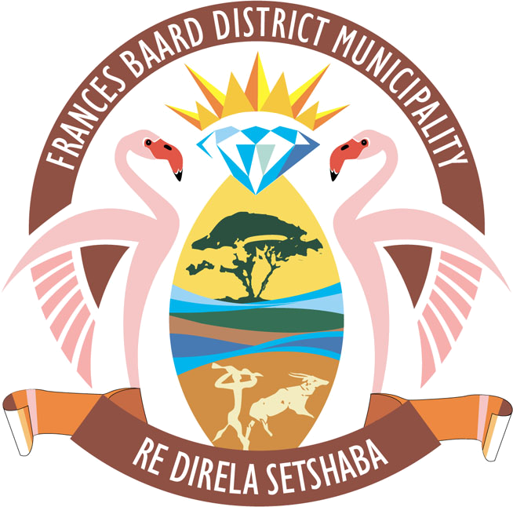

BID 23/22: TRAINING ON BUSINESS ADMINISTRATION SERVICES: SAQA ID: 14338 –SAQA ID 14348 - SAQA ID 14349 - SAQA ID14351 (RE-ADVERT)

