Specifications
2 X New Felco 822+ Tronic double battery kit electric pruning shear with power+ battery and power pack (see below)
2 x Felcotronic 820HP extension length 150
Included warranty and training
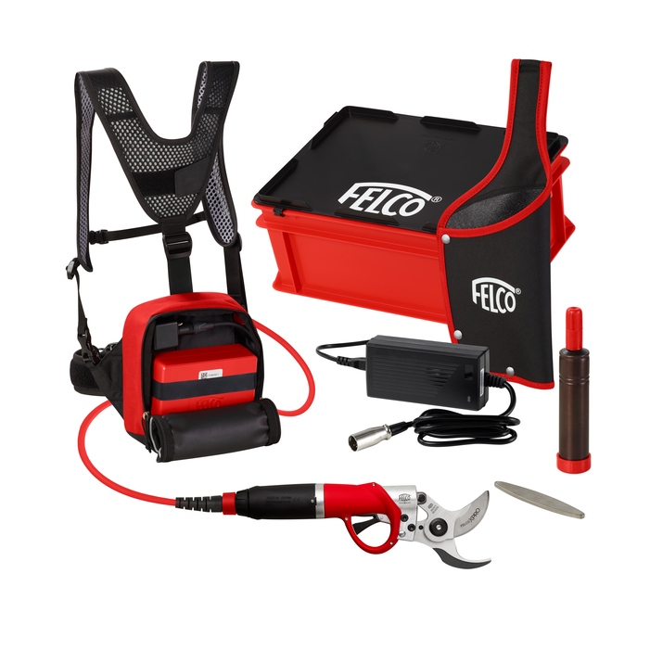
FELCO 822+
Kit electric pruning shear with Power+battery and PowerPack
D
escription
These powerful electric pruning shears cut hardwood branches up to a 45mm / 1.8inch diameter very easily, allowing you to have significant productivity gains regardless of where you work.

Plug in and power up your FELCO 882 power pack and FELCO 880/194 double capacity battery to unleash powerful clean cutting over a full day of intensive pruning. With a simple double click of the trigger you can choose between a larger or smaller cutting head opening setting to cut more efficiently and quickly through larger or smaller branches.

Understanding the performance of the FELCO 822 is as simple as reviewing the FELCO application on the display of your smart phone or tablet, the application contains all the data about your tool from number of cuts to battery life, it also allows you to manage tool settings so you can keep it operating at the highest level of efficiency.

However tough and intensive your day becomes; with this powerful tool you can just keep going and going cutting through tough wood while being sure that you will not pay a price from aches and pains once you stop.

Your battery work time is between 2 & 3 days before it will need to be charged again.
Lithium Batteries takes 180 minutes to charge from empty to full. Battery is also protected against overcharging so can be left over-night for charging.

