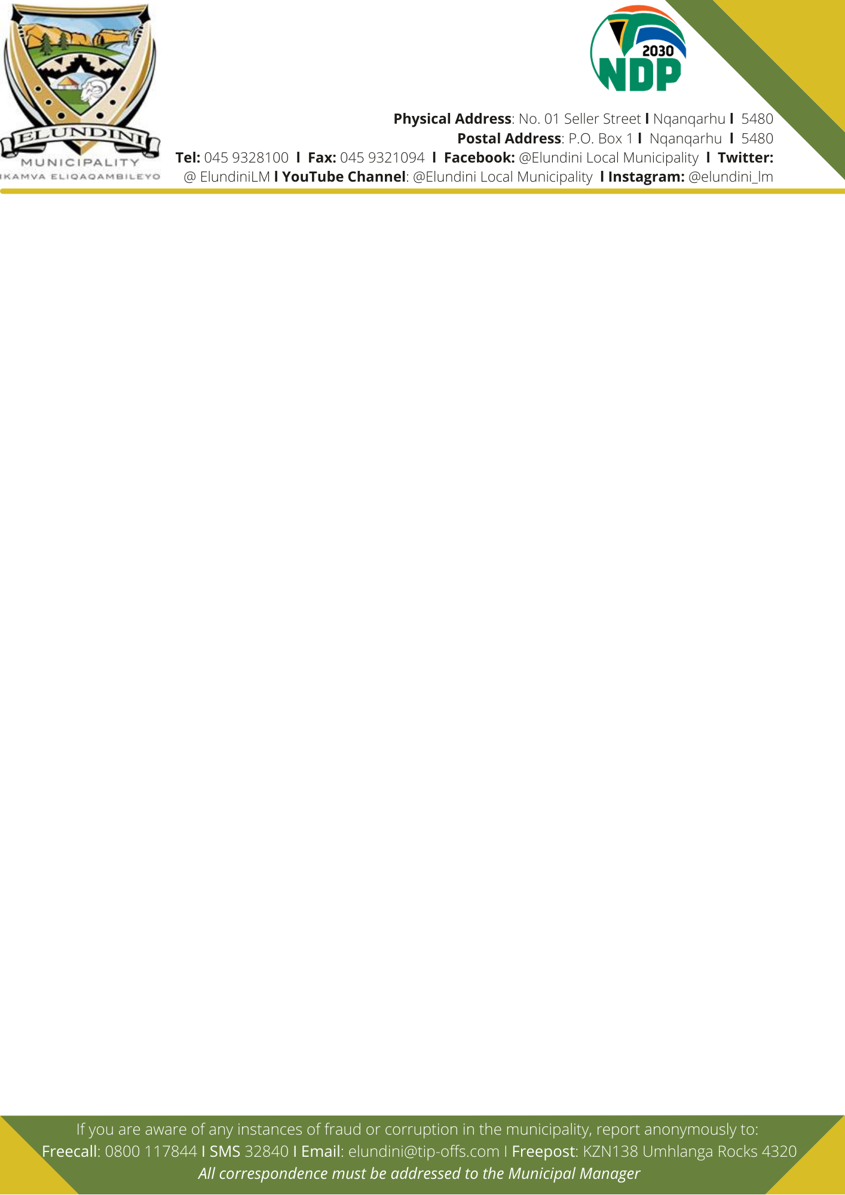


TENDER NOTICE AND INVITATION TO TENDER
The Elundini Local Municipality invites tenders from three (3) to Five (5) experienced and competent contractors for the framework contracts within Elundini Local Municipality of three (03) Years on and as when instructed without a guarantee to any quantum of work on the following construction:

PROJECT NAME | Contract Number | CIDB Grading
Electrical Network Upgrades and Maintenance | ELM-3/010/2023-2024 | Valid Grade 4EP and above
Public Lighting | ELM-3/011/2023-2024 | Valid Grade 4EP and above

Contracts will be based on the NEC3 Engineering and Construction Contract (Option B Priced contract with Bill of Quantities).
Only those tenderers who are registered with the above CIDB are eligible to tender.
Stage 1: Test for responsiveness and eligibility Criteria (Compliance, responsiveness to the bid rules and conditions, thereafter (if applicable).
Stage 2: of Evaluation – Quality
Stage 3: Price and Preference

PREFERENTIAL PROCUREMENT POLICY FRAMEWORK ACT (PPPFA) POINTS WILL BE AWARDED AS FOLLOWS:
Maximum points on price - 80 points
Maximum points for Specific Goals - 20 points
Maximum points - 100 points

NB: Specifications on evaluation criteria will be made available on municipal website and e-tender portal for bidders to test whether they qualify or not. However, it must be noted that the tender document to be submitted as the final offer will be sold as Paragraph 8 of this tender notice and invitation to tender under Purchasing and Submission of Tender Documents and ELM website: www.elundini.gov.za

Quality criteria | Maximum number of points: ELM-3/010/2022 | Maximum number of points: ELM-3/011/2023-2024
Experience of the tenderer in related scope of works | 20 | 30
Key Persons | 65 | 40
Approach paper | 15 | 30
Maximum possible score for quality (M_{s}) | 100 | 100

The minimum number of evaluation points for quality will be 70 points
The provisions of Preferential Procurement Regulations 2022 will apply.
The procedure for the evaluation of the responsive tenders will be Method 4

Note to tenderers: The tenderer must attach proof for validating points for each preference point system indicated below.
Bidder that fail to submit proof of specific goal as stipulated below will not be allocated points
The Specific Goals allocated points ELM-3/010/2023-2024 | The Specific Goals allocated points ELM-3/011/2023-2024 | Proof to claim points for specific goal
EME or QSE which is at least 51% Enterprise owned by Black people  Points = 15 | EME or QSE which is at least 51% Enterprise owned by Black people  Points = 15 | Company Registration Document and Certified BBBEE Certificate or Original Sworn Affidavit and CSD Report
Local Enterprise  Within Elundini Local Municipality = 5 Points  Within Joe Qgabi District = 3 Points  Outside region = 1 Points | Local Enterprise  Within Elundini Local Municipality = 5 Points  Within Joe Qgabi District = 3 Points  Outside region = 1 Points | Proof of business operation within the Elundini municipal Jurisdiction or within JOE Qgabi District or outside region along with CSD Report
Total Specific Goals = 20 Points | Total Specific Goals = 20 Points

PURCHASING AND SUBMISSION OF TENDER DOCUMENTS.
Tender documents may be obtained from the Elundini Local Municipality SCM Unit or emailed to a bidder upon payment of a non-refundable amount of R250 (two hundred and fifty Rand). Payment for tender document can be made either paid in cash or by means of electronic funds transfer (EFT) to the Elundini Local Municipality (Where EFT is used proof of payment must be sent to kwaneles@elundini.gov.za ). The cash amount is to be paid at the cashier’s office between the hours of 08:00 and 16:00, prior to the collection of the tender documents from the SCM unit.
NB: For EFT payment bidders must pay using this account: First National Bank (FNB) cheque account No: 62159933772, Ref No. 020114350000.
ELM Cashier’s office is situated at Elundini Traffic Department, ERF 3503 Station Street, Nqanqarhu, 5480.
The tender documents will be available on Monday, 04 September 2023
Completed bid documents and supporting documentation are to be placed in a sealed envelope endorsed with Project Name and Bid Number. At the back of the envelope bidders must write the bidder’s name and address. Bid submissions must be delivered to the Elundini Local Municipality, at No. 1 Seller Street, Nqanqarhu, Finance Department. The tender document must be placed in the Tender Box not later than 12H00 Noon on Thursday, 05 October 2023 at which time the tenders will be opened in public.
Bidders are encouraged to make electronic copies of the bid submission in a form of USB / CD as a precautionary backup. This is not compulsory.
Enquiries relating to SCM may be addressed to Ms. H Mduzulwana, Tel No. 045 932 8125 or email: hlubikazi@elundini.gov.za. Technical inquiries may be addressed to Mr. K Matubatuba on email: kanum@elundini.gov.za Tel No. 045 932 8218
Telegraphic, telephonic, telex, facsimile, e-mail and late tenders will not be accepted.
Tenders may only be submitted on the tender documentation that is issued. Requirements for sealing, addressing, delivery, opening and assessment of tenders are stated in the tender data and tender documents
The minimum specifications, other bid conditions and rules are detailed in the bid document under Tender Data. The Elundini Local Municipality SCM policy applies. Tender validity period is 12 Weeks
Tenderers must request clarification on the tender documents, if necessary, by notifying the employer at least 5 (Five) working days before the closing time stated in the tender data. No clarifications that will require issue of an addendum will be entertained after this period
FOR COMPLAINTS, FRAUD, & TENDER ABUSE: Call: 080 070 1701

______________________________
JACK MDENI
MUNICIPAL MANAGER

