DATE : 2021/12/09
REF. NO. : RPH-SPE-(3019)-21/01

TO: ALL SERVICE PROVIDERS

ADDITIONAL REQUIREMENTS TO BE SATISFIED IN ADDITION TO THOSE LISTED IN THE USER REQUIREMENT SPECIFICATIONS
RPH-SPE-3019:

DUE TO THE NATURE OF A RADIOACTIVE CELL AND THE DIFFICULTIES PRESENTED BY OPERATING EQUIPMENT UNDER SUCH CONDITIONS.

KINDLY OUTLINE BRIEF RESPONSES TO COMMONLY ENCOUNTERED CHALLENGES BY A RADIOACTIVE CELL USING THE TABLE BELOW:

THE FACILITY HAS 2 HOT CELLS AVAILABLE: CELL 8 AND 10 DIAMETERS
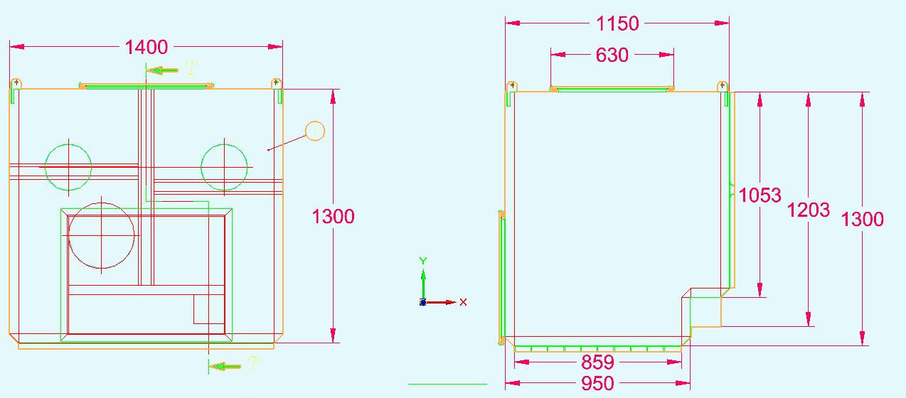

Cell 8

Cell 10
DISPENSING OVERVIEW DIAGRAM

MAINTENANCE REQUIREMENTS

Power connection:
- Only 220VAC- currently set up. What are the power requirements of your unit given the current set-up?
Maintenance Work on the Unit
- Which parts of the Unit are prone to breakdown or subject to regular maintenance taking into consideration usage of manipulators once the cell is active?

- How accessible are these part from outside the cell box?

- Ease of operation of the Unit- will be operable through the use of currently installed manipulators. See Appendix 1 (Picture of Manipulators)

Electronic components built inside the Dispensing Unit (“The Automated parts” )
- Which components of the unit will be inside the cell?

- What effects does radiation dose rate/ Humidity and Temperature changes have on these parts?

Cables and connections:
- Describe the type and size of Cables used for connecting the unit in the cell to the controls on PLC.

- Describe their resistance to radiation and ease of connection to LEMO Plugs.

Equipment run to failure
- Should any failure occur on the dispensing Unit – could we consider that the equipment will be a run to failure and it will be something that can be easily be disposed of?

THANK YOU FOR YOUR PARTICIPATION

