ANNEXURE C4.D : LOCALITY MAP

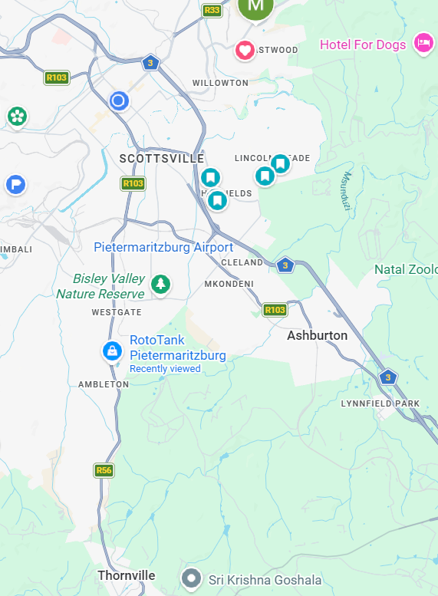
SITE 29.679990, 30.374629

CBD

