

PICTURES OF FURNITURE AT TAMBOTIE LODGE IN SCHUINSDRAAI NATURE RESERVE

ITEM NO | DESCRIPTION | QUANTITY | LOCAL CONTENT
1. | 3-Seater Couch:  - Recycled pine wood three-seater couch.  - Complete with removable cushions upholstered in polyester, with removable Grey cushion covers.  - Add: masterguard for cushion covers  - Dimensions: 2250mm (L) x 1100mm (W) x 870mm (H)  Seat Height: 410mm | Seat Depth: 560mm.  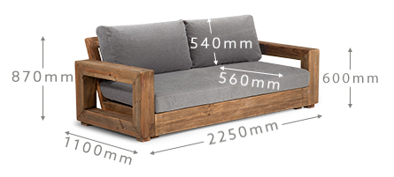 | 10 | 90%
2. | Armchair:  - Reclaimed pine wood armchair.  - Dimensions: as per the photo below this table.  - Complete with fixed upholstered back, removable seating cushion upholstered in polyester, with removable Grey cushion cover.  - Add: masterguard for cushion covers  - Dimension: 770mm (L) x 870mm (W) x 870mm (H)  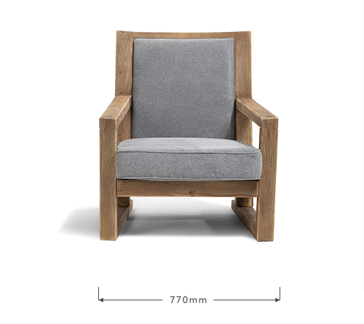  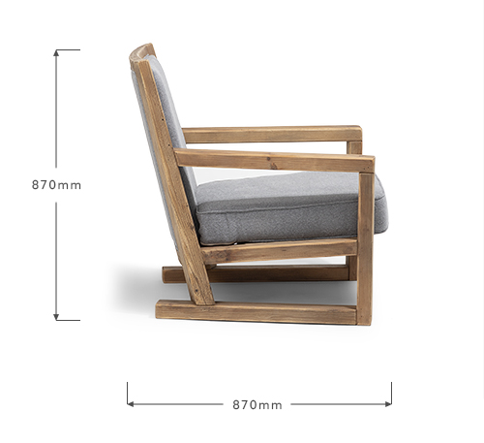 | 20 | 90%
3. | Wood Coffee Table:  - Reclaimed pine wood coffee table.  - Dimensions: 1400mm (L) x 680mm (W) x 430mm (H).  - Colour: Natural (vanished)  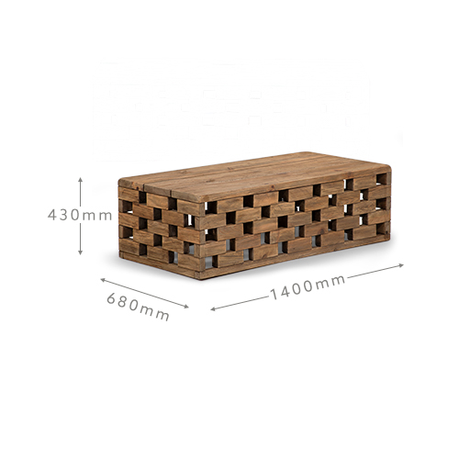 | 10 | 100
4. | Queen Size Headboard:  - Solid Acacia wood with Acacia wood veneers.  - Wire brushed for a slightly rustic, matte finish.  - Standalone queen size headboard.  - Dimensions: 1890mm (W) x 1150mm (H).  - See the photo below this table.  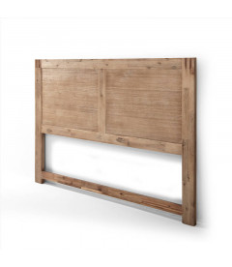 | 10 | 90%
5. | Three-Quarter Size Headboard:  - Solid wood similar to Acacia or recycled Pine.  - Wire brushed for a slightly rustic, matte finish.  - Standalone three-quarter headboard.  - Dimensions: 1070mm (W) x 1150mm (H) | 20 | 90%
6. | Wood Pedestal:  - Solid Acacia wood with Acacia wood veneers.  - Wire brushed for a slightly rustic, matte finish  - 2 Smooth-glide drawers.  - Dimensions: 550mm (L) x 420mm (D) x 590mm (H).  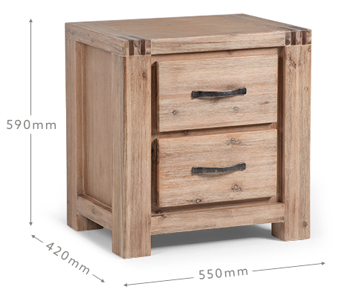 | 40 | 90%
7. | Bar Chair:  - Manufactured from Mango wood, vanished or treated for durability  - Contoured seat.  - Dimensions: 420mm (W) x 900mm (H) x 300mm (D).  - See the photo below this table.  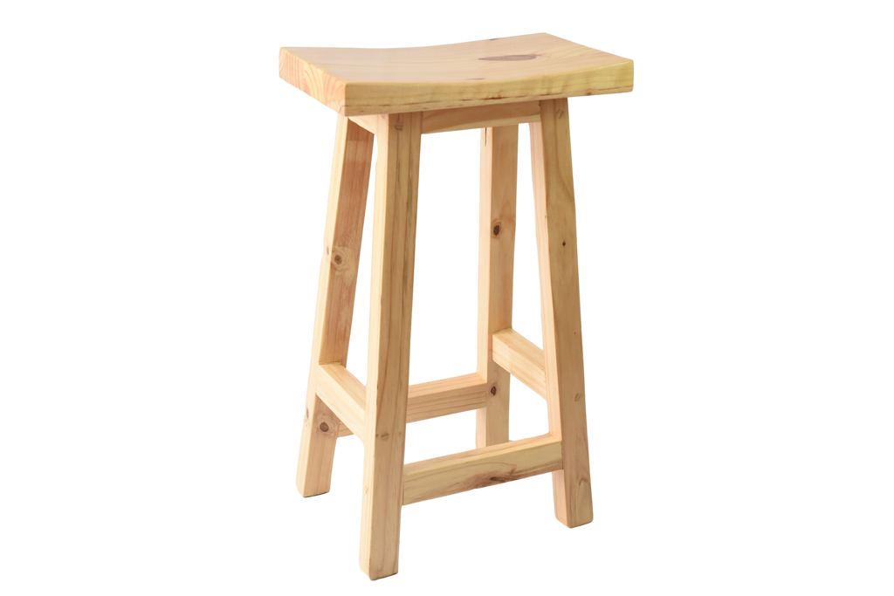 | 40 | 100%
8. | 4 Seater Table:  - 4 Seater square table  - Dimensions: 1000 x 1000 x 750mm  - Acacia or similar quality solid wood  - Colour : Dark wood stain, varnished  - Physical appearance exactly as per the example below this table.  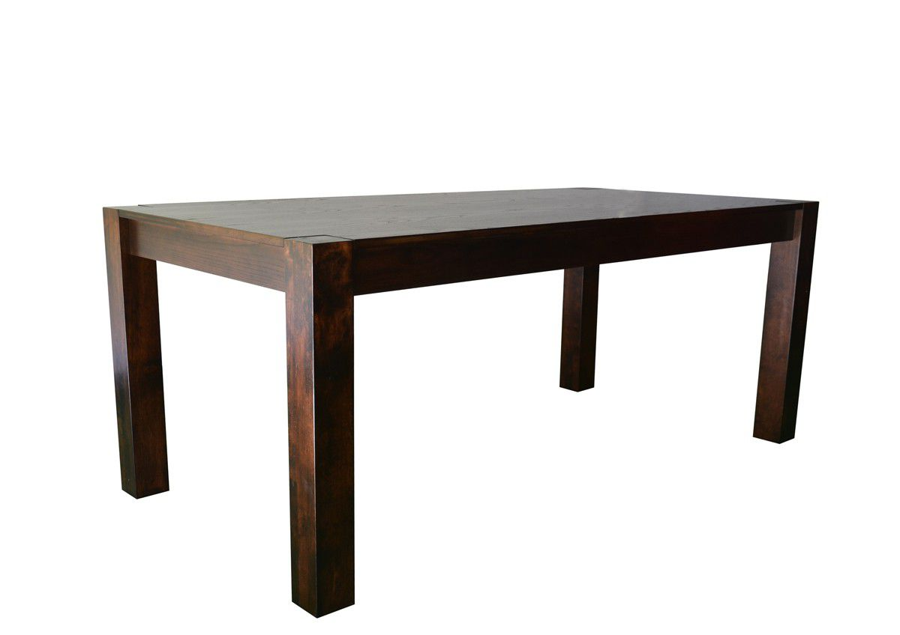 | 12 | 100%
9. | Straight leg Chair:  - Straight leg chair  - Dimensions: 420 x 420 x 1030mm  - Acacia or similar quality solid wood  - Colour : Dark wood stain, varnished  - Removable cushions and cushion cover (colour : stone)  - Add: master guard for cushion covers  - Physical appearance exactly as per the example below this table.  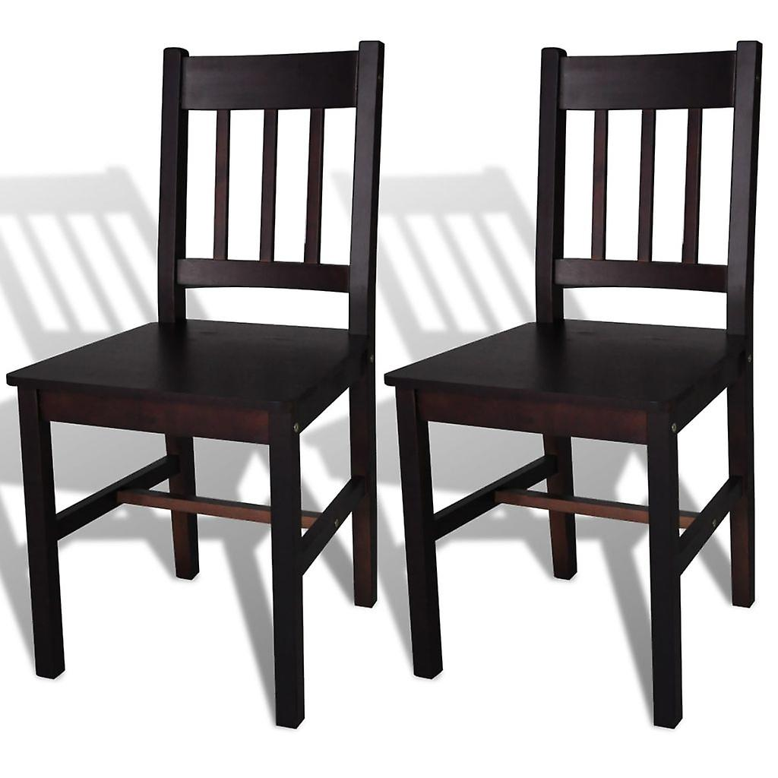 | 48 | 90%

