Request for office chairs x 24

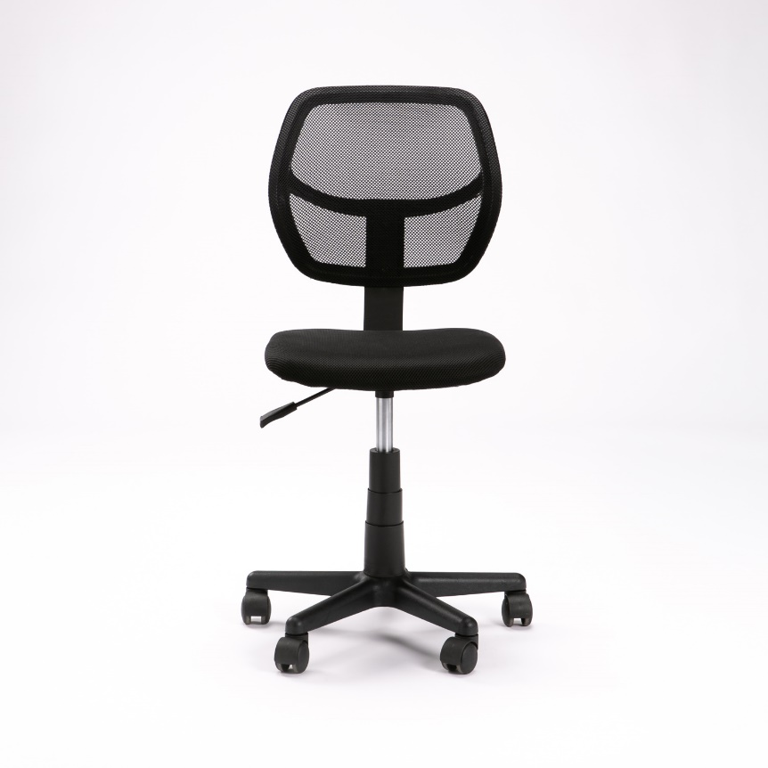

Office Desk Chair with Breathable Mesh Back-rest.
Features
- Breathable Mesh Fabric
- Padded Upholstered Cushion
- Ergonomic Seating Position
- 360 Degree Rotation
- Space Saving Office Chair
Specifications
- Material - Mesh, Plastic & Steel
- Wheels
- Gas-lift chair raising/lowering mechanism
Dimensions
- Chair width – 40cm (W)
- Chair depth – 50cm (D)
- Chair height – adjustable minimum 80cm to at least 92cm (H)
Quantity: 24

