

Tender No. | SDITCE02/NC061/09/2022
Closing Date and Time | 06 OCTOBER 2022
Description:INVITATION FOR SUPPLY AND DELIVERY INSTALLATION OF INFORMATION TECHNOLOGY EQUIPTMENT FOR ONE (1) YEAR TO BE DELIVERED TO RICHTERSVELD MUNICIPALITY
Contractor / Bidder
Bid amount | R
Physical address
Contact person
Telephone no.
Fax no.
Cell no.
Email address

CONDITIONS OF TENDER
- The prospective bidder’s attention is drawn to the following list of forms, attached to this document and other documents that shall be completed and submitted with his/her bid documents:
  - Tender Form
  - Form of Offer
  - Declaration of interest
  - Certificate of independent Bid Determination
  - An original Tax Clearance Certificate issued by the South African Revenue Services
  - A current account or proof that utilities account (municipal rates and taxes, water and lights account) of the bidder is up to date. (Not in arrears for more than 3 months).
  - Proof of registration for VAT (if applicable).
  - Valid B-BBEE Certificate
  - Central Supplier Database (CSD) Registration Number.
In terms of Section 112 (1) I of the Local Government Municipal Finance Management Act, (Act 56 of 2003), persons who were convicted of fraud or corruption or who willfully neglected, reneged on or failed to comply with a government tender during the past 5 years, or whose tax matters are not cleared by the South African Revenue Services may not participate in the tendering process and the Tenderer shall submit a sworn statement to this effect.
- The official tender form shall be completed in BLACK ink and any corrections to the official tender form must also be made in BLACK ink and signed by the bidder. Any tender documents received with correction fluid (Tippex) corrections shall be disqualified.
- Bids shall be sealed and endorsed (with bid number and bid description) and must be deposited at Richtersveld Municipality’s tender box (Cashiers office).
- Richtersveld Municipality’s Supply Chain Management Policy shall apply.
- Late, Telexed, faxed or emailed tenders will not be accepted.
- The Council does not bind itself to accept the lowest or any tender and reserves the right to accept any tender in whole or in part.
- Persons in the service of the state are not allowed to bid.
- In the event that you are awarded a tender the strict compliance with terms have to observed and in so doing within a period (3 days) (*after an order is issued) a confirmation letter must be forwarded by you in terms of which you need to indicate whether or not you will be in a position to source the items per the tender and deliver same by the due date.
- In the event that you do not furnish us with the said letter as requested and fail to comply as per the tender the Richtersveld Municipality reserves in terms of rights to cancel this tender automatically after 3 days on the basis of your non-compliance and furthermore should you fail to deliver said goods which

may necessitate the allocation of a new supplier the Richtersveld Municipality may impose any further penalty or charges against you.
- In the case where all MBD Documents are not completely filled and returned, your quotation will be disqualified.
- The 80/20 Preferential Procurement System will be used to evaluate all the Formal Written Quotations.
- Bidders must ensure that, the company status is “in business” with the Company and Intellectual Property Commission (CIPC).
- Bidders who are not registered on the Central Supplier Database are requested to contact National Treasury at csd@treasury.gov.za or 012 406 9222 for any assistance.
- Exempted Micro Enterprises can submit a letter from the accounting officer; and
- A trust, consortium or joint venture must submit a consolidated B-BBEE Status Level Verification.

Richtersveld Municipality

DOCUMENT |  | PAGE  NUMBER
INVITATION TO BID | MBD 1 | 4
CLEARANCE CERTIFICATE FOR WATER & LIGHTS |  | 8
TERMS OF REFERENCE/SPECIFICATIONS |  | 9
PRICING SCHEDULE – FIRM PRICES (PURCHASES) | MBD 3.1 | 15
DECLARATION OF INTEREST | MBD 4 | 16
PREFERENCE POINTS CLAIM FORM | MBD 6.1 | 19
CONTRACT FORM – PURCHASE OF GOODS | MBD 7.1 | 25
DECLARATION OF BIDDER’S PAST SUPPLY CHAIN MANAGEMENT  PRACTICES | MBD 8 | 27
CERTIFICATE OF INDEPENDENT BID DETERMINATION | MBD 9 | 31
FORM OF OFFER AND ACCEPTANCE |  | 38
CREDIT ORDER INSTRUCTION |  | 38

CT4

MBD 1
INVITATION TO BID
YOU ARE HEREBY INVITED TO BID FOR REQUIREMENTS OF THE RICHTERSVELD MUNICIPALITY
BID NUMBER: | SDITCE02/NC061/09/2022 | CLOSING DATE: |  | 06 OCTOBER 2022 |  |  | CLOSING TIME: |  | 12H00
DESCRIPTION | INVITATION FOR SUPPLY DELIVERY AND INSATALLATION OF INFORMATION TECHNOLOGY EQUIPTMENT FOR ONE (1) YEAR TO BE DELIVERED TO RICHTERSVELD MUNICIPALITY
THE SUCCESSFUL BIDDER WILL BE REQUIRED TO FILL IN AND SIGN A WRITTEN CONTRACT FORM (MBD7).
BID RESPONSE DOCUMENTS MAY BE DEPOSITED IN
THE BID BOX SITUATED AT (169 MAIN ROAD, PORT NOLLOTH, 8280)
MUNICIPAL BUILDING
CASHIERS OFFICE
PORT NOLLOTH
8280
SUPPLIER INFORMATION
NAME OF BIDDER
POSTAL ADDRESS
STREET ADDRESS
TELEPHONE NUMBER |  |  | CODE |  |  | NUMBER
CELLPHONE NUMBER
FACSIMILE NUMBER |  |  | CODE |  |  | NUMBER
E-MAIL ADDRESS
VAT REGISTRATION
NUMBER
TAX COMPLIANCE STATUS |  |  | TCS PIN: |  | OR | CSD No:
B-BBEE STATUS LEVEL |  |  |  |  | B-BBEE STATUS
VERIFICATION CERTIFICATE  [TICK APPLICABLE BOX] |  |  | Yes  No |  | LEVEL  SWORN AFFIDAVIT |  |  | Yes  No
[A B-BBEE STATUS LEVEL VERIFICATION CERTIFICATE/ SWORN AFFIDAVIT (FOR EMES & QSEs) MUST BE SUBMITTED IN ORDER TO QUALIFY FOR PREFERENCE POINTS FOR B-BBEE]

PART A

5
ARE YOU THE ACCREDITED REPRESENTATIVE IN SOUTH AFRICA FOR THE GOODS  /SERVICES /WORKS OFFERED? |  | Yes No  [IF YES ENCLOSE PROOF] |  |  |  | ARE YOU A FOREIGN BASED SUPPLIER FOR THE GOODS  /SERVICES /WORKS OFFERED? |  |  | Yes No  [IF YES, ANSWER PART B:3 ]
TOTAL NUMBER OF ITEMS OFFERED |  |  |  |  |  | TOTAL BID PRICE |  |  | R
SIGNATURE OF BIDDER |  | ……………………………… |  |  |  | DATE
CAPACITY UNDER WHICH
THIS BID IS SIGNED
BIDDING PROCEDURE  DIRECTED TO: | ENQUIRIES |  | MAY | BE | TECHNICAL  DIRECTED TO: |  | INFORMATION |  |  | MAY | BE
DEPARTMENT |  | SUPPLY CHAIN MANAGEMENT |  |  | DEPARTMENT |  |  | INFORMATION  TECHNOLOGY DEPARTMENT
CONTACT PERSON |  | SERAH-MARI VAN NIEL |  |  | CONTACT PERSON |  |  | ALEX SEPTEMBER
TELEPHONE NUMBER |  | 027 851 1139 |  |  | TELEPHONE NUMBER |  |  | 027 851 1107
E-MAIL ADDRESS |  | serah@richtersveld.gov.za |  |  | E-MAIL ADDRESS |  |  | alex@richtersveld.gov.za

PART B
TERMS AND CONDITIONS FOR BIDDING
1. | BID SUBMISSION:
1.1. | BIDS MUST BE DELIVERED BY THE STIPULATED TIME TO THE CORRECT ADDRESS. LATE BIDS
 | WILL NOT BE ACCEPTED FOR CONSIDERATION.
1.2. | ALL BIDS MUST BE SUBMITTED ON THE OFFICIAL FORMS PROVIDED– (NOT TO BE RE-
 | TYPED) OR ONLINE
1.3. | THIS BID IS SUBJECT TO THE PREFERENTIAL PROCUREMENT POLICY FRAMEWORK ACT AND
 | THE PREFERENTIAL PROCUREMENT REGULATIONS, 2017, THE GENERAL CONDITIONS OF
 | CONTRACT (GCC) AND, IF APPLICABLE, ANY OTHER SPECIAL CONDITIONS OF CONTRACT.
2. | TAX COMPLIANCE REQUIREMENTS
2.1 | BIDDERS MUST ENSURE COMPLIANCE WITH THEIR TAX OBLIGATIONS.
2.2 | BIDDERS ARE REQUIRED TO SUBMIT THEIR UNIQUE PERSONAL IDENTIFICATION NUMBER (PIN)
ISSUED BY SARS TO ENABLE THE ORGAN OF STATE TO VIEW THE TAXPAYER’S PROFILE AND
 | TAX STATUS.
2.3 | APPLICATION FOR THE TAX COMPLIANCE STATUS (TCS) CERTIFICATE OR PIN MAY ALSO BE
MADE VIA E-FILING. IN ORDER TO USE THIS PROVISION, TAXPAYERS WILL NEED TO REGISTER
 | WITH SARS AS E-FILERS THROUGH THE WEBSITE WWW.SARS.GOV.ZA.
2.4 | FOREIGN SUPPLIERS MUST COMPLETE THE PRE-AWARD QUESTIONNAIRE IN PART B: 3.
2.5 | BIDDERS MAY ALSO SUBMIT A PRINTED TCS CERTIFICATE TOGETHER WITH THE BID.
2.6 | IN BIDS WHERE CONSORTIA / JOINT VENTURES / SUB-CONTRACTORS ARE INVOLVED, EACH
 | PARTY MUST SUBMIT A SEPARATE TCS CERTIFICATE / PIN / CSD NUMBER.
2.7 | WHERE NO TCS IS AVAILABLE BUT THE BIDDER IS REGISTERED ON THE CENTRAL SUPPLIER
 | DATABASE (CSD), A CSD NUMBER MUST BE PROVIDED.
3. QUESTIONNAIRE TO BIDDING FOREIGN SUPPLIERS
3.1  . | IS THE ENTITY A RESIDENT OF THE REPUBLIC OF SOUTH AFRICA (RSA)? | YES
 | NO
3.2  . | DOES THE ENTITY HAVE A BRANCH IN THE RSA? | YES
 | NO
3.3  . | DOES THE ENTITY HAVE A PERMANENT ESTABLISHMENT IN THE RSA? | YES
 | NO
3.4  . | DOES THE ENTITY HAVE ANY SOURCE OF INCOME IN THE RSA? | YES
 | NO
3.5  . | IS THE ENTITY LIABLE IN THE RSA FOR ANY FORM OF TAXATION? | YES
 | NO
IF THE ANSWER IS “NO” TO ALL OF THE ABOVE, THEN IT IS NOT A REQUIREMENT TO
REGISTER FOR A TAX COMPLIANCE STATUS SYSTEM PIN CODE FROM THE SOUTH AFRICAN
REVENUE SERVICE (SARS) AND IF NOT REGISTER AS PER 2.3 ABOVE.

NB: FAILURE TO PROVIDE ANY OF THE ABOVE PARTICULARS MAY RENDER THE BID INVALID. NO BIDS WILL BE CONSIDERED FROM PERSONS IN THE SERVICE OF THE STATE.
SIGNATURE OF BIDDER: ……………………………………………
CAPACITY UNDER WHICH THIS BID IS SIGNED: ……………………………………………
DATE:………






Richtersveld Municipality Private Bag X113 Port Nolloth
Republic of South Africa Tel: +27 851 1111
Fax: +27 851 1101

CLEARANCE CERTIFICATE FOR WATER & LIGHTS

Section 38 (d) (i) of Municipal Supply Chain Regulations requires that the municipality must reject a bidder whose municipal rates and taxes are in arrears for more than three months.

The purpose of this form is to obtain prove that municipal services, rates and taxes of the service provider are not more than three months in arrears with the relevant municipality / landlord in the municipal area where the service provider conduct his / her business. This form is to be completed only if the service provider’s rates and taxes are not in arrears for more than three months.

EACH BIDDER MUST COMPLETE THE BELOW CHECKLIST (Please tick with X where appropriate):

QUESTIONS |  | YES | NO
1. Is your municipal rates and taxes account up to date/current (not in arrears for more than three months)?
2. If yes, please submit proof in the form of the original or certified copy of the bidder’s municipal rates and taxes account.
3. Does the bidder lease/rent the property where the business is situated?
4. If yes provide the contact name and contact number of the lessor/landlord:
Contact Name: | Contact Number:
5. Please attach the copy of the lease agreement signed by the Landlord/ lessor and the tenant/lessee as proof.

I (FULL NAMES), OF (PHYSICAL
ADDRESS) being a Director / principal shareholder, owner of company¹ (COMPANY NAME)

Hereby confirms that, the information submitted in this form is accurate, to the best of my knowledge.

INVITATION FOR SUPPLY DELIVERY AND INSTALLATION OF INFORMATION TECHNOLOGY FOR (1) ONE YEAR TO BE DELIVERED TO PORT NOLLOTH
RICHTERSVELD MUNICIPALITY

Richtersveld Municipality is requesting bidders to submit tenders for the Supply Delivery and Installation of Information Technology for one (1) year to be delivered to Richtersveld Municipality.

- PURPOSE
Richtersveld Municipality (RVM) is requesting potential service providers to submit Bid documents to supply deliver and install Information Technology Equipment to Richtersveld Municipality for One (1) Year.

- BACKGROUND
Richtersveld Municipality is adding new offices the location will be more central to the Public in regard to Account queries. The New offices of the Municipality will need brand ITC Equipment hence. This Tender is focusing on the
On the Supply , Delivery and Installation of these Equipment

Additional Maintenance will also be required for the Period on (1) one year

- SCOPE AND DEFINITION OF WORK

Richtersveld Municipality is requesting bidders to submit tenders for the Supply Delivery and Installation of Information Technology for one (1) year to be delivered to Richtersveld Municipality.

- Projector full HD – 400Im, Full HD , 1920 x 1080, 16.9 16000:1
- USB 2.0 Type A , USB 2.0 TYPE B , WIRELESS LAN IEEE 802, 11b/g/n
- VGA in HDMI in (2x) Composite in Cinch audio in Miracast 3.1 kg
- COMPUTER CABLE MAIN UNIT POWER CABLE , REMOTE CONTROL BATTERIES
- 46M 4K FIBRE HDMI FIBRE OPTIC HDMI 2.0 FULL 4 K@60HZ 4:4:4
- UNDIRECTIONAL 18 GBS SUPPORTS HDR
- HDMI TO VGA CONVERTER
- 120” 16:9 RATION MOTORISED WHITE SCREEN WITH IR & RF CONTROL & 12V TRIGGER , 2656 X 1,494 MM . OPTIONAL POWERLITE – PO-SCBXB31 SCREEN BOX AND KIT

- MAINTENANCE charges must also be included for the period of (1) year

DURATION OF THE CONTRACT
The successful bidder will be appointed to render the requisite service portfolio for a maximum period of three (1) year

ADJUDICATION
It is anticipated that the tender amount will not exceed R 50,000,000.00; therefore, it is advertised for adjudication on an 80/20 preferential pointing system.

The evaluation criteria will consist of three sections, namely technical evaluation, financial evaluation and equity evaluation.
Full compliance with the required information requested in the matrix is (section 8) is required to enable tenderers to score points during the technical evaluation process. Failure to do so will lead to a low score in this process and could possibly lead to the dismissal of the proposal before the price evaluation process starts.
In order for a service provider to be scored in the financial and equity sections the proposal must at least score 70 points during the technical evaluation process.

Unless otherwise indicated, point allocation will be awarded in context to:

TECHNICAL AREA(S) | WEIGH T | VALUE | SCORE | COMMENTS
Compliance with specification requirements of tender.  5=Excellent; 4=Very good; 3=Good; 2=Average; 1=Poor | 30
Contactable references as per scoring matrix 5 points for 5 or more contactable references 4 points for 4 contactable references  3 points for 3 contactable references  2 points for 2 contactable references  1 point for less than 2 contactable references | 10
Vendor Rand value of completed projects as per scoring matrix  5 points for over R500,000 4 points for over R400,000 3 points for over R300,000 2 points for over R200,000  1 point for less than R200,000 | 10
Detailed project plan indicating installation and commissioning of the required system with detailed Lan and wan configuration also provide a presentation and proposals on proposed system.  Quality of proposal  5=Excellent; 4=Very good; 3=Good; 2=Average; 1=Poor | 50
ICASA, IECS,IECNS certificate  (Registered in the name of the company tendering) | Yes / No |  |  | Automatic disqualification
Qualified VOIP Engineer on site 2 hours | Yes / No |  |  | Automatic disqualification

SUBMISSION REQUIREMENTS
In submission of the proposal, service providers are required to include the following:
  - Pricing schedule as per items specified.
  - Company/Consortium profile with clear reference to the company’s core business, relevant support staff within the company servicing technical delivery contracts and indicate if and for which companies your company is a registered redistributor and/or reseller;
  - Evidence of years of experience in providing the required services (relevant years of experience). Points are awarded in terms of this specification – please indicate this item clearly (years of experience must be applicable to the supply of telephone systems);

  - Evidence of completed contracts (Rand value of contracts/orders/deliveries completed by the company in the last two years). Points are awarded in terms of the contract value of previous orders/bid successfully delivered – please indicate the contract values clearly;
  - List up to five contactable references of previous installations of telephone systems. Contact numbers of references should be clearly stated; and
  - Complete the matrix below as part of your submission

ITEM |  | COMPLIANCE / PRICE
11.6.1 | Formal quote/price schedule attached as per items stipulated in section 2 | Yes / No
11.6.2 | Company profile attached | Yes / No
11.6.3 | Years of experience | years
11.6.4 | Rand value of completed contracts in the last two years | R
11.6.5 | Listed up to 5 contactable references | Yes / No
11.6.6 | Locality of vendor (distance to Richtersveld Municipality) | km
11.6.7 | All products quoted carry a full original manufacturer’s guarantee | Yes / No
11.6.8 | Turnaround time of 2 working days on repairs acceptance | Yes / No

Failure to complete the matrix in section 8 will lead to disqualification of the proposal during the verification process

SPECIAL CONDITIONS OF CONTRACT
  - Failure to complete the submission matrix will lead to disqualification of the proposal during the verification process;
  - All logistics must be catered for in the proposal;
  - Only true original manufactured parts will be accepted in terms of this contract;
  - Service providers who qualified will be required to perform a live demonstration of the telephone system with a full presentation and a question and answer session.

STANDARD CONDITIONS OF CONTRACT
  - Quotations, which are late, incomplete, unsigned or submitted by facsimile or electronically, will not be accepted;
  - Richtersveld Municipality Procurement Policy will apply;
  - The lowest or any quote will not necessarily be accepted and the Municipality reserves the right to accept where applicable a portion of any quotation;
  - The Richtersveld Municipality reserves the right to enter into a maintenance agreement with the appointed company;
  - All persons in the service of the state are not allowed to bid; and
  - 80/20 preferential pointing system will be used to evaluate the quote.
MBD 3.1

17
PRICING SCHEDULE – FIRM PRICES (PURCHASES)

NOTE: ONLY FIRM PRICES WILL BE ACCEPTED. NON-FIRM PRICES (INCLUDING PRICES SUBJECT TO RATES OF EXCHANGE VARIATIONS) WILL NOT BECONSIDERED

IN CASES WHERE DIFFERENT DELIVERY POINTS INFLUENCE THE PRICING, A SEPARATE PRICING SCHEDULE MUST BE SUBMITTED FOR EACH DELIVERY POINT

Name of Bidder……………………………………
SDITCE/NC061/08/2022
Closing Time: 12H00 Closing Date: 06 October 2022
OFFER TO BE VALID FOR 90 DAYS FROM THE CLOSING DATE OF BID.

ITEM QUANTITY DESCRIPTION BID PRICE IN RSA CURRENCY NO.
**(ALL APPLICABLE TAXES INCLUDED)

- Required by: ………………………………….

- At: ………………………………….

- Brand and Model ………………………………….

- Country of Origin ………………………………….

- Does the offer comply with the specification(s)? *YES/NO

- If not to specification, indicate deviation(s) ………………………………….

- Period required for delivery ………………………………….
*Delivery: Firm/Not firm

- Delivery basis …………………………………….

Note: All delivery costs must be included in the bid price, for delivery at the prescribed destination.

** “all applicable taxes” includes value- added tax, pay as you earn, income tax, unemployment insurance fund contributions and skills development levies
*Delete if not applicable

MBD 4
DECLARATION OF INTEREST

- No bid will be accepted from persons in the service of the state¹.

- Any person, having a kinship with persons in the service of the state, including a blood relationship, may make an offer or offers in terms of this invitation to bid. In view of possible allegations of favoritism, should the resulting bid, or part thereof, be awarded to persons connected with or related to persons in service of the state, it is required that the bidder or their authorized representative declare their positioning relation to the evaluating/adjudicating authority.

- In order to give effect to the above, the following questionnaire must be completed and submitted with the bid.

  - Full Name of bidder or his or her representative:……………………………………………..

3.2 Identity Number: ………………………………………………………………………………….

3.3 Position occupied in the Company (director, trustee, hareholder²):………………………..

3.4 Company Registration Number: ……………………………………………………………….

3.5 Tax Reference Number:…………………………………………………………………………

3.6 VAT Registration Number: ……………………………………………………………………

  - The names of all directors / trustees / shareholder members, their individual identity numbers and state employee numbers must be indicated in paragraph 4 below.

  - Are you presently in the service of the state? YES / NO

3.8.1 If yes, furnish particulars. ….……………………………………………………………

…………………………………………………………………………………………….. ¹MSCM Regulations: “in the service of the state” means to be –
- a member of –
  - any municipal council;
  - any provincial legislature; or
  - the national Assembly or the national Council of provinces;

- a member of the board of directors of any municipal entity;
- an official of any municipality or municipal entity;
- an employee of any national or provincial department, national or provincial public entity or constitutional institution within the meaning of the Public Finance Management Act, 1999 (Act No.1 of 1999);
- a member of the accounting authority of any national or provincial public entity; or
- An employee of Parliament or a provincial legislature.

² Shareholder” means a person who owns shares in the company and is actively involved in the management of the company or business and exercises control over the company.

  - Have you been in the service of the state for the past twelve months? YES / NO

3.9.1 If yes, furnish particulars.………………………...……………………………………..

…………………………………………………………………………………………….

  - Do you have any relationship (family, friend, other) with persons in the service of the state and who may be involved with the evaluation and or adjudication of this bid? YES / NO

    - If yes, furnish particulars.
………………………………………………………………………………
………………………………………………………………………………
  - Are you, aware of any relationship (family, friend, other) between any other bidder and any persons in the service of the state who may be involved with the evaluation and or adjudication of this bid?

YES / NO

    - If yes, furnish particulars
…………………………………………………………………………………
……………………………….……............................................................

  - Are any of the company’s directors, trustees, managers,
Principle shareholders or stakeholders in service of the state? YES / NO

    - If yes, furnish particulars.
……………………………………………………………………………….
……………………………………………………………………………….

  - Are any spouse, child or parent of the company’s director’strustees, managers, principle shareholders or stakeholders in service of the state? YES / NO

    - If yes, furnish particulars.
……………………………………………………………………………….
……………………………………………………………………………….

  - Do you or any of the directors, trustees, managers, Principle shareholders or stakeholders of this company have any interest in any other related companies or
business whether or not they are bidding for this contract. YES / NO

    - If yes, furnish particulars:
……………………………………………………………………………..

4. Full details of directors / trustees / members / shareholders.

Full Name | Identity Number | State Employee Number

………………………………….. ……………………………………..
Signature Date

…………………………………. ……………………………………
Capacity Name of Bidder

MBD 6.1

PREFERENCE POINTS CLAIM FORM IN TERMS OF THE PREFERENTIAL PROCUREMENT REGULATIONS 2011

This preference form must form part of all bids invited. It contains general information and serves as a claim form for preference points for Broad-Based Black Economic Empowerment (B-BBEE) Status Level of Contribution

NB: BEFORE COMPLETING THIS FORM, BIDDERS MUST STUDY THE GENERAL CONDITIONS, DEFINITIONS AND DIRECTIVES APPLICABLE IN RESPECT OF B-BBEE, AS PRESCRIBED IN THE PREFERENTIAL PROCUREMENT REGULATIONS, 2011.

- GENERAL CONDITIONS
  - The following preference point systems are applicable to all bids:
- the 80/20 system for requirements with a Rand value of up to R50 000 000 (all applicable taxes included); and
  - The value of this bid is estimated not to exceed R50 000 000 (all applicable taxes included) and therefore the 80/20 system shall be applicable.

  - Preference points for this bid shall be awarded for:

    - Price; and
    - B-BBEE Status Level of Contribution.

    - The maximum points for this bid are allocated as follows:

POINTS

PRICE 80

B-BBEE STATUS LEVEL OF CONTRIBUTION 20
Total points for Price and B-BBEE must not exceed 100

  - Failure on the part of a bidder to fill in and/or to sign this form and submit a B-BBEE Verification Certificate from a Verification Agency accredited by the South African Accreditation System (SANAS) or a Registered Auditor approved by the Independent Regulatory Board of Auditors (IRBA) or an Accounting Officer as contemplated in the Close Corporation Act (CCA) together with the bid, will be interpreted to mean that preference points for B-BBEE status level of contribution are notclaimed.

1.5. The purchaser reserves the right to require of a bidder, either before a bid is adjudicated or at any time subsequently, to substantiate any claim in regard to preferences, in any manner required by the purchaser.

DEFINITIONS

  - “all applicable taxes” includes value-added tax, pay as you earn, income tax, unemployment insurance fund contributions and skills development levies;

  - “B-BBEE” means broad-based black economic empowerment as defined in section 1 of the Broad
-Based Black Economic Empowerment Act;

  - “B-BBEE status level of contributor” means the B-BBEE status received by a measured entity based on its overall performance using the relevant scorecard contained in the Codes of Good Practice on Black Economic Empowerment, issued in terms of section 9(1) of the Broad-Based Black Economic

Empowerment Act;
  - “bid” means a written offer in a prescribed or stipulated form in response to an invitation by an organ of state for the provision of services, works or goods, through price quotations, advertised competitive bidding processes or proposals;

  - “Broad-Based Black Economic Empowerment Act” means the Broad-Based Black Economic Empowerment Act, 2003 (Act No. 53 of 2003);

  - “comparative price” means the price after the factors of a non-firm price and all unconditional discounts that can be utilized have been taken into consideration;

  - “consortium or joint venture” means an association of persons for the purpose of combining their expertise, property, capital, efforts, skill and knowledge in an activity for the execution of a contract;

  - “contract” means the agreement that results from the acceptance of a bid by an organ of state;

  - “EME” means any enterprise with an annual total revenue of R5 million or less .

  - “Firm price” means the price that is only subject to adjustments in accordance with the actual increase or decrease resulting from the change, imposition, or abolition of customs or excise duty and any other duty, levy, or tax, which, in terms of the law or regulation, is binding on the contractor and demonstrably has an influence on the price of any supplies, or the rendering costs of any service, for the execution of the contract;

  - “functionality” means the measurement according to predetermined norms, as set out in the bid documents, of a service or commodity that is designed to be practical and useful, working or operating, taking into account, among other factors, the quality, reliability, viability and durability of a service and the technical capacity and ability of a bidder;

  - “non-firm prices” means all prices other than “firm” prices;

  - “person” includes a juristic person;

  - “rand value” means the total estimated value of a contract in South African currency, calculated at the time of bid invitations, and includes all applicable taxes and excise duties;

  - “sub-contract” means the primary contractor’s assigning, leasing, making out work to, or employing, another person to support such primary contractor in the execution of part of a project in terms of the contract;

  - “total revenue” bears the same meaning assigned to this expression in the Codes of Good Practice on Black Economic Empowerment, issued in terms of section 9(1) of the Broad-Based Black Economic Empowerment Act and promulgated in the Government Gazette on 9 February 2007;

  - “trust” means the arrangement through which the property of one person is made overor Bequeathed to a trustee to administer such property for the benefit of another person; and

  - “trustee” means any person, including the founder of a trust, to whom property is bequeathed in order for such property to be administered for the benefit of another person.

ADJUDICATION USING A POINT SYSTEM

  - The bidder obtaining the highest number of total points will be awarded the contract.

  - Preference points shall be calculated after prices have been brought to a comparative basis taking into account all factors of non-firm prices and all unconditional discounts.

  - Points scored must be rounded off to the nearest 2 decimal places.
  - In the event that two or more bids have scored equal total points, the successful bid must be the one scoring the highest number of preference points for B-BBEE.
  - However, when functionality is part of the evaluation process and two or more bids have scored equal points including equal preference points for B-BBEE, the successful bid must be the one scoring the highest score for functionality.
  - Should two or more bids be equal in all respect, the award shall be decided by the drawing of lots.

POINTS AWARDED FOR PRICE

  - THE 80/20 PREFERENCE POINT SYSTEMS

A maximum of 80 points is allocated for price on the following basis:

80/20
Ps = 80⎜⎛1 − Pt − P min ⎞
⎟
⎝ P min ⎠
Where
Ps | = | Points scored for comparative price of bid under consideration
Pt | = | Comparative price of bid under consideration
Pmin | = | Comparative price of lowest acceptable bid

- Points awarded for B-BBEE Status Level of Contribution

  - In terms of Regulation 5 (2) and 6 (2) of the Preferential Procurement Regulations, preference points must be awarded to a bidder for attaining the B-BBEE status level of contribution in accordance with the table below:

B-BBEE Status Level of Contributor | Number of points (80/20 system)
1 | 20
2 | 18
3 | 16
4 | 12
5 | 8
6 | 6
7 | 4
8 | 2

Non-compliant contributor | 0

  - Bidders who qualify as EMEs in terms of the B-BBEE Act must submit a certificate issued by an Accounting Officer as contemplated in the CCA or a Verification Agency accredited by SANAS or a Registered Auditor. Registered auditors do not need to meet the prerequisite for IRBA’s approval for the purpose of conducting verification and issuing EMEs with B-BBEE Status Level Certificates.

  - Bidders other than EMEs must submit their original and valid B-BBEE status level verification certificate or a certified copy thereof, substantiating their B-BBEE rating issued by a Registered Auditor approved by IRBA or a Verification Agency accredited by SANAS.

  - A trust, consortium or joint venture, will qualify for points for their B-BBEE status level as a legal entity, provided that the entity submits their B-BBEE status level certificate.

  - A trust, consortium or joint venture will qualify for points for their B-BBEE status level as an unincorporated
entity, provided that the entity submits their consolidated B-BBEE scorecard as if they were a group structure and that such a consolidated B-BBEE scorecard is prepared for every separate bid.

  - Tertiary institutions and public entities will be required to submit their B-BBEE status level certificates in terms of the specialized scorecard contained in the B-BBEE Codes of Good Practice.

  - A person will not be awarded points for B-BBEE status level if it is indicated in the bid documents that such a bidder intends sub-contracting more than 25% of the value of the contract to any other enterprise that does not qualify for at least the points that such a bidder qualifies for, unless the intended sub- contractor is an EME that has the capability and ability to execute the sub-contract.

  - A person awarded a contract may not sub-contract more than 25% of the value of the contract to any other enterprise that does not have an equal or higher B-BBEE status level than the person concerned, unless the contract is sub-contracted to an EME that has the capability and ability to execute thesub-contract.

BID DECLARATION

1.1 Bidders who claim points in respect of B-BBEE Status Level of Contribution must complete the following:

B-BBEE STATUS LEVEL OF CONTRIBUTION CLAIMED IN TERMS OF PARAGRAPHS
1.3.1.2 AND

  - B-BBEE Status Level of Contribution: …………. = (maximum of 20 points)

(Points claimed in respect of paragraph 7.1 must be in accordance with the table reflected in paragraph 5.1 and must be substantiated by means of a B-BBEE certificate issued by a Verification Agency accredited by SANAS or a Registered Auditor approved by IRBA or an Accounting Officer as contemplated in the CCA).

SUB-CONTRACTING

  - Will any portion of the contract be sub-contracted? YES / NO (delete which is not applicable)

    - If yes, indicate:
      - What percentage of the contract will be subcontracted? %
      - The name of the sub-contractor? …………………………………………………………..
      - The B-BBEE status level of the sub-contractor? ……………..
      - Whether the sub-contractor is an EME? YES / NO (delete which is not applicable)

DECLARATION WITH REGARD TO COMPANY/FIRM

9.1 Name of firm :.............................................................................................

9.2 VAT registration number :.............................................................................................
9.3 Company registration number …………………………………………………………………….
:
  - TYPE OF COMPANY/ FIRM

Partnership/Joint Venture / Consortium One person business/sole propriety Close corporation
Company (Pty) Limited

[TICK APPLICABLE BOX]

  - DESCRIBE PRINCIPAL BUSINESS ACTIVITIES

…………....................................................................................................................................................
………………............................................................................................................................................
……………................................................................................................................................................
  - COMPANY CLASSIFICATION Manufacturer
Supplier
Professional service provider
Other service providers, e.g. transporter, etc. [TICK APPLICABLE BOX]

  - MUNICIPAL INFORMATION Municipality where business is situated
…………………………………………………………………..
Registered Account Number …………………………….
Stand Number ……………………………………………….

  - TOTAL NUMBER OF YEARS THE COMPANY/FIRM HAS BEEN IN BUSINESS?

……………………………………
  - I/we, the undersigned, who is / are duly authorized to do so on behalf of the company/firm, certify that the points claimed, based on the B-BBEE status level of contribution indicated in paragraph 7 of the foregoing certificate, qualifies the company/ firm for the preference(s) shown and I / we acknowledge that:
    - The information furnished is true and correct;

    - The preference points claimed are in accordance with the General Conditions as indicated in paragraph 1 of this form.

    - In the event of a contract being awarded as a result of points claimed as shown in paragraph 7, the contractor may be required to furnish documentary proof to the satisfaction of the purchaser that the claims are correct;

    - If the B-BBEE status level of contribution has been claimed or obtained on a fraudulent basis or any of the conditions of contract have not been fulfilled, the purchaser may, in addition to any other remedy it may have –

      - Disqualify the person from the bidding process;

      - Recover costs, losses or damages it has incurred or suffered as a result of that person’s conduct;

      - Cancel the contract and claim any damages which it has suffered as a result of having to make less favourable arrangements due to such cancellation;

      - restrict the bidder or contractor, its shareholders and directors, or only the shareholders and directors who acted on a fraudulent basis, from obtaining business from any organ of state for a period not exceeding 10 years, after the audialteram’partem (hear the other side) rule has been applied; and
      - forward the matter for criminal prosecution

WITNESSES:

1. ………………………………………

…………………………………… SIGNATURE(S) OF BIDDER(S)

2. ………………………………………

DATE:................................................

ADDRESS:…………………………..

….…………………………………….

……………………………………

CONTRACT FORM - PURCHASE OF GOODS/WORKS

THIS FORM MUST BE FILLED IN DUPLICATE BY BOTH THE SUCCESSFUL BIDDER (PART 1) AND THE PURCHASER (PART 2). BOTH FORMS MUST BE SIGNED IN THE ORIGINAL SO THAT THE SUCCESSFUL BIDDER AND THE PURCHASER WOULD BE IN POSSESSION OF ORIGINALLY SIGNED CONTRACTS FOR THEIR RESPECTIVE RECORDS.

PART 1 (TO BE FILLED IN BY THE BIDDER)

- I hereby undertake to supply all or any of the goods and/or works described in the attached bidding documents to (name of institution)………..…………………………. in accordance with the requirements and specifications stipulated in bid number at the price/s quoted. My offer/s remain binding upon me and open for
acceptance by the purchaser during the validity period indicated and calculated from the closing time of bid.

- The following documents shall be deemed to form and be read and construed as part of this agreement:

  - Bidding documents, viz
    - Invitation to bid;
    - Tax clearance certificate;
    - Pricing schedule(s);
    - Technical Specification(s);
    - Preference claims for Broad Based Black Economic Empowerment Status Level of Contribution in terms of the Preferential Procurement Regulations 2011;
    - Declaration of interest;
    - Declaration of bidder’s past SCM practices;
    - Certificate of Independent Bid Determination;
    - Special Conditions of Contract;
  - General Conditions of Contract; and
  - Other (specify)

- I confirm that I have satisfied myself as to the correctness and validity of my bid; that the price(s) and rate(s) quoted cover all the goods and/or works specified in the bidding documents; that the price(s) and rate(s) cover all my obligations and I accept that any mistakes regarding price(s) and rate(s) and calculations will be at my own risk.

- I accept full responsibility for the proper execution and fulfilment of all obligations and conditions devolving on me under this agreement as the principal liable for the due fulfilment of this contract.

- I declare that I have no participation in any collusive practices with any bidder or any other person regarding this or any other bid.

- I confirm that I am duly authorised to sign this contract.

NAME (PRINT) ………………………………………….
WITNESSES
1
…….……………
2.
……………………

CAPACITY ………………………………………….

SIGNATURE ………………………………………….

NAME OF FIRM ………………………………………….

DATE ………………………………………….

CONTRACT FORM - PURCHASE OF GOODS/WORKS PART 2 (TO BE FILLED IN BY THE PURCHASER)

1. I……………………………………… in my capacity as…………………………………………………...…..
Accept your bid under reference number ………………dated… for the supply of
goods/works indicated hereunder and/or further specified in the annexure(s).

- An official order indicating delivery instructions is forthcoming.

- I undertake to make payment for the goods/works delivered in accordance with the terms and conditions of the contract, within 30 (thirty) days after receipt of an invoice accompanied by the deliverynote.

ITEM NO. | PRICE (ALL APPLICABLE TAXES INCLUDED) | BRAND | DELIVER Y PERIOD | B-BBEE STATUS LEVEL OF CONTRIBUTIO N | MINIMUM THRESHOL D FOR  LOCAL PRODUCTIO N AND  CONTENT (if  applicable)

- I confirm that I am duly authorized to sign this contract.

SIGNED AT ………………………………………ON………………………………..

NAME (PRINT) …………………………………….

SIGNATURE …………………………………….
WITNESSES
1.
……………………….
2.
……………………….
DATE ……………………….

OFFICIAL STAMP





MBD 8

DECLARATION OF BIDDER’S PAST SUPPLY CHAIN MANAGEMENT PRACTICES
  - This Municipal Bidding Document must form part of all bids invited.
  - It serves as a declaration to be used by municipalities and municipal entities in ensuring that when goods and seo°ices are being procured, all reasonable steps are taken to combat the abuse of the supply chain management system.

  - The bid of any bidder may be rejected if that bidder, or any of its directors have:

- abused the municipality’s / municipal entity’s supply chain management system or committed any improper conduct in relation to such system;
- been convicted for fraud or corruption during the past five years;
- willfully neglected, reneged on or failed to comply with any government, municipal or other public sector contract during the past five years; or
- been listed in the Register for Tender Defaulters in terms of section 29 of the Prevention and Combating of Corrupt Activities Act (No 12 of 2004).

  - In order to give effect to the above, the following questionnaire must be completed and submitted with the bid.

Item | Question | Yes | No
4.1 | Is thebidder or any of itsdiiectois listed on the National Tieasury’s Database of Resticted Suppliers as  companies or persons pt oliibited froiii doing business with the public sector?  (Companies or persons who are listed on this Database were informed in writing of this resti iction by the Accounting Officer/Authority of the institution that imposed the iesfi‘iction after the audialterampai tern rule wasapplied).  The Database of Restricted Suppliers now resides on the National Treasury’s website(www fieasurv. Nov. za) and can be accessed by clicking on its link at the bottom of the home page. | Yes   | No  
4.1.1 | If so, finnish particulars:
4.2 | Is the bidder or any of its directors listed on the Register for Tender Defaulters in  terms of section 29 of the Prevention and Combating of Comipt Activities Act (No 1.2 of 2004)?  TheRegister for Tender Defaulters can be accessed on the National Treasury’s website (www.treasury.gov.z a) by clicking on its link at the bottom of the home page. | Yes | No
4.2.1 | If so, furnish particulars:

4.3
\Vas the bidder or any of its du‘ectors convicted by a court of law (including a court of law outside the Republic of South Africa) for fraud or corruption during the past five years?
Yes No

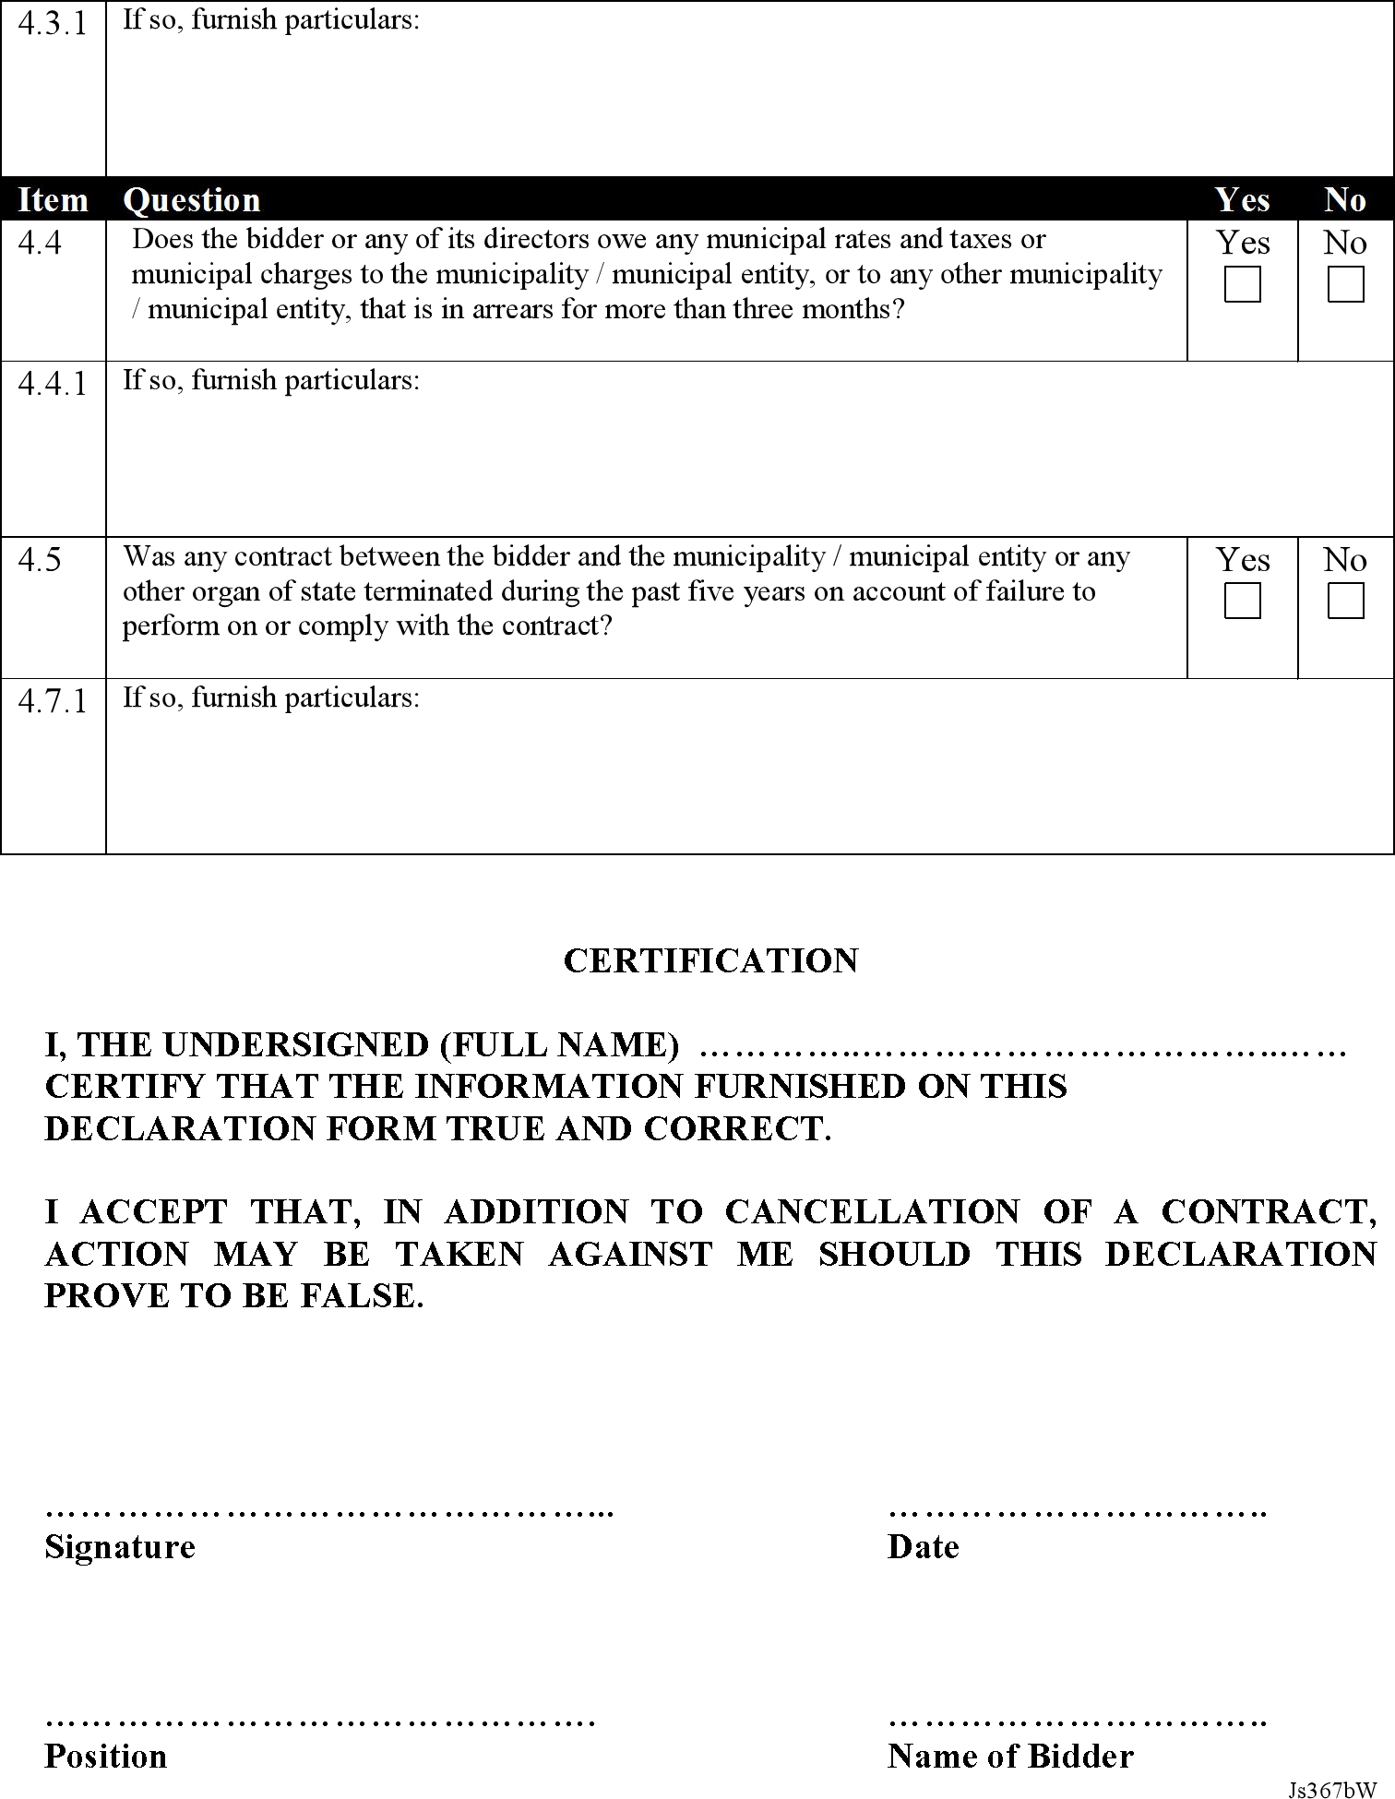
30

31

Richtersveld Municipality Private Bag X113 Port Nolloth, 8280
Republic of South Africa Tel: +27 851 1111
Fax: +27 851 1101

Please provide at least 3 references
1. Name:………………………………………………………………..
Company:…………………………………………………………….
Position Held:………………………………………………………..
Contact Number (s) work..………………………………………….
Mobile………………………………………….
2. Name:………………………………………………………………..
Company:…………………………………………………………….
Position Held:………………………………………………………..
Contact Number (s) work..………………………………………….
Mobile…………………………………………
3. Name:………………………………………………………………..
Company:…………………………………………………………….
Position Held:………………………………………………………..
Contact Number (s) work..………………………………………….
Mobile………………………………………….
4. Name:………………………………………………………………..
Company:…………………………………………………………….
Position Held:………………………………………………………..
Contact Number (s) work..………………………………………….
Mobile………………………………………….
5. Name:………………………………………………………………..
Company:…………………………………………………………….
Position Held:………………………………………………………..
Contact Number (s) work..………………………………………….
Mobile………………………………………….

32
PLEASE NOTE THAT THIS IS COMPULSORY***

DESCRIPTION |  | YES  (√) | NO  (X)
1. | All pages are completely filled and signed by the authorized person:
2. | Original valid Tax Clearance Certificate obtainable from any South African Revenue Services branch has been attached:
3. | Original BBBEE Certificate
4. | Original current account of water and lights/Rates and Taxes  obtainable from any Local or Metropolitan Municipality has been attached
5. | In a case of Joint Ventures (JV)/Consortium, the JV agreement has  been attached
6. | The bidder has provided at least three contactable references
7. | Company registration documents e.g. CK document has been attached, in a case of a Private/Public company, shareholding information e.g. share certificate, has been attached
8. | Central Supplier Database summary report.

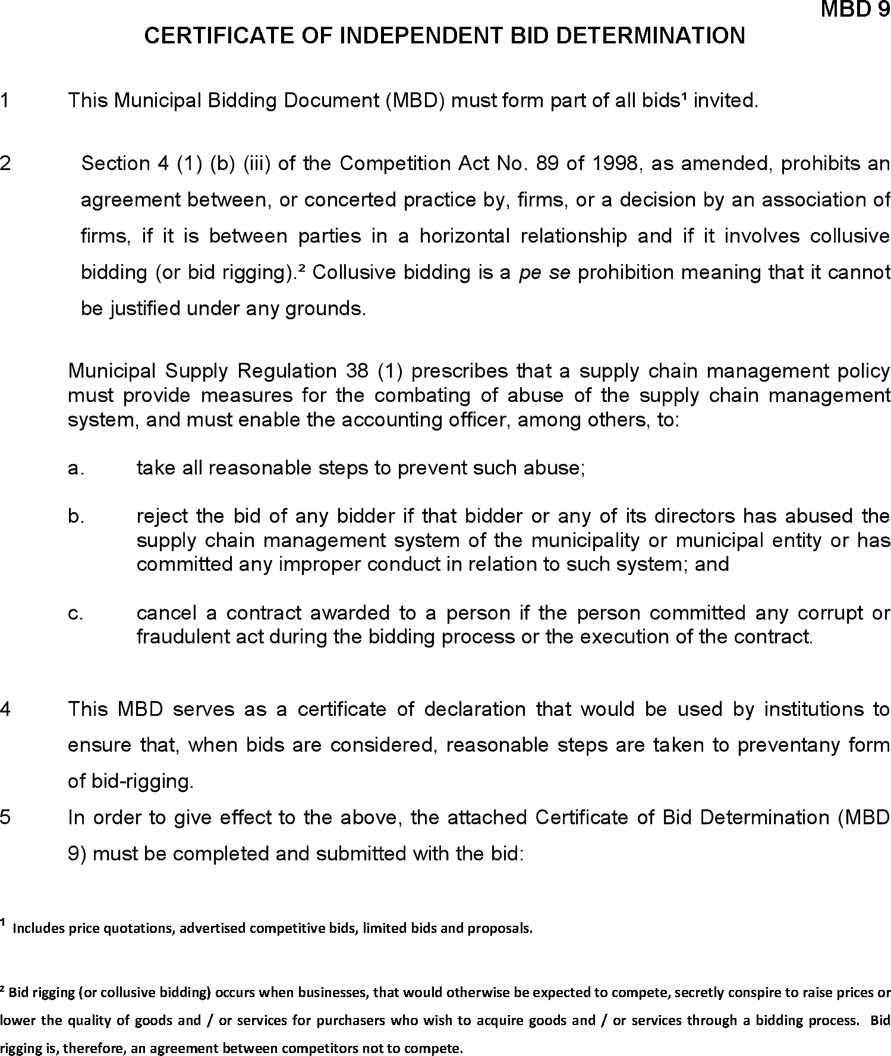
33

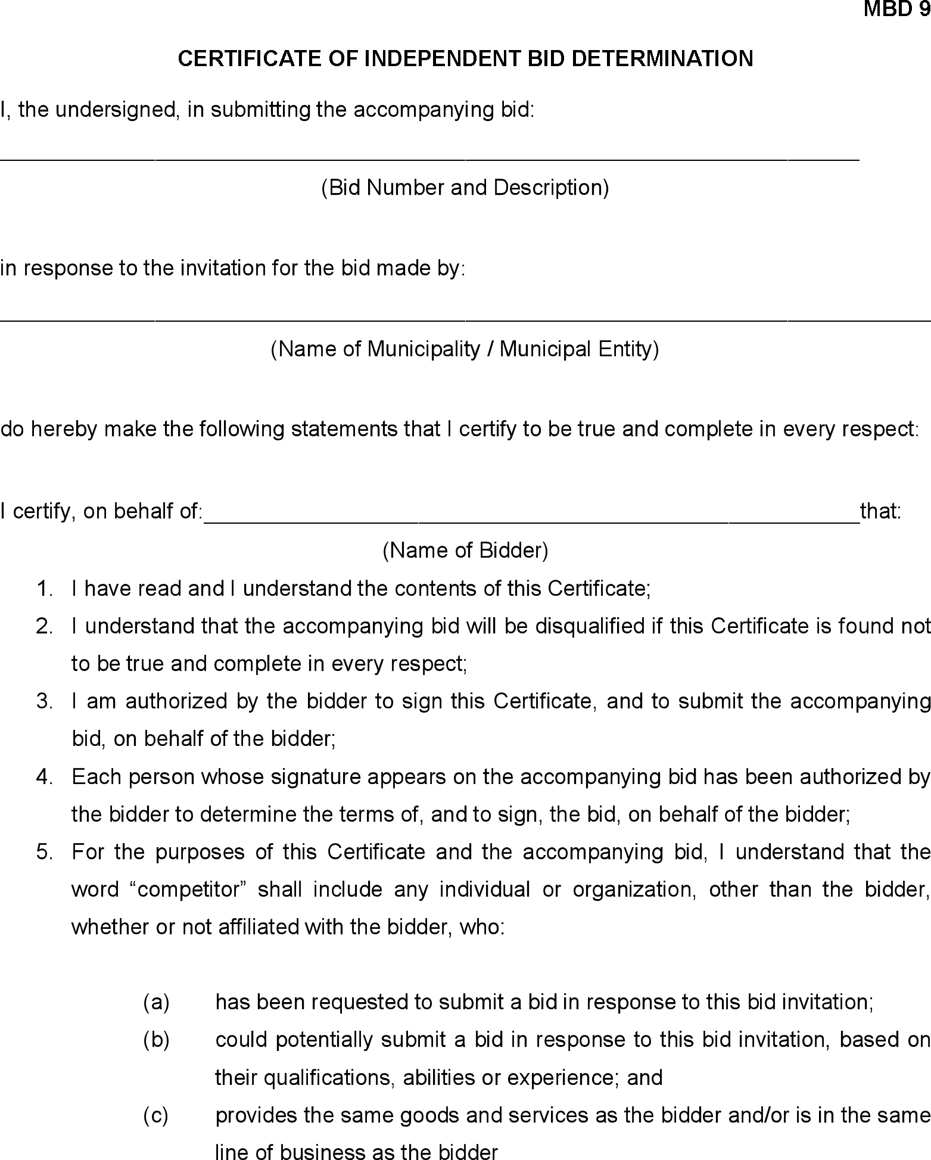

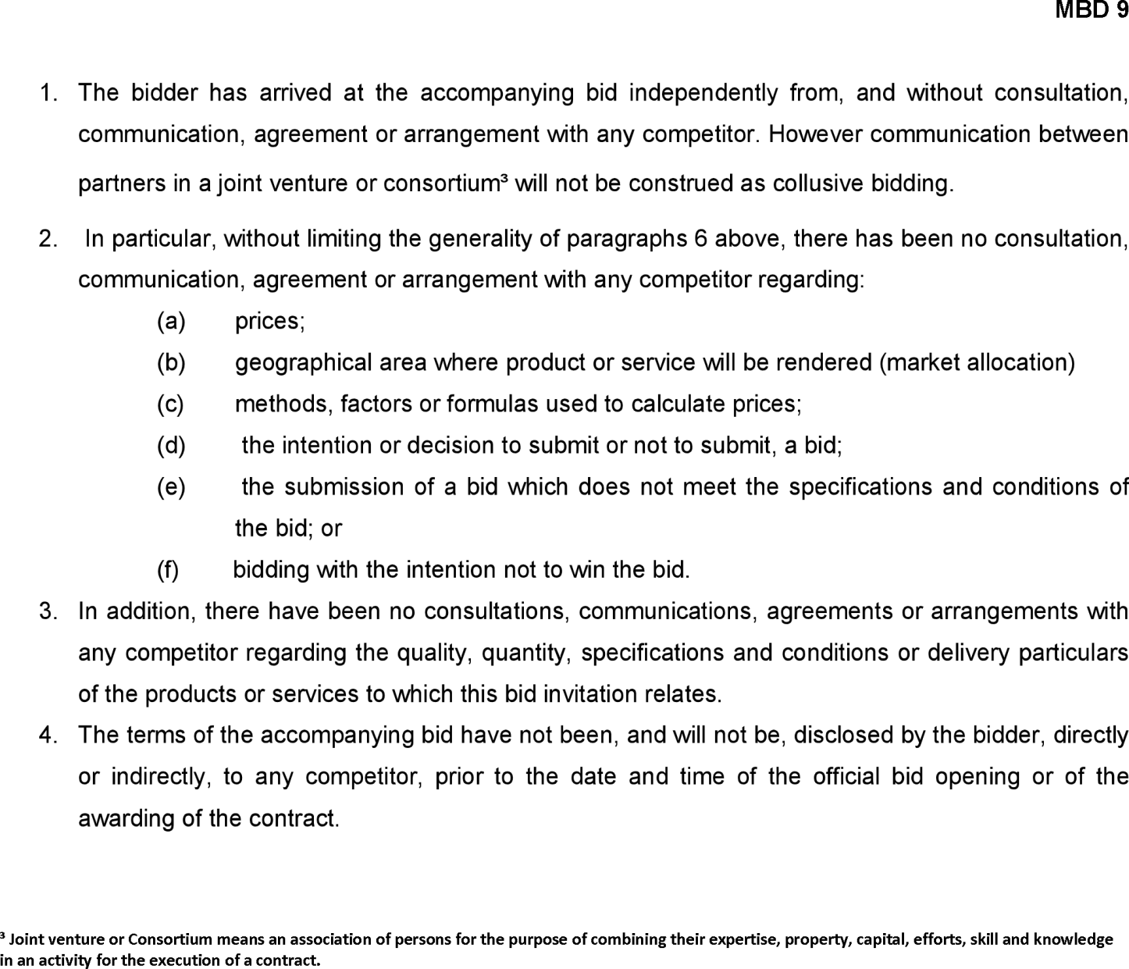

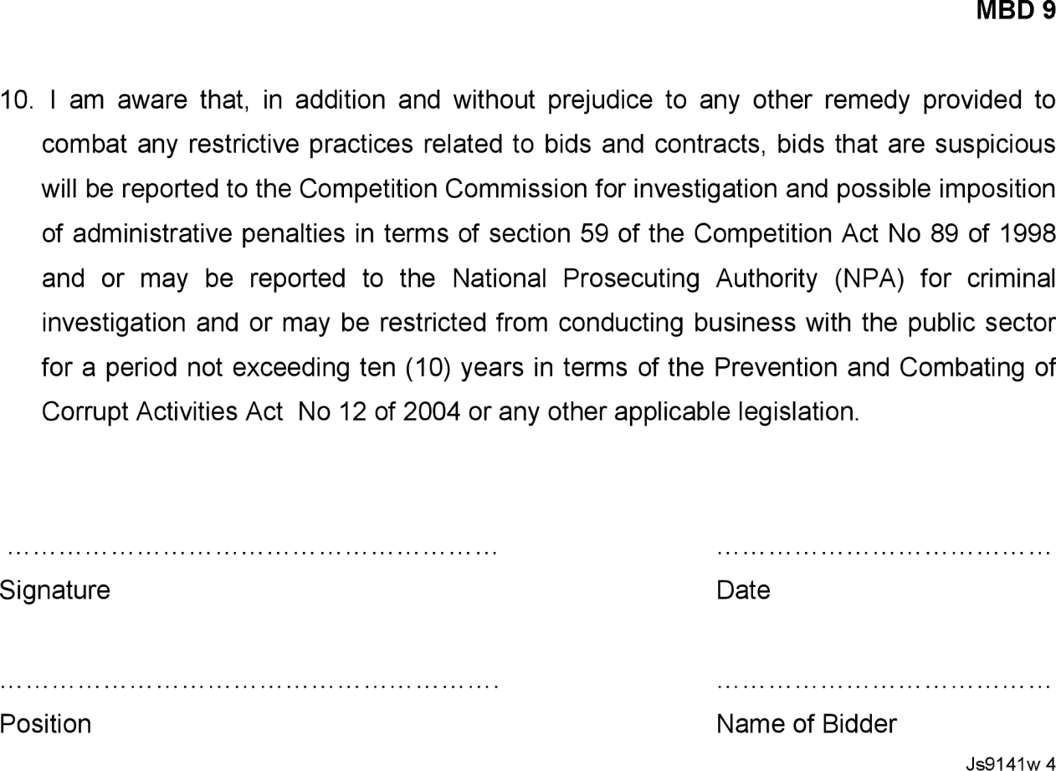

FORM OF OFFER AND ACCEPTANCE OFFER
The Employer, identified in the acceptance signature block, has solicited offer to enter into a Contract in respect of the following service:

TENDER No: SDITCE/NC061/08/2022

The tenderer, identified in the offer signature block has examined the documents listed in the tender data and addenda thereto as listed in the tender schedules, and by submitting this offer has accepted the Conditions of Tender.

By the representative of the tenderer, deemed to be duly authorized, signing this part of this form of offer and acceptance, the tenderer offer to perform all of the obligations and liabilities of the Service Provider under the contract including compliance with all its terms and conditions according to their true intent and meaning for an amount of R……… be determined in accordance with the conditions of contract identified in the Conditions of Contract.

THE OFFERED PRICE IS R (INCLUSIVE OF VAT)

This offer may be accepted by the Employer by signing the Acceptance part of this form of offer and acceptance and returning one copy of this document to the Tenderer before the end of the period of validity stated in the Conditions of Tender, whereupon the Tenderer becomes the party named as the Service Provider in the Condition of Contract.

Signature(s):…………………………………………………………………………………………………………
………

Name(s):………………………………………………………………………………………………………………
………

Capacity for the
Tenderer: ……………………………………………………………………………………………………………
…

Name and address of organization)……………………………………………………………………………………………………

Name and Signature of
Witness:……………………………………. Date:…………………………………………………

ACCEPTANCE

By signing this part of this form of offer and acceptance, the Employer identified below accepts the Tenderer’s offer. In consideration thereof, the Employer shall pay the Service Provider the amount due in accordance with the Conditions of Contract identified in the contract that is the subject of this agreement.

Deviations from and amendments to the documents listed in the tender data and any addenda thereto as listed in the tender scheduled as well as any changes to the terms of the offer agreed by the tenderer and the Employer during this process of offer and acceptance, are contained in the schedule of deviations attached to, and forming part of this agreement. No amendments to or deviations from said documents are valid unless contained in this schedule, which must be signed by the authorized representative(s) of both parties.

The tenderer shall within two weeks after receiving a completed copy of this agreement, including the schedule of deviations (if any), contact the Employer’s agent (whose details are given in the contract data) to arrange the delivery of any bonds, guarantees, proof of insurance and any other documentation to be provided in terms of the conditions of contract identified in the Contract Data at, or just after, the date this agreement comes into effect. Failure to fulfill any of these obligations in accordance with those terms shall constitute a repudiation of this agreement.

Notwithstanding anything contained herein, this agreement comes into effect on the date when the tenderer receives one fully completed original copy of this document, including the schedule of deviations (if any). Unless the tenderer (now Service Provider) within five days of the date of such receipt notifies the Employer in writing of any reason why he cannot accept the contents of this agreement shall constitute a binding between the parties.

Signature(s):

…………………………………………………………………………………………………………. Name(s):
………………………………………………………………………………………………………………………
…….

Capacity for the
Employer: ……………………………………………………………………………………………………………

(Name and address of organization)………………………………………………………………………………………………...

……………………………………………………………………………………………………………………… Name and Signature of
Witness:………………………………………

Date:………………………………………..

CREDIT ORDER INSTRUCTION

It is the policy of the Richtersveld Municipality to pay all creditors by means of direct bank transfers. Please complete this information and acquire your banker’s confirmation.

Name of Firm Account Holder

………………………………………………………………………………………………… Address:………………………………………………………………………………………………...
………………………………………………………………………………………………………………………
………

Name of Bank: ………………………………………………………………………………………………...

Name of Branch:………………………………………………………………………………………………….

Branch Code:…………………………………………………………………………………………………

Account Number:………………………………………………………………………………………………...

Type of Account:…………………………………………………………………………………………………

I/we hereby requested and authorize the Richtersveld Municipality to pay any amounts that may accrue to me/us to the credit of my/our bank account.

I/we understand that a payment advice will be supplied by the Richtersveld Municipality in the normal way that will indicate the date on which funds will be available in my/our bank account and details of payment.

I/we further undertake the inform the Richtersveld Municipality in advance of any change in my/our bank details and accept that this authority may only be cancelled by me/us by giving thirty days’ notice by prepaid registered post.

…………………………………….. …………………………………………….
Initials and Surname Authorized Signature

Date:…………………………….

FOR BANK USE ONLY

OFFICIAL DATE STAMP
……………………………………………………………………..
AUTHORISED SIGNATURE(S)
I/We hereby certify that the details of our clients bank account as
Indicated on the credit order instruction is correct:

