INVITATION TO QUOTE
Description | Rigging and Transportation of Package Plant from UMhlabatshane Waterworks to Ixopo Water Works
Advert Date | 28/05/2025
Closing Date and Time | 06/06/2025 @ 23h59
Compulsory Briefing Session | Venue: Ixopo Water Works  Date:03/06/2025  Time: 11h00
SCM Enquiries | Nokwanda Mboyi  Tel: 033 846 1818  Email: nokwanda.mboyi@uuw.co.za
Technical Enquiries | Njabulo Kheswa  Tel: 033 846 1800  Email: njabulo.Kheswa@uuw.co.za
Contents of RFQ | - Invitation to quote  - Bidders’ information  - Terms and Conditions  - Undertaking by Bidder  - RFQ specifications  - Price Schedule [SBD 3.1]  - Authority to Sign  - Bidders’ disclosure [SBD 4]  - Preference points claim form (SBD 6.1)  - Briefing session certificate  - Contract Form [SBD 7.1]

Submissions: | Tip-Offs Anonymous Hotline:
Quotations must be emailed to :  scmquotes@uuw.co.za using Quote number as the email subject  Quotations dropped in the tender box will NOT be ACCEPTED.  Emailed Quotations received after 00h00 will also NOT be ACCEPTED  Suppliers are under no circumstances allowed to cc buyers when emailing/submitting RFQs to the scmquotes@uuw.co.za  Failure to adhere to the above will result in your RFQ not getting accepted, | Report unethical conduct at uMngeni-uThukela Water on:  Toll Free Number: 0800 864 463  Email: umgeniwater@whistleblowing.co.za  Toll Free Fax: 0800 212 689  Postal: Freepost KZN665, Musgrave, 4062  SMS: 33490  Online: www.whistleblowing.co.za  Stop theft / fraud / dishonesty / bribery /blackmail / intimidation, and remain anonymous.

2.BIDDERS INFORMATION
Name of Bidder
Company Registration number
VAT registration number
Contact Person
Telephone number
Cell number
E-mail address
Postal address
Physical address
uMngeni-uThukela Water Vendor Number
CSD Supplier number

I certify that the information furnished on this form is true and correct. I further accept that, in addition to cancellation of a contract, action may be taken against me should this declaration prove to be false.

______________________ _____________ ____________
Name of Representative Signature Date
(Duly Authorised)

3. TERMS AND CONDITIONS OF REQUEST FOR QUOTATION (RFQ)

- Any alteration made by the bidder must be initialled.
- Use of correcting fluid is prohibited.
- Bidders must be registered on the National Treasury’s Central Suppliers Database.
- Tenderers are required to submit a valid Tax clearance verification PIN or CSD MAAA number.
- This quotation is subject to the Preferential Procurement Policy Framework Act and the Preferential Procurement Regulations, 2022; the General Conditions of Contract (GCC) and if applicable any other Special Conditions of Contract.
- The applicable preference point system for this tender is the 80/20 preference point system, Failure on the part of a tenderer to submit proof or documentation required in terms of this RFQ to claim points for specific goals, will be interpreted to mean that preference points for specific goals are not claimed by the bidder. Kindly refer to SBD 6.1 form for additional information.
- Suppliers must complete the attached SBD 4 – Bidders disclosure, failure to complete these documents may result in the quotation being invalidated.
- Quotations must be in accordance and comply with the terms of reference/specifications provided, unless otherwise stipulated.
- The official uMngeni-uThukela Water quotation form must be used to quote the offered price. Should the allocated price page be insufficient, the tenderer may supplement the price page with an additional pricing breakdown.
- Price Declaration must be completed, and should the total RFQ prices differ, the one indicated on the price declaration shall be considered the correct price.
- The successful supplier may be required to fill in and sign a written Contract Form. (If applicable)
- This document may contain confidential information that is the property of uMngeni-uThukela Water.
- No part of the contents may be used, copied, disclosed or conveyed in whole or in part to any party in any manner whatsoever other than for preparing a proposal in response to this RFQ, without prior written permission from Umgeni Water and the Bidder.
- All Copyright and Intellectual Property herein vests with uMngeni-uThukela Water and its Bidder.
- Responses to this RFQ must be submitted by email scmquotes@umgeni.co.za or be deposited in tender box situated as indicated on the quotation request form marked appropriated as directed. (The applicable submission method is reflected on the cover page).
- It is the responsibility of the bidder to ensure that its response reaches Umgeni Water on or before the closing date and time of the RFQ. Late and incomplete submissions will not be accepted.
- No services must be rendered or goods delivered before an official uMngeni-uThukela Water Purchase Order form has been received.
- UMngeni-uThukela Water reserves the right to appoint more than one supplier/service provider and or to award the quote as whole or in part.
- A full copy of General Conditions of Contract (GCC) are available on the National Treasury website (https://www.treasury.gov.za/divisions/ocpo/sc/generalconditions/general%20conditions%20of%20contract.pdf)

UNDERTAKING BY BIDDER

1. I/We hereby quote to supply all or any of the supplies and/or to render all or any of the services described in the attached documents to uMngeni-uThukela Water on the terms and conditions. In accordance with the specifications stipulated in the quotation documents (and which shall be taken as part of and be incorporated into this quote) at the prices and on the terms regarding time for delivery and/or execution inserted therein.

2. I/we agree that:
(a) The offer herein shall remain binding upon me and open for acceptance by uMngeni-uThukela Water during the validity period indicated and calculated from the closing time of the quote;
(b) This quote and its acceptance shall be subject to the Public Finance Management Act, 1999, UMngeni-uThukela Water’s Supply Chain Management Policy and Procedures, the General and Special Conditions of Contract as may be applicable, with which I/we am fully acquainted;
(c) If I/we withdraw my quote within the period for which I/we have agreed that the quote shall remain open for acceptance, or fail to fulfil the contract when called upon to do so. UMngeni-uThukela Water may, without prejudice to its other rights, agree to the withdrawal of my quote or cancel the contract that may have been entered into between uMngeni-uThukela Water and I/us. I/we will then pay to uMngeni-uThukela Water any additional expenses incurred for having either to accept any less favourable quote or, if fresh quote have to be invited, the additional expenditure incurred by the invitation of fresh quotes and by the subsequent acceptance of any less favourable quotes. uMngeni-uThukela Water shall reserve the right to recover such additional expenditure by set-off against monies which may be due to me under this, or any other tender or contract or against any guarantee or deposit that may have been furnished by me or on my behalf for the due fulfilment of this or any other tender or contract. Pending the ascertainment of the amount of such additional expenditure to retain such monies, guarantee or deposit as security for any loss uMngeni-uThukela Water may sustain by reason of my default;
(d) If my quote is accepted, the acceptance may be communicated to me by electronic mail, to the email address supplied in my quotation document;
(e) the law of the Republic of South Africa shall govern the contract created by the acceptance of my quote and I choose domicilium citandi et executandi in the Republic at (full physical address) :
_______________________________________________________________________________________________________________________________________

3. I/we furthermore confirm that I/we have satisfied myself as to the correctness and validity of my quote: that the price(s), rate(s) and preference quoted cover all of the work/item(s) and my obligations under a resulting contract, and I accept that any mistakes regarding the price(s) and calculations will be at my risk.

4. I/we hereby accept full responsibility for the proper execution and fulfilment of all obligations and conditions devolving on me under this agreement, as the Principal(s) liable for the due fulfilment of this contract.

5. I/we agree that any action arising from this contract may in all respects be instituted against me and I/we hereby undertake to satisfy fully any sentence or judgement which may be pronounced against me as a result of such action.

6. I/we confirm that I/we have declared all and any interest that I or any persons related to my business has with regard to this quote or any related quotations by completion of the Declaration of Interest Section.

7. I/WE, THE UNDERSIGNED, WHO WARRANT THAT I AM DULY AUTHORISED TO DO SO ON BEHALF OF THE TENDERER, CERTIFY THAT THE INFORMATION SUPPLIED IN TERMS OF THIS DOCUMENT IS CORRECT AND TRUE, THAT THE SIGNATORY TO THIS DOCUMENT IS DULY AUTHORISED AND ACKNOWLEDGE THAT:

(1) The tenderer will furnish documentary proof regarding any tendering issue to the satisfaction of the uMngeni-uThukela Water, if requested to do so.

(2) If the information supplied is found to be incorrect and/or false then uMngeni-uThukela Water, in addition to any remedies it may have, may: -

- Recover from the contractor all costs, losses or damages incurred or sustained by uMngeni-uThukela Water as a result of the award of the contract, and/or
- Cancel the contract and claim any damages which uMngeni-uThukela Water may suffer by having to make less favourable arrangements after such cancellation.

______________________ _____________ ____________
Name of Representative Signature Date
(Duly Authorised)
(Duly Authorise
SPECIFICATIONS OF GOODS REQUIRED

- Background
uMngeni-uThukela Water invites competent and experienced rigging and transportation service providers to supply services of crane hire, rigging and transportation of the package waterworks plant from UMhlabatshana to Ixopo Waterworks.
.
uMngeni uThukela Water is in the process of augmenting and increasing water supply at Ixopo Waterworks. This package plant needs to be moved to Ixopo waterworks to ensure that that additional supply is achieved.

- Description of goods/ services required

This project comprises of crane hire, rigging and transportation of containerised units of the package plant from uMhlabatshana Waterworks to Ixopo waterworks

- Clarifiers (L 7 m x W 3 m x H 3.5 m) x 2 no. of
- Filters ( Diameter 2.4m x Height 3. 5 m Weight - 3 000kg each) x 3 no. of
- Head of works (L 2.4 x W 3.1 x H 3.5)
- Containerized units - 6 m storage containers
- N.B. SERVICE PROVIDERS MUST PREDETERMINE WEIGHTS OF THE EQUIPMENT SINCE IS UNKOWN AND BE INCLUDED ON THE FINAL QOUTATION.

- Extent of the services
- Two teams rigging crew /personnel to rig out the package plant units at the Mhlabatshana Waterworks and offload at Ixopo Water Works.
- Cranes 50 to 70 ton for lifting and rigging
- Lowbed /flatbed trucks for transportation of package plant to Ixopo
- Assessment of loading and offloading area and preparations
- The contractor will be expected to conduct rigging studies and risk assessments before conducting any lifting.
- The Contractor will be expected to ensure that all rigging equipment are certified(load tested) and properly inspected prior to using them as per the OHSAct of 1993.
- As a minimum uMngeni uThukela Water requires the following persons to be part of the rigging crew:
  - Supervisor (Qualified Rigger).
    - Minimum years practicing as a rigger: 4 years.
    - Minimum Qualifications: SAQA Qual ID 59731 or 13693.
  - Semi-skilled riggers
- Minimum years in the Rigging field: 1 year.
- Qualification: Matric & Basic training in rigging (Working at height, Basic rigging and rigging and slinging).
  - Assistant
    - Minimum years in the technical field: 6 months working in a technical environment / workshop.
    - Qualification: Not required but the person should have a technical background.
  - Crane Drivers
    - Minimum years practicing as a crane operator: 4 years.
- Although not part of the daily crew (i.e. only required on request), the Supplier needs to ensure that all their crane drivers are certified according to SAQA Qual ID 242982.
- Code 14 Truck Driver
  - Minimum years code 14-truck driver: 4 years.
  - Code 14 driving licence

- Contractor Responsibility
The Contractor shall:
- Provide all the necessary skills, resources, tools, equipment, lifting cranes and expertise to carry out the works;
- Ensure that all their crews are qualified (and trade tested).
- Review, familiarize and understand the proposed site including all constraints and environmental factors that will affect the performance of the contractor.
- Conduct risk assessments before starting any job.
- Review, familiarize and understand the operational requirements of the facilities in UMhlabatshane and Ixopo Water works
- Provide all necessary SHE compliance documentation as per uMngeni uThukela Water SHE specifications, including the submission and approval of a Safety File and SHE Officer on site (on instances where the OHSAct requires one).
- Make available any documentation that UWW might require, these include load test certificates and inspections, job cards and any other relevant document.
- On a fair notice, allow UUW to conduct site visits and audit the workshop and compliance to the lifting equipment regulations (OHSAct).
- Governing Codes, Standards and Specification

The Contractor’s works must be in accordance with the requirements of the latest edition of the following specifications and codes:

Title | Document No.
National & International Standards
Inspection and testing of non-fixed load-lifting attachments (2008 ver 1). | SANS 687
Inspection, examination and testing of manually operated chain blocks and chain lever hoists in use. | SANS 500:2009 Ed. 1
The inspection, examination and testing of lift trucks. | SANS10388:2008 Ed. 1
Textile slings — Safety Part 1: Flat woven webbing slings made of man- made fibres for general purpose use. | SANS 94-1:2003 Ed. 1
Part 2: Round slings made of man-made fibres for general purpose use. | SANS 94-2:2003
Steel wire ropes for general purposes — Minimum requirements | SANS 2408:2005
Manually operated chain lever hoists | SANS 1636:2007 Ed. 2
Manually operated chain blocks | SANS 1594:2007 Ed 2.1
Non-calibrated round steel link lifting chain and chain slings — Use and maintenance | ISO 3056:1986 Ed. 2
Calibrated round steel link lifting chains — Guidelines to proper use and maintenance | SANS 7592:1983 Ed. 1
Short-link steel chain (close-tolerance) for lifting appliances | SANS 1592:2005 Ed. 1.2
Occupational Health and Safety Act and Regulations | 85 of 1993

- Statutory Requirements for the Tools and Machinery
All the lifting equipment and lifting attachments used should be compliant to the applicable Standards, ACTS, Codes and regulations as listed in Section 6: Governing Codes, Standards and Specifications.
As a minimum, this is:

Ropes/Chains/Sling
- Inspected regularly for damage (minimum once a month).
- Inspected before use by a Technical person (Tradesperson).

Chain blocks/Lever Hoist
- Certified – valid load test certificate (minimum once a year).
- Inspected regularly for damage (minimum once a month). ▪ Inspected before use by a Technical person (Tradesperson).
Cranes
- Certified – valid load test certificate (minimum once a year).
- Calibrated (when required as recommended during load tests).
- Inspected regularly for damage by an LMI - Lifting Machinery Inspector (minimum once a month).
- Inspected before use by a Technical person (Tradesperson).
General
- UUW bears the right to request any of these documentation at any stage and can reject the use of equipment if the condition is not acceptable or the documentation is not available.

Workmanship and Compliance to Regulations
The following is expected from the Contractor to ensure compliance to theOHSAct and for good workmanship:
- Use of qualified riggers (SAQA ID59731/13693) and well trained crane drivers (SAQA 242982) to carryout the rigging service at all times.
- Use of compliant lifting equipment as per the applicable regulations

- Format of communications
Communication will be conducted telephonically and via e-mail.

- Vehicle Safety
  - Drivers, passengers and pedestrians must obey safety requirements in terms of the National Road Traffic Act, No 93 of 1996, as amended, including other relevant provincial or local requirements. b)
  - All drivers must possess a valid, national driver’s licence of the correct category/class, must not be under the influence of alcohol or other drugs which will impair the senses and must be authorised by the Contractor to drive the company vehicle.
  - All vehicles must be roadworthy and passenger vehicle specifications must include at least a front airbags for the driver and front passenger and an anti-lock braking system (ABS).
  - All vehicles must be driven with due consideration for personnel and property. A maximum speed limit of 40 km/hour will be adhered to on the premises at all times.
  - Transportation of passengers on the back of open or closed light delivery vehicles (LDVs), trailers, trucks or any other form of transportation is prohibited. It is a legal requirement for all employers to provide safe transportation of all employees both on and off site.
  - Drivers and passengers entering uMngeni –uThukela Water site may be subjected to compulsory breathalyser testing.
  - The vehicle driver/s must ensure that their passengers are seated and wear seatbelts at all times..

- Health and Safety Requirements
The Contractor shall comply with uMngeni uThukela Water Health Safety and Environmental Specification.

- Electronic payments
State details required / procedures to obtain electronic payments, as relevant
- Site Information

The contract is applicable to the following site: UMhlabatshana Waterworks and Ixopo Waterworks
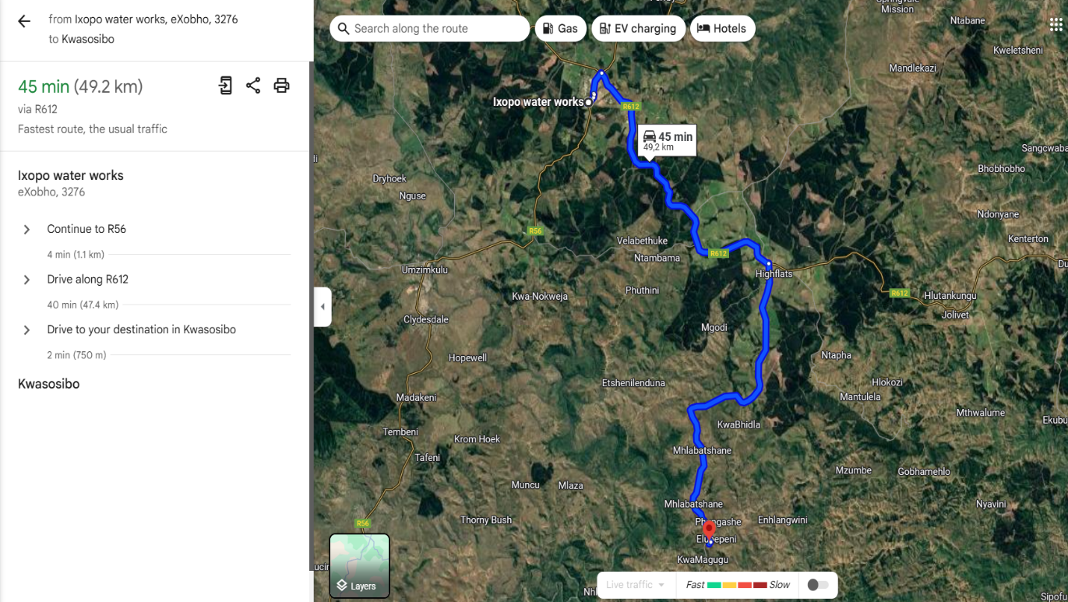
Figure 1 direction Ixopo – Mhlabatshane 50 km

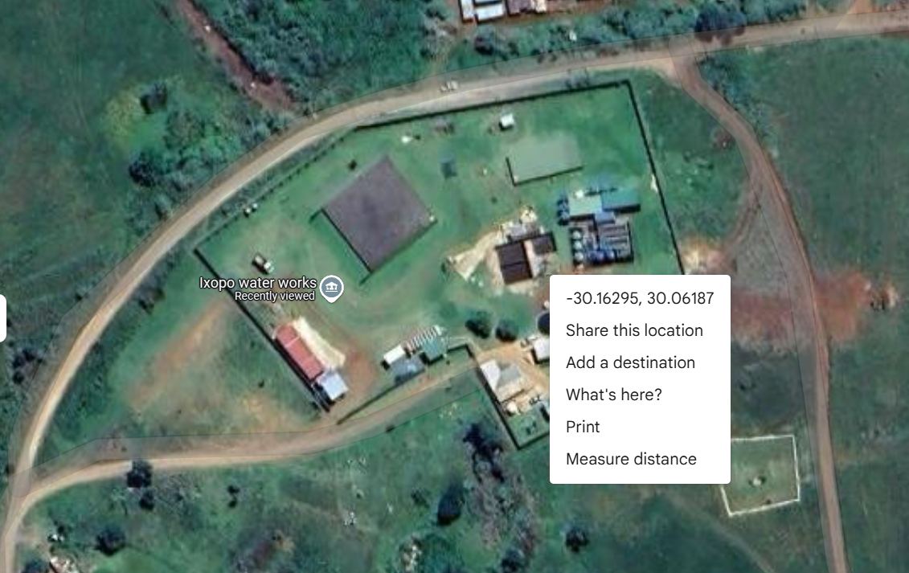
Figure 2 Ixopo WW co-ordinates

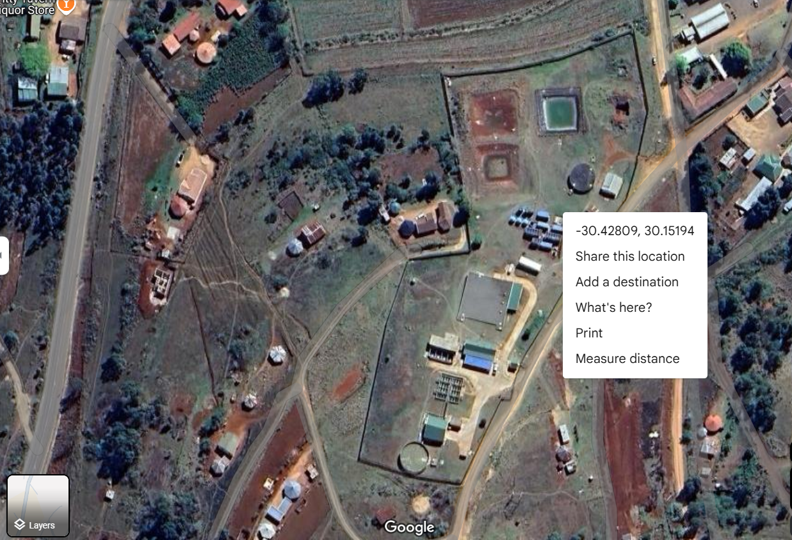
Figure 3 UMhlabatshana coordinates

- Contract term
- We anticipate that the Contract will be as per deliverables

- Mandatory documentation
- SBD 4 – Bidders disclosure

- Pricing
- The bidder shall provide the price proposal as detailed in SBD 3.1
- The bidders’s price must be fully inclusive, and each item must be clearly specified.
- All additional costs must be clearly specified and included in the total quotation price, (e.g. transport, labour, etc.).
- All prices must be VAT inclusive.
- The bidder is responsible for all the cost that they shall incur related to the preparation and submission of the quotation.

- Evaluation Process

The RFQ will be evaluated using a two (03)-stage evaluation approach:
  - First stage:
Mandatory Requirements
SBD 4 – Bidders disclosure

Administrative Requirements:
Bidder completed all RFQ Forms
Bidder submitted CIPC document/CSD Report
Valid B-BBEE Certificate/Sworn Affidavit

16.2 Second Stage: Evaluation of Functionality
The purpose of application of qualification criteria is to determine the functionality of each proposal by assessing the quality thereof. Below is a detailed breakdown of the scoring criteria

Bidders from the second stage who have achieved 70(Seventy) points or more will be eligible to submit to be evaluated on Price and Specific Goals

Failure to score a single point in any of the functionality criteria will deem the bid non-responsive and the bidder will be disqualified.

Functionality criteria | Description of requirements | Maximum points
Tenderer’s Experience | provision of crane hire/rigging services and transportation of heavy machinery and goods | 50
Key Personnel | Experience of key personnel  - Crane operator  - Rigger | 30
Equipment compliance | Load certificate | 20
TOTAL POINTS |  | 100
MINIMUM QUALIYING POINTS |  | 70

16.2.1 TENDERER’S EXPERIENCE

The experience of the Tenderer or joint venture partners in the case of an unincorporated joint venture or consortium will be evaluated on the basis of experience in similar projects or similar areas and conditions in relation to the scope of work.

The evaluation will consider experience in relation to the management of programmes and projects and the provision of cost consulting services in relation to programmes of work as opposed to projects where bills of quantities have been used.

Tenderers should very briefly describe his or her experience in this regard relevant to the scope of work and attach this to this schedule.

The description should be put in tabular form with the following headings:

Project name | Period/Year | Value of work inclusive of VAT (Rand) | Size of the load rigging operations | Client (where the project was done) | Contact Details of Client

16.2.1.1 Scoring of the Tenderer’s experience will be as follows: 50

DESCRIPTION | MAX POSSIBLE SCORE
Company experience provision of crane hire/rigging services and transportation of heavy machinery and goods.  - <2 projects – 0 points  - 2 projects – 50 points  - 3 projects – 70 points  10 additional points for every project more than 3 projects to a maximum 100 points | 100

16.2.2 KEY PERSONNEL ASSIGNED TO THE WORK

Insert in the table below the key personnel and their proposed function

11.2.2.1 KEY PERSONNEL SCHEDULE

No. | Proposed Function | Key Person Name
 | Crane Operator
 | Rigger

16.2.2.2 EXPERIENCE OF KEY PERSONNEL

Provide relevant information as prescribed below for the following Key Persons proposed in the tender to fulfil the following positions:

Key Person Positions

A. Crane Operator
B. Rigger

The experience of each key person, relevant to the scope of work, will be evaluated from the points below:
- General experience (total duration of activity), level of education and training and positions held by the key person.
- The education, training and experience of the person, in the specific sector, field, subject, etc. which is directly linked to the scope of work.

A CV of each key person of not more than 3 pages should be attached to this schedule.

Each CV should be structured under the following headings:

- Personal particulars
- name
- date and place of birth
- place (s) of tertiary education and dates associated therewith
- Qualifications
- Name of current employer and position in enterprise
- Overview last 10 years of experience (year, organization, position and projects)
- Outline of recent assignments / experience that has a bearing on the scope of work

The scoring of the experience of key staff will be as follows: 30

Experience of the crane operator in years operation of the designated proposed size of lifting equipment/crane and a valid crane operator driver certificate SAQA ID 242982 or equivalent  - 1 year – 10 points  - 2 to 3 year – 30 points  - 4 to 5 years – 40 points  - More than 5 years – 50 Points (maximum)  Experience of the Rigger in years on rigging operations and a valid rigging certification SAQA ID 59731 or 13693  - 1 year – 10 points  - 2 to 3 year – 30 points  - 4 to 5 years – 40 points  - More than 5 years – 50 Points (maximum) | 100

16.2.3 TENDERER’S LIFTING EQUIPMENT COMPLIANCE CERTIFICATION (20)

The scoring of the Tenderers Lifting Equipment Compliance will be as follows: (Weighting = 20%)

The tenderers must submit proof of technical compliance to the specifications below for the proposed products in the bid.
Scoring Functionality
The functionality criteria and maximum score in respect of each of the criterion are as follows:
CRITERIA | MAX POSSIBLE SCORE
1. LIFTING EQUIPMENT COMPLIANCE CERTIFICATION (100 – POINTS MAXIMUM)  General Specification: Lifting equipment/Crane  The specification are not limited to the perimeters assessed for functionality tenders must provide prices on the full specification as provided on the technical scope of the document.  Tenderers must submit valid certificates of compliance with the specification and regulations as prescribed above. | 100
  Description | Specification | POINT ALLOCATION
  Description | Specification | YES | No | Scoring
  Lifting equipment/Crane | Valid Load Test Certificates and calibration certificate | 100 | 0
  TOTAL POINTS |  | 100

  - Third Stage: Price and Preference goals
- Subsequent to the evaluation of mandatory/ administrative requirements, the second stage of evaluation of the bids will be in respect of price and preferential procurement only.
- Tenderer is tax complaint.
- In compliance with the Preferential Procurement Regulations 2022, the 80/20 preference point system is applicable: points for this bid shall be awarded for:
a) Price; and (80) and Preference as defined in SBD 6.1 (20)
- The Preference Goals that have been identified for this bid is stipulated in SBD 6.1
- Preferential goals and applicable points for this tender in terms of Preferential Procurement Regulations 2022, are indicated in the table below:

 | Description | 80/20 | Evidence to be provided
HDI | 51% owned by Black people | 10 | Valid B-BBEE Certificate/Sworn Affidavit
RDP | The promotion of South African owned enterprises | 10 | CIPC documents/CSD report
Total points for preferential goals |  | 20

- Failure on the part of a bidder to submit proof or documentation required in terms of this RFQ to claim points for specific goals, will be interpreted to mean that preference points for specific goals are not claimed by the bidder.

- UUW reserves the right to request a bidder, either before a bid is adjudicated or at any time subsequently, to substantiate any claim in regard to preferences, in any manner required by UW.

- UUW reserves the right to conduct negotiations with the qualifying bidder/s regarding any terms and conditions, including price(s), of a proposed contract where applicable UW reserves the right not to accept the lowest financial offer or any offer

PRICING SCHEDULE – FIRM PRICES (PURCHASES)

NOTE:

- Only firm prices will be accepted. Non-Firm prices (including prices subject to rates of exchange variations) will not be considered

- In cases where different delivery points influence the pricing, a separate pricing schedule must be submitted for each delivery point

Name of bidder _______________________ RFQ number __Q25/876NM_______

Closing Time ___________23h59_________ Closing date : 06/06/2025

OFFER TO BE VALID FOR___________CALENDER DAYS FROM THE CLOSING DATE OF QUOTE.

Item No. | Material / Description of item |  | Unit | Qty (A) | Unit Price Per m/ Unit Excl. Vat (B) | Quoted Price(AxB)  Excl. Vat
 | Safety file, Risk assessments and all OHS requirements |  | Sum | 1
 | Mobilization and logistics |  | Sum | 1
 | Hire of loading equipment/ Mobile Crane Loading at Mhlabatshana |  | Days | 2
 | Hire of loading equipment/Mobile Crane off-Loading at Ixopo WW |  | Days | 2
 | Hire of 30 Ton low bed/flatbed horse and trailer |  | Days | 2
 | Hire of 30 Ton low bed/flatbed horse and trailer |  | Days | 2
 | Transportation of plant from UMhlabatshane to Ixopo WW |  | Sum | 1
 | Access preparation and loading platforms |  | Pro. Sum | 1 | R200 000 | R200 000
- 1 | Profits on attendance on item 8 |  | % | 20% | R 20 000 | R 20 000
A – Sub-Total for all Items excluding VAT
B- VAT @ 15% of C
C – Total Contract Price including VAT (A+B)
I (full name)__________________________________________, in my capacity as ___________________________, the duly authorized representative of ________________________________________________(business name) hereby declares that the offer is in accordance with the attached specification, notes to suppliers & accepts all conditions/clauses contained in the said documents.
Signature of duly authorized representative |  | _______________ |  |  | DATE:  __________________
BASIC GOODS PRICE TABLE

Required by _____________________

Delivered to: _____________________

_____________________

Brand and model _____________________

Country of origin _____________________.

Does the offer comply with the specification(s)? YES/NO

If not to specification, indicate deviation(s) _____________________.

Period required for delivery _____________________.

Delivery: Firm/not firm

Delivery basis _____________________.

Note:

All delivery costs must be included in the bid price, for delivery at the prescribed destination.

All applicable taxes” includes value added tax, pay as you earn, income tax, unemployment insurance fund contributions and skills development levies.

*Delete if not applicable

AUTHORITY TO SIGN

RFQ NO: ______________________________

Description: ______________________________________________________________

Close Corporation / Company / Partnership / Trust /Sole proprietor or Sole trader

Company Name: __________________________________________________________________

Registration Number: _______________________________________________________ Resolution Of The Directors Of The Company etc. resolved that _____________________, in his/her capacity as _______________________________, is authorized to make applications on behalf of the Close Corporation / Company / Partnership / Trust /Sole proprietor or sole trader for:

Any documentation relating to the business (which is not necessarily a change of ownership). The nominated person will also have access to webpage for the business. Signature(s) for Close Corporation / Company / Partnership / Trust/ Sole proprietor or sole trader.
(Sole member still must sign this resolution)

Signature of members:

Name Signature Date

1. _______________________ ________________________ ____________________
2. _______________________ ________________________ ____________________
3. _______________________ ________________________ ____________________
4. _______________________ ________________________ ____________________
5. _______________________ ________________________ ____________________
6. _______________________ ________________________ ____________________

SBD 4 - BIDDER’S DISCLOSURE

- PURPOSE OF THE FORM

Any person (natural or juristic) may make an offer or offers in terms of this invitation to bid. In line with the principles of transparency, accountability, impartiality, and ethics as enshrined in the Constitution of the Republic of South Africa and further expressed in various pieces of legislation, it is required for the bidder to make this declaration in respect of the details required hereunder.

Where a person/s are listed in the Register for Tender Defaulters and / or the List of Restricted Suppliers, that person will automatically be disqualified from the bid process.

- Bidder’s declaration

2.1 Is the bidder, or any of its directors / trustees / shareholders / members / partners or any person having a controlling interest in the enterprise, employed by the state YES/NO

2.1.1 If so, furnish particulars of the names, individual identity numbers, and, if applicable, state employee numbers of sole proprietor/ directors / trustees / shareholders / members/ partners or any person having a controlling interest in the enterprise, in table below.
Full Name | Identity Number | Name of State institution

2.2 Do you, or any person connected with the bidder, have a relationship with any person who is employed by the procuring institution? YES/NO

2.2.1 If so, furnish particulars:

____________________________________________________________________________________________________________________________________________________
2.3 Does the bidder or any of its directors / trustees / shareholders / members / partners or any person having a controlling interest in the enterprise have any interest in any other related enterprise whether or not they are bidding for this contract? YES/NO

    - If so, furnish particulars:

________________________________________________________________________________________________________________________________________
- DECLARATION

I, the undersigned, (name)__________________________________________________ in submitting the accompanying bid, do hereby make the following statements that I certify to be true and complete in every respect:
  - I have read and I understand the contents of this disclosure;

  - I understand that the accompanying bid will be disqualified if this disclosure is found not to be true and complete in every respect;

  - The bidder has arrived at the accompanying bid independently from, and without consultation, communication, agreement or arrangement with any competitor. However, communication between partners in a joint venture or consortium will not be construed as collusive bidding.

  - In addition, there have been no consultations, communications, agreements or arrangements with any competitor regarding the quality, quantity, specifications, prices, including methods, factors or formulas used to calculate prices, market allocation, the intention or decision to submit or not to submit the bid, bidding with the intention not to win the bid and conditions or delivery particulars of the products or services to which this bid invitation relates.

  - The terms of the accompanying bid have not been, and will not be, disclosed by the bidder, directly or indirectly, to any competitor, prior to the date and time of the official bid opening or of the awarding of the contract.

  - There have been no consultations, communications, agreements or arrangements made by the bidder with any official of the procuring institution in relation to this procurement process prior to and during the bidding process except to provide clarification on the bid submitted where so required by the institution; and the bidder was not involved in the drafting of the specifications or terms of reference for this bid.

  - I am aware that, in addition and without prejudice to any other remedy provided to combat any restrictive practices related to bids and contracts, bids that are suspicious will be reported to the Competition Commission for investigation and possible imposition of administrative penalties in terms of section 59 of the Competition Act No 89 of 1998 and or may be reported to the National Prosecuting Authority (NPA) for criminal investigation and or may be restricted from conducting business with the public sector for a period not exceeding ten (10) years in terms of the Prevention and Combating of Corrupt Activities Act No 12 of 2004 or any other applicable legislation.

I CERTIFY THAT THE INFORMATION FURNISHED IN PARAGRAPHS 1, 2 and 3 ABOVE IS CORRECT.

I ACCEPT THAT THE STATE MAY REJECT THE BID OR ACT AGAINST ME IN TERMS OF PARAGRAPH 6 OF PFMA SCM INSTRUCTION 03 OF 2021/22 ON PREVENTING AND COMBATING ABUSE IN THE SUPPLY CHAIN MANAGEMENT SYSTEM SHOULD THIS DECLARATION PROVE TO BE FALSE.

_________________________ _________________
Signature Date

_________________________ _________________
Position Name of bidder

PREFERENCE POINTS CLAIM FORM IN TERMS OF THE PREFERENTIAL PROCUREMENT REGULATIONS 2022 (SBD 6.1)

This preference form must form part of all tenders invited. It contains general information and serves as a claim form for preference points for specific goals.

NB: BEFORE COMPLETING THIS FORM, TENDERERS MUST STUDY THE GENERAL CONDITIONS, DEFINITIONS AND DIRECTIVES APPLICABLE IN RESPECT OF THE TENDER AND PREFERENTIAL PROCUREMENT REGULATIONS, 2022

- GENERAL CONDITIONS
  - The following preference point systems are applicable to invitations to tender:
the 80/20 system for requirements with a Rand value of up to R50 000 000 (all applicable taxes included); and
the 90/10 system for requirements with a Rand value above R50 000 000 (all applicable taxes included).

  - To be completed by the organ of state
The applicable preference point system for this tender is the 80/20 preference point system.
  - Points for this tender (even in the case of a tender for income-generating contracts) shall be awarded for:
- Price; and
- Specific Goals.

  - To be completed by the organ of state:
The maximum points for this tender are allocated as follows:
 | POINTS
PRICE | 80
SPECIFIC GOALS | 20
TOTAL POINTS FOR PRICE AND SPECIFIC GOALS | 100

  - Failure on the part of a tenderer to submit proof or documentation required in terms of this tender to claim points for specific goals with the tender, will be interpreted to mean that preference points for specific goals are not claimed.
  - The organ of state reserves the right to require of a tenderer, either before a tender is adjudicated or at any time subsequently, to substantiate any claim in regard to preferences, in any manner required by the organ of state

- DEFINITIONS
- “tender” means a written offer in the form determined by an organ of state in response to an invitation to provide goods or services through price quotations, competitive tendering process or any other method envisaged in legislation;

- “price” means an amount of money tendered for goods or services, and includes all applicable taxes less all unconditional discounts;
- “rand value” means the total estimated value of a contract in Rand, calculated at the time of bid invitation, and includes all applicable taxes;
- “tender for income-generating contracts” means a written offer in the form determined by an organ of state in response to an invitation for the origination of income-generating contracts through any method envisaged in legislation that will result in a legal agreement between the organ of state and a third party that produces revenue for the organ of state, and includes, but is not limited to, leasing and disposal of assets and concession contracts, excluding direct sales and disposal of assets through public auctions; and
- “the Act” means the Preferential Procurement Policy Framework Act, 2000 (Act No. 5 of 2000).

- FORMULAE FOR PROCUREMENT OF GOODS AND SERVICES
  - POINTS AWARDED FOR PRICE
3.1.1 THE 80/20 OR 90/10 PREFERENCE POINT SYSTEMS
A maximum of 80 or 90 points is allocated for price on the following basis:

80/20 or 90/10

$Ps=80\left(1-\frac{Pt-P\min{}}{P\min{}}\right)$ or $Ps=90\left(1-\frac{Pt-P\min{}}{P\min{}}\right)$

Where
Ps = Points scored for price of tender under consideration
Pt = Price of tender under consideration
Pmin = Price of lowest acceptable tender

  - FORMULAE FOR DISPOSAL OR LEASING OF STATE ASSETS AND INCOME GENERATING PROCUREMENT

    - POINTS AWARDED FOR PRICE
A maximum of 80 or 90 points is allocated for price on the following basis:

80/20 or 90/10

$Ps=80\left(1+\frac{Pt-P\max{}}{P\max{}}\right)$ or $Ps=90\left(1+\frac{Pt-P\max{}}{Pmax}\right)$
Where
Ps = Points scored for price of tender under consideration
Pt = Price of tender under consideration
Pmax = Price of highest acceptable tender

- POINTS AWARDED FOR SPECIFIC GOALS
  - In terms of Regulation 4(2); 5(2); 6(2) and 7(2) of the Preferential Procurement Regulations, preference points must be awarded for specific goals stated in the tender. For the purposes of this tender the tenderer will be allocated points based on the goals stated in table 1 below as may be supported by proof/ documentation stated in the conditions of this tender:
  - In cases where organs of state intend to use Regulation 3(2) of the Regulations, which states that, if it is unclear whether the 80/20 or 90/10 preference point system applies, an organ of state must, in the tender documents, stipulate in the case of—
- an invitation for tender for income-generating contracts, that either the 80/20 or 90/10 preference point system will apply and that the highest acceptable tender will be used to determine the applicable preference point system; or
- any other invitation for tender, that either the 80/20 or 90/10 preference point system will apply and that the lowest acceptable tender will be used to determine the applicable preference point system, then the organ of state must indicate the points allocated for specific goals for both the 90/10 and 80/20 preference point system.

Table 1: Specific goals for the tender and points claimed are indicated per the table below.
(Note to organs of state: Where either the 90/10 or 80/20 preference point system is applicable, corresponding points must also be indicated as such.

Note to tenderers: The tenderer must indicate how they claim points for each preference point system.)

The specific goals allocated points in terms of this tender | Number of points allocated  (80/20 system)  (To be completed by the organ of state) | Number of points claimed (80/20 system)  (To be completed by the tenderer)
South African Owned Enterprise | 10
51% owned by Black people | 10

DECLARATION WITH REGARD TO COMPANY/FIRM

  - Name of company/firm ____________________________________________
  - Company registration number: …………………………………………………………...
TYPE OF COMPANY/ FIRM [Tick applicable box]
Partnership/Joint Venture / Consortium
One-person business/sole propriety
Close corporation
Public Company
Personal Liability Company
(Pty) Limited
Non-Profit Company
State Owned Company

  - I, the undersigned, who is duly authorised to do so on behalf of the company/firm, certify that the points claimed, based on the specific goals as advised in the tender, qualifies the company/ firm for the preference(s) shown and I acknowledge that:
- The information furnished is true and correct;
- The preference points claimed are in accordance with the General Conditions as indicated in paragraph 1 of this form;
- In the event of a contract being awarded as a result of points claimed as shown in paragraphs 1.4 and 4.2, the contractor may be required to furnish documentary proof to the satisfaction of the organ of state that the claims are correct;
- If the specific goals have been claimed or obtained on a fraudulent basis or any of the conditions of contract have not been fulfilled, the organ of state may, in addition to any other remedy it may have –
  - disqualify the person from the tendering process;
  - recover costs, losses or damages it has incurred or suffered as a result of that person’s conduct;
  - cancel the contract and claim any damages which it has suffered as a result of having to make less favourable arrangements due to such cancellation;
  - recommend that the tenderer or contractor, its shareholders and directors, or only the shareholders and directors who acted on a fraudulent basis, be restricted from obtaining business from any organ of state for a period not exceeding 10 years, after the audi alteram partem (hear the other side) rule has been applied; and
  - forward the matter for criminal prosecution, if d

SIGNATURE(S) OF TENDERER(S) ________________________________
SURNAME AND NAME: ________________________________
DATE: ________________________________
ADDRESS: ________________________________
________________________________
________________________________
________________________________

OFFICIAL BRIEFING SESSION/SITE INSPECTION CERTIFICATE

Rigging and Transportation of Package Plant from UMhlabatshane Waterworks to Ixopo Water Works

THIS IS TO CERTIFY THAT (NAME)

____________________________________________________

ON BEHALF OF

____________________________________________________________________

ATTENDED THE COMPULSORY BRIEFING SESSION AT UMNGENI-UTHUKELA WATER AS FOLLOWS:

TIME: 11h00
DATE: 03/06/2025
VENUE: Ixopo Water Works

AND IS THEREFORE FAMILIAR WITH THE CIRCUMSTANCES AND THE SCOPE OF THE SERVICE TO BE RENDERED

___________________________________________
TENDERER’S SIGNATURE /REPRESENTATIVE DATE: __________________

__________________________________________ ____________
UMNGENI-UTHUKELA WATER SCM REPRESENTATIVE SIGNATURE
(PRINT NAME)

UMNGENI-UTHUKELA WATER’S STAMP

__________________________
KZN LEGISLATURE STAMP

SBD 7.1 CONTRACT FORM - PURCHASE OF GOODS/WORKS

This form must be filled in duplicate by both the successful bidder (part 1) and the purchaser (part 2). Both forms must be signed in the original so that the successful bidder and the purchaser would be in possession of originally signed contracts for their respective records.

PART 1 (TO BE FILLED IN BY THE BIDDER)

- I hereby undertake to supply all or any of the goods and/or works described in the attached bidding documents to uMngeni-uThukela Water in accordance with the requirements and specifications stipulated in the above mentioned RFQ number at the price/s quoted. My offer/s remain binding upon me and open for acceptance by the purchaser during the validity period indicated and calculated from the closing time of bid.
- The following documents shall be deemed to form and be read and construed as part of this agreement:
- Bidding documents, viz
- Invitation to bid;
- Proof of tax compliance status;
- Pricing schedule(s);
- Technical Specification(s);
- Preference claim form for Preferential Procurement in terms of the Preferential Procurement Regulations;
- Bidder’s Disclosure form;
- Special Conditions of Contract;
- General Conditions of Contract; and
- Other (specify)
- I confirm that I have satisfied myself as to the correctness and validity of my bid; that the price(s) and rate(s) quoted cover all the goods and/or works specified in the bidding documents; that the price(s) and rate(s) cover all my obligations and I accept that any mistakes regarding price(s) and rate(s) and calculations will be at my own risk.
- I accept full responsibility for the proper execution and fulfilment of all obligations and conditions devolving on me under this agreement as the principal liable for the due fulfillment of this contract.
- I declare that I have no participation in any collusive practices with any bidder or any other person regarding this or any other bid.
- I confirm that I am duly authorised to sign this contract.

NAME (PRINT) ________________________________
WITNESSES

- ______________

- ______________

DATE: ______________
CAPACITY ________________________________
SIGNATURE ________________________________
NAME OF TENDERER ________________________________
DATE ________________________________

SBD 7.1 CONTRACT FORM - PURCHASE OF GOODS/WORKS

PART 2 (TO BE FILLED IN BY THE PURCHASER)

- I____________________________________ in my capacity as _________________________
accept your quotation under reference number ________________dated ___________________ for the supply of goods/works indicated hereunder and/or further specified in the annexure(s).

- An official order indicating delivery instructions is forthcoming.

- I undertake to make payment for the goods/works delivered in accordance with the terms and conditions of the contract, within 30 (thirty) days after receipt of an invoice accompanied by the delivery note.

ITEM NO.
PRICE
(ALL APPLICABLE TAXES INCLUDED)
BRAND
DELIVERY PERIOD
TOTAL PREFERENCE POINTS CLAIMED
POINTS CLAIMED FOR SPECIFIC GOAL 1 –SOUTH AFRICAN OWNED ENTERPRISE
51% OWNED BY BLACK PEOPLE

4. I confirm that I am duly authorised to sign this contract.

SIGNED AT _______________________________________ ON:_____________________

NAME (PRINT):___________________________________ SIGNATURE:_____________________

OFFICIAL STAMP
WITNESSES

- ______________________

- ______________________

DATE: ______________________

the power, by one person or a group of persons holding the majority of the equity of an enterprise, alternatively, the person/s having the deciding vote or power to influence or to direct the course and decisions of the enterprise.
Joint venture or Consortium means an association of persons for the purpose of combining their expertise, property, capital, efforts, skill and knowledge in an activity for the execution of a contract.

