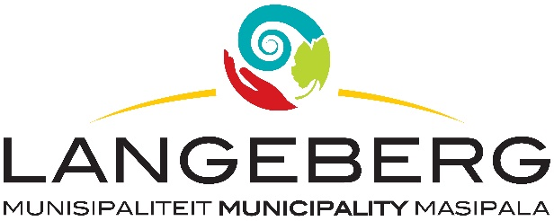

TENDER 12/2024

Tenders are hereby requested for the PROVISION OF SERVICES FOR THE DISCONNECTION AND RE-CONNECTION OF MUNICIPAL SERVICES FOR A PERIOD OF THREE (3) YEARS, as specified in the bid document.

Completed Bids, in sealed envelopes, clearly marked “TENDER 12/2024: PROVISION OF SERVICES FOR THE DISCONNECTION AND RE-CONNECTION OF MUNICIPAL SERVICES FOR A PERIOD OF THREE (3) YEARS,” should be placed in the tender box, at the Langeberg Municipal Office, 28 Main Road, Ashton, not later than 12:00 on 26 APRIL 2024 when the Bids will be opened in public. Late, faxed or e-mailed tenders will not be considered.

COMPULSORY CLARIFICATION MEETING
A COMPULSORY CLARIFICATION MEETING WILL BE HELD ON THE 09 APRIL 2024, AT 10H00, AT LANGEBERG MUNICIPAL OFFICES, 28 MAIN ROAD, ASHTON, IN COMMITTEE ROOM 35, Persons arriving later than 10H15 will not be allowed into the meeting.

This will be a 2 ENVELOPE COMPETITIVE BIDDING PROCESS, comprising of a Technical Evaluation process (FUNCTIONALITY EVALUATION) and a Price Evaluation process (PRICE EVALUATION). Two separate envelopes must be submitted, clearly marked “TECHNICAL EVALUATION” and “PRICE EVALUATION”; and should contain the documentation required for the respective evaluation process.

The Municipality will at first, only open the envelope marked as “TECHNICAL EVALUATION” and evaluate all the Technical Evaluation bid documentation received in terms of the functionality criteria. Bidders scoring less than a minimum score of 15 points out of 30 in respect of “Functionality”, will be regarded as submitting a non-responsive tender and will be disqualified.

The Price Evaluation documentation for all responsive tenders who for - Functionality points have scored a minimum 15 points or more out of 30), will thereafter be opened and evaluated in terms of the Price criteria which includes the Langeberg Municipality’s Preferential Procurement Policy.

Shortlisted bidders may be required to do presentations regarding bid documentation submitted.

PLEASE NOTE:

The official Bid document must be fully completed in black ink, all pages must be submitted and the document should preferably be bound.
Supporting documents must be submitted separately and must be stapled or bound.
The lowest, or any tender, will not necessarily be accepted and council reserves the right to accept any tender. Tenders will be evaluated according to the Council’s Supply Chain Management Policy and the 80/20 Preference Point system. The Supply Chain Management Policy can be viewed at Municipal Offices or www.langeberg.gov.za

Tender documents are available from 22 MARCH 2024, on the Langeberg Municipal website: www.langeberg.gov.za

Please refer written enquiries to MRS J LADOUCE (jladouce@langeberg.gov.za).

DP LUBBE
MUNICIPAL MANAGER
Private Bag X2
Ashton,
6715

