
Specifications

2 x AutoCAD 2022 software packages:
Full discription below :

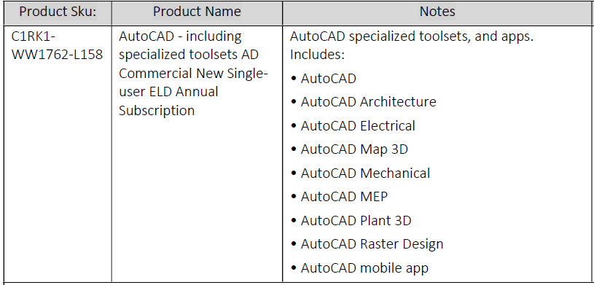

NB! The supplier must have options to give ARC support if needed with AutoCAD 2022 and must have partnership with AutoCAD (proof must be sent along with the quotation).

