SPECIFICATIONS: PHASE 1 WEB-APP AND DATA ANALYTICS SUPPORT FOR THE SOCIAL HOUSING PORTAL
07 November 2023

1. Background:

The goal of integrating the Apartheid city has been continually frustrated since 1994 by the exclusionary urban land market. The high price of well-located land in the urban core and accessible suburbs has displaced low cost housing to peripheral areas, far from jobs and social amenities, thereby reinforcing the spatial divisions and pathologies of the past. In response, there are growing policy efforts to accelerate the delivery of well-located social housing in our cities. Through the Social Housing Programme (SHP), government offers subsidies to third- or private-sector institutions to build and manage medium-density rental housing in well-located areas.

While social housing has received much attention in the media, there is very little public knowledge about actual progress and trends on the ground. A lack of up-to-date and credible information about the delivery of social housing, including details on location, typologies, size, managing institutions, affordability, accessibility, constrains objective assessments, evidence-based debates and opportunities for better planning. While the Social Housing Regulatory Authority (SHRA) collects information about every registered social housing project, there is no publicly accessible database, where residents, researchers, policy makers and social activists can find reliable data needed to inform analysis and debate.

The purpose of this assignment is to assist with the development of an interactive social housing webportal that allows users to explore social housing projects in the country. This is the first phase of the project, which centres on social housing projects accredited with the Social Housing Regulatory Authority (SHRA). The portal will be developed in collaboration with the HSRC and inputs from key sector stakeholders (e.g. Social Housing Regulatory Authority, National Association of Social Housing Organisations, civil society organisations).

2.1 Overview: core requirements

The HSRC seeks to appoint a capable service provider with experience in web-app development AND data analytics to assist in the first phase of developing a social housing portal.

In phase 1, the webportal shall have the following functionality:

Basic webpage setup:
Attractive design that is easily navigable, with informative static content pages about the project, social housing in SA, contact information
Social housing map toolbox:
- Visual mapping of the social housing database (database supplied by HSRC): includes geocoordinates, street address, date of project completion, number of social housing units, delivery agent type, delivery agent name etc.
  - The database has information on approximately 200 observations (i.e. social housing projects) which are located in South African metros and a few secondary cities and smaller municipalities. The file size is currently very small at less than 1mb.
- Interactive map exploration functions such as location search/filter, map pan, base map (that to include basic map elements like roads, suburbs, etc.) and viewing of restructuring zones and social housing projects (all stages – pipeline to constructed). {all data and shapefiles to be provided by the HSRC}
- Integration of additional information layers at neighbourhood or municipal level \in restructuring zones:
  - Population and household data, property valuation and market data, economic data
  - Demographic and socio economic profile
  - Income and Employment
  - Social and Economic amenities

Social housing chart toolbox:
- Dynamic charts which highlight key trends over time and between cities/municipalities based on the social housing database (+- 5 charts)
  - E.g. share of total housing units per city/municipality (pie chart)
  - E.g. total number of social housing units per year per city/municipality (line graph)
  - E.g. total number new social housing constructed each year per city/ municipality (stacked bar)
  - E.g. average rentals, demographic composition, typologies

- Note: these charts could be integrated as additional pieces of the map explorer or as a separate feature. This functionality needs to be discussed as part of the co-design.

Administrator interface:
- An administrative interface should allow the HSRC team to upload an updated version of the social housing database (in a standardised format, with no changes to the configuration, but new ‘observations’ or updated ‘observations’ included). The new database must integrate with the social housing portal (i.e. update the tools).
  - A new version of the database will need to be uploaded on a quarterly basis.
- End user of the web portal should also be able to download the latest version of the raw database. This is a single file download with no restrictions.

Note: at this point we do not foresee the implementation of any user registration system. Anyone will be able to access and explore the web portal with no sign-up/login process. However, a user registration might be added as a feature in the future.

The core tasks include:

- Identification of appropriate technology stack
- Overall Planning and Product Management
  - Plan and co-design the web portal with HSRC team
  - Agree on minimum features, core pages and design elements
  - Co-create content on static sites (e.g. about, background, contacts)
  - Provide training in managing the web portal
- System and Support
  - Hosting
    - Set up a Primary DNS for the web portal and host with the current service provider. Set up application of Email Delivery from this server.
    - Set up the Database and Application Hosting.
  - Database Management Architecture
  - Performance & Security
    - Monitor performance
    - Application Security Updates
    - Application Code Updates
- Admin and Download interface
  - Planning and product management
  - Wireframe design
  - Update of database functionality
  - User download of single raw database file
- Map Explorer UX
  - Planning and product management
  - Wireframe design
  - Map construction
  - Search and city-level display
  - Export data from view
  - Location zoom in and out
  - Aggregate municipal level with shapefile
  - Mobile ready
- Charts UX
  - Planning and product management
  - Wireframe design
  - Figures and bar charts

An example of a web portal with similar features include:
- Spatial Tax Portal (see map explorer tool): www.spatialtaxdata.org.za

The following is an example of a map visualisation based on the social housing database for the city of Cape Town:
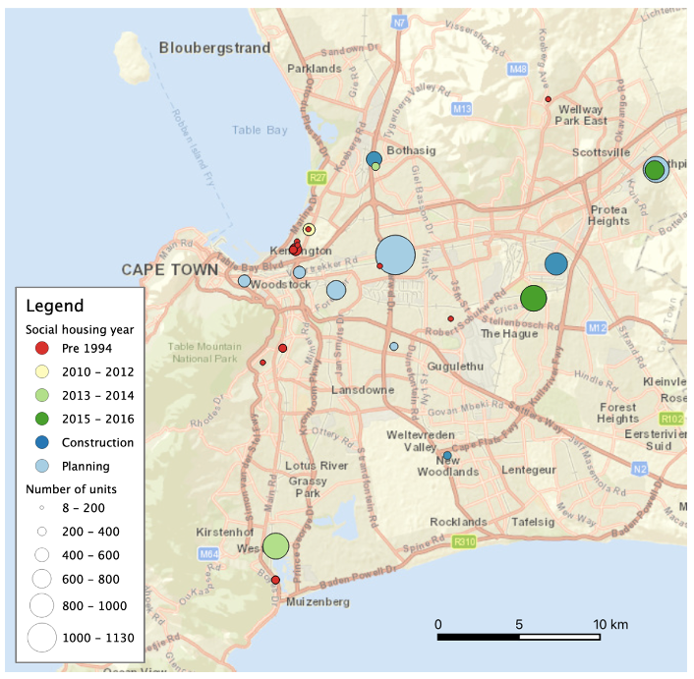

Note that there will be some flexibility in co-design of features to ensure a reasonable workload in achieving these outcomes.

Please note that the HSRC is a research institution and therefore value for money is essential. The delivery of tools and information about social housing is intended for the public benefit.

3.1 Reporting

The service provider will liaise with Dr Andreas Scheba AScheba@hsrc.ac.za Senior Research Specialist, Equitable Education and Economies Division, HSRC.
Thabang Mafa TMafa@hsrc.ac.za Senior Developer will oversee the technical implementation and manage project from the HSRC side.

3.2 Mandatory quotation requirements:

Please provide the following in your quotation to qualify for evaluation:
- Company experience and examples of any related projects
- Qualifications and experience of the lead developer assigned to this project
- Technical workplan
- Breakdown of prices
- Timelines: The project will be delivered over a period of 3 months. There is no flexibility on the timeline so sufficient dedicated project resourcing must be provided in order to deliver within the 3 months.

3.3 Evaluation Criteria

The RFQ will be evaluated on the following functionality criteria:
The evaluation criteria for functionality aim to assess the bidder’s capability, reliability and ability to execute and maintain a bid and / or contract. The minimum functionality criteria is 70%. Bids that score less than 70% on functionality will be disqualified and will not progress to evaluation on Price and preferential points.

CRITERIA | Weight
Functionality
- Track record of the bidder on web-app development and data analytics  The bidder must provide three (3) contactable reference letters (not older than 4 years) to demonstrate track record on web-app and data analytics of a similar scope (public or private) (i.e. relevant reference). The reference letters must be on the bidder’s client letterhead, dated duly signed by an authorized person confirming high quality level of service and effective delivery provided by the bidder.  Points allocation:  1 relevant reference letter = 5 points  2 relevant reference letters = 10 points  3 relevant reference letters = 15 points | 15
- Company profile which demonstrates the experience of the company in web-app development and data analytics  The bidder must provide a company profile in sufficient detail to demonstrate experience in web-app and data analytics development. The profile must illustrate experience of relevant related projects.  Points allocation  One similar project = 5 points  Two similar projects = 10 points  Three similar projects = 15 points | 15
- Capacity and experience of the proposed team leader and project staff  The Project Manager  Must have relevant qualification plus CV with at least 5 years’ experience of managing similar projects as per scope of work. (10 Points)  Points Allocation (Project Manager)  5-7 years= 5 points  8 and more years=10 points  Technical Team  Must have relevant qualifications and with experience in technology/skills as per scope of work. Their experience and skills must be demonstrated by provision of recently updated CVs listing technical skills and work on projects making use of these skills, proof of highest qualification should also be provided.(20 Points)  Points allocation (2 technical staff):  5 - 7 years = 5 points  8 -10 years = 15 points  11 years and more = 20 points | 30
- Methodology and approach of the bidder  The bidder must submit a comprehensive technical workplan where the bidder is required to demonstrate understanding and response to the scope of work and the approach on how the project will be managed through its entire life cycle according to the following key aspects:  - Comprehensive workplan  - Detailed process mapping methodology which links to required technology deployment to complete the scope of work  Points guidance allocation:  Excellent methodology and approach= 40 points  Good methodology and approach= 30 points  Sound methodology and approach= 20 points  Insufficient methodology and approach = 5 points | 40
TOTAL (Functionality) | 100

Bidders should obtain a minimum of 70% on functionality in order to be considered for price and Preferential Points.

Briefing Session Date: Thursday 23 November 2023@14:00 -15:00
Enquiries Purposes: Andreas Scheba. AScheba@hsrc.ac.za

