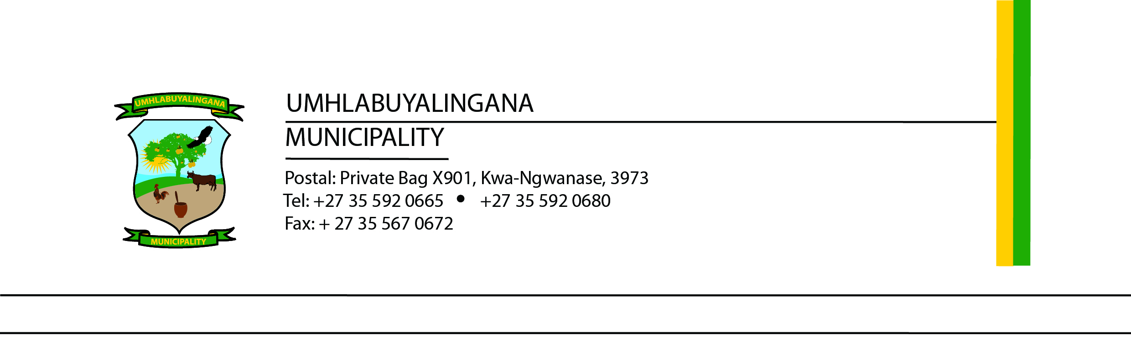

INVITATION TO BID
TENDER NUMBER: UMHL14/2025/2026
The Municipality invites bids for the Procurement and Renewal of Microsoft 365 Business Standard Licenses for 160 users for one-year subscription.
Scope: Supply, renew, and support Microsoft 365 licenses, ensuring uninterrupted access to cloud services (Email, OneDrive, SharePoint, Teams, Office Apps, etc) and compliance with South African data laws.
Requirements:
- Accredited Microsoft Cloud Solution Provider
- Proof of Microsoft Partner status
- Demonstrated experience in similar public sector projects
- Compliance with all statutory documents (Company Registration, SARS Tax, CSD, Municipal Rates Clearance, COIDA, etc.)
Evaluation: Functionality scoring with a minimum of 60% to proceed to pricing. The 80/20 preference point system applies.
Closing Date: 09 April 2026 & 12h00.
Sealed bids must be clearly marked and submitted to the Municipal Offices on R22 Manguzi Main Road, Kwa-Ngwanase, 3973. No late, faxed, or emailed bids will be accepted.
Enquiries:
Technical: mxolisin@mhlabuyalingana.gov.za for attention of Mr Ngubane (IT Manager)
SCM: bafanam@mhlabuyalingana.gov.za for attention of Mr NM Mthembu (SCM Manager)
Council reserves the right to appoint in part or whole or cancel this project at any time.

………………………….
Mr NPE Myeni
Municipal Manager

