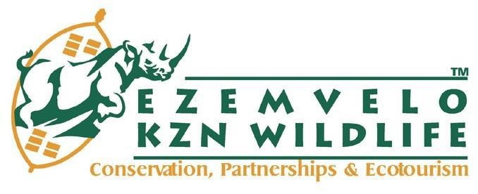`

INVITATION TO QUOTE
RFQ NUMBER: | EKZNW06.05.2024
DESCRIPTION OF GOODS/SERVICE/WORK REQUIRED: | REQUEST FOR QUOTATION: PROVISION OF LAUNDRY SERVICE AT CHEMSFORD NATURE RESERVE FOR A PERIOD OF ONE YEAR.
REQUIRED CIDB GRADING | N/A
COMPULSORY BRIEFING SESSION DATE & ADDRESS: | Date: 23 May 2024  Time: 11:00  Venue: Chelmsford Nature Reserve Ezemvelo KZN Wildlife, Newcastle
CLOSING DATE AND TIME: | Date: 31 May 2024  Time: 17:00
BID VALIDITY PERIOD: | 90 calendar days (commencing from the Closing Date)
QUOTATION DOCUMENT MUST BE SUBMITTED BY E-MAIL TO: | procurement@kznwildlife.com
FOR ATTENTION:

NAME OF BIDDER:
QUOTE PRICE
BIDDERS SIGNATURE:

