- INSULATION RESISTANCE TEST (TIN8D 15kV)
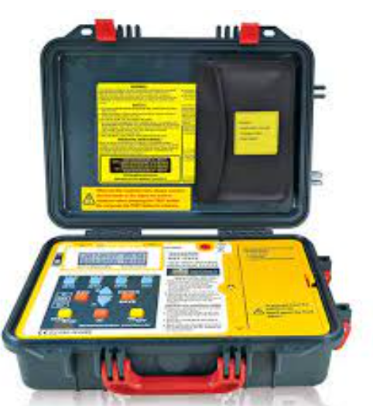
- Resistance range:
- 10 k to 15 TΩ @ 15 kV
- Insulation test voltage up to 15 kV
- Test insulation resistance up to 30 TΩ (30000 GΩ)
- Short circuit current up to 5 mA
- Auto hold function to freeze the reading
- Overload protection
- 30 insulation test voltages
- Adjustment for testing time (duration) : 1~30 minutes
- Auto off
- Software included
- USB to RS-232 data transmission.
- 200 Measurement results can be saved and recalled on the display

- HIGH POWERD SURGE WAVE GENERATOR “WITH IT’S ACCESSORIES”(SWG 1750):
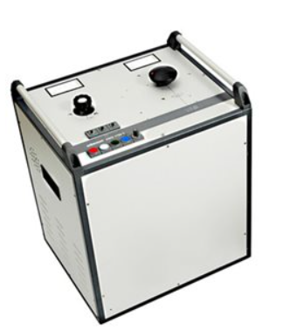
- AC Supply Voltage: 90-264 V rms
- Out put voltages in steps: 0, 8kV, 16kV, 32kV
- Voltage reflection: Analog
- Current(leakage) reflection: Analog
- Weight: 140kg
- digiPHONE+
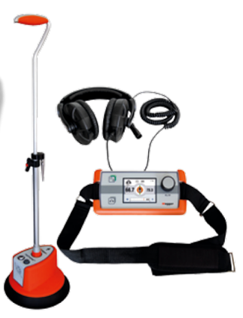
- Display :
TFT-colour display, 320 x 240 Pixel
- Safety :
Volume limitation to 84 dB (A)
- Gain :
120 dB, automatic
- Supply :
6 x LR6 Alkali-Mangan batteries
- Operation time:
> 10 hrs.
- Protection rating :
IP 54
- Dimensions (H x W x D) :
65 x 225 x 100 mm
- Weight :
0.9 kg (incl. batteries)
- Sensor DPP-SU
- Dimensions:
Diameter 230 mm (outer rim)
- Height:
140 mm
- Handle length:
480 ... 750 mm adjustable
- Weight:
2.2 kg (incl. batteries and handle)
- Dynamic range:
Magnetic channel > 110 dB
- Acoustic channel > 110 dB:
- Frequency range:
100 ... 1500 Hz
- Filter stages OFF:
100 ... 1500 Hz
- Low pass:
100 ... 400 Hz
- Band pass:
150 ... 600 Hz
- High pass:
200 ... 1500 Hz

- Protection rating:
IP 65

- Multimeter (AVO410):
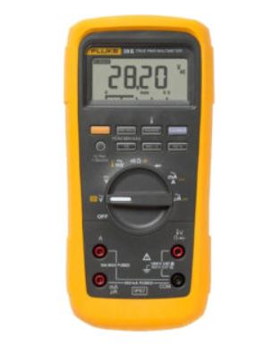
- Voltage measurementsBoth AC and DC:
- up to 750 V and 1000 V respectively are possible with the AVO410, the AC reading being a true RMS value.
- Current measurements:
- up to 10 A, a separate fused terminal is provided to protect both user and instrument from excess current.
- Continuity / diode testing
- The continuity function features a buzzer and provides the user both optical and audio indication of identifying and confirming continuity between two points. This function also allows forward and reverse bias testing of diode and semiconductor junctions.
- Resistance, capacitance and frequency
- Resistance can measured directly on the ohms range from 0 to 60 MΩ with capacitance measurements from 0 to 6.000 Mf.
- In addition, frequency measurements from 0 to 60 MHz are possible.

- RCL Multimeter (LCR-4070):
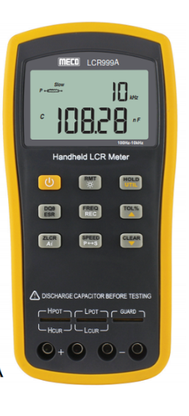
- Technical specification
- 3½ Digit LCD Display
- 2000 Counts
- Large LCD Display
- Full Protection function, capacitor with the function of Self discharge
- Auto Power OFF

- Basic Functions :

- Resistance
- Capacitance
- Inductance

- Range :
- 200pF / 2nF / 20nF / 200nF / 2μF /
- 20μF / 200μF / 2000μF
- 200μH / 2mH / 20mH / 200mH /
- 20Ω/ 200Ω/ 2kΩ/ 20kΩ/ 200kΩ/ 20MΩ

- Clamp Multimeter (preferable, DCM 2608):
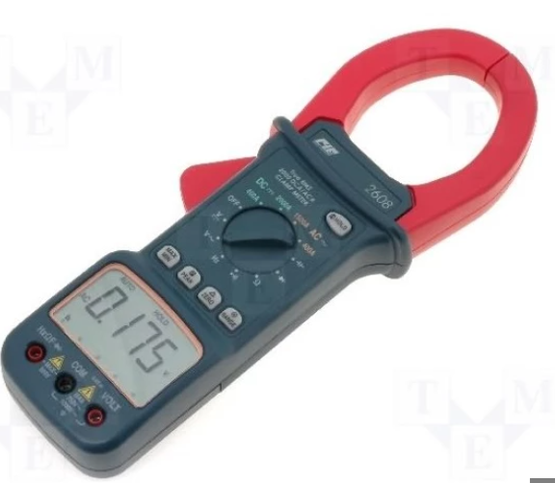
- Display: 3 3/4 digit(4000 counts), 9999 counts(Frequency Mode), 42 segment Analog bar graph and function/units sign annunciators.
DC Voltage Ranges: 400mV,4V,40V,400V,1000V, ±(0.5%+1dgt)
AC Voltage Ranges: 400mV,4V,40V,400V,750V,±(1.5%+4dgts)
AC Current Ranges: 200A,1500A,±(1.5~5%+5dgts)
DC Current Ranges: 200A,1000A,±(1.5~5%+5dgts)
Resistance Ranges: 400Ω,4kΩ,40kΩ,400kΩ,4000kΩ,40MΩ, ±(1.0%+4dgts)
Continuity Test: Audible indication
Polarity: Automatic (-) negative polarity indication.
Overrange indication: MSD (Most Significant Digit) blinks.
Lower Batery indication: the ""battery sign"" is displayed when the battery voltage drops below accurate operating level.
Measurement rate: 2/sec. nominal 1/sec. Capacitanc and Frequency mode. 20/sec. Analog display.
Operating Environment: 0 °C to 50 °C at < 70% RH
Storage Environment: -20 °C to 60 °C at 80% RH
Temperature Coefficient: 0.1 x (specified accuracy)/ °C ( < 18 °C or > 28 °C)
Auto Power Off: 30 minutes after rotary switch or mode changes.
Altitude 6561.7 Feet (2000M)
Power : One standard 9-Volt battery, NEDA 1604, IEC 6f22, jis 006P
Battery Life: 100 Hours typical with alkaline battery.
Jaw Opening Capacity: 57 mm conductor , 70 x 18 mm bus bar.
Weight: Approx. 18.9 OZ/ 540 g grms (including battery).
Dimensions: 10.9""x4.0""x1.9"" (277x102x49mm)
Accessories: Test leads; soft carrying case, battery, and owners manual

- DC-AC Hipot-tester (HVA60)
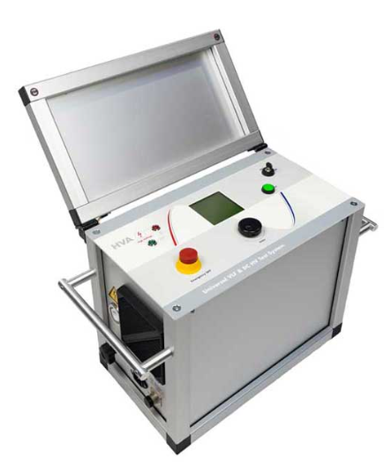
- Power Supply/Input Voltage:
110 to 240V AC ±10% (50/60Hz)
Input Power Requirements:
1.5kVA
Rated Max Output Voltage:

Sinusoidal RMS/Peak
44kV / 62kV
Squarewave
60kV
DC
±60kV
Rate Max Output Current:

Sinusoidal RMS
26mA
DC/Squarewave
40mA
Output Frequency (default 0.1Hz):
0.01Hz to 0.1Hz adjustable small increment of 0.01Hz (10 frequencies)
Frequency Optimization:
Yes
Maximum Output Load Capability @ MAXIMUM voltage and frequency:
1 µF
*10,000ft
*3km
Maximum Output Load Capability @ REDUCED voltage and/or frequency:
10 µF
*50,000ft
*15km
Metering:

Voltage
0.1kV Resolution ±1% Accuracy
Current
1 µA Resolution ±1% Accuracy
Capacitance
0.1 nF to 20 µF Range
Resistance
0.1MΩ to 20GΩ Range
Timing
Included and integrated
Fast Arc/Flashover
Detection included and integrated
Waveform
Real time oscilloscope display of actual output voltage waveform
Output Mode (all load independent & symmetrical):
VLF AC Sinewave
VLF AC Squarewave
DC (both Positive and Negative Polarity)
Fault Condition Mode / Fault Trip Mode
Vacuum Bottle Test Mode (DC) - optional
Cable Jacket / Sheath Test Mode
Output Duty:
Continuous
Computer Interface:
RS232 Standard, USB Flash Memory Download Module (optional)
‍
HVA Control Center Software included with every HVA instrument

Memory / Test Record Storage:
‍
Built in Memory
50 Test Records
USB Flash Drive
Unlimited (see options)
No. of programmable Automatic Test Sequences:
40
Standard HV Test Lead Cable Included:
15ft / 4.5m

Weight:
126 lbs / 57 kg
Dimensions:

Imperial (inches)
18 x 13.5 x 20.5"
Metric (mm)
450 x 340 x 520 mm
Environmental:

Storage
-13°F to 158°F / -25°C to 70°C
Operating
23°F to 113°F / -5°C to +45°C
Humidity
85% RH non-condensing

Millivolt injector(preferable Fluke 715 Volt/mA Loop Calibrator)
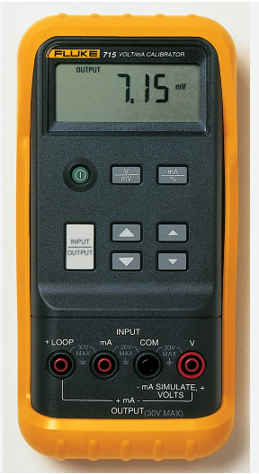

Key features
- Compact mA calibrator for measuring 0-20 mA or 4-20 mA signals
- High accuracy—0.01% and 1 µA resolution
- Measures voltage output process signals from PLCs and transmitters
- Sources or simulates 4-20 mA loop current
- Sources voltage to 100 mV or 10 V
- With all required accessories

- 4kV DC voltage injector
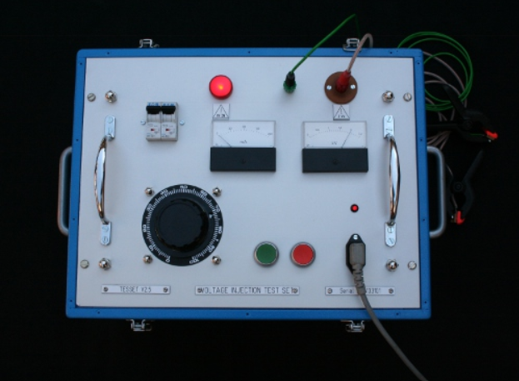
- DC output power: 0 – 4kV DC
- Measurement of voltage 0-4kV
- Class: 1,5
- Measurement of current: 1mA - 5mA
- Automatic trip on fault circuit and over loads
- Class: 1,5
- Automatic discharge circuit after use
- Buzze button
- Weight: max of 15 kg
- Power Supply 100 – 240 VAC 50/60HZ
- Operating Temperature -10ºC/ +50ºC

- 200A DC Current injector

- Voltage regulator (Variac), load transformer and rectifier must be incorporated on one test unit or two separate units.

Input Power Supply | AC: 220V· 25A, 50Hz.
Output Current | AC: 1000A·5V or 500A·10V.
Output Current “DC” | 200 A DC current
LCD Screen Digital Display | Simultaneous display of primary current and secondary current as well as the turn ratio;
The Range of Primary Current | 0~1100A, Resolution: 0.1A;
The Range of Secondary Current | 0～6A; Resolution: 0.001A.
Stopwatch | 0.0001～999.99S precision ±5 significant figures.
Precision | TRUE RMS ±0.5%.
Duplicate Protection (electronic overload protection and software protection).
Usage Environment | Temperature -10~40℃,
Relative humidity | <80%.
Volume | 430×260×260mm³.
Weight | < 30kg.
Accessories | 2x High current test leads, 1 earth lead, 1x powe supply lead, double core sheathed wire, small clip: 2x black & 3x red

- Three phase turn ration test
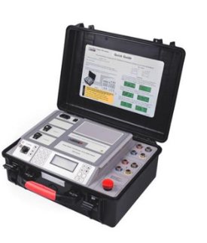
Rating | Variable Ratio - 0.9～10000 Angle - 0-360°
Angle measurement | 0-360°
Accuracy | ±0.1% (below500) 0.2%(501-2000) 0.5% (2001-10000)
Output voltage | Automatically adjusted according to load
Resolution | Minimum is 0.0001，Angle - 0.01°
Working power supply | AC 220V±10% 50Hz
Applied temperature | -10℃～40℃
Relative humidity | ≤85%, non-condensing
Dimension tester | 360*290*170(mm)
Wire box | 360*290*170(mm)
Weight | Tester 5.9KG Wire box: 5.65KG
Accessories | 1x black test line, 1x red test line, 1x power line, 1x earth lead, Print paper, and 2x fuses

