- MOISTURE PROBES

Package to include the following;
5 X AquaCheck Basic II Wireless Probes
- 6 sensor probes
- Size – 800mm
- 868MHz
- For use with the BIII wireless logger
1 X AH BIII RF Hand logger (4637-LME)
1 X Hand auger, 32mm x 1.2m
1 X Software setup
Courier and delivery costs

As in photos;
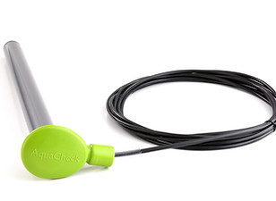Probes
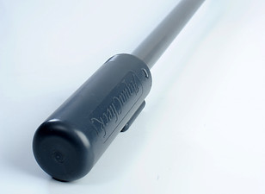 Hand logger

