Annexure A5 10.2 AS IS Design

Current as Built Schedule

AS-IS GBN Design
The following information serves to provide an indication of how the current GBN solution including associated applications and systems are architected and implemented. These different building blocks will have to be taken into consideration when designing the proposed solution. This will include re-use and possible upgrades to increased capacity requirements.

GBN Topology and Architecture
Below is the GBN network topology diagram showing the network solution for GPG.
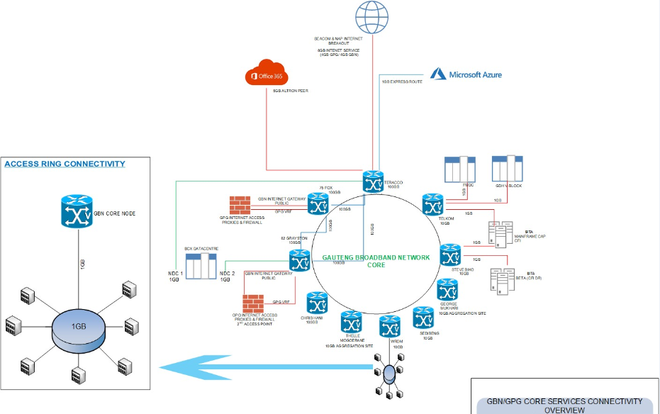
Figure 1: GBN Network Topology
The eight cores site are interconnected on the transmission layer with Dense Wavelength-Division Multiplexing (DWDM) equipment allowing for link redundancy with multiple channels/links through a single pair of fibre cable. On the IP layer, the Core router routes all traffic via MPLS protocol and the Core distribution switch connects all access sites to that particular core site. The two distribution sites are connected via the IP layer only with a Core router and switch. The IP layer and Optical layer link protection will be provided. Access sites are protected by ring protection.

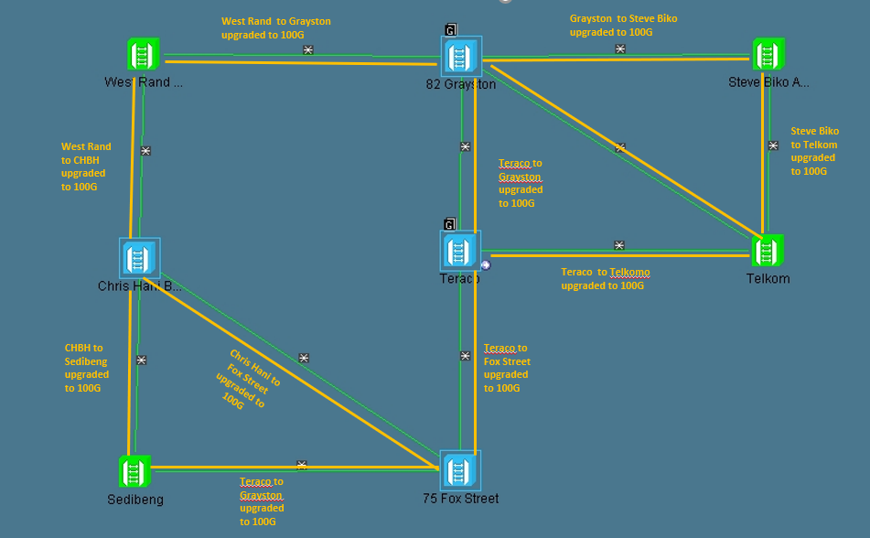
The Above network diagram depicts DWDM core backbone with the 8 cores sites that was upgraded to 100G highlighted in brown

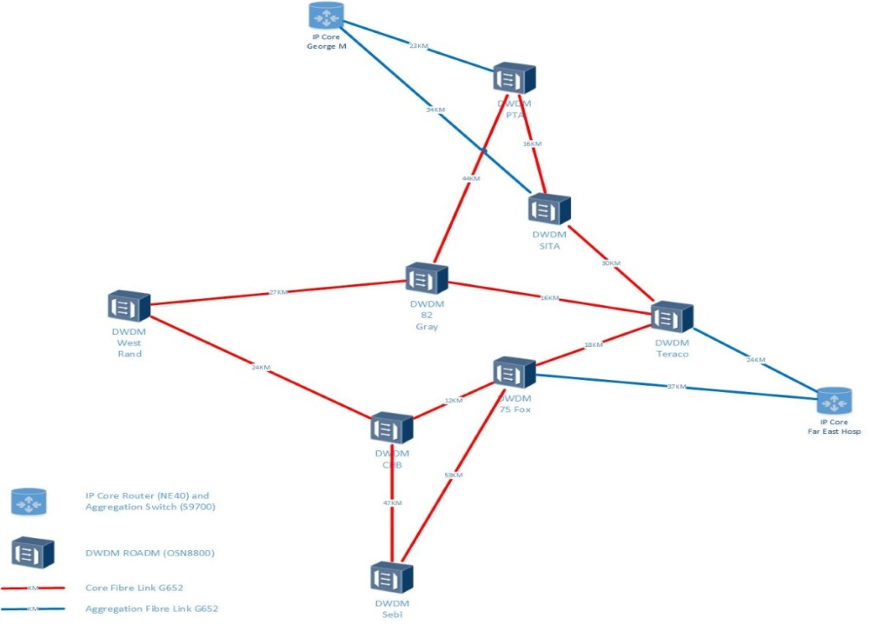
Figure 2: Optical backbone network

LAN Topology
The LAN is designed to provide minimum 1Gbps connectivity to the end user device. All equipment used supports 10Gbps backbone transmission but currently 1Gbps fibre modules for backbone connectivity are used.
The basic component used:
- Fibre distribution switch
- Fibre cabling (OM3)
- LAN Access Switch
- Fibre connection modules
- UTP Cabling (CAT6)

The design principals:
- Each segment of the network connects directly to the distribution switch. No daisy chain connections allowed
- Only fibre cabling to be used in the backbone
- All UTP used is CAT 6
- All cabling installed complies to OEM specifications and approved cabling standards

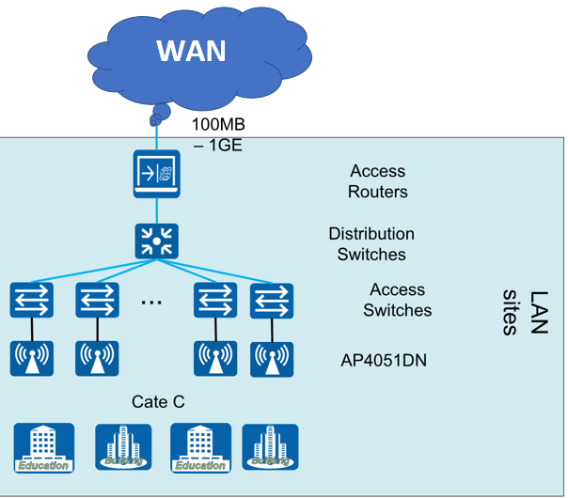

Network Management System
The GPG has setup a NOC facility in their Grayson Drive centre. The department has purchased the NMS tool. The tool is licensed for the current installed base. The HR component has been outsourced.
To manage the network, GBN has implemented Huawei Network Cloud Engine (NCE) equipment management system. It is also a major future-oriented Network Management Solution (NMS) that provides powerful element management and network management functions. The current NMS solution also includes the following functionalities:

Network elements (NE) or devices on boarding and plug-and-play

Basic configuration: Single NE configuration in the NE Explorer and batch configuration

Network monitoring: Topology, alarm, and performance

Service management: Tunnel, PWE3, and WDM/SDH

Maintenance and diagnosis: DC upgrade, TCAT, and diagnosis tool

North Bound interface: See the NBI compatibility description

Security management: All inherited

System settings: All inherited

Distribution and Access Networks
In addition to the eight core locations and two (2) aggregation nodes, GPG Broadband Network is currently providing connectivity to 1496 Sites. Access sites are connected by 1Gbps protection rings to each other and via dual 1Gbps connections to one of the core locations. Each Core node is designed to host access rings made up of a maximum of 10 access sites in a ring. In case where fibre connectivity is not feasible, Microwave is used as a transmission medium, which connects to the transmission fibre backhaul. All microwave sites use licensed spectrum which is leased from the microwave provider
Each core node has a distribution switch, with up to 24 x 1GB SFP access ports. The access network for each building has a pair of single-mode fibre (SMF) for each network end point (terminating equipment).

Access Layer
Service Delivery – The core network is currently providing the following services:
- Internet Services: GBN currently provides an 15 GB bandwidth internet solution, International traffic is routed through Seacom and NAP Africa peering.
- Virtual Private Network Services
- IP Telephony Services – GBN Core Voice switching is SIP based.
- Microsoft peering – 5GB bandwidth.
- Microsoft express routes - 1GB bandwidth.

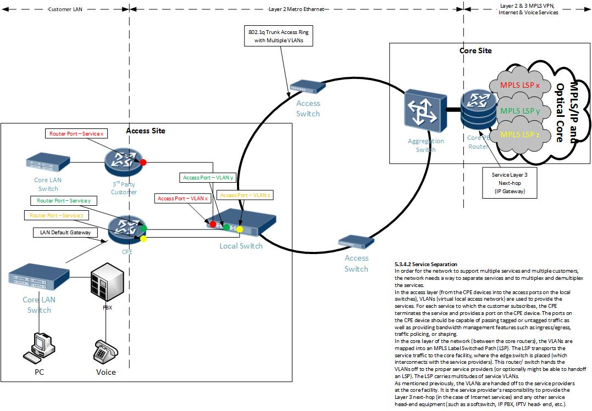
Figure 3: GBN Access Layer Network

Aggregation Switch
Huawei Aggregation switch (S9700) is installed at each Core location and is used to aggregate all the access rings and provide high performance switching in to the MPLS core backbone network. The Aggregation switches use ERPS as a layer 2 redundancy protocol to ensure sub 50msec access ring protection.

WAN Access Switch
Huawei S5700 series WAN Access Switch is installed at each access site and provided the following functions:
- High Performance switching of Ethernet packets.
- Optional upgrade to 10Gbps uplinks with full forwarding and switching performance.
- Access site aggregation of multiple customers and services
- Full ERPS protection for fast failover on Access rings when a fibre link breaks.
- QoS policies on access port; and
- Configuration and management on access ring configuration and redundancy.

WAN Access Router
Huawei AR1200 and AR2200 series WAN Access routers are installed at access sites and provided the following functions:
- Connects to the access switches S5700
- Does enhance Routing of traffic from access LAN and to the GBN Core and vice versa.
- Connects to the Customer LAN at each access sites.
- Supports optional interface cards for additional services I.E. Wireless, Voice, LTE
- Integration of routing, switching and security functions in a single device.
- QoS policies, VPN and security are some of the key features.

Voice Platform
GBN has implemented Huawei IP Multimedia Subsystem (IMS) platform to enable centralized VOIP service to all facilities on the GBN Network. Currently GPG has legacy PBX, (both analogue and IP PBXs) and Central Cisco Call Manager with full redundancy has been installed at e-Gov (75 Fox Street) and Teraco. Those PBXs are integrated with the IMS by two different ways as below:
- Existing Analogue PBX integrating to the CPE router’s E1 ports, the SIP Trunk of the CPE provide SIP Trunk capability to IMS,
- Existing IP PBX integrates with IMS via direct SIP trunk.

Centralised Unified Call Manager (CUCM) with Voicemail
Below are the components deployed to provide Centralized PBX services to GPG:
- CUCM (1 Publisher, 4 Subscribers, 2 TFTP servers and 2 Media Resource Servers)
- Cisco Unity Connection (1 Primary and 1 Secondary)
- Cisco CUBE Router (2 Cisco ISR4431)
- Cisco Analog Gateways (VG350 or VG450)
- Cisco Unified Attendant Console
- CA UIM Monitoring Tool
- Cisco Analogue Voice Gateway is deployed for Analogue devices at the sites. Each Voice Gateway is capable of handling 144 devices. Existing analogue Phones and Fax machines are configured with Analogue Gateways.
- The Cisco Centralized PBX Cluster is integrated with the existing IMS. All Incoming/Outgoing calls from one site to another are traversing through IMS.
- Cisco Centralized PBX is deployed at 2 Data Centers, i.e. Teraco and 75 Fox Street
- Teraco Data Center is the primary location for hosting the UC core components required to provide UC Service for GPG and 75 Fox Street is the secondary location for providing the redundant services. Core applications deployed at both the location are working in active-active mode and providing services in load balanced mode handling 144 devices. Existing analogue Phones and Fax machines are configured with Analogue Gateways.
- CUCM Licenses composition :
Type | Product Type | Purchased | Installed
Enhanced Plus (12.5) | Unified CM | 200 | 200
Enhanced (12.5) | Unified CM | 1674 | 1674
Basic (12.5) | Unified CM | 2140 | 2140
Essential (12.5) | Unified CM | 3500 | 3500
Basic Messaging (12.5) | Unity Connection | 5600 | 5600
SpeechConnect Port (12.5) | Unity Connection | 4 | 4

Figure below shows an overview of physical technology architecture of the VOIP solution:
Figure 4: GBN VOIP Solution

Teraco Hardware CUCM Primary Site
- Cisco UCS C240 M4 server
- Lenovo Server
- Cisco Router ISR 4431 x 2

Software:
- ESXi 6.5 hypervisor for Virtual Server Management
- Cisco Unified Communication Manager version 12.5
- Cisco Unity Connection Version 12.5
- CA Unified Infrastructure Management
- Cisco Unified Attendant Console

75 Fox Street hardware: CUCM Secondary Site
- Cisco UCS C240 M4 Server

Software:
- ESXi 6.5 hypervisor for Virtual Server Management
- Cisco Unified Communication Manager version 12.5

CUCM Features
Feature List | IP Phone
Basic call | √
Call forward all | √
Call forward busy | √
Call forward cancel | √
Call forward no answer | √
Call hold or resume | √
Call pickup group | √
Call pickup local | √
Call transfer blind | √
Call transfer consultative | √
Call waiting | √
Caller ID | √
Caller ID on call waiting | √
PIN based dialling | √
Conference call | √
Meet-me conference call | √
Directed call park | √
Directed call pickup | √
Directed call pickup of ringing extension | √
Redial | √
Speed dial | √
Call toggle | √
Music on Hold (MoH) | √
Precedence and pre-emption | √
Call Park and Directed Call Park | √
Call Pickup | √
Cisco Extension Mobility | √
Cisco Unified Mobility | √
Cisco Mobile VoIP Clients | √
Cisco Web Dialler | √
Device Mobility | √
Do Not Disturb | √
Immediate Divert | √
Presence | √
Quality Report Tool | √
Phone Login | √
Active Directory Integration | √
Message Waiting Indicator | √
Single Number Reach | √

IP Telephone Handsets

Requirements
Executive Level IP phones

- Large graphics display (160 x 320) with at least 24 programmable keys, fixed function keys: Hold, Settings, Message, Speaker, Mute, Transfer/Conference, Redial, Dual-mode phone: support for SIP protocols, Dual-port IP phone (10/100 Mb integrated Ethernet switch), dedicated headset interface
- POE Class 2
Standard IP Phone

- 16 MB of memory to support unified communications applications
- 12 programmable keys with dual-colour LED indicators (for speed dialling, line appearances, feature access, etc.)
- Dual-port (10/100 MB switched Ethernet), Dual-mode (supports SIP)
- POE Class 1
Standards for both Executive and Standard IP Telephone

- Support for SIP protocols and wideband audio support
- Page Send/Receive, on-hook dialing, off-hook voice announces and hands-free answerback, Hearing aid-compatible phone, two-position,
- Use of RJ45 cable to power the phone
- Speed dialing keys
- Voice Mail key
- Allow auto-negotiation on both ports (LAN and PC)
- Standard Colours (Charcoal)
- Placing/Mounting: Table-top, wall-mounted

Switchboard console
Requirements
Switchboard Software

- Web-based administration utility
- Support JAWS Scripts
- MS-Outlook Integration

Queue Features

- Support for three queues with prioritization
- Operator queue assignment
- Queue operator views
- Overflow options
- Music in queue

Directory Features

- Support for up to 500 IP phone users
- Directory integration
- Personal directory groups
- Search options
- Presence integration
Telephony Features

- Operator handset ringing
- Transfer reversion (call recall)
- Call park
- Call park recall
- Call toggle
- Conference
- Emergency Mode switch
- Night service

Audio codes Voice gateway
There is currently an install base of 30 x audio codes, model M800B and M500B which provides versatile connectivity between legacy TDM-based PBX systems to IP networks. The audio codes mediant session border controller is the interface between the site PBX’s and the Huawei IMS where SIP trunk is connected. SBCs form an effective demarcation point between the business’s VoIP network and the service provider’s SIP trunk, performing SIP protocol mediation and media handling (interoperability), and securing the enterprise VoIP network. The specifications of the installed base, based on site requirements are:
- Mediant 800B Enterprise Session Border Controller (E-SBC) - 60 sessions.
- Includes Mediant 800B chassis, 6 Active/Standby pairs of FE/GE ports, 2 pairs of GE ports and 4 pairs of FE ports, single AC power supply and software license for 60 E-SBC sessions.
- Mediant 500B Enterprise Session Border Controller (E-SBC) - 30 sessions.
- Includes Mediant 500B chassis, 6 Active/Standby pairs of FE/GE ports, 2 pairs of GE ports and 4 pairs of FE ports, single AC power supply and software license for 30 E-SBC sessions.

Mediant Session Border Controller (SBC) features
- Powerful SIP normalization and routing mechanism for seamless interoperability
- Support for analogue and digital Time Division Multiplexing (TDM) interfaces
- Hybrid SBC enables seamless migration
- Internet Protocol version (IPV6) and Internet Protocol version (IPV4) support
- Enhanced perimeter defence against Denial of Service (DoS) Attacks
- Advanced monitoring tools to analyse and optimize VoIP service quality-of-experience
- Embedded Digital Signal Processors (DSP) performs advanced media handling

Telephone Management System (TMS) - (Rampage)
VSA RAMpage is a Resource Accounting and Management software, is designed to collect, analyse, and interpret important information from a multitude of data sources and data source types, relating it to a directory of users and contacts, empowering your organisation's managers to make decisions that improve employee productivity, optimise usage of resources, and control and allocate costs by implementing budget barring.
The TMS is used for all the calls accounting: This is the monitoring of outbound, inbound, and internal call traffic to establish the level of use, misuse, and abuse of telephony resources, and enable the billing back thereof to individuals and departments. It is also used as a tool to establish peak call periods to enable an organisation to determine line availability, call traffic pattern analyses to specify optimum least cost routing solutions, and view operator answer response times to determine customer satisfaction. It is also used as a tool to implement as budget barring solution based on department’s requirements and call limits.
TMS Rampage resources:
- Telephone Management System currently setup and configured on the Application server
- Collects and process data made from the Cisco Call Manager.
- Presents detailed reports drawn up for Cisco Call Manager Devices and Users for the different departments;
- Quota Management – Exercise Budget Control and set predetermined limits for Users.
- Microsoft SQL Database and Server
- Data Collection / Processing from Cisco Call Manager
- Processing Alert Wizard
- Directory Import
- End User and Administrator Training

The IP multimedia subsystem (Huawei IMS)
The IP multimedia subsystem (IMS) network unifies access of broadband, VoIP and fixed networks such as PBX’s;
- It provides convergent and IP-based multimedia services,
- facilitate transformation from fixed mobile convergence (FMC)
- Traditional voice services to ICT convergent services.
- Implements authentication for IMS subscribers,
- Sessions controls,
- Manages roaming mobility,
- controls bearer-plane QoS and media resources,
- Enables interconnection and interworking.
- Consists of various application servers and resource servers, provides diverse services (such as traditional voice, and instant messaging) and service capabilities (such as group and media resources).

Session Initiation Protocol (SIP)
The Huawei IMS is equipped with 1150 SIP channels that enables end user to dial directly to all fixed-line or mobile networks. The current installed base of 285 VOIP sites has been ported to Liquid Telecoms. SIP provider has the following services:
- Configuration of number of simultaneous calls per SIP trunk.
- Monitoring tool for SIP trunk performance.
- Port numbers from previous service provider
- Offer their customers real-time voice
- Provide DID range to be allocated for new sites.
- High availability and uptime through fully redundant core network.
- Competitive local and international call rates featuring per second billing, from the first second.
- A selectable number of Direct Inward Dial (DID) numbers.

OSS and BSS for Voice Services.
OSS and BSS are customer management solutions that allow the provisioning, bill and manage all VoIP services being offered on the GBN VoIP network.
The current Astel’s Globill product allows for
- Metering,
- Rate and tariff different technologies such as GSM, VOIP and more.

Product list of current Installed Network and Voice equipment
Current product model as reference:
Network Position | Current Equipment / Product(s) | Install Base
Core-DWDM | HUAWEI OSN8800 | 8
Core-DWDM | HUAWEI OSN9800 (100G) | 4
Core-DWDM | HUAWEI OSN6800 | 22
Core-Internet Gateway | HUAWEI NE40E | 2
Core-Firewall | HUAWEI USG9560 | 2
Core MPLS Router | HUAWEI NE40E | 8
Core MPLS Router | NE8000 (100G Core Router) | 4
Aggregation Metro Ethernet Switch | HUAWEI S9703 | 10
Access-Switch | HUAWEI S5700-28C-SI-AC | 1082
CPE | HUAWEI AR1220 | 1235
CPE | HUAWEI AR2220 | 317
CPE | HUAWEI 6140 | 9
WLAN Controllers | Huawei Controllers 6800V (public) | 2
WLAN Controllers | Huawei Controllers 6800V (cooperate) | 2
WLAN Controllers | Nokia Controllers Airscale (schools, Health and OOP)  *(Not a GPG asset) | 2
WLAN Access Points | Public at 75 Fox street | 166
WLAN Access Points | Hauwei AP | 3599
WLAN Access Points | Nokia AP (schools, Health,OOP) | 533
Cloud Campus  HUAWEI AGILE CLOUD CAMPUS ACCESS CONTROLLER  Agile Controller-Campus V100R00 | Huawei Cloud Campus WIFI  FusionSphere Virtualization Suite  FusionSphere 6.5.1 & 8.0 Software  CloudCampus@AC-Campus HW V300R0  Cloud Management Platform Basic Software  Cloud Management Platform Basic Software  d Management Platform Basic Software | 1
Access Points – cloud campus | AP4050DN access points | 5204
LAN | 24 Port S5720-28X-PWR-LI-AC | 359
LAN | 48 Port S5720-52X-PWR-LI-AC | 465
LAN | 125 - S6720-16X-LI-16S-AC | 125
NMS | HUAWEI NCE | 1
Voice Platform | HUAWEI IMS | 1
Cisco Centralised PABX | Cisco Unified Communications Manager | 1
Cisco Core Gateway Routers | Cisco CUBE ISR4431 Routers | 2
TMS | Rampage | 1
OSS | HUAWEI OSS | 1
BSS | Astel Globill BSS | 1
Service Desk | CATS | 1

