Annexure A
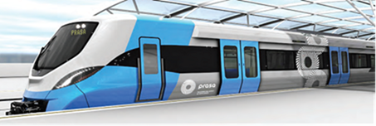

PROJECT SPECIFICATION AND BILL OF QUANTITY
FOR:

REQUEST FOR QUOTATION FOR PROCUREMENT OF SAFETY HARNESSES AND RESCUE KIT.
Contents

1. The technical specification for various tools………………………………………………………1-4
2. Bill of quantities...………………………………………………………………………………………..……5
3. Benchmark……………………………………………………………………………………………………..…6

1.1 Provide special training to 25 people for Working at heights.
1.1.1. Requirements
- 25 people will be required to be grouped into two groups.
- Training to take place for maximum of four days.
- Training to be done at Salt River Depot.
- Training dates to be scheduled with successful bidder.
- Certificate must be given after training and assessments are done.
- New equipment that is requested on this RFQ can be used for training.

1.1.2. Areas to be covered by the training

- Legal compliance
- How to Conduct Risk Assessments
- Fall protection Plans
- Principles of fall arrest and fall arrest equipment
- Inspection and maintenance of fall arrest equipment
- Practicals and assessments

1.1.2. Registered Unit Standard

Install, use and perform basic rescues from fall arrest systems and implement the fall protection plan

SAQA US ID | UNIT STANDARD TITLE
229995 | Install, use and perform basic rescues from fall arrest systems and implement the fall protection plan
ORIGINATOR

1.2 Technical specification for Powerlines Full Body Safety Harness.
- Full body harness with Dorsal D-rings, Sternal D-rings and Lateral D-rings.
- Padded waist belt for comfort.
- 2 x Attachment point: 1 x between shoulder blades and 1 x on the chest.
- Frame Resistant/ Anti-static webbing.
- Aluminium buckles and D-rings.
- Adjustable webbing lanyard 1.75m for work positioning attachment straps.
- Safe Working Load: 100 kg -120 kg.
- SANS 50361/ SANS 50358/ SANS 50355/ SANS 50354
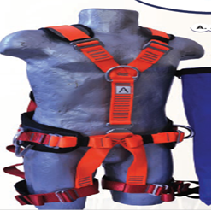
1.2.1 Standard Accessories.
- Double Adjustable lanyard: Complete with a shock absorber, aluminium pylon hooks and one tri-lock/ captive eye karabiner.
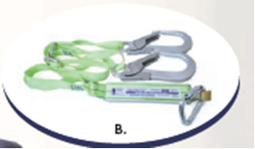
- Webbing Pole Strap: Complete with two aluminium snap hooks.
- Nylon Rope Pole Strap: Complete with a rope grab and an aluminium tri-lock captive eye karabiner with a snap hook on one end.
- Attachment Strap: 1.5m in size.
- Carry bag.

1.3 Fall Arrest Rescue Kit
Description:
- The Rescue Kit is designed for Fall Arrest Rescue situations where small teams can perform their own rescue when a victim is not injured and can assist in the rescuing process. The system incorporates a Self-Recovery Stirrup line device that is used to transfer the weight off the Shock Absorbing Lanyard onto the Rescue System.

Specifications:
- Red protection bag.
- Rope Compatibility: 20m or 30m X 11mm static rope made of Poly-Amide Material.
- Webbing Cutter.
- Indy Descending Device.
- 1.5 m Attachment Strap.
- Aluminium Karabiner with captive eye and tri-lock.
- Safe Working Load: 150 kg.

1.4: Sling Polyester webbing 3Ton.
- Endless Round Slings.
- Durable 100% high –tenacity pes polyester.
- Seamless, close-woven heavy-duty tubular polyester sleeve.
- Certified and according to BS EN 1492.2.2000+A1:2023
- Sling with a protective layer.
- Reinforced Edges with anit-cut and rubbing cords.
Technical data
Colour | Yellow
Lifting weight | 3 Tons
Size | 3 m

1.5: Warning Device
- Rechargeable with any source of compressor air.
- Plastic case.
- Yellow in colour.
- With pressure gauge.
Technical data
Sound Level115 Db A | 115 Db A (up to 300 sounds per charge)
Weight | 1 kg
Part Number | N05153 or equivalent

2. Bill of quantities

ITEM | DESCRIPTION AS PER ON TECHNICAL SPECIFICATION ATTACHED | UNIT | QUANTITY | RATE |  | AMOUNT
1 | Provide special training to 25 people for Working at heights | Each | 25 | R |  | R
2 | Powerlines Full Body Safety Harness. Size: Medium | Each | 8 | R |  | R
3 | Powerlines Full Body Safety Harness. Size: Large | Each | 10 | R |  | R
4 | Powerlines Full Body Safety Harness. Size: Extra Large | Each | 10 | R |  | R
5 | Fall Arrest Rescue Kit | Each | 8 | R |  | R
6 | Sling Polyester webbing 3Ton | Each | 5 | R |  | R
7 | Warning Device | Each | 15 | R |  | R
Sub - Total (excl VAT) |  |  |  |  | R
Vat @ 15% |  |  |  |  | R
Total Cost (Incl VAT) |  |  |  |  | R

