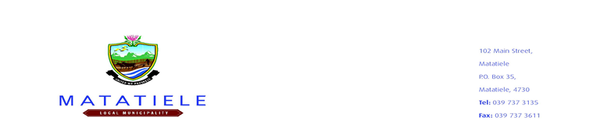
Matatiele Local Municipality
BID NOTICE
RE-ADVERTISEMENT
Bidders are hereby invited to submit their tenders for the following priority projects:

Bid Number | Project Name | Advert Date | Closing Date
MATAT/2022/2023-43 | SMART METERING: ELECTRICAL VENDING | 24 FEBRUARY 2023 | 24 MARCH 2023

MANDATORY DOCUMENTS AS LISTED IN THE TENDER TO BE SUBMITTED, FAILURE TO DO SO WILL RESULT IN THE BID BEING DEEMED TO BE NON-RESPONSIVE

Matatiele Local Municipality Supply Chain Management policy will apply. A confirmation from SARS with a verification PIN, Proof of Central Supplier Database (CSD) registration- a full updated report printed, Completion of MBD 1-9 and its Annexures in full. Prices quoted must be firm and must be inclusive of VAT. Original Certified I.D. Copies of Managing Directors / Owners. Joint Ventures will only be accepted if all necessary requirements as per tender document are met.

EVALUATION CRITERIA

Only competent bidders who are competent in the advertised work and who have exceeded the minimum functionality threshold will be two phases Phase 1= Functionality=100 Points and Phase 2= is 80/20 in line with the Preferential Procurement Policy Framework Act (PPPFA) of November 2022. Only bidders who obtain 50 points as a minimum functionality threshold will be evaluated further on 80/20.

Tenderers will be awarded points on the following basis:
1 Tender Price 80 points
2. HDI – Equity ownership 6 points
3. Youth-Enterprises 0-35 years (MLM) 6 points
3. Women – Equity ownership 4 points
4. Disability – Equity ownership 2 points
5. Rural Enterprises 2 points
Total 100

Points for functionality will be scored on the following:
Functionality Criteria | Points
Previous Company Experience | 40
Project Implementation Plan | 10
Key Personnel | 15
Proof of Partnership with National Payment System (NPS) | 20
Total | 85

OBTAINING OF TENDER DOCUMENTS:

Bid Documents will be available as from 03 March 2023 at the Municipal Website and BTO Offices for a non – refundable tender fee of R500 payable in the Municipal bank account (Ned Bank 1011292106 branch code 198765, name of company and bid no as reference) (Failure to attach proof of purchase will lead disqualification). To obtain tender documents please login to www.matateiele.gov.za or email nngcobo@matatiele.gov.za.

Bidders are warned not to solicit bribes in connection with these bids. The municipality and its employees will never solicit bribes for the exchange of a tender.

The Matatiele Local Municipality reserves the right not to appoint a contractor on highest points scored. Value for money, past experience and functionality will be the key determinants of appointment. All tenders must be deposited in the tender box situated at the Matatiele Local Municipality, Matatiele, Eastern Cape 4730 reception area not later than 10h00 as per provided closing dates, where they will be opened in public. All tenders must be clearly marked “Name of the project indicated above”. The Municipality will not make any award to a person or persons working for the state, or failing to possess relevant credentials as stipulated in the tender requirements.

All SCM enquiries relating to this bid must be directed to Z.C Matolo, e-mail: zmatolo@matatiele.gov.za during office hours (07h30 – 16h00) weekdays. All Technical enquiries relating to this bid must be directed to Ms N Majova, e-mail: NMajova@matatiele.gov.za during office hours

_______________________
Mr L. Matiwane
Municipal Manager

