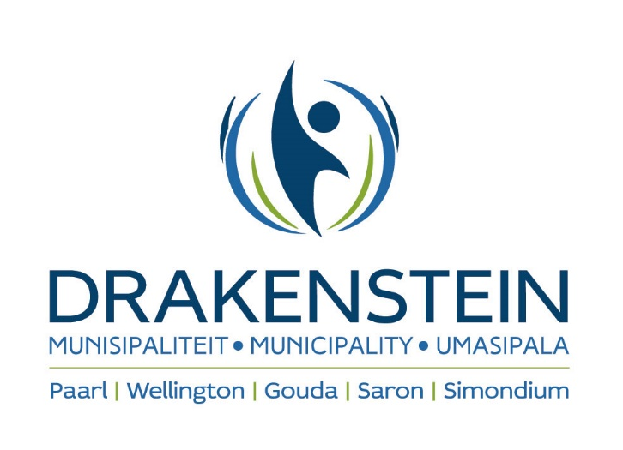

YOU ARE HEREBY INVITED TO BID FOR THE REHABILITATION AND MAINTENANCE OF BASIC SERVICES IN THE INFORMAL SETTLEMENTS WITHIN THE DRAKENSTEIN MUNICIPAL AREA FOR A PERIOD ENDING 30 JUNE 2025

TENDER NUMBER: CES 03/2022
DESCRIPTION : Rehabilitation and maintenance of basic services in the informal within the Drakenstein
Municipal area for a period ending 30 June 2025
CLOSING DATE : 10 November 2022
CLOSING TIME : 10H00
Bids will be opened in the Civic Centre, 1st Floor, Berg River Boulevard, Paarl in public at 10h15.

CIDB : Tenderers must be registered with the CIDB in a 4CE class of construction works
and have a grading designation equal to or higher than that determined in accordance with
the sum tendered or a value determined in accordance with regulation 25(7A) of the
Construction Industry Development Regulations, 2004. It is estimated that tenderers will
need a grading designation of 4CE or higher.

INFORMATION : Obtain documentation:
Drakenstein Municipality
Engineering Department
Second Floor
Corner of Market Street and Main Road
Paarl
7622
(GPS co-ordinates: 33°44’19.37” S 18°57’47.10” E)

Enquiries regarding tender documentation:
Neil Lyners & Associates (RF)(Pty) Ltd
Mr Harlind Leng
Tel: 021 – 914 0300
E-mail: harlind@lyners.co.za

Office hours for collection:
08h30 – 15h00 as from 6 October 2022. A non-refundable fee of R450.00 is payable to
Drakenstein Municipality for collection of documents. No fee will be charged when the tender documents is requested electronically.

A compulsory clarification meeting will be held on 13 October 2022 at 10:00 at Library Conference Room, Ground Floor of Drakenstein Municipal Offices, Corner of Market Street and Main Street, Paarl (GPS co-ordinates: 33°44’19.37”S 18°57’47.10” E) Bidders that fail to attend the compulsory clarification meeting will be disqualified. A representative may only represent one tenderer at this meeting. Bidders that arrive after the starting time of the compulsory clarification meeting as indicated, will be disqualified.

Bids may only be submitted on the bid documentation provided by the municipality and must remain valid for a minimum of 120 days after bid closing.

Telegraphic, telephonic, telex, facsimile, e-mailed or late tenders will not be accepted. The lowest, only or any bid shall not necessarily be accepted and the Council reserves the right to accept any part of the bid.

TENDERS TO BE DEPOSITED IN: The tender box 1 in the foyer of the Civic Centre, Drakenstein Municipality, Berg River Boulevard, PAARL, 7620. The tender box 1 is open from Mondays until Thursdays from 08:00 until 16:45 and on Fridays from 08:00 until 15:30. This excludes weekends and public holidays.

NOTE: This tender will be evaluated in terms of the Preferential Procurement Regulations, 2017 that was promulgated by the Minister of Finance on 20 January 2017 in Government Gazette No 40553. Please take note of the responsiveness criteria as stipulated in the tender document.

PROCUREMENT PREFERENCE POINT SYSTEM: 80/20

The successful bidder will be required to fill in and sign a written contract form.

The following conditions to bid exist (failure to comply may result in your bid being disqualified):

1. This bid is subject to the General Conditions of contract for Construction works and special conditions of CIDB and Supply Chain Management;
2. Relevant specifications;
3. Bidders must be registered on Drakenstein Municipality’s supplier database if they wish to conduct business with the municipality.
4. The tax status requirements as per MBD 1 (Part B) must be complied with. No contract will be awarded to any bidder that is not deemed tax compliant at the date of award.
5. Bids submitted must be in a sealed envelope clearly marked with the bid number, placed in the tender box 1 before closing time. Failure will result in the bid being invalid.

Paarl Post; Die Burger; Cape Times

DR JOHAN LEIBBRANDT
CITY MANAGER

U WORD HIERMEE UITGENOOI OM TE TENDER VIR DIE REHABILITASIE EN ONDERHOUD VAN BASIESE DIENSTE IN DIE INFORMELE NEDERSETTINGS GELEË IN DIE DRAKENSTEIN MUNISIPALE AREA VIR ‘N PERIODE EINDIG 30 JUNIE 2025

TENDER NOMMER : CES 03/2022
BESKRYWING : Rehabilitasie en onderhoud van basiese dienste in die informele nedersettings geleë in die Drakenstein munisipale area vir ‘n periode eindig Junie 2025
SLUITINGSDATUM : 10 November 2022
SLUITINGSTYD : 10H00
Tenders sal in die openbaar geopen word in die Burgersentrum, 1ste Vloer, Bergrivier Boulevard, Paarl om 10:15

CIDB :Tenderaars moet geregistreer wees by die CIDB met ‘n 4CE klas vir konstruksie werk en moet ‘n kontrakteurs gradering het gelykstaande aan- of hoër as die gradering wat in ooreenstemming met die tender bedrag bepaal word kragtens regulasie 25(7A) van die CIDB regulasies 2004. Daar word beraam dat voornemende tenderaars ‘n CIDB kontrakteurs gradering van 4CE of hoër moet hê.

INLIGTING : Dokumentasie verkrygbaar:
Drakenstein Munisipaliteit
Ingenieurs Afdeling
Tweede Vloer
Hoek van Mark en Hoofstraat
Paarl
7622
(GPS koordinate: 33°44’19.37” S 18°57’47.10” O)

Navrae in verband met die tender:
Neil Lyners & Associates (RF)(Pty) Ltd
Mnr Harlind Leng
Tel: 021 – 914 0300
Epos: harlind@lyners.co.za

Kantoorure vir afhaal van tenderdokumente
08h30 - 15h00 vanaf 6 October 2022 teen ‘n nie- terugbetaalbare fooi van R450.00 betaalbaar aan Drakenstein Munisipaliteit. Geen fooi is van toepassing indien tender dokumente elektronies versoek word nie.

‘n Verpligte terreinvergadering sal plaasvind op 13 Oktober 2022 om 10:00 by Biblioteek Konferensie Kamer, Grond Vloer van Drakenstein Munisipaliteit se Kantore, h/v Markstraat en Hoofstraat, Paarl (GPS koordinate: 33°44’19.37” S 18°57’47.10” O). Tenderaars wat nie die verpligte terreinvergadering bywoon nie, sal gediskwalifiseer word. ‘n Verteenwoordiger mag slegs een tenderaar by hierdie vergadering verteenwoordig. Tenderaars wat laat opdaag vir die verpligte terreinvergdaering, sal onmiddelik gediskwalifiseer word.

Tenders mag slegs ingedien word op die tender dokumentasie soos voorsien word deur die munisipaliteit en moet geldig bly vir ‘n minimum periode van 120 dae na tendersluiting.

Telegrafiese, telefoniese, telex, faksimilee, laat tenders of tenders per e-pos sal nie aanvaar word nie. Die Raad behou die reg voor om nie noodwendig die laagste, enigste of enige tender te aanvaar nie asook enige gedeelte van enige tender.

Tenders moet geplaas word in die tenderbus 1 in die voorportaal van die Burgersentrum, Drakenstein Munisipaliteit, Bergrivier Boulevard, PAARL, 7620. Die tenderbus 1 is oop vanaf Maandae tot Donderdae tussen 08:00 en 16:45 en op Vrydae vanaf 08:00 tot 15:30. Naweke en publieke vakansiedae is uitgesluit.

NOTA: Hierdie tender sal ge-evalueer word in terme van die Voorkeur Verkrygingsregulasies van 2017 soos
gepubliseer deur die Minister van Finansies op 20 Januarie 2017 in Staatskoerant Nr 40553. Neem kennis van
die antwoordende kriteria soos vervat in die tender dokument.

VOORKEUR VERKRYGINGS PUNTESTELSEL: 80/20

Daar sal van die suksesvolle tenderaar verwag word om ‘n geskrewe kontrakdokument in te vul en te onderteken.

Die volgende tendervoorwaardes geld (nalating om hieraan te voldoen mag lei tot diskwalifikasie van die tender):

- Die tender is onderhewig aan die Algemene Kontrakvoorwaardes vir Konstruksiewerke en spesiale voorwaardes van CIBD en Voorsieningskanaalbestuur;
- Relevante spesifikasies;
- Tenderaars moet geregistreer wees op Drakenstein Munisipaliteit se verskaffers databasis indien hulle besigheid wil doen met die munisipaliteit
- Die belasting status vereistes soos per MBD 1 (Deel B) moet nagekom word. Geen kontrak sal toegeken word aan ‘n tenderaar wie nie voldoen aan belasting vereistes op datum van toekenning nie.
- Die tender moet ingedien word in 'n verseëlde koevert en duidelik gemerk met die tender nommer daarop en geplaas word in die tenderbus 1 voor die sluitingstyd. Indien daar nie aan hierdie vereistes voldoen word nie sal die tender as ongeldig beskou word.

Paarl Post; Die Burger; Cape Times

DR JOHAN LEIBBRANDT
STADSBESTUURDER

