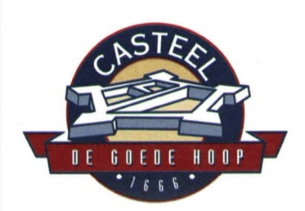

REQUEST FOR QUOTATION
REF.NO: CCB2023/07/01 Dehumidifiers

The Castle Control Board (CCB) is a Schedule 3A Public Entity established in terms of the Castle Management Act, 1993 (Act 207 of 1993). Its mandate is to preserve and protect the military and cultural heritage of the Castle of Good Hope, to optimise its tourism potential, and to optimise accessibility of the Castle of Good Hope by the public.

The Castle of Good Hope Military Museum need dehumidifiers. In order to do so, we require the services of a company to assist with the supply of dehumidifiers.
The bid documents that required to be completed will be given on the day of the compulsory briefing session.

Please indicate if you will be present for the briefing sessions by email procurement@castleofgoodhope.co.za

Date of issue: 10th July 2023
Briefing session: 20th July 2023 @ 10:30
Closing date: 27th July 2023 @ 14:00

Further details regarding the RFQ can be requested from Ms Deidre Hartzenberg at
021-461-4673/76

