
RFI SPECIFICATION
COVER PAGE (SUMMARY)

BIDDERS MUST SUBMIT ANNEXURE 1 TOGETHER WITH THE INVITATION TO BID DOCUMENT
RFI No: | RFI 2763-2023
Description | Request for information (RFI) for the Provisioning of a Private Government Cloud Region to Complement the Ringfenced Government Secure Cloud within a Fully Managed Data Centre (FMDC)
Publication Date | 09 June 2023
Virtual Vendor Briefing Session | A Non-Compulsory Virtual Briefing Session will be held as follows:  Date: 14 June 2023  Time: 11h00 am (South African Time)  Venue: Online (Teams)  Link: https://teams.microsoft.com/l/meetup-join/19%3ameeting_YjJiYjU0NWMtY2NhYi00MTZmLTlhNzYtMTNhZDgwMmNjZmRj%40thread.v2/0?context=%7b%22Tid%22%3a%2248cd5724-88c7-48c3-a665-945436edd7fc%22%2c%22Oid%22%3a%227f31f060-5686-4639-8b33-89e7606dc7f3%22%7d
Closing Date for questions / queries | 23 June 2023
Proposal Submission Address | Proposals will be accepted electronically via the following email address: tenders@sita.co.za
RFI Closing Details and Address | Date: 01 July 2023  Time: 11h00 am (South African Time)  Email: tenders@sita.co.za  Late response will not be considered.
RFI Validity Period | 120 Days from the Closing Date

PROSPECTIVE RESPONDENTS MUST REGISTER ON NATIONAL TREASURY’S CENTRAL SUPPLIER DATABASE PRIOR TO SUBMITTING RESPONSES.

Contents
ANNEX A: INTRODUCTION 3
1. EXECUTIVE SUMMARY 3
2. PURPOSE AND BACKGROUND 4
2.1. PURPOSE 4
2.2. BACKGROUND 4
2.3. Objective 9
3. Confidentiality 9
4. Precedence of documents 10
5. Briefing and information session 10
6. Submission of documents 10
7. TECHNICAL AND FUNCTIONAL REQUIREMENTS 11
7.1. Overview 11
7.2. Data Centre Facilities 11
7.3. Cloud Infrastructure and IaaS Requirements 12
7.4. Integration Requirements 14
7.5. Interoperability 14
7.6. Professional Services Requirements 15
7.7. Business and Commercial Dependencies 15
7.8. Assumptions 15
7.9. Training and Skills Development 16
7.10. Summarised Checklist 16
8. Contact details 18
ANNEX B: Terms and definitions 19
1. Abbreviations 19
2. Definitions 19

- INTRODUCTION

EXECUTIVE SUMMARY
    - SITA wants to achieve the following with the transitioning of the Government Private Cloud Ecosystem (GPCE) to align with the revised Cloud Strategy. This includes a partnership with a single service provider to provision the following:
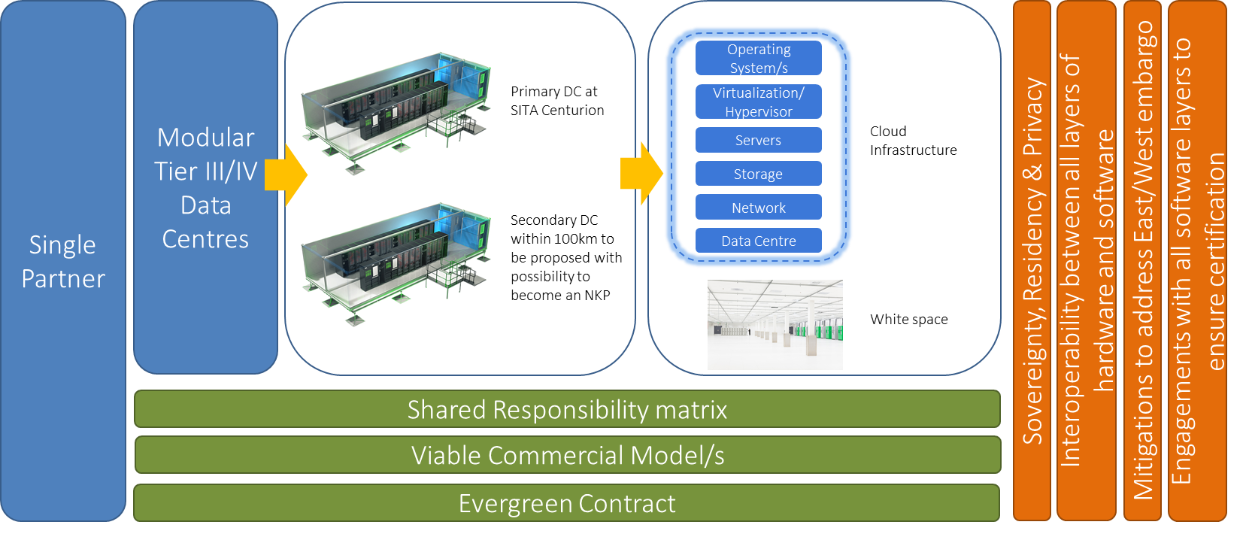
Figure 1: Private Government Cloud Region Partnership

    - This entail the following in summary
      - Modular Tier III/IV primary and secondary Data Centre/s at NKP sites:
        - Primary DC preferred at Centurion; and
        - Secondary DC within 100km to be proposed with possibility to become a NKP;
      - Within the modular DC, the partner must provision:
        - Cloud Infrastructure inclusive of maintenance and support of the infrastructure up to Hypervisor and Operating System (OS) software level; and
        - White space for the housing of IT infrastructure.
      - Contract term will be ever-green;
      - Potential viable commercial model/s to be provided – this could for example be a Shared profit model based on usage, royalty fee, but should exclude a rental model; and
      - Shared responsibility matrix.

    - This will be underpinned by the following:
      - Partner must engage with all software layers to ensure certification of hardware;
      - Data sovereignty, residency and privacy;
      - Interoperability between all layers of hardware and software; and
      - Mitigations to address East/West embargo.

PURPOSE AND BACKGROUND

PURPOSE
    - The purpose of this Request for Information (RFI) is to invite suppliers (hereinafter referred to as “bidders”) to submit information on the provisioning of a Private Government Cloud Region within a Fully Managed Data Centre deployed on SITA’s premises.
    - SITA is gathering information on the complexities and available solutions within the country to provide a Private Government Cloud Region within a Fully Managed Data Centre deployed on SITA’s premises. This solution will complement the ringfenced Government Secure Cloud within the Government Private Cloud Ecosystem (GPCE) for the delivery of Infrastructure-as-a-Service (IaaS) Cloud Services to the South African Government.
    - The Private On-Premise cloud variants within the GPCE are experiencing risks regarding limited CAPEX availability to ensure scalability, Tier III data centre compliance, and East/West embargo and sanctions on the current technology stack. This therefore necessitates SITA to revise its cloud strategy to partner with either a single Cloud Service Provider or a single hyper-scaler for the provisioning of a Private On-Premise Government Cloud Region that can address several specific requirements that SITA may not be able to meet.
    - This will not replace the current Secure Private Region, but will augment the cloud offerings to the South African Government to:
- Improve cost effectiveness;
- Improve time to delivery;
- Expand service offering;
- Elasticity to automatically scale up or down resources based on changing demand; and
- Auto scaling to automatically add or remove instances based on predefined rules.
    - The Private On-Premise Government Cloud Region will require a high level of security, compliance, and control over the Government data and applications and will need a shared management and support matrix. This document will focus on the Fully Managed Data Centre (FMDC) and Infrastructure-as-a-Service (IaaS) only addressing the vision of GPCE Version 2.0.
    - This RFI is solely for information gathering purpose and NOT to make a selection or an award. The information collected in this fashion will not be used to lead to sourcing from one supplier only, nor will it be used to write the ultimate specification in a matter that would suit just one specific supplier.

BACKGROUND
    - SITA is committed to be a world-class provider of core network, hosting and data infrastructure services. To realize this commitment SITA embarked on an infrastructure modernization journey to re-engineer the current environment into modern state-of-the-art facilities that includes the introduction of a cloud capability. The vision of SITA, with this journey, was to establish a Government Private Cloud (GPC), defined as an eco-system of different clouds, for exclusive access by Government Departments that will be owned by Government and operated and managed by SITA. The aim with the Government Private Cloud Ecosystem (GPCE) is to not only enable fast, efficient and cost-effective service delivery, but also to digitally transform the South African Government.
    - The GPCE bring together private and hybrid clouds, hosted either within a government data centre or at 3rd party data centre, into a single ecosystem from where Cloud Services can be provisioned through a single Cloud Suite. These Cloud Services will not be limited to infrastructure provisioning, Infrastructure-as-as-Service (IaaS), but will also include the provisioning of commercially available software services (Software-as-a-Service (SaaS) and the provisioning of commercially available development and runtime environments (Platform-as-a-Service (PaaS). The overview of the GPCE Version 1.0 was as follows:

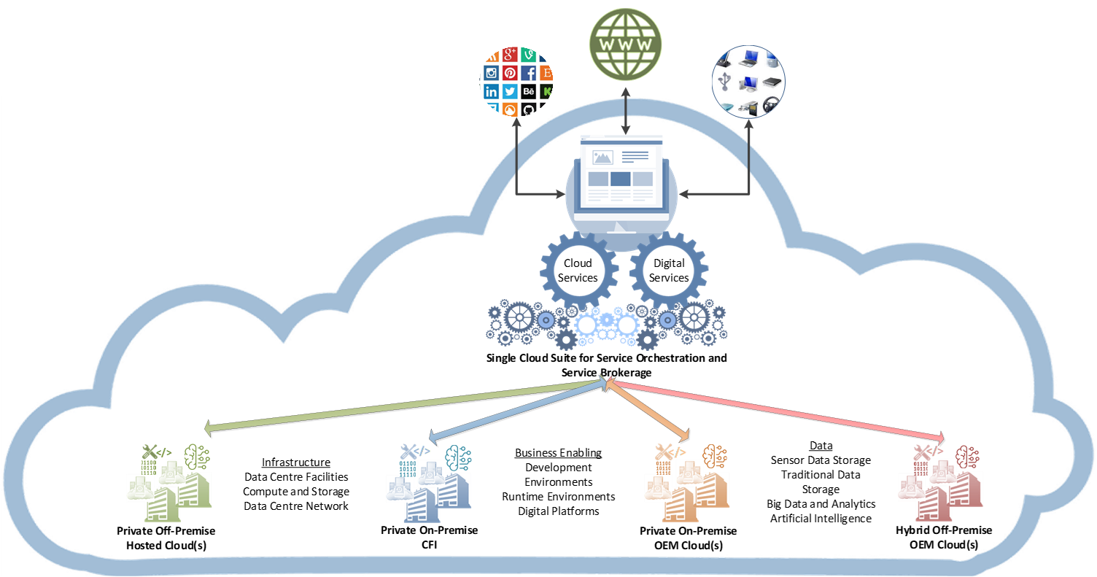
Figure 2: Overview of the Government Private Cloud Ecosystem (GPCE)

    - One of the key areas of SITA’s work was to strengthen its ICT infrastructure to support the adoption of digital solutions and applications. SITA has thus made some significant strides in strengthening its IT infrastructure:
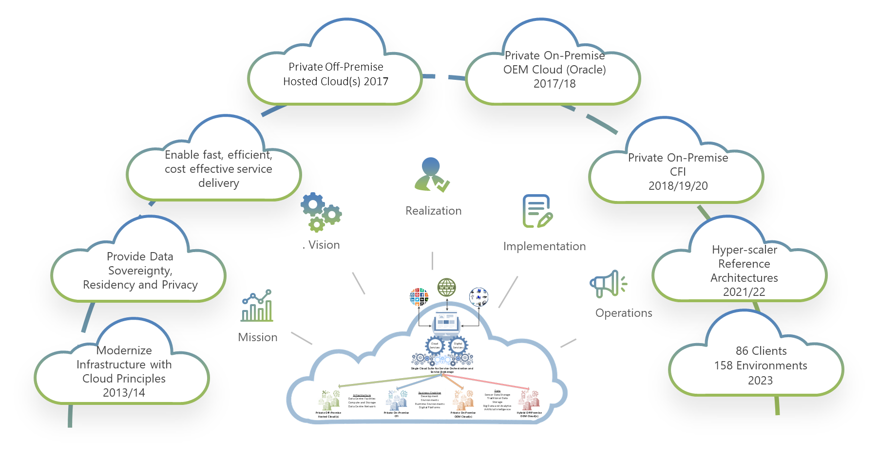
Figure 3: Journey of the Government Private Cloud Ecosystem (GPCE)

    - SITA will build on the capital investments made to modernise its product and service offerings. Although the IT infrastructure is available to support digital services and applications, a lot more needs to be done to fulfill the targets as per the fourth Annual Performance Plan (APP) of the five (5) year SITA strategic plan (2020 – 2025).
    - The GPCE is crucial to the government’s transformation and digitization programme. It brings together private and hybrid clouds, into a single secure ecosystem. From here, cloud services can be made available through a single cloud suite. The GPCE functionality also allows multiple technologies to establish access channels, which can improve communication with and feedback to citizens and businesses alike. SITA will continue to mature its GPCE offering from Infrastructure-as-a-Service (IaaS) to a Platform-as-a-Service (PaaS) and Software-as-a-Service (SaaS) cloud computing service model.
    - However, noting a constrained national economy, increasing issues due to the East/West embargo and SITA’s own capability for capital investments at this point, it has become imperative to transition towards Version 2.0 of the GPCE.
    - Under the theme of “Perfecting business as usual” of the 2020-2025 SITA Strategic plan, the GPCE will need to transition with visible impact, and in an always-on and secure environment.
    - This will also need to address Government’s expectations and requirements of SITA:
- Readily available capabilities to meet its digital transformation needs;
- End-to-end integrated digital solutions aligned to 4IR;
- Agility and readiness to respond to digital transformation requirements;
- Leadership to enable customers to optimally realise their strategies;
- Broadband connectivity, applications, software defined networks, and digital technologies that will stimulate the local economy;
- Uninterrupted network services;
- Uninterrupted support for and maintenance of services procured through SITA;
- Prompt and high-quality service delivery; and
- Consistent, cheaper, cost-saving and competitive prices for all services.

    - The following also necessitates the reason for transitioning to GPCE Version 2.0:
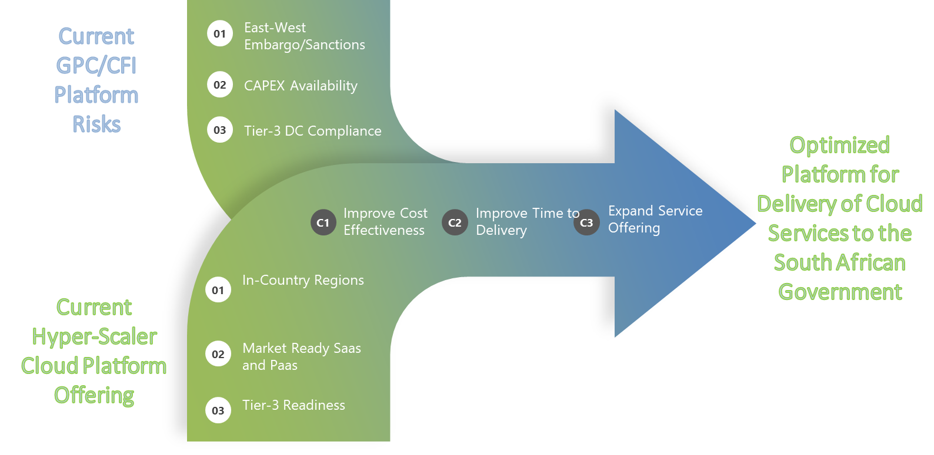
Figure 4: Need for Transitioning to GPCE 2.0

    - The limitations that are driving SITA to a Private Government Cloud Region is as follows:
- Limited CAPEX availability: A private government cloud region can be more cost-effective than building and maintaining a Private On-Premise cloud variant and on-premise data centres. Instead of investing in expensive hardware, software, and infrastructure, SITA can use a private cloud provider's resources on a pay-per-use basis, allowing it to scale up or down as needed without incurring significant upfront costs;
- Tier III data centre compliance: SITA’s data centres are not yet Tier III compliant, but it is Government’s expectation that their data be hosted or housed in a Tier III ready or certified data centres; and
- East/West embargo and sanctions: The current embargo and sanctions between the East and West is restricting the use of all cloud services on the current technology stack.
    - Cloud platforms of hyper-scalers, such as Amazon Web Services (AWS), Microsoft Azure, and Google Cloud Platform (GCP), provide a wide range of computing resources, including storage, processing power, and networking, to customers around the world. Governments often use cloud platforms to host their applications and data to leverage the benefits of cloud computing, such as scalability, cost-effectiveness, and flexibility.
    - SITA has to this effect already completed Reference Architectures (RAs) with some of the hyper-scalers in the country as part of the ecosystem within the GPCE. These RAs were based on the fact that the hype-scalers provide segregation, which is a logical separation of resources within a cloud region. Segregation allows governments to create their own virtual private cloud (VPC), which is a private, isolated network that can be used to host their applications and data. This ensures that government data is completely separated from other customers' data, even within the same region. The progress for the inclusion of these under the umbrella of a single cloud suite has not been satisfactorily.
    - For this reason, it is important that SITA explores using Cloud Service Providers (CSPs) and hyper-scalers to provide Private Government Cloud Regions within an On-Premise data centre for the delivery of cloud services to the South African Government.
    - The use of a separate region or segregation can provide governments with greater control and visibility over their data and applications, as well as improved security and compliance. It also allows them to meet regulatory requirements and ensure that their data is protected from unauthorized access, data breaches, and other security threats.
    - In order for SITA to transition to the GPCE 2.0, the following will need to be done to augment the On-Premise capacity with Private Government Regions:
- The provisioning of a Fully Managed Data Centre (Tier III) for the hosting and hosting of SITA and Government IT infrastructure. This will be provided by either a single CSP or in-country Hyper-scaler in a long-term partnership;
- The provisioning of a Private Government Cloud Region for the delivery of IaaS Cloud Services to the South African Government. This will be provided by either a single CSP or in-country Hyper-scaler in a long-term partnership;
- Integration to all other hyper-scalers for identified PaaS, SaaS and other XaaS Services;
- Integration to the existing Private On-Premise Cloud variants within the GPCE; and
- Provide a single marketplace capability for all cloud services as per the SITA Service catalogue.

    - This will however not affect the current investment as depicted below:
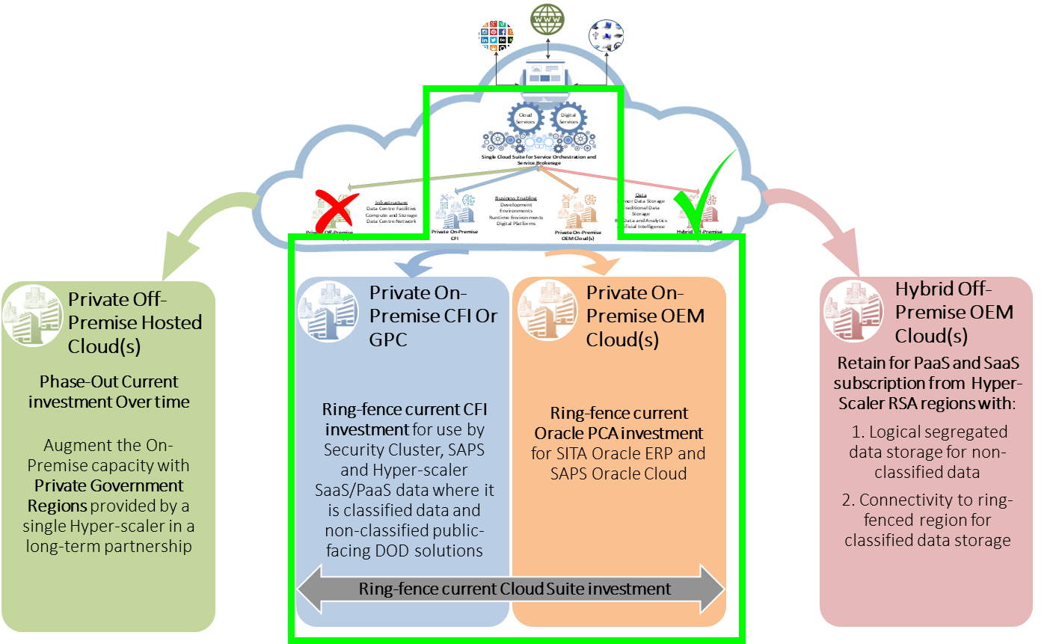
Figure 5: Augmentation of current GPCE

    - This strategy will then provide a Platform for the Orchestration of Cloud Services across all Private On-Premise and Hybrid OEM Clouds (Hyper-scalers). To achieve this, the SITA needs to engage with industry to understand the best practices and deployment options that are available to a service provider to make sure that any deployment is free from lock-in, can support legacy applications as much as possible, has multi-tenant capability and can adapt to the fast changes within ICT.

Objective
    - The aim of this RFI is to source information for the provisioning of an FMDC and Private On-Premise Government Cloud Region for the delivery of IaaS Cloud Services to the South African Government.

Confidentiality
  - The information contained in this document is of a confidential nature, and must only be used for purposes of responding to this RFI. This confidentiality clause extends to all respondent(s) or associates whom you may decide to involve in preparing a response to this RFI.
  - For purposes of this process, the term “confidential information” shall include all technical and business information, including, without limiting the generality of the foregoing, all secret knowledge and information (including any and all financial, commercial, market, technical, functional and scientific information, and information relating to a party’s strategic objectives and planning and its past, present and future research and development), technical, functional and scientific requirements and specifications, data concerning business relationships, demonstrations, processes, machinery, know-how, architectural information, information contained in a party’s software and associated material and documentation, plans, designs and drawings and all material of whatever description, whether subject to or protected by copyright, patent or trademark, registered or un-registered, or otherwise disclosed or communicated before or after the date of this process.
  - The receiving party shall not, during the period of validity of this process, or at any time thereafter, use or disclose, directly or indirectly, the confidential information of SITA or the client (even if received before the date of this process) to any person whether in the employment of the receiving party or not, who does not take part in the performance of this process.
  - The receiving party shall take all such steps as may be reasonably necessary to prevent SITA and the client confidential information coming into the possession of unauthorised third parties. In protecting the receiving party’s confidential information, SITA and the client shall use the same degree of care, but no less than a reasonable degree of care, to prevent the unauthorised use or disclosure of the confidential information as the receiving party uses to protect its own confidential information.
  - Any documentation, software or records relating to confidential information of SITA or the client, which comes into the possession of the receiving party during the period of validity of this process or at any time thereafter or which has so come into its possession before the period of validity of this process:
  - Shall be deemed to form part of the confidential information of SITA or the client;
  - Shall be deemed to be the property of SITA or the client;
  - Shall not be copied, reproduced, published or circulated by the receiving party unless and to the extent that such copying is necessary for the performance of this process and all other processes as contemplated in; and
  - Shall be surrendered to SITA or the client on demand, and in any event on the termination of the investigations and negotiations, and the receiving party shall not retain any extracts.

Precedence of documents
  - This RFI consists of a number of sections. Where there is a contradiction in terms between the clauses, phrases, words, stipulations or terms and herein referred to generally as stipulations in this RFI and the stipulations in any other document attached hereto, or the RFI submitted hereto, the relevant stipulations in this RFI shall take precedence.
  - Where this RFI is silent on any matter, the relevant stipulations addressing such matter and which appears in the SITA Procurement Policy and Procedures shall take precedence. RFI shall refrain from incorporating any additional stipulations in its RFI submitted in terms hereof other than in the form of a clearly marked recommendation that SITA may in its sole discretion elect to import or to ignore. Any such inclusion shall not be used for any purpose of interpretation unless it has been so imported or acknowledged by SITA.
  - It is acknowledged that all stipulations in the SITA Procurement Policy and Procedures are not equally applicable to all matters addressed in this RFI. It however remains the exclusive domain and election of SITA as to which of these stipulations are applicable and to what extent. The bidders are hereby acknowledging that the decision of SITA in this regard is final and binding. The onus to enquire and obtain clarity in this regard rests with the bidders. The bidders shall take care to restrict its enquiries in this regard to the most reasonable interpretations required to ensure the necessary consensus.

Briefing and information session
  - A Non-compulsory virtual briefing session will be held on 14 June 2023.
  - Bidders who respond to this RFI may be requested to give an oral presentation.

Submission of documents
  - Bidders shall submit RFI response in accordance with the prescribed manner of submissions as specified below.
  - RFI responses must be submitted electronically to SITA at Tenders@sita.co.za on or before 05 December 2022 not later than 11h00 South African Standard Time (UTC+2).
  - Respondents are requested to complete their responses in electronic format, in the spaces provided for answers within this document.
  - All additions to the information documents i.e. appendices, supporting documentation, photographs, technical specifications and other support documentation covering suggested solutions etc. shall be submitted as part of this RFI. No product information or company profiles will be considered.
  - No information shall be accepted by SITA if submitted in any manner other than as prescribed above.
  - SITA will not be liable for any costs incurred by the respondents in the preparation of response to this RFI. The preparation of responses will be made without obligation to accept any of the suggestions included in any response, or to discuss the reasons why such suggestions were accepted or rejected.

TECHNICAL AND FUNCTIONAL REQUIREMENTS

Overview
    - In the submission to the Request for Information (RFI) the responded are requested to submit detailed information regarding the provisioning of a Private Government cloud region within a SITA owned facility (On-Premise) and could either be modular data centres or built data centres at Primary and Secondary sites. This is to ensure that it complies to the requirements for a South African national key point (NKP) as outlined in the National Key Points Act of 1980.
    - Detailed information, i.e. deployment options, architecture, responsibility matrix, costing models for the implementation of the solution must be included.

Data Centre Facilities
    - The data centre facilities will have to cater for the following workload:
- Hosting of SITA’s IT infrastructure:
  - Private On-Premise Government region;
  - The Private On-Premise cloud variants’ infrastructure currently located in the SITA data centres; and
  - SITA Mainframe infrastructure.
- White space for the housing of Government Department’s IT infrastructure:
- Departments’ infrastructure currently located in the SITA data centres;
- Departments’ infrastructure at a current Private Off-Premise data centre; and
- Growing demand for Departments’ infrastructure at their own data centres.
    - The requirements for the data centre facilities are as follows:
- Hosting of SITA’s IT infrastructure:
  - Scalability to address the increasing capacity and accommodate growing computing needs. This need to align with the actual requirements, avoiding over-provisioning or underutilization;
  - Rapid deployment that require immediate IT infrastructure solutions or need to set up temporary data centres for specific projects;
  - Portability to allow the relocation or repositioning if as needed. This flexibility will enable SITA to adapt to changing circumstances, such as moving data centres to different geographical regions or adjusting infrastructure to support disaster recovery strategies;
  - Energy-efficient technologies and optimized cooling systems to reduce power consumption and enhance overall efficiency;
  - Secure caged space with biometric access and closed-circuit television (CCTV) video surveillance for the hosting of Government Information Systems and Data, the hosting of Cloud Foundation Infrastructure and the provisioning of service provider IT infrastructure (cloud-enabled compute and storage) for growth and new requirements. Cages to be provisioned on request; and
  - The provisioning of cloud IT infrastructure products and services to be used by SITA to deploy the Private On-Premise Government Cloud Region and technology stacks. This will need to include infrastructure with technology management tools to monitor and manage the availability, capacity and accessibility of the infrastructure.
- Data centre white space for housing of SITA and Government infrastructure:
- Secure caged white space with biometric access and CCTV video surveillance for the housing of Government Information Systems and Data. Cages to be provisioned on request; and
- A designated staging area where equipment, hardware, and software are assembled, tested, and configured before being deployed in the production environment. This area will have to be a separate environment that is physically and logically isolated from the production environment.
- Requirements irrespective of usage:
- Data Centre facilities (Primary and Secondary sites) to be at a minimum of Tier III, but preferably Tier IV;
- Maintenance and support of the facility will be the responsibility of the successful partner/bidder;
- Compliance to international standards and best practises for the primary and secondary sites for the IT infrastructure, e.g. ISO/IEC 27001, ANSI/TIA-942, Uptime Institute's Tier Standard, BICSI-002, NFPA 75 and 76, etc.
- Ensuring that critical systems such as power, cooling, and network connectivity have backup systems in place. This helps ensure that if one system fails, the secondary system can take over seamlessly without any downtime;
- Provision of robust security measures such as access control, surveillance cameras, and intrusion detection systems to prevent unauthorized access and protect sensitive data;
- The DC needs to have high-speed network connectivity between the sites within the region, to SITA and the Connectivity to Vendor Neutral Facility (VNF);
- This space must be provisioned with full building management system capabilities to proactively monitor uninterruptable power, cooling, security and access;
  - Disaster recovery: Having a well-defined disaster recovery plan that outlines how the systems and data will be in the event of a disaster;
  - Regular testing and maintenance: Conducting regular tests and maintenance to ensure that systems are functioning correctly and can handle unexpected failures;
  - Data centre capabilities should be modular; and
  - Provide a list of guidelines and compliance criteria that will be needed for the data centres to be located on SITA premises.

Cloud Infrastructure and IaaS Requirements
    - The requirements for the Private Government Cloud Region for IaaS Cloud Services to the South African Government are as follows:
- Adherence to data sovereignty, data residency and data privacy guidelines;
- Provisioning maintenance and support of the hardware layer, hypervisor and OS will be the responsibility of the successful bidder/partner;
- A shared responsibility framework will be used for the management of the software layer and hosted workload;
- Provision of a single IaaS Cloud Platform:
  - Provisioning and reporting automation: should provide automated provisioning and reporting capabilities, so SITA can easily onboard Government Departments and bill them for their services;
  - Resource management: The platform should provide a centralized dashboard to manage cloud resources, such as virtual machines, storage, and network components;
  - Analytics and reporting: The marketplace should provide analytics and reporting features to allow SITA and Government Departments to monitor the performance of their products and services;
  - Cost optimisation: The platform should provide cost optimization features, such as resource utilisation analysis, and utilisation-reducing recommendations;
  - Performance optimisation: The platform should provide performance optimization features, such as auto-scaling, load balancing, and application optimisation;
  - Security and compliance: The platform should provide security and compliance features, such as network security, identity and access management, data encryption, and compliance reporting. Government has strict security requirements and regulations that needs to be adhered to;
  - Service level agreement (SLA) management: The platform should provide SLA management features, such as monitoring and reporting of SLA compliance across all environments;
  - Integration with third-party tools: The platform should allow integration with third-party tools and platforms, such as DevOps tools, automation frameworks, and monitoring and logging tools.
  - Automation and orchestration: The platform should provide automation and orchestration capabilities, such as automated deployment, configuration management, and workflow automation;
  - User management: The platform should have user management capabilities, such as user registration, authentication, and access control;
  - Multi-tenancy;
  - Interoperability: The hyper-scaler needs to be interoperable with other technologies and the Cloud variants within the GPCE to allow seamless integration of services and applications;
  - Standardization: The platform needs to adhere to industry standards for cloud services, such as OpenStack, Cloud Foundry, and Kubernetes, to ensure compatibility;
  - Scalability: The platform needs to be highly scalable to handle the increased load and demand;
  - Security: The platform needs to have robust security measures in place to protect data and resources;
  - Performance optimization: The platform needs to provide performance optimization features, such as load balancing, auto-scaling, and optimization, to ensure high performance;
  - Compliance: The platform needs to comply with data protection and privacy regulations, such as POPIA, to ensure the safe and secure exchange of data with other CSPs; and
  - Customer support: The platform needs to provide excellent customer support, including documentation, training, and troubleshooting.
- Provision of a Virtualisation Software/Management layer;
- Provisioning of Hardware/Foundation Infrastructure;
- Provision of hardware and software up to Operating System (OS) level with various types of OS to be provided;
- Provision of SDDN connectivity;
- SITA has the right to do physical audits on the facilities, hardware and software;
- Provide list of technologies that are currently certified on the infrastructure and software layers of the platform; and
- IaaS to be inclusive of the following Services:
  - Disaster Recovery-as-a-Service (DRaaS);
  - Backup-as-a-Service (BaaS);
  - Storage-as-a-Service (STaaS);
  - Archiving-as-a-Service (AaaS); and any other infrastructure related services.

Integration Requirements
    - The requirements for the integration into the Private Government Cloud Region, once available, are as follows:
- Single cloud marketplace: Integration into an integrated cloud marketplace that allows government departments to access and purchase various cloud-based services and products from multiple hyper-scalers in one place. Citizen-facing data can be stored within the hyper-scalers, but any confidential data is to be stored in the Private Government Cloud Region;
- Multi-cloud integration: The cloud region should support multiple cloud providers, such as AWS, Microsoft Azure, and Google Cloud Platform, inclusive of the Private On-site cloud variants within the GPCE;
- API integration: The cloud region should have API integration capabilities to allow hyper-scalers to integrate their services and products with other systems and applications;
- Integration with third-party applications: The cloud region should allow SITA and Government Departments to integrate their cloud services and products with other third-party applications, such as CRM or ERP systems;
- Integration with SITA solutions: IT Service Management (ITSM), Network Operation Centre (NOC), Data Centre Operation Centre (DOC) and (Security Operation Centre (SOC); and
- Service level agreement (SLA) management: Back-to-back agreements will be required with the other CSPs and hyper-scalers, to ensure consistent performance and service quality when integrating.

Interoperability
    - The solution must adhere to the government’s MIOS, MISS and POPIA requirements; and
    - The solution must adhere to Open standards, protocols, and interfaces.

Professional Services Requirements
    - The minimum requirements for professional services from the Service are as follows:
- Infrastructure management skills for the cloud-enabled environment. A shared role and responsibility matrix will be followed. The service provider must indicate what the foresee what they will be responsible for versus what will be a shared responsibility and what SITA will be responsible for;
- Data centre operational management;
- Planning skills to assist with the planning and sizing of tenant IT workload planning;
- Conduct training needs analysis to identify the training requirements for SITA staff to enable them to support the deployed technologies, software technology stacks and management tools;
- Service management to provide and end-to-end delivery of IT services to SITA for the Government Private Cloud Region. This includes all the processes and activities to design, create, deliver, and support these services according to SITA’s methodologies; and
- Architectural and design skills if needed.

Business and Commercial Dependencies
    - Provide clarification on the following possible occurrences:
- CSP or Hyper-scaler withdraws from South Africa – retention of data and possibly the region (kit and DC);
- Embargo’s/sanctions against South Africa – retention of data and possibly the region (kit and DC);
- Embargo with any other hyper-scalers or CSP;
- Requests for special technologies not on offer by successful bidder;
- Shared roles and responsibility matrix: what each service provider foresee what they will be responsible for versus what will be a shared responsibility and what SITA will be responsible for. The SITA Act and financial sustainability of SITA will guide the Shared Responsibility Framework when the RFB is published;
- Potential viable commercial model/s to be provided – this could for example be a Shared profit model based on usage, royalty fee, but should exclude a rental model
- Any risks on the above deployment/s; and
- Any other dependencies not highlighted above.

Assumptions
    - The following assumptions were made:
- The SITA Act and financial sustainability of SITA will guide the Shared Responsibility Framework;
- The physical location of the Private Government Cloud Region will be at SITA NKP classified premises;
- All human resources with access to Private Government Region will require security classifications;
- SITA will establish presence at a Vendor Neutral Facility(VNF) such as Terraco;
- The hyper-scaler will provide a dedicated, secure, and reliable private connection services capability from the Private Government Region to the VNF. This will inter alia include the following:
  - Microsoft Azure has a service called Express Route, which is a dedicated network connecting Microsoft services;
  - Amazon Web Services (AWS): AWS has a service called Direct Connect, which is a dedicated network connection that enables users to connect their on-premises infrastructure to AWS;
  - Google Cloud Platform (GCP): GCP has a service called Cloud Interconnect, which enables users to connect their on-premises infrastructure to GCP using a dedicated, private connection;
  - IBM Cloud: IBM Cloud has a service called Direct Link, which is a private network connection service that enables users to connect their on-premises infrastructure to IBM Cloud; and
  - Oracle Cloud Infrastructure (OCI): OCI has a service called FastConnect, which is a dedicated private connection service that enables users to connect their on-premises infrastructure to OCI.
- SITA will establish connectivity to clients on foreign networks (i.e. not using NGN but their own networks such as GPG, GPAA, STASSA).

Training and Skills Development
    - The Responder must include all details on the training and/or skills transfer availability on the proposed options and solutions.

Summarised Checklist
7.10.1 The following are compulsory components which must be compulsory to the submission.

Paragraph | Requirement | Feature | Comply  (Y/N) | Information provided  (Reference to paragraph in submission)
7.2 | Data Centre Facilities | Tier III/IV
7.2 | Data Centre Facilities | Hosting of Cloud Infrastructure environments
7.2 | Data Centre Facilities | White space
7.2 | Data Centre Facilities | Modular
7.2 | Data Centre Facilities | Scalable
7.2 | Data Centre Facilities | Cages
7.2 | Data Centre Facilities | Potability
7.2 | Data Centre Facilities | Energy-efficient and Optimised cooling
7.2 | Data Centre Facilities | Staging area
7.2 | Data Centre Facilities | Maintenance and support of DC
7.2 | Data Centre Facilities | Compliance to international standards
7.2 | Data Centre Facilities | Backup systems
7.2 | Data Centre Facilities | Security
7.2 | Data Centre Facilities | Network connectivity
7.2 | Data Centre Facilities | Building management system
7.2 | Data Centre Facilities | Disaster recovery
7.2 | Data Centre Facilities | Regular testing and maintenance
7.2 | Data Centre Facilities | List of guidelines and compliance
7.3 | Cloud Infrastructure and IaaS | Data sovereignty, residency and privacy
7.3 | Cloud Infrastructure and IaaS | Maintenance and support of the hardware layer, hypervisor and OS
7.3 | Cloud Infrastructure and IaaS | Shared responsibility framework
7.3 | Cloud Infrastructure and IaaS | Iaas Platform
7.3 | Cloud Infrastructure and IaaS | Virtualisation Software/Management layer
7.3 | Cloud Infrastructure and IaaS | Hardware/Foundation Infrastructure
7.3 | Cloud Infrastructure and IaaS | Software up to Operating System (OS) level with various types of OS to be provided
7.3 | Cloud Infrastructure and IaaS | SDDN connectivity
7.3 | Cloud Infrastructure and IaaS | List of technologies that are currently certified
7.3 | Cloud Infrastructure and IaaS | Inclusive of DRaaS
7.3 | Cloud Infrastructure and IaaS | Inclusive of BaaS
7.3 | Cloud Infrastructure and IaaS | Inclusive of STaaS
7.3 | Cloud Infrastructure and IaaS | Inclusive of AaaS
7.4 | Integration | Multi-cloud service providers |  | Also list non-conformance and challenges
7.4 | Integration | API integration capabilities |  | Also list non-conformance and challenges
7.4 | Integration | Third-party applications |  | Also list non-conformance and challenges
7.4 | Integration | SITA solutions
7.4 | Integration | Back-to-back agreements
7.5 | Interoperability | MIOS, MISS and POPIA |  | Also list non-conformance and challenges
7.5 | Interoperability | Open standards, protocols, and interfaces |  | Also list non-conformance and challenges
7.6 | Professional services | Infrastructure management
7.6 | Professional services | DC management
7.6 | Professional services | Capacity Planning
7.6 | Professional services | Training
7.6 | Professional services | Service management
7.6 | Professional services | Architectural and design
7.6 | Professional services | Any other skills |  | List
7.7 | Business and commercial | Withdraw from South Africa
7.7 | Business and commercial | Embargo/sanctions against South Africa
7.7 | Business and commercial | Embargo with other hyper-scalers or CSPs
7.7 | Business and commercial | Viable commercial model/s
7.7 | Business and commercial | Risk/s
7.7 | Business and commercial | Dependencies
7.9 | Training and skills development | Training options
7.9 | Training and skills development | Skills transfer options

7.10.2 Responses must be in a formal submission according to the requirements above from paragraphs 7.1 to 7.9. It must not be in a brochure or with link/s to a website. Those could be added as additional information.

Contact details
The following contact details are applicable:
- For general enquiries contact Audrey Matlapeng at audrey.matlapeng@sita.co.za or
- 012 482 2339
- Terms and definitions

Abbreviations
Acronym | Definition
AaaS | Archiving-as-a-Service
BaaS | Backup-as-a-Service
CaaSP | Container-as-a-Service Platform
CCTV | Closed Circuit Television
CFI | Cloud Foundation Infrastructure
DaaS | Desktop-as-a-Service
DBaaS | Database-as-a-Service
DRaaS | Disaster Recovery-as-a-Service
FaaS | Function-as-a-Service
FMDC | Fully Managed Data Centre
GPCE | Government Private Cloud Ecosystem
IaaS | Infrastructure-as-a-Service
ITI | Information Technology Infrastructure
NKP | National Key Point
PaaS | Platform-as-a-Service
RA | Reference Architecture
RFB | Request for Bid
RFI | Request for Information
SaaS | Software-as-a-Service
SITA | State Information Technology Agency
SLA | Service Level Agreement
STaaS | Storage-as-a-Service
XaaS | Everything-as-a-Service

Definitions
Term | Description
ISO/IEC 27001 | This standard provides guidelines for information security management systems, including data centre security. It outlines requirements for the physical security, environmental controls, and other aspects of data centre operations.
ANSI/TIA-942 | This standard provides guidelines for data centre design and construction. It covers everything from site selection and building design to power and cooling systems, cabling, and security.
Uptime Institute's Tier Standard | This standard provides a framework for evaluating the reliability and redundancy of data centre infrastructure. It defines four levels of data centre availability, ranging from Tier I (basic infrastructure) to Tier IV (fault-tolerant and concurrently maintainable).
BICSI-002 | This standard provides guidelines for the design and implementation of data centre cabling infrastructure. It covers everything from cable types and connectors to labelling and documentation.
Modular data centre | Type of data centre design that incorporates pre-fabricated modules or building blocks to create a flexible and scalable IT infrastructure. Instead of constructing a traditional data centre from scratch, modular data centres are built using standardized components that can be easily assembled, expanded, or relocated as needed
NFPA 75 and 76 | These are two standards from the National Fire Protection Association that provide guidelines for fire protection and suppression in data centres. They cover everything from fire detection and alarm systems to automatic sprinklers and clean agent suppression systems.
South African National Key Point | A location or facility that the South African government has deemed essential to the country's security, economic stability, or public safety. National key points can include military installations, government buildings, power plants, airports, and other critical infrastructure. The requirements for a South African national key point are outlined in the National Key Points Act of 1980. Some of the key requirements include:  - Security measures: National key points must have appropriate security measures in place to protect against unauthorized access, damage, or sabotage. This can include physical security measures such as fencing, surveillance cameras, and access control systems, as well as operational security measures such as background checks for personnel and regular security audits.  - Emergency preparedness: National key points must have plans and procedures in place to respond to emergencies such as fires, natural disasters, or terrorist attacks. These plans should be regularly tested and updated to ensure they are effective.  - Reporting obligations: The owners or operators of national key points must report any security incidents or breaches to the relevant authorities, as well as any changes to the facility or security measures.  - Restrictions on access: Access to national key points is restricted to authorized personnel only. Visitors must have prior authorization and must be accompanied by authorized personnel at all times.  - Oversight: The South African government has the authority to oversee and inspect national key points to ensure that they are complying with the requirements of the National Key Points Act.
White Space | Refers to the area or physical space within the DC that is specifically designated for housing IT equipment, such as servers, networking devices, storage systems, and other hardware. It typically includes the server racks, cabinets, and associated infrastructure needed to support the IT equipment, such as power distribution units (PDUs), cooling systems, cabling, and raised floors.

