Specification to install the wet wall and exhaust pump

Item and description | Specifications | Quantity
Wet wall, with wall | Height = 2 m x length 8 m | 1
Pool Pump 1.1kw with a floating switch | Motor speed 2840 rpm | 1
Duty Exhaust Fan with Automatic Shutter and supporting frame |  | 2
Under ground tank | 250 - 300 L | 1
PVC pipe 32 mm to pump the wet wall, and 110 mm return to the tank
PVC elbows | 32 mm | 10
PVC elbows | 110 mm | 2
Wet wall gutters | Aluminium 8 m | 2
Cable | 60 m | 1
Circuit breakers
Thermostat |  | 2
Valve | 32 mm | 2
Cage for the pump and a locking padlock, on a ground slab

Figure 1 Pool pump
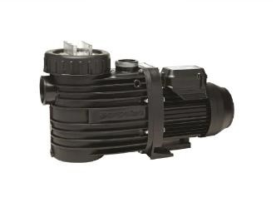
Figure 2 Exhaust and wet wall
