E2727EREMWP: Clarification Register Questions and answers.

Items | Category | Section from Tender Documents | Questions | Answers
1. | Technical | Specification | Detailed Scope of Works  We noted that the technical folder currently contains limited documentation, and we were unable to locate a detailed scope of work. Kindly confirm if a comprehensive scope document is available and, if so, please share it. | The detailed scope of work is addressed in the Revised NEC document. Kindly download the revised NEC document on Eskom Tender Bulletin.
2. | Technical | Specification | Floor Plans / Existing Site Information  As part of our design-led approach, we would greatly benefit from understanding the existing spatial conditions.  Please advise if any of the following can be provided.  • Floor plans for the respective buildings/areas  • Photographs of the current spaces- the proposed furniture is different from the current furniture  • Layouts indicating furniture placement (if available) | • This is not a site-specific item, it is the design, manufacture, and supply for 3 co-operate sites. No drawings can be shared at this point. The offices are across MWP, EAL and ERIC.  • No need as this is not a site-specific requirement  • The proposed furniture is different from the current furniture.  • No need
3. | Technical | Scope of Work | Delivery & Installation Logistics  In the absence of drawings, kindly provide clarification on the following:  • The specific buildings and floor levels where furniture will be delivered and installed  • Any access restrictions (e.g. lifts, loading bays, working hours)  • Any phasing requirements for installation | • Across various areas and floors within the three campuses.  • No restrictions, there are goods lifts and loading bays. Working hours to be during normal working hours weekdays, weekend work only through prior arrangements and approval.  • Yes, this will be communicated and confirmed when a task order is issued. The whole list of furniture does not need to be delivered in one go.
4. | Technical | Specification | We are currently reviewing the RFQ document and would like to request clarification on a few items to ensure that our submission is aligned with your requirements:  • Item 12.3 – Furniture for Pause Area  The table reflects a quantity with a column requiring an amount; however, the specific furniture items are not clearly defined. Could you kindly confirm whether this was an omission or advise on the exact furniture specifications required for this section?  • Item 13.1 – Framed Artworks  We would appreciate guidance on the type or style of artwork you are looking for. For example, should these be abstract, corporate-themed, landscape, or any specific design preference?  • Pricing – VAT Inclusion  Kindly confirm whether all quoted values, including unit prices, should be inclusive or exclusive of VAT, as this was not stated in the document. | • This is for the Data Centre open plan space. See specification below:  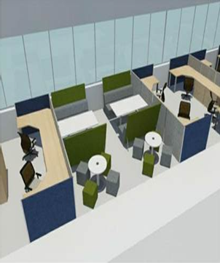  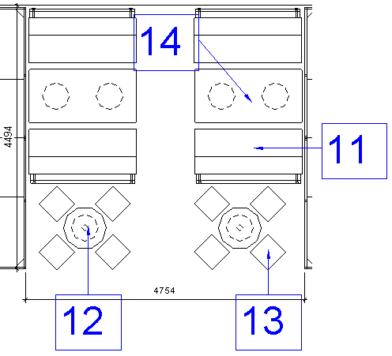  - Abstract art, acrylic or similar finish, not digital prints.  - The quotes should be exclusive of VAT.
  11 | Soft Seating | Fully upholstered using contract grade fabric, cold moulded polyurethane foam; Accent Eskom colours can be used for upholstery (i.e. green, terra cotta, ochre, blue and turquoise - refer to Eskom Corporate Identity Manual)
  12 | Coffee table | The coffee table consists of a round top and metal base  Work surfaces: to be manufactured from 16mm thick high-density particleboard.  Minimum density: of 720 kilogram per cubic meter complying with SANS Standards.  Finishes: minimum of 0.5mm low glare continuous decorative laminate in Vancouver Maple.  Underside finish: balancing backer of 0.2mm CPL. No paper backers allowed.  Edges: Work surfaces to have a 3mm thick extruded PVC or ABS edging with all corners profiled and leaving no sharp edges. Edging to be in white to match the top, and be of such a nature that it will not wear or wipe off. All edging to be applied using high-grade hot-melt adhesive.
  12 | Coffee table | Metal Components:  Body: steel tubing powder coated light grey colour.  Legs are to be fixed to underside of table top using appropriate fixing method to ensure that they do not come loose nor that any part of the fixing devise is visible from the top side of the table  Finishes: the leg to be zinc phosphate washed and coated to the following specifications: Polyester TGIC, matt, Colour: Light grey
  13 | Soft Seating (Ottomans) | Fully upholstered using contract grade fabric, high density foam ottomans; Accent Eskom colours can be used for upholstery (i.e. green, terra cotta, ochre, blue and turquoise - refer to Eskom Corporate Identity Manual)
  14 | Meeting table | The table consists of a rectangular top 1200mm in diameter and four round pole legs.  Work surfaces: to be manufactured from 32mm thick high-density particleboard  Minimum density: 720 kilogram per cubic meter complying with SANS Standards  Finishes: minimum of 0.5mm low glare continuous decorative laminate in a Vancouver Maple finish .  Underside finish: balancing backer of 0.2mm CPL. No paper backers allowed  Edges: Work surfaces to have a 3mm thick extruded PVC or ABS edging with all corners profiled, leaving no sharp edges. Edging to have a wood grain surface that matches the top, and be of such a nature that it will not wear or wipe off. All edging to be applied using high-grade hot-melt adhesive
  14 | Meeting table | Metal components:  Body: 75mm diameter steel tubing with a minimum wall thickness of 1.6mm  Finishes: the leg to be zinc phosphate washed and coated to the following specifications: Polyester TGIC, matt, Colour: Light grey  Top plate: to be formed from 4mm steel plate with a vertical reinforcing gusset for additional strength. Each plate is punched with long slotted holes to allow for attachments to the work surface in various positions; legs to be fitted with an adjuster that can cope with uneven floor surfaces and have the capability to vary the work surface height between 690mm and 750mm; the leg top plate to be attached to the underside of the table with four 6mm machine screws
5. | Technical | Bill of Quantity | Pricing spreadsheet  I notice that the pricing spreadsheet does not have the following line items:  • Design fee  • Delivery and Installation  • Project Management fee  Should the above be added to the provided spreadsheet? | • This must be allowed on the pricing or on overheads.  • The delivery fee should be included in the pricing while delivering on 3 sites mentioned in the enquiry.  • This is part of the suppliers P&Gs or overheads
6. | Technical | Specification | Please can you share the specifications for the artwork required for this project. | Specification is as follows:  The artwork shall consist of a contemporary abstract acrylic painting or high-quality acrylic print with minimum dimensions of 1200 mm × 1500 mm, suitable for a corporate interior environment. It should be produced on a durable substrate such as stretched canvas or primed board, finished with a UV-protective matte, satin, or gloss coating for longevity. The design must align with Eskom’s branding and interior colour palette, maintaining a professional and visually balanced aesthetic. The piece is to be framed in a floating timber or timber veneer frame, with the finish matching the executive furniture. The artwork must be delivered ready for installation, using concealed mounting suitable for commercial wall applications, and designed to ensure durability, ease of maintenance, and long-term visual quality.
7. | General | General | Briefing Session Recording  Kindly share the recording of the briefing session held yesterday, if available, to ensure that all requirements and clarifications are fully understood and correctly interpreted. | See the attached presentation PowerPoint.

