 | Scope of Work | Hendrina Power Station

Title: Repairs of 6.6kV MV Switchgear Circuit Breakers and Contactors
Document Identifier: 380-137383

Alternative Reference : N/A
Number:

Area of Applicability: Hendrina Power Station

Functional Area: Engineering

Revision: 0
Total Pages: 17
Next Review Date: AR

Disclosure Classification:
Controlled Disclosure

Compiled by Supported by Functional
Responsibility
Authorized by

Content
Page
- Introduction 4
- Supporting Clauses 4
  - Scope 4
    - Purpose 4
    - Applicability 4
    - Effective date 4
  - Normative/Informative References 4
    - Normative 4
    - Informative 4
  - Definitions 5
  - Abbreviations 5
  - Roles and Responsibilities 5
  - Process for Monitoring 5
  - Related/Supporting Documents 5
- Scope of work 6
  - CONTRACTOR - RETROFITTING SCOPE OF WORK 6
    - Circuit breakers/ Contactors Technical Specifications 7
- Description 10
    - Employer Design requirements 12
    - Equipment identification 13
    - Maintenance requirements 13
  - CONTRACTOR – REPAIRS SCOPE OF WORK 13
    - G.E.C vacuum circuit breakers. 14
    - SACE Vacuum circuit breakers 14
    - Hawker Siddeley vacuum circuit breaker 16
    - Hawker Siddeley and Toyo Denki Vacuum contactors 16
    - Merlin Gerin SF6 gas circuit breakers 16
- Acceptance 17
- Revisions 17
- Development Team 17
- Acknowledgements 17
Figures
Figure 1: Merlin & Gerin circuit breaker installed at Hendrina power station 8
Figure 2: Arc chute 15
Figure 3: Ceramic plates & Arc runners 15

Tables
Table 1: Merlin Gerin air circuit breaker specification 7
Table 2: G.E.C vacuum circuit breaker specifications 9
Table 3: SACE vacuum circuit breaker specifications 9
Table 4: Hawker Siddeley vacuum circuit breaker specifications 10
Table 5: Hawker Siddeley vacuum contacor specifications 11
Table 6: Toyo Denki vacuum contactor specifications 12

Introduction
The Hendrina power station 6.6kV circuit breakers have surpassed their design life with no notable maintenance or refurbishment. Spares are obsolete, and aging has been one of the contributing factors to most circuit breaker failures. This document provides the required scope of work information regarding the retrofitting(conversion), and repairs of all 6.6kV circuit breakers and contactors used on MV switchgear system.

Supporting Clauses

Scope
The scope of this document covers a detail scope of work for the retrofitting and the repairs of the
6.6kV circuit breakers, and detail scope of work for the repairs of 6.6kV vacuum contactors used at Hendrina power station.

Purpose
The main purpose of this document is to provide a technical specification for the retrofitting (conversion) of MV circuit breakers, the repairs of MV circuit breakers and MV contactors used at Hendrina power station.

Applicability
This document shall apply throughout Eskom Hendrina power station, MV switchgear system only.

Effective date
The document is effective from the date of authorisation.

Normative/Informative References
Parties using this document shall apply the most recent edition of the documents listed in the following paragraphs.

Normative
- ISO 9001 Quality Management Systems
- Insert normative document references here.

Informative
- EPRI technical report TR-106761: Considerations for conversion or replacement of medium voltage air -magnetic circuit breakers using vacuum or SF6 technology.

Definitions

    - Controlgear: a generic term that stands for either switching device, circuit breaker, or contactor.

    - Retrofit: replacement of existing technology in a controlgear by different or new technology

    - Switchgear: A general term covering switching devices and their combination with associated control, measuring, protective and regulating equipment, also assemblies of such devices and equipment with associated interconnections, accessories, enclosures and supporting structures, intended in principle for use in connection with generation, transmission, distribution, and conversion of electric energy.

Abbreviations

Abbreviation | Explanation
AR | As Required
MV | Medium voltage
QCP | Quality control Plan
QIP | Quality Inspection Plan
SF6 | Sulfur hexafluoride

Roles and Responsibilities
This document will be used as the scope of work that is required to initiate the process of retrofitting the MV circuit breakers use at Hendrina power station.
MV switchgear system engineer : responsible for compiling and reviewing the content requirement of this document.
Electrical maintenance : responsible for ensuring that the requirements of this document are utilised on retrofitting and repairs contract.

Process for Monitoring
The document shall be utilised as the main scope of work for the retrofit of MV circuit breakers, repairs of MV circuit breakers and contactors at Hendrina power station. All reviews shall follow the Hendrina power station main document centre procedures.

Related/Supporting Documents
None.

Scope of work
The retrofitting of the MV circuit breaker, repairs of MV circuit breakers and contactors utilised at Hendrina power station MV switchgear system shall be done in accordance with the requirements of this document; however, the supplier is treated as the expect on the subject matter.
All the works is done in accordance with SANS 62271-100, SANS 62271-1, SANS 62271-200 and IEC 60059.

  - CONTRACTOR - RETROFITTING SCOPE OF WORK
- Only Vacuum and SF6 interrupting medium may be use for retrofitting.
- Retrofit 26 x Melin Gerin (Schneider) Circuit breakers, 4 x Toyo Denki vacuum contactors and when required; the employer to make decision.
- Purchase and deliver the retrofitting spares for the following makes:
  - 3x Merlin, Gerin air circuit breakers used on Schneider 6.6kV switchgear board.
  - 3x G.E.C, Vacuum circuit breakers used on G.E.C 6.6kV switchgear board.
  - 3x SACE, Vacuum circuit breakers used on SACE 6.6kV switchgear board.
  - 2x Hawker Siddeley vacuum circuit breakers used on Hawker Siddeley 6.6kV switchgear board.
  - 2x Hawker Siddeley and Toyo Denki vacuum contactors used on Hawker Siddeley and Toyo Denki 6.6kV switchgear boards.
- Contractor to provide original data sheet for the controlgear (i.e. Contactor/Circuit breaker)
- Contractor adheres to the requirements of section 3.1.1 to 3.14 which details the circuit breaker and contactor specification (Employer design parameters) and maintenance requirements for the retrofit/repair of controlgears.
- The Contractor collects controlgears at Hendrina power station.
- The Contractor develops a QIP/QCP for each controlgear to retrofit/repair from air circuit breaker to SF6 or vacuum circuit breaker or contactor, using the same controlgear trolley.
- Replace controlgear auxiliary cable harting plug with the new harting plug of equal contacts, and same circuit wiring. The replacement to be done on the controlgears themselves as well as the switchgear at Hendrina power station.
- Each controlgear shall have an operating counter mounted on the controlgear trolley and connected to the circuit breaker or contactor auxiliaries.
- Each controlgear shall have a pressure measuring instrument indicating the level of SF6 gas for those with the SF6.
- The Contractor Merlin Gerin circuit breakers contacts are to make simultaneously.
- The Contractor rewires the auxiliary control circuit in accordance with Eskom’s drawings.
- Contractor sandblasts the old paint and rust off the controlgears and paints the controlgears trollies with the original colour of the breaker (use only a fire-retardant paint).
- New controlgear shall have a type test certificates

- Contractor conducts FATS and routine tests in the presence of an Eskom representative (EMD personnel and/or EED personnel and/or PTM personnel and/or Quality department personnel.)
- Contractor delivers a fully functional controlgear(s) at Hendrina power station
- Contractor provides the electrical circuit drawing for all the controlgears in a micro-station format (provides hard copies and a soft copy on a memory stick).
- Contractor delivers the fully functional controlgears at Hendrina power with the data packs.

Circuit breakers/ Contactors Technical Specifications

      - Merin Gerin Air Circuit Breaker:

Description
Service Voltage | 6.6kV
Rated Voltage | 7.2kV
Rated power frequency withstand voltage | 28kV
Rated lightning impulse withstand voltage | 75kV
Rated frequency | 50Hz
Altitude | 1650m
Rated current | 630A (Feeders),1200A(Feeders) and 2000A (Incomer breaker)
Rated short circuit breaking current | 25kA
Rated peak withstand current | 63kA
Rated duration of short circuit | 3s
Opening and closing coil voltage | 220VDC
Charging motor Voltage | 220VDC
Close coil minimum pick up voltage | 176VDC
Trip coil minimum pick up voltage | 85VDC
Time spread between poles during closing and opening operation | less than 4micro seconds and 3micro seconds
Table 1: Merlin Gerin air circuit breaker specification

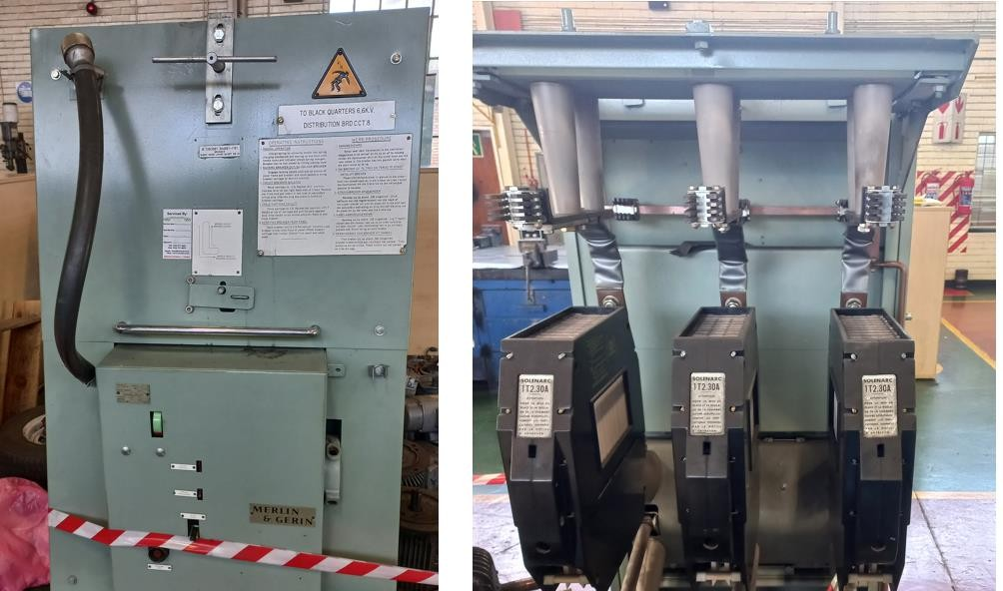
Figure 1: Merlin & Gerin circuit breaker installed at Hendrina power station

      - G.E.C vacuum circuit breakers.

Description
Service Voltage | 6.6kV
Rated Voltage | 7.2kV
Rated power frequency withstand voltage | 28kV
Rated lightning impulse withstand voltage | 75kV
Rated frequency | 50Hz
Rated current | 800 and 2000 (Feeders), and 2000A (Incomer breaker)
Rated short circuit breaking current | 25kA
Rated peak withstand current | 63kA
Rated duration of short circuit | 3s

Opening and closing coil voltage | 220VDC
Charging motor | 220VDC
Close coil minimum pick up voltage | 176VDC
Trip coil minimum pick up voltage | 85VDC
Time spread between poles during closing and opening operation | less than 4micro seconds and 3micro seconds
Table 2: G.E.C vacuum circuit breaker specifications

      - SACE vacuum circuit breakers

Description
Service Voltage | 6.6kV
Rated Voltage | 7.2kV
Rated power frequency withstand voltage | 28kV
Rated lightning impulse withstand voltage | 75kV
Rated frequency | 50Hz
Rated current | 800A (Feeders)
Rated short circuit breaking current | 25kA
Rated peak withstand current | 63kA
Rated duration of short circuit | 3s
Opening and closing coil voltage | 220VDC
Charging motor | 220VDC
Close coil minimum pick up voltage | 176VDC
Trip coil minimum pick up voltage | 82VDC
Time spread between poles during closing and opening operation | less than 4ms and 3ms respectively
Table 3: SACE vacuum circuit breaker specifications

      - Hawker Siddeley, vacuum circuit breakers; substation board 2A

4. Description
Service Voltage | 6.6kV
Rated Voltage | 7.2kV
Rated power frequency withstand voltage | 28kV
Rated lightning impulse withstand voltage | 75kV
Rated frequency | 50Hz
Rated current | 630A (Feeders) 1200A(Feeders) and 2000A (Incomer breaker)
Rated short circuit breaking current | 25kA
Rated peak withstand current | 63kA
Rated duration of short circuit | 3s
Opening and closing coil voltage | 220VDC
Time spread between poles during closing and opening operation | less than 4ms and 3ms respectively
Charging motor | 220VDC
Close coil pick up voltage | 176VDC
Trip coil minimum pick up voltage | 85VDC
Table 4: Hawker Siddeley vacuum circuit breaker specifications

      - Hawker Siddeley, vacuum contactor; substation board 2A

Description
Service Voltage | 6.6kV
Rated Voltage | 7.2kV
Rated power frequency withstand voltage | 28kV
Rated lightning impulse withstand voltage | 75kV
Rated frequency | 50Hz

Rated current | 400A (Feeders)
Rated short circuit breaking current | 25kA
Rated peak withstand current | 63kA
Rated duration of short circuit | 3s
Permissible Switching Frequency | 1200/Hour
Mechanical and Electrical Life | 2,500,000 and 250 000 operations
Closing time | 80 ms or less
Opening Time | 25 ms
Opening and closing coil voltage | 220VDC
Auxiliary arrangement | 3NO – 3NC
Close coil pick up voltage | 154VDC (cold)
Drop-out voltage | 88VDC
Table 5: Hawker Siddeley vacuum contactor specifications

      - Toyo Denki vacuum contactor

Description
Service Voltage | 6.6kV
Rated Voltage | 7.2kV
Rated power frequency withstand voltage | 28kV
Rated lightning impulse withstand voltage | 75kV
Rated frequency | 50Hz
Rated current | 630A (Feeders)
Rated short circuit breaking current | 25kA
Rated peak withstand current | 63kA
Fuse(s) rating | In = 200A, Un = 6/12kV
Close coil | 110VDC
Close coil minimum pick up voltage | 77VDC (cold)

Drop-Out Voltage | 44 V ≤ drop-out ≤ 55V
Time spread between poles during closing and opening operation | less than 4 microseconds
Opening/Closing cycles | 150 0000
Table 6: Toyo Denki vacuum contactor specifications

    - Employer Design requirements
The controlgear(s) shall be new, and factory tested as direct replacement, and it shall fit within the existing circuit breaker frame/trolly and shall be able operate in the existing switchgear cubicles interacting with all cell features to provide the same interlocks and interactions as the original circuit breakers.
Controlgears shall have the following:
      - The ability to electrically and mechanically trip free under normal and abnormal condition(s) and at any point in the stroke without additional modifications to the existing cubicles.
      - Anti-pumping features.
      - A breaker-mounted indicating device to indicate breaker contact “open-closed” position.
      - The circuit breaker open and close semaphores shall be red for “Closed” and green for “Open.”
      - Charging of the stored energy mechanism will be initiated after the circuit breaker is closed.
      - An indicator showing when the mechanism is charged shall be provided. Spring “Charged” and “Discharged” semaphores shall be yellow and white, respectively.
      - All primary current conductors between circuit breaker components shall be constructed of copper bar or flexible copper strap. Sliding contacts are not permitted.
      - All control wires shall be type 400 V, single-conductor, copper Class B stranding, 2,5mm².
      - All wiring and terminations within the controlgear shall comply with the applicable sections of the Plant Name design guidelines unless otherwise noted or approved in writing by Plant Name.
      - Wiring to terminals shall be equal, with identification numbers corresponding to those on the existing wiring diagram.
      - All wiring shall be capable of passing the NEMA Flame Resisting Test, NEMA WC5-1992, or the IEEE Flame Tests, IEEE Std. 383_1974. If a different Flame Resisting Test Standard is used than the aforementioned, that standard shall be approved by Employer in writing prior to manufacture of the controlgear.
      - The controlgear control scheme shall be compatible with the existing units to be replaced.
      - Wires shall not be spliced or taped between terminal points. No wire shall be used that is cut or nicked.

      - There shall be no more than two (2) wires connected to each terminal. The controlgear wiring shall be arranged so that breaker components may be removed and/or serviced without unduly disturbing the wiring. No wire shall be routed across the face of any device.
      - Wires shall be grouped in bundles and secured with non-flammable tie bands. The bundles shall be run in an orderly manner and shall be adequately supported with not less than the minimum radius bends as per industry standards.
      - Where wiring must cross sharp edges, adequate protection shall be provided by approved devices.
      - All welded assemblies after fabrication shall be thoroughly cleaned and treated to provide corrosion resistance and adhesion of paint finish. All steel surfaces shall be painted or zinc dichromate coated.

Equipment identification
      - Nameplates providing the new circuit breaker data shall be provided in accordance with ANSI C37.59, Section 7.
      - Nameplates shall be engraved or embossed with lettering that is a minimum of 4mm in height.
      - Each breaker shall also be supplied with a unique identifier for future tracking of maintenance history.
      - Two identical nameplates shall be permanently attached to the controlgears. One will be attached to the frame in a manner in which removal is extremely difficult, and the other will be attached to the front cover for ease and speed of identification

Maintenance requirements
      - The Vendor shall include in the proposal a summary of any routine, periodic, or special maintenance (including recommended frequencies for routine planned maintenance (PM)) required for maintaining the proper controlgear operation for a 5-year period.
      - The Vendor shall include in the proposal a list of recommended spare parts and pricing to support the breaker maintenance for the next five years.

  - CONTRACTOR – REPAIRS SCOPE OF WORK
Hendrina power station has different types of MV switchgears and their controlgear(s) differs as well. The repairs must be done on controlgear as and when required. See annexure A for the list of all the controlgears utilised at Hendrina power station on the MV switchgears.

The scope of work includes but not limited to:
- Collect the controlgear(s) (circuit breaker/ vacuum contactor) at Hendrina power station.
- Strip & assess the controlgear for damage(s), develop a QIP for the controlgear and email back the report to the Eskom system engineer at dumanezm@eskom.co.za for the scope final approval.
- FAT and routine tests in the presence of an Eskom representative and deliver the contactor at Hendrina power station. See annexure B for all the circuit breaker tests to be conducted.

- Deliver the controlgears at Hendrina power with all the circuit breaker data packs.
- All technical communications concerning the scope of work to be done via email to dumanezm@eskom.co.za

G.E.C vacuum circuit breakers.
      - Clean the circuit breaker trolley/frame.
      - Sand blast the trolley and repaint (fire retardant paint to be used) the trolley with the original colour of the circuit breaker.
      - Replace all the worn-out parts.
      - Replace vacuum bottles with the new ones and return the old bottles to Employer.
      - Replace/Rewind the trip coil and the close coil with new ones.
      - Inspect and overhaul the charging motor.
      - Replace the brushes of the charging motor.
      - Install the operation counter.
      - Conduct circuit breaker tightness checks.
      - Ensure that all arcing contacts make simultaneously. Check the loading spring for irregularities and check spring tension.

SACE Vacuum circuit breakers
      - Clean the circuit breaker trolley/frame.
      - Clean carefully the insulating parts, clean and lubricate the operating mechanism and the connection rods.
      - Sand blast the trolley and repaint (fire retardant paint to be used) the trolley with the original colour of the circuit breaker.
      - Replace all the worn-out parts.
      - Inspect and overhaul the charging motor.
      - Replace the brushes of the charging motor.
      - Install the operation counter.
      - Conduct circuit breaker tightness checks.
      - Ensure that all arcing contacts make simultaneously. Check the loading spring for irregularities and check spring tension.
      - Inspect the Tulip contact.

Arc chute checking:
Remove the interphase barrier and bolts fastening the arc chutes to the front insulating support (3) (fig. 2); tilt the arc-chute on pin (2) (fig. 2).

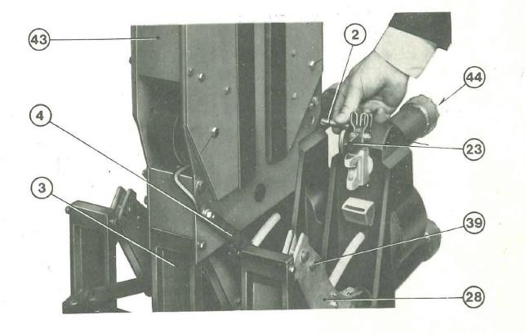

Figure 2: Arc chute
      - Ceramic plate – (21) figure 3:
        - Check ceramic plates for breaking or cracks and replace where necessary.
        - Remove the smoke or dust deposits with dry clean rags or with dry compressed air.
        - Remove metal deposit due to arc by means of sand pate. NOTE: Do not use wire brushes, files, or emery cloth.

Arc runners – (22) figure 3:
        - Remove smoke or dirt deposits with dry clean cloth.

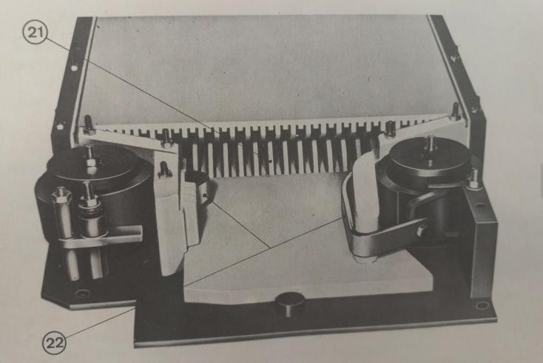

Figure 3: Ceramic plates & Arc runners

      - Arcing contacts inspection and replacement
To inspect the arcing contacts, remove the safety barrier and tilt the arc-chutes backwards.

        - Clean carbon traces due to the arc by means of clean cloth drenched with a cleaning solvent.
        - Remove any pitting of contact with fine sandpaper, taking care not to alter the shape of the contacts.
        - Remove any metal traces from the insulating parts of the controlgear

Hawker Siddeley vacuum circuit breaker
      - Clean the circuit breaker trolley/frame.
      - Sand blast the trolley and repaint (fire retardant paint to be used) the trolley with the original colour of the circuit breaker.
      - Replace all the worn-out parts.
      - Replace vacuum bottles with the new ones and return the old bottles to Employer.
      - Replace/Rewind the trip coil and the close coil with new ones.
      - Inspect and overhaul the charging motor.
      - Replace the brushes of the charging motor.
      - Conduct circuit breaker tightness checks.
      - Ensure that all arcing contacts make simultaneously. Check the loading spring for irregularities and check spring tension.

Hawker Siddeley and Toyo Denki Vacuum contactors
      - Clean the circuit breaker trolley/frame.
      - Sand blast the trolley and repaint (fire retardant paint to be used) the trolley with the original colour of the circuit breaker.
      - Replace all the worn-out parts.
      - Replace vacuum bottles with the new ones and return the old bottles to Employer.
      - Replace HRC fuses with new one of the same ratings and return the old fuses to Employer.
      - Replace/Rewind the trip coil and the close coil with new ones.
      - Inspect and overhaul the charging motor.
      - Replace the brushes of the charging motor.
      - Conduct circuit breaker tightness checks.
      - Ensure that all arcing contacts make simultaneously. Check the loading spring for irregularities and check spring tension.

Merlin Gerin SF6 gas circuit breakers
      - Clean the circuit breaker trolley/frame.

      - Sand blast the trolley and repaint (fire retardant paint to be used) the trolley with the original colour of the circuit breaker.
      - Replace all the worn-out parts.
      - Replace/Rewind the trip coil and the close coil with new ones.
      - Inspect and overhaul the charging motor.
      - Replace the brushes of the charging motor.
      - Install the operation counter.
      - Conduct circuit breaker tightness checks.
      - Check SF6 gas leaks and provide report of the findings.
      - Refill the SF6 gas.
      - Ensure that all arcing contacts make simultaneously. Check the loading spring for irregularities and check spring tension.

Acceptance
This document has been seen and accepted by:

Name | Designation

Revisions

Date | Rev. | Compiler | Remarks
July 2025 | 0 | Z Mdluli | First issue

Development Team
The following people were involved in the development of this document:

Acknowledgements

